Sommario

Documents used 6

Sezione 1: Notes and Information 7

3. What is this course all about? 7

15. Testing Hello-World through SWV 8

Sezione 6: Embedded Code Debugging Tips and tricks 11

17. Debugging options 11

18. Single stepping 11

19. Disassembly and Register windows 12

20. Breakpoints 13

21. Expression and variable windows 14

22. Memory browser windows 15

23. Call stack and fault analyzers 17

24. Data watch-points 19

25. SFR windows (Peripheral Registers) 22

26. Other basic feature of IDE 23

Sezione 7: Understanding MCU Memory Map 24

27. Understanding Memory Map of the MCU: Part 1 24

28. Understanding Memory Map of the MCU: Part 2 26

29. Understanding Memory Map of the MCU: Part 3 27

Sezione 8: MCU Bus Interfaces 30

30. MCU Bus Interfaces Explanation Part 1 : I-Code / D-Code / S-Bus 30

31. MCU Bus Interfaces Explanation Part 2 : AHB / APB1 / APB2 35

32. MCU Bus Interfaces Explanation Part 3: Q/A session 38

33. Understanding MCU Bus Matrix 43

Sezione 9 45

Understanding MCU Clocks and Details 45

Understanding MCU clock sources and HSE 46

36. HSI and RCC registers 51

37. Peripheral clock configuration 55

38. Exercise: HSI measurements 58

40. Code implementation 61

41. Exercise: HSE measurement 62

Sezione 11: Understanding MCU Vector Table 64

42. Understanding MCU Vector Table 64

NVIC (Nested Vector Interrupt Controller) 68

Sezione 12: Understanding MCU interrupt Design, NVIC, Interrupt handling 69

43. MCU Interrupt Design, NVIC, Interrupt handling: Part 1 69

44. MCU Interrupt Design, NVIC, Interrupt handling: Part 2 73

45. MCU Interrupt Design, NVIC, Interrupt handling: Part 3 76

Sezione 13: Importance of “Volatile” keyword 81

46. Importance of “Volatile” keyword: Part 1 81

47. Importance of “Volatile” keyword: Part 2 82

Sezione 14: GPIO must know concepts 84

48. GPIO pin and GPIO port 84

49. GPIO behind the scenes 85

GPIO pin: output mode 85

GPIO pin: input mode 86

50. GPIO input mode with high impedance state 87

51. GPIO input mode with pull-up/down state 88

52. GPIO output mode with open drain state 88

53. GPIO output mode with push-pull state 92

54. Optimizing I/O power consumption 94

Sezione 15: GPIO Programming structure and registers 96

55. GPIO programming structure 96

56. Exploring GPIO Port and pins of STM32F4xx Discovery Board 98

57. GPIO Mode register (used to set mode for a pin) 99

58. Input configuration of a Microcontroller’s GPIO Pin 104

GPIO pin: Input mode 105

59. Output Configuration mode of a GPIO Pin in Push-Pull mode 111

60. Output Configuration mode of a GPIO Pin in open drain mode 113

61. Input stage of a GPIO pin during output configuration 116

62. Alternate functionality configuration of a GPIO pin 117

63. GPIO output type register explanation 119

Sezione 16: GPIO Registers: SPEED, PULL UP/DOWN, IDR and ODR 120

64. GPIO output speed register and its applicability 120

65. GPIO Pull-up and Pull-down register 126

66. GPIO input data register 127

67. GPIO output data register and summary of various modes discussed 128

Sezione 17: GPIO Alternate functionality register and example of usage 130

68. Alternate functionality settings of a GPIO pin with example: Part 1 130

69. Alternate functionality settings of a GPIO pin with example: Part 1 133

Sezione 18: GPIO peripheral clock control 139

71. Enabling and disabling GPIO peripheral clock 139

Sezione 19: GPIO driver development overview and project creation 140

72. GPIO driver development overview 140

73. MCU specific header file and its contents 142

74. New project creation and creating MCU specific header file 144

75. Include path settings 145

Sezione 20: Updating MCU specific header file with bus domain and peripheral details 146

77. Writing base address C macros for MCU’s embedded memories: Part 1 146

78. Writing base address C macros for MCU’s embedded memories: Part 2 148

79. Defining base addresses of different bus domains 149

80. Defining base addresses of AHB1 Peripherals 153

81. Defining base addresses of APB1 and APB2 peripherals 155

82. Defining base addresses conclusion 157

83. Address of peripheral registers 158

84. Structuring Peripheral register details 160

85. Peripheral definition macros 165

Sezione 22: Writing Clock enable and disable macros 168

86. Writing peripheral clock enable and disable C macros 168

87. Project include settings and build 171

Sezione 23: GPIO driver API requirements and handle structure 173

88. Creating GPIO driver header and source file 173

89. Defining GPIO handle and configuration structure 173

90. Driver API requirements and adding API prototypes 176

91. Driver API input parameters and return types 177

92. Driver empty API implementation and documentation 179

Sezione 24: GPIO driver API Implementation: Clock control 181

93. Implementation of GPIO peripheral clock control API 181

Sezione 25: GPIO driver API Implementation: GPIO init and de-init 183

94. Writing user configurable macros 183

95. Implementation of GPIO init API 187

96. Implementation of GPIO init API contd. 191

97. Configuring Alternate function registers 192

98. GPIO de-init API implementation 195

Sezione 26: GPIO driver API Implementation: GPIO data read and write 197

99. Implementation of GPIO input port read and input pin read APIs 197

100. Implementation of GPIO output port write and output pin write APIs 198

101. Implementation of GPIO pin toggle API 199

Sezione 27: Exercise 200

102. Exercise: LED toggling with Push Pull configuration 200

103. Exercise: LED toggling with Open Drain configuration 203

104. Exercise: Handling on board LED and button 205

105. Exercise: connecting external button and circuit explanation 208

106. Exercise: Testing button interface 214

107. Button interrupt introduction 215

Sezione 28: GPIO pin Interrupt configuration 216

108. GPIO pin interrupt configuration coding: Part 1 216

109. GPIO pin interrupt configuration coding: Part 2 219

110. GPIO pin interrupt configuration coding: Part 3 221

111. GPIO pin interrupt configuration coding: Part 4 222

112. GPIO pin interrupt configuration coding: Part 5 227

113. GPIO pin interrupt configuration coding: Part 6 235

114. GPIO pin interrupt configuration coding: Part 7 239

Sezione 29: Exercise: GPIO Interrupts 244

115. Exercise: External button interrupt implementation 244

Sezione 30: MCU I/O Pin Specifications 249

118. STM32 Pin specifications 249

119. Pin current characteristics 258

120. Logic levels 261

Sezione 31: SPI introduction and bus details 266

121. Introduction to SPI Bus 266

122. SPI comparison with other protocols 269

123. Importance of SPI slave select pin 271

124. SPI Minimum bus configuration 272

125. SPI behind the scene data communication principle 273

Sezione 32: SPI bus configuration and functional block diagram 276

126. SPI bus configuration discussion: full duplex, half duplex and simplex 276

127. SPI functional block diagram explanation 279

Sezione 33: STM32 NSS pin settings and management 283

128. NSS settings in STM32 master and slave modes 283

129. STM32 SPI hardware and software slave managements 285

Sezione 34: SPI CPOL and CPHA discussion 289

130. SPI CPOL and CPHA discussion 289

Sezione 35: SPI serial clock discussion 295

132. SPI peripherals of your MCU 295

133. SPI serial clock frequency 296

Sezione 36: SPI Driver: API requirements and configuration structure 298

134. SPI API requirements and configuration items 298

135. Updating MCU specific header file with SPI related details 302

135. SPI adding API prototypes to driver header file 303

137. Implementation of SPI peripheral clock control API 304

Sezione 38: SPI Driver API implementation : SPI init / deinit 305

138. SPI user configuration options writing and register bit definition macros 305

# Documents used

* ***Reference Manual STM32F407x***: [STM32F405/415, STM32F407/417, STM32F427/437 and STM32F429/439 advanced Arm<Sup>®</Sup>-based 32-bit MCUs - Reference manual](https://www.st.com/resource/en/reference_manual/rm0090-stm32f405415-stm32f407417-stm32f427437-and-stm32f429439-advanced-armbased-32bit-mcus-stmicroelectronics.pdf)
* ***Datasheet STM32F407x:*** [DS8597_STM32F41xxx.book](https://www.st.com/resource/en/datasheet/stm32f415rg.pdf)
* ***User Manual STM32F407VG Discovery Board:*** [Discovery kit with STM32F407VG MCU - User manual](https://www.st.com/resource/en/user_manual/dm00039084-discovery-kit-with-stm32f407vg-mcu-stmicroelectronics.pdf)
* ***STM32NUCLEO-H563ZI Reference Manual:*** [STM32H523/33xx, STM32H562/63xx, and STM32H573xx Arm<Sup>®</Sup>-based 32-bit MCUs - Reference manual](https://www.st.com/resource/en/reference_manual/rm0481-stm32h52333xx-stm32h56263xx-and-stm32h573xx-armbased-32bit-mcus-stmicroelectronics.pdf)
* ***STM32NUCLEO-H563ZI Datasheet***: [Datasheet - STM32H573xx - Arm<Sup>®</Sup> Cortex<Sup>®</Sup>-M33 32-bit MCU + TrustZone<Sup>®</Sup> + FPU, 375 DMIPS, 250 MHz, 2-Mbyte flash memory, 640-Kbyte RAM, cryptography](https://www.st.com/resource/en/datasheet/stm32h573ai.pdf)
* ***Schematic NUCLEO***-***H563ZI (CAD Resources):*** mb1404-h563zi-c01-schematic.pdf
* ***Schematic STM32F407VG discovery board:*** mb997-f407vgt6-c01_schematic.pdf
* ***ARM Cortex M4 Generic User Guide:*** DUI0553.pdf
* ***ARM Cortex M33 Generic User Guide:*** [Arm Cortex-M33 Devices Generic User Guide](https://developer.arm.com/documentation/100235/0100/Overview/About-the-Cortex-M33-processor-and-core-peripherals)

# Sezione 1: Notes and Information

## 3. What is this course all about?

Hi, welcome to the course. First of all thank you for taking this course in this video. Let me quickly give an overview of the course structure is very very simple.

The course mainly has 3 Phases.

In the **phase 1**, We will learn about behind the scene working off each Peripheral like GPIO, SPI, I2C and USART in this phase. You will learn the fundamental operation of each peripheral. Its control and configuration registers programming structure configuring Peripheral clocks, IRQs and interrupt configurations and many other interesting things.

After that we will move to the **phase 2** by gaining full confidence about the peripheral. What we do is start implementing a driver code for the peripheral. In this phase let's first to write the Peripheral Driver Header File followed by the driver source code. We will populate the header file with various Macros explaining the peripheral and also we will prototype all that required APIs which needs to be implemented by the driver source code. Then I will walk you through step by step procedure to implement various APIs as part of driver source code implementation.

After that comes the **phase 3**. In phase-III we will do testing and debugging of our implementation by writing a sample application for each Peripheral. So, Phase-III consist of write a sample application on top of a driver using Driver Exposed APIs here We will write separate sample application to test each and every peripheral and the second tours we do in Phase-III is testing and debugging using logic and Analyzer hardware and software to keep everything professional. We not only test it on the real hardware but also get the trace on logic analyzer to analyze the behavior of the Peripheral. So, in this phase I will teach you how to configure the logic analyzer how to do connections between board and the logic analyzer. How to get the trace on the logic analyzer. And I will show you how you can decode various protocols into hex or ASCII. Also I will discuss common problems and debugging hints and tips related to protocol like SPI and I2C.

To conclude this the entire course is divided into three phases. The Phase-I is all about Demystifying the behind the scene working of the peripherals. In the Phase-II We will learn about the peripheral driver development by scratch. And finally in the Phase-III we will carry out debugging and testing. Now, hang on. It's not over yet. As a part of this course you will also get lots of bonus lectures related to bus interfaces clocks and software setup etc..

In this course by code implementation I will thoroughly discussed about different bus interfaces of your MCU like AHB, APB and different clocks like HCLK, PCLK, System clock PLL etc.. I will also discuss about various clock sources such as high speed external clock (HSE), high speed internal clock(HSI), phase clock loop(PLL) etc..

Through coding I will show you how to enable configure and finally how to use different clock sources as System clock to run them see you. Also I will teach you how you can route different clock sources to GPIOs to take measurement of different clock sources on your microcontroller and not only this. In this course I will help you to do entire software setup such as installing KEIL-MDK-5 Software, installing software pack for your microcontroller, creating your first KEIL project, Debugging, creating libraries from the key etc..

I have passionately created this course, to bring maximum advantage to your career and to improve your knowledge in the area of embedded systems. Great! thanks for watching this overview lecture from the next section. Let's begin with the first peripheral that is GPIO see in the next video.

## 15. Testing Hello-World through SWV

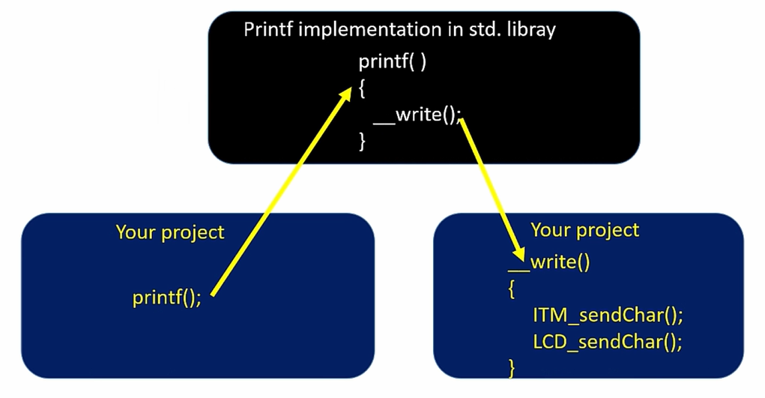

All’interno del file ***syscalls.c*** vi è il corpo della funzione ***__write()***:

**__attribute__**((weak)) **int** **_write**(**int** file, **char** *ptr, **int** len)

{

(**void**)file;

**int** DataIdx;

**for** (DataIdx = 0; DataIdx < len; DataIdx++)

{

//__io_putchar(*ptr++);

ITM_SendChar(*ptr++);

}

**return** len;

}

Abbiamo quindi commentato la funzione ***__io_putchar()*** e aggiunto la ***ITM_SendChar()*** in modo tale da inviare i dati all’***ITM (Instrumentation Trace Macrocell)***, in modo tale da popolare il suo buffer FIFO che verrà poi utilizzato dall’***SWO*** (***Serial Wire Output***) il quale è un pin tramite il quale i dati vengono inviati all’***ST-Link***. Tramite questo giro riusciremo a stampare sulla console dell’IDE i vari messaggi inseriti nella ***printf()***.

La funzione ***ITM_SendChar()*** è stata implementata sempre nel file ***syscalls.c***:

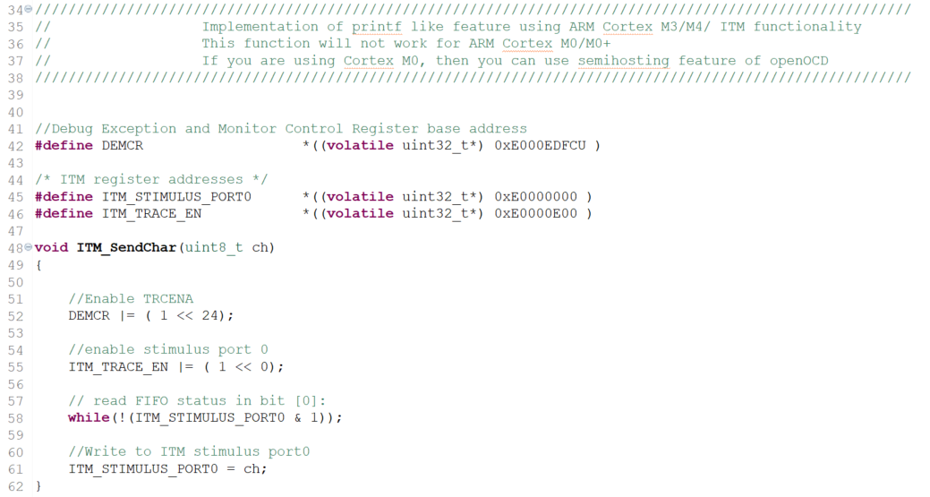

Quindi, se vi è bisogno di inviare i caratteri su un display LCD o tramite una comunicazione UART bisognerà aggiungere anche le 2 funzioni che permettono di inviare ciascun carattere sulla UART e/o sull’LCD.

Verrebbe fuori qualcosa del genere:

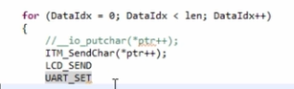

Andando su ***Project -> Debug configuration as***, cliccando sul progetto attuale e andando nella sezione ***Debugger***, dobbiamo essere sicuri che sia abilitata la ***Serial Wire Viewer (SWV)***, altrimenti la stampa in console non funzionerà:

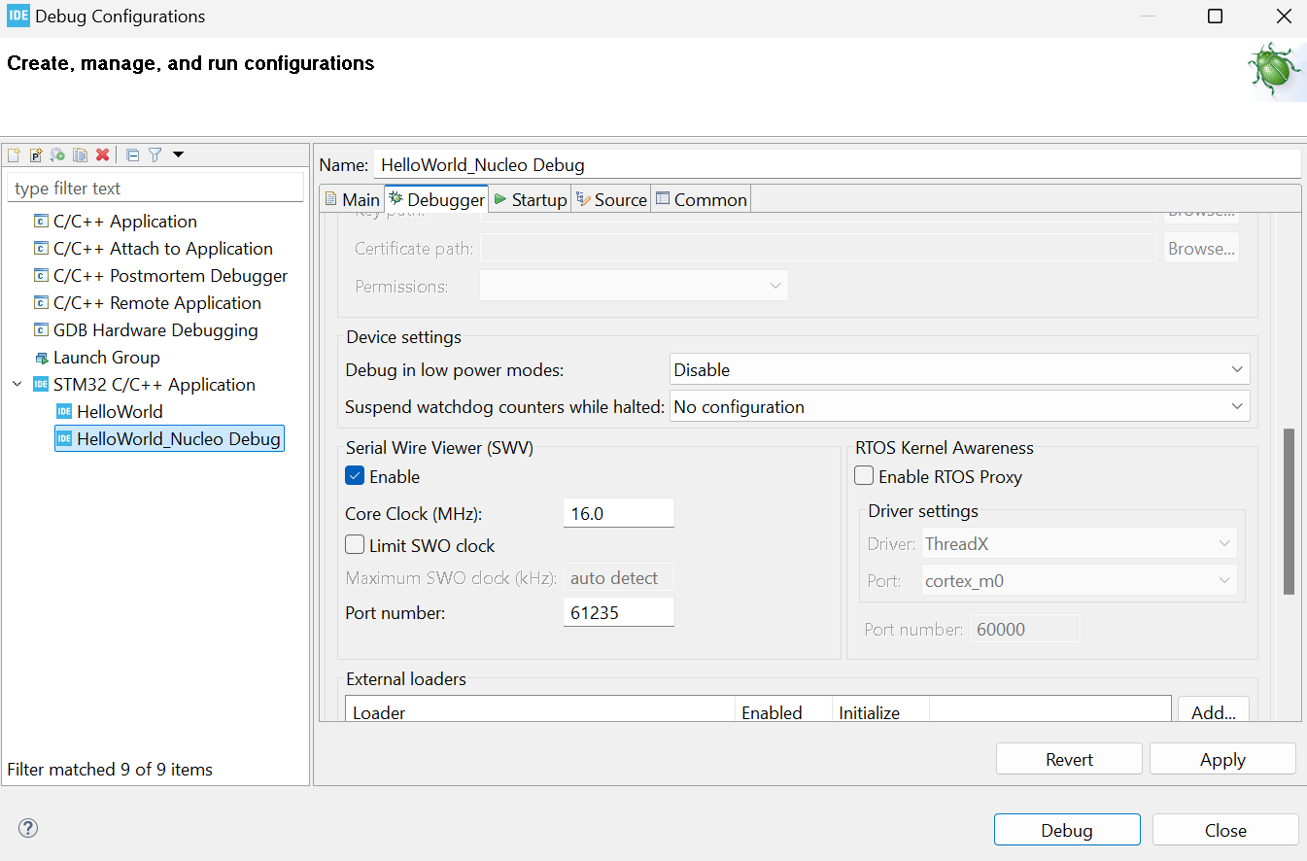

Una volta avviato il debug, il programma si bloccherà alla prima istruzione. Andare quindi in ***Window -> Show View -> SWV -> SWV ITM Data Console***

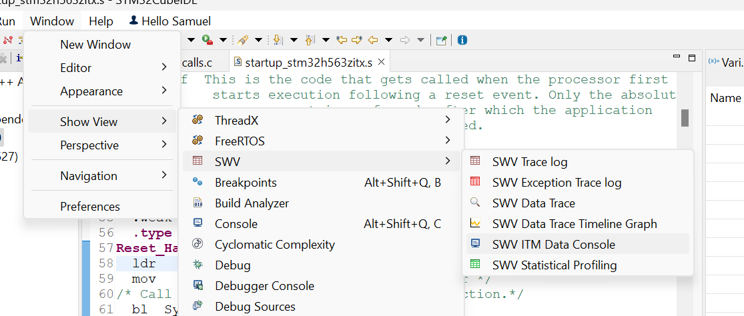

Una volta aperta la finestra dell’***SWV ITM Data Console***, cliccare sul pulsante di ***Configuration Trace*** ed in basso a dx selezionare la ***port 0,*** in quanto la funzione ***ITM_SendChar()*** invia i caratteri alla ***ITM stimulus port 0***:

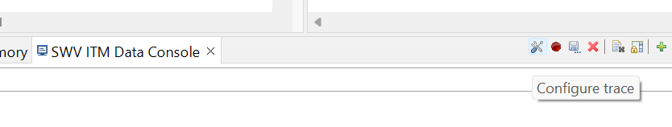

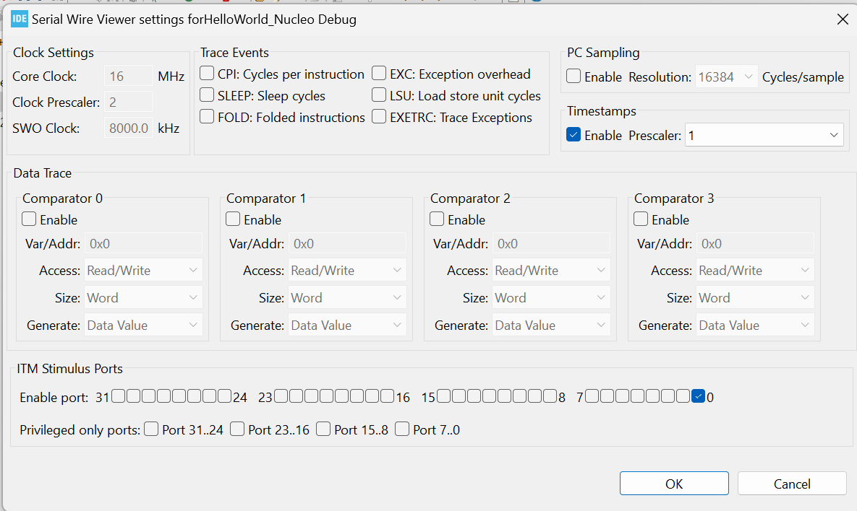

Una volta premuto su ***Ok***, bisogna necessariamente cliccare sul pulsante ***Start trace*** (pallino rosso):

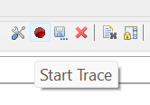

Questo codice non sembra funzionare sulla ***NUCLEO-H563ZI***.

# Sezione 6: Embedded Code Debugging Tips and tricks

## 17. Debugging options

Vi sono diverse ***embedded code debugging options:***

* ***Serial Wire Viewer*** e ***data tracing*** (*printf* style debugging)
* ***Single stepping, stepping over and stepping out***
* ***Breakpoints*** (inserting, deleting and skipping breakpoints)
* ***Disassembly***
* ***Call stack***
* ***Expression and variable windows***
* ***Memory browser***: viene utilizzato per esaminare i vari contenuti delle memorie presenti sul microcontrollore. Permette di leggere il contenuto di diverse memorie del micro come la *flash, SRAM* e altre memorie.
* ***Data watch-points***: sono una specie di breakpoint che vengono utilizzati per bloccare il processore quando si verificano certe condizioni

## 18. Single stepping

Quando lanciamo il debug del codice, il codice si ferma in automatico alla prima istruzione presente nel ***main()***. Quando siamo in questa situazione, il programma in realtà non è ancora partito.

Vedendo la finestra del ***Disassembly*** (***Window -> Show View -> Disassembly***) per visualizzare l’***assembly*** ***code*** avremmo questa situazione:

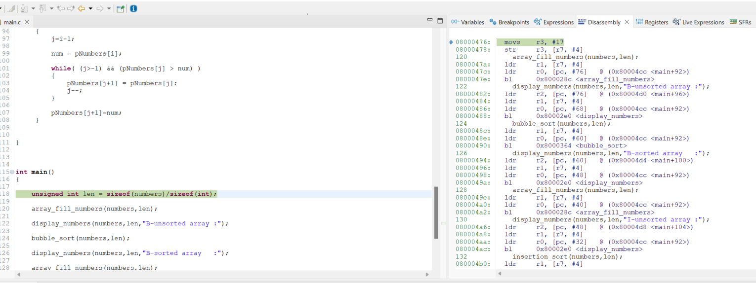

Se clicco sul pulsante ***Instruction Stepping Mode***, ogni volta che farò uno step nel debug del codice, in realtà non verrà eseguita una riga di codice per volta, ma verrà eseguita un’*istruzione assembly* per volta:

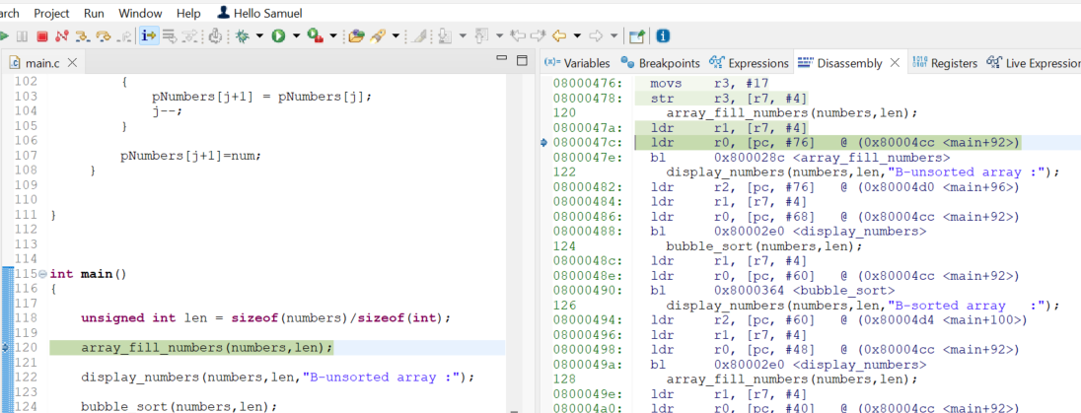

## 19. Disassembly and Register windows

Analizzando la finestra di ***Dissasembly*** possiamo vedere come sulla sinistra, in verde, vi sia l’***instruction memory***, ossia l’indirizzo di memoria della ***flash*** nella quale è salvata quell’istruzione:

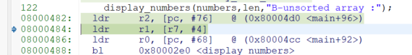

Cliccando col tasto dx su quella riga e possiamo abilitare lo ***Show Opcodes***, in quanto le ***instructions*** vengono salvate sottoforma di ***opcodes***:



Prendiamo come esempio questa istruzione:



In questo caso, si vuole *muovere* il numero 17 nel registro ***r3***, il quale è un registro interno del processore. Il valore ***17*** corrisponde al valore della variabile ***len*** che vi è nella prima riga di codice del ***main()***:

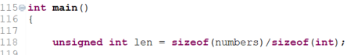

Per visualizzare una *window* con tutti i ***registri*** bisogna andare in ***Window -> Show View -> Registers***:

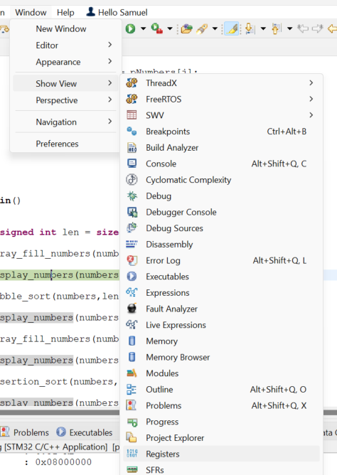

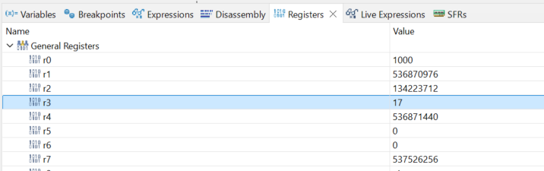

Possiamo quindi notare come nel registro ***r3*** sia presente il valore ***17***.

## 20. Breakpoints

* ***Breakpoints*** are the ways to tell the processor to halt or stop execution at certain instructions address.
* ***Breakpoints*** are realized through hardware address comparators that are there inside the processor debug unit.
* The underlying processor must support breakpoints. In questo caso il processore è un ***ARM Cortex-M4*** (***STM32*** usata nel corso).
* By using IDEs, we can set the breakpoints, we can delete it, and we can skip the breakpoints.
* These breakpoints which we about to use are also called ***hardware breakpoints*** because these are realized through the ***hardware unit*** of the ***processor***.
* There are also ***software breakpoints*** which are realized through ***breakpoints instructions***.

Quando si inserisce un ***breakpoint*** nel codice, quello che succede dietro le quinte è che stiamo configurando l’***hardware comparatore unit*** del processore con l’***address memory*** dell’***istruzione***. Perciò, quando il ***program counter address*** incontra l’***address*** corrispondente a quell’*istruzione*, il processore si ferma.

Vi è un numero limitato di ***hardware breakpoints*** che possono essere inseriti nel codice: questo dipende proprio da delle ***limitazioni hardware*** (solitamente è possibile inserire 5 o 10 breakpoints in totale).

## 21. Expression and variable windows

Possiamo aggiungere una *variabile* nella ***Expressions window*** per visualizzarne il valore.

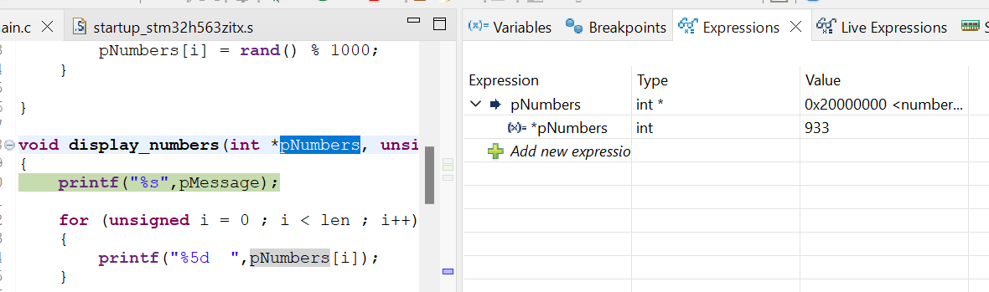

Ma, in realtà, la cosa più semplice da fare è andare nella ***Variables windows***, in quanto in questa sono presenti i valori di tutte le ***variabili*** relative alla funzione corrente (***stack function***):

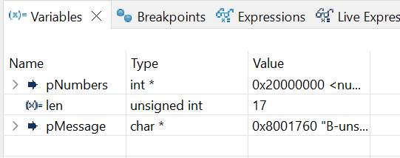

Infatti, se aggiungiamo un *breakpoint* in un’altra funzione e andiamo lì, la ***Variables window*** cambierà in automatico mostrandoci le variabili relative a quella funzione:

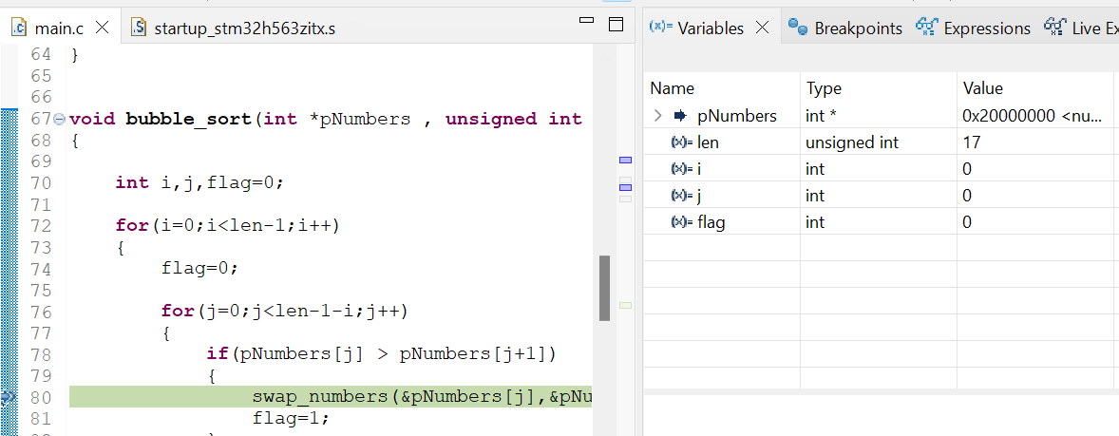

## 22. Memory browser windows

La ***Memory window*** è utilizzata per analizzare le diverse ***memorie*** presenti su un microcontrollore, e per leggerne il contenuto.



Quando dichiariamo ed inizializziamo delle variabili come nell’esempio, ossia delle **variabili globali** in un certo file **.c**, la tipologia di memoria del microcontrollore utilizzata per immagazzinarne il contenuto è la ***data memory***, chiamata anche ***SRAM*** o ***RAM***.

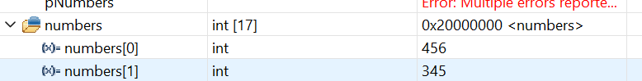

Possiamo inoltre vedere come tale variabile sia salvata nell’***address memory 0x20000000***: tale ***address memory*** corrisponde proprio al ***base address*** dell’***SRAM*** in questo microcontrollore.

Quando siamo all’inizio della funzione ***main()*** (ossia non appena avviamo il debug), se andiamo nella ***Variable window*** potremo osservare che però non vi è la variabile ***numbers***. Questo avviene in quanto tale variabile non fa parte dello ***stack frame*** delle funzione ***main()***.

Quindi, ***numbers*** è una variabile che non fa parte dello ***stack***, in quanto è una *variabile globale*. Per tale variabile dovremmo quindi utilizzare la ***Expression window***. Infatti, tale variabile viene salvata direttamente nella ***SRAM***, ossia nella *memoria statica*.

Oppure, possiamo utilizzare la ***Memory Browser window*** (selezionandola sempre da ***Window -> Show View***):

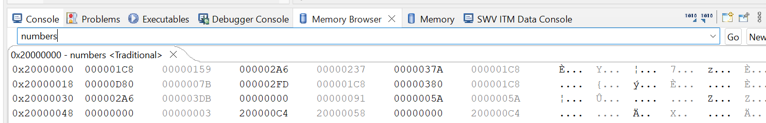

Digitando il nome della variabile (in questo caso ***numbers***), verremo reindirizzati direttamente all’***address memory*** in cui è salvata quella variabile.

In alternativa, potremmo inserire nella barra di ricerca direttamente l’***address memory*** che vogliamo andare a monitorare: in questo caso ***0x20000000***.

Sempre nella ***Memory Browser window***, cambiando la ***Radix*** in ***Decimal signed*** e il ***Columns*** in ***1***, avremo la seguente visualizzazione in cui è possibile fare facilmente un confronto tra i valori salvati nella variabile ***numbers*** e gli ***address memory*** di ogni valore:

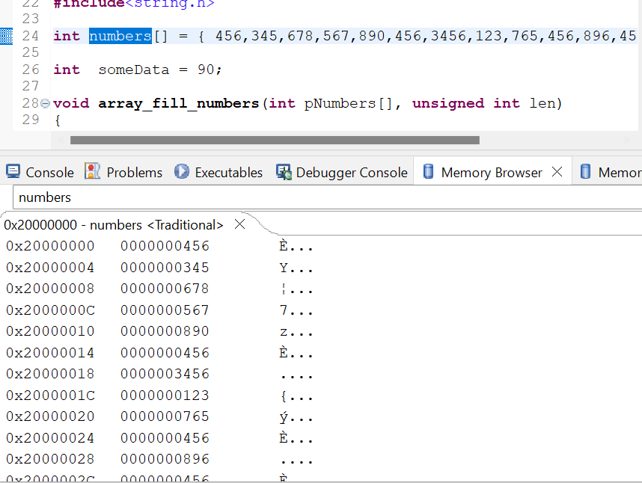

In questo caso l’***offset*** è sempre di ***4 byte***, ma è possibile anche cambiare tale parametro sempre cliccando col tasto dx all’interno di una riga della ***Memory Browser window.***

Un altro esempio lo possiamo fare inserendo come variabile un puntatore:

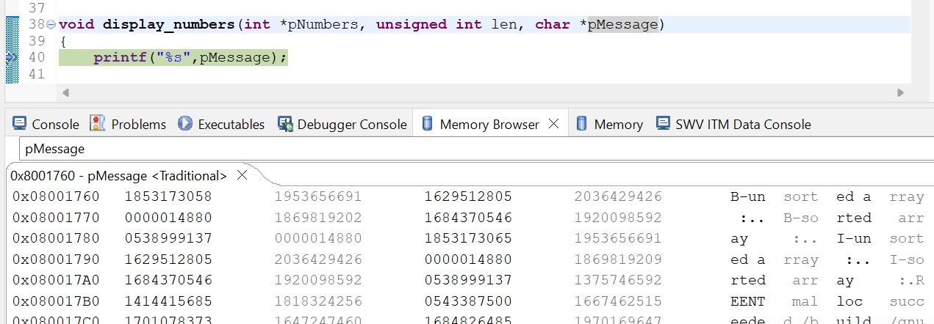

Inoltre, noi sappiamo che quando effettuiamo il download del codice all’interno del microcontrollore, il codice viene scaricato proprio nella ***flash memory***. Questo vuol dire che siamo in grado di localizzare tutte le varie istruzioni usando la ***Memory Browser window***: per far questo è sufficiente inserire nella barra di ricerca il ***base address*** della ***flash memory*** in cui viene salvato il codice dall’inizio.

Il ***base address*** della ***flash memory*** è ***0x08000000*** per l’***STM32F407***.

Immaginiamo quindi di voler localizzare una certa ***istruzione***: andiamo nella ***Disassembly window*** e da lì prendiamo l’***address memory*** della prima istruzione:



In questo caso l’***address memory*** è ***0x08000476***: inseriamo quindi quell’indirizzo di memoria nella barra di ricerca della ***Memory Browser window***:

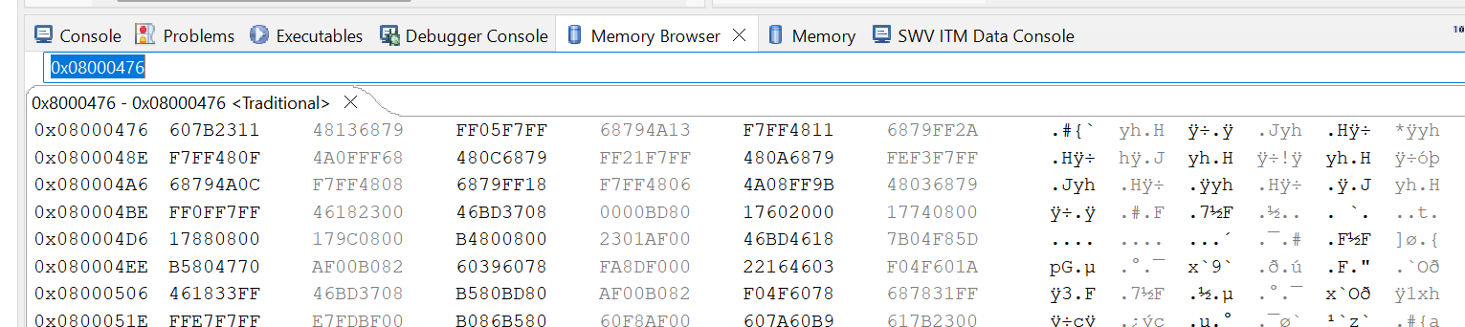

Possiamo quindi notare che a quell’***address memory*** è salvato propriol’***opcode*** di quella istruzione (*11 23*):

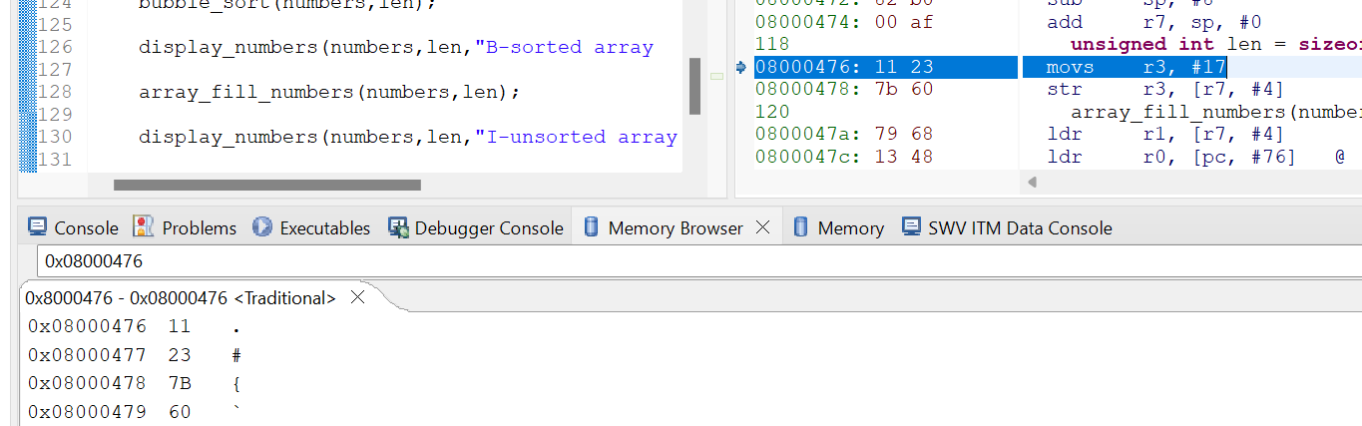

È possibile, inoltre, creare un ***file*** in cui esportare tutto il contenuto di una certa ***memoria***.

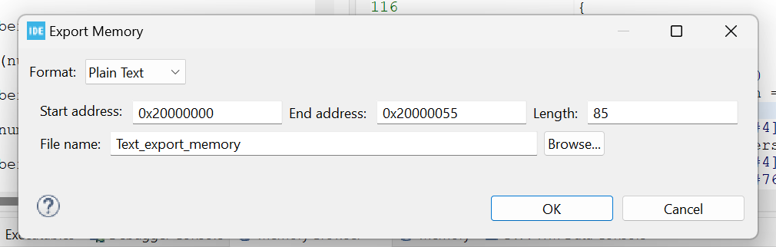

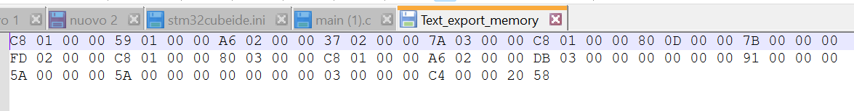

## 23. Call stack and fault analyzers

Questa feature può essere utilizzata per tener traccia dello ***stack frames*** delle varie funzioni chiamate all’interno del programma.

A volte, quando si hanno tante funzioni all’interno di un programma, potrebbe avvenire una ***processor exception*** che causerebbe un *crash* del codice.

*Come facciamo quindi a capire quale linea di codice o quale istruzione ha generato quel problema?*

Possiamo effettuare un debug utilizzando la ***call stack*** in modo tale da trovare la riga di codice o l’istruzione responsabile del *crash*.

Per fare un esempio abilitiamo l’#if presente in questa funzione:

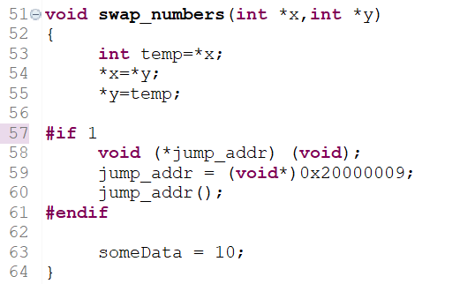

In questo caso stiamo utilizzando una ***function pointer***: ciò che avviene è che quando viene chiamata ***jump_addr()***, il codice va a puntare a quell’indirizzo di memoria assegnato nella riga precedente ed inizia ad eseguire il codice a partire da quel *memory address*.

Però, in quel *memory address* non c’è nessuna istruzione particolare, di conseguenza, quando il processore tenterà di eseguire l’istruzione presente a quell’*address memory*, dato che l’istruzione non è valida, vi sarà un ***instruction fault exception*** che determinerà un *crash*.

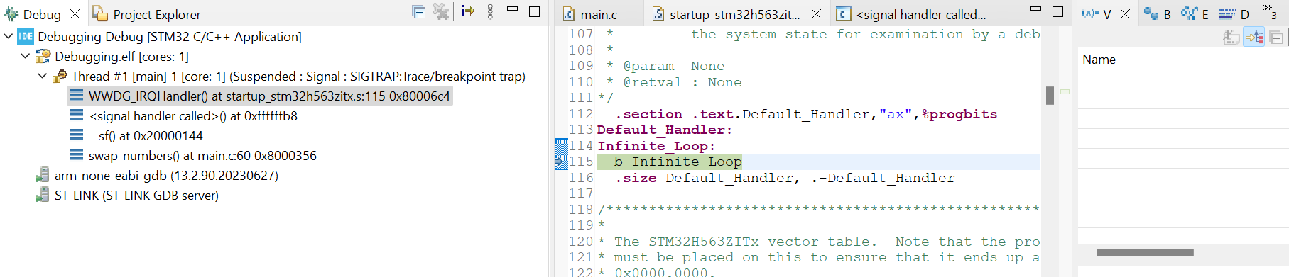

Infatti, si va a finire in un ***infinite loop***: possiamo inoltre notare come la ***Variables window*** sia vuota.

Se dalla finestra di debug andiamo nella riga di ***_sf()*** notiamo come vi sia un ***“No source available for …”***

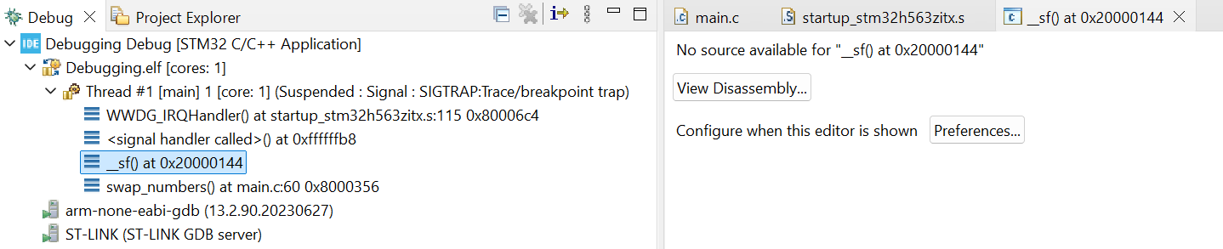

Questo è corretto in quanto a quell’*address memory* non vi è nessuna istruzione valida.

Subito dopo, vi è un ***signal handler called***, il quale avviene quando si verifica una ***exception***. Normalmente, dopo un evento di questo tipo, il processore va a finire in un ***infinite handler***.

Un altro strumento molto utile in questi casi è la ***Fault Analyzer window*** (***Window -> Show View -> Fault Analyzer***):

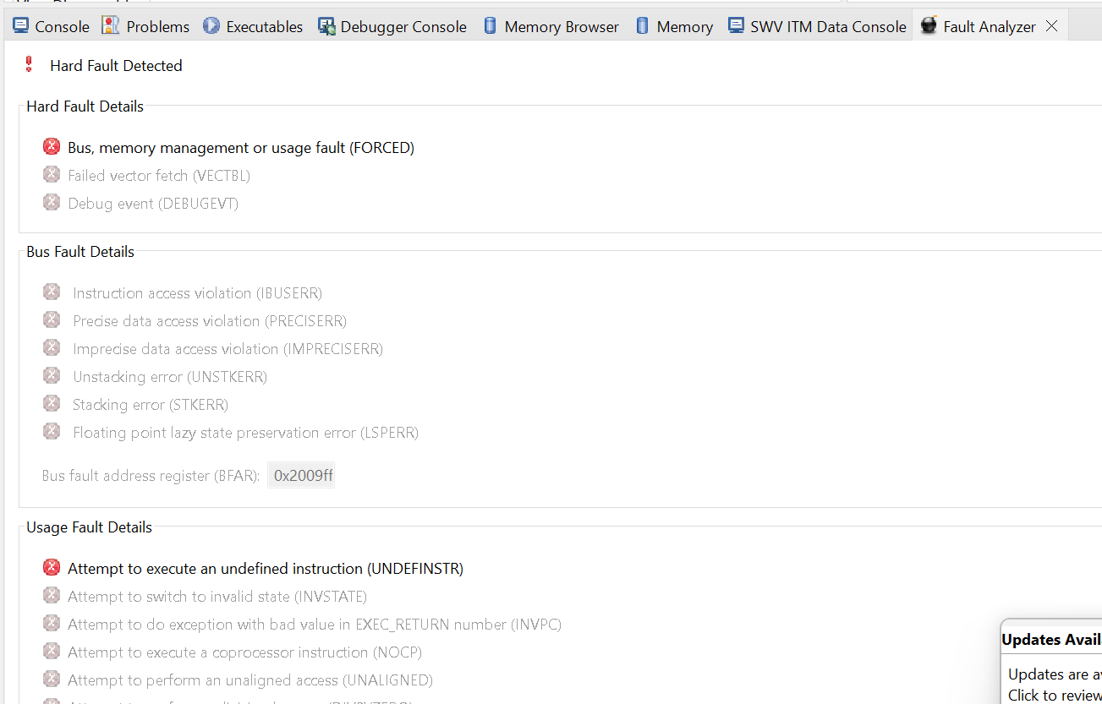

Da tale *window* otteniamo la seguente informazione: l’*exception* è avvenuta a causa di un ***usage fault***, nel tentativo di eseguire una ***undefined instruction*** (***Attempt to execute an undefined instruction***).

Da questa *exception* è poi scaturito un ***hard fault exception*** (per questo motivo è evidenziato anche un ***Hard Fault Details***) dal punto di vista dell’applicativo.

Quindi, quando viene individuato un ***hard fault***, vuol dire che c’è stato un problema col processore, ossia è stato implementato qualcosa che non rispetta le regole di design di un processore.

## 24. Data watch-points

I ***data watch-points*** sono una specie di *breakpoint*.

All’inizio del codice abbiamo questa riga di codice in cui viene dichiarata ed inizializzata a ***90*** questa variabile:

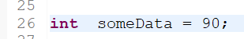

Successivamente, in questa funzione, viene modificato il valore di questa variabile:

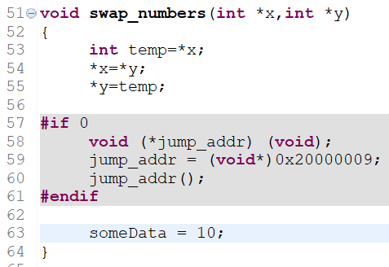

*Come è possibile trovare quale istruzione all’interno del progetto ha modificato il valore della variabile globale* ***someData****?*

A volte, infatti, anche a causa di problemi con la ***stack*** (es. ***stack overflow***), il valore di una variabile potrebbe essere modificato in maniera indesiderata.

Utilizzando i ***data watch-points*** possiamo risolvere questo problema, andando a vedere esattamente chi sta modificando il valore di una variabile o di un puntatore.

Inoltre, utilizzando i ***data watch-points*** è possibile ridurre significativamente il numero di breakpoint da utilizzare: infatti, invece di inserire un breakpoint in ogni riga di codice in cui viene modificato il valore della variabile ***someData***, sarà sufficiente aggiungere un ***data watch-point*** per quella variabile.

Quello che vogliamo fare è quindi aggiungere un ***data watch-point*** nella riga di codice in cui viene dichiarata ed inizializzata la variabile ***someData***: per far questo dobbiamo andare nella ***Breakpoints window,*** cliccare sui 3 pallini verticali che si trovano a dx, e andare su ***Add watchpoint***:

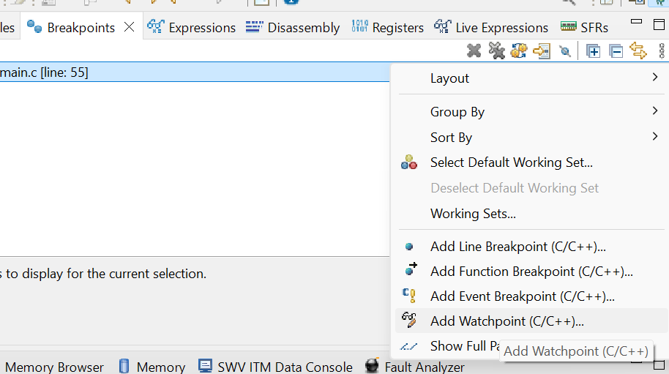

Si aprirà quindi quest’altra finestra in cui andremo ad inserire il nome della variabile da monitorare, e lasceremo come modalità quella di ***Write*** (avessimo aggiunto anche la ***read*** avremmo visto tutti i punti in cui la variabile viene anche letta):

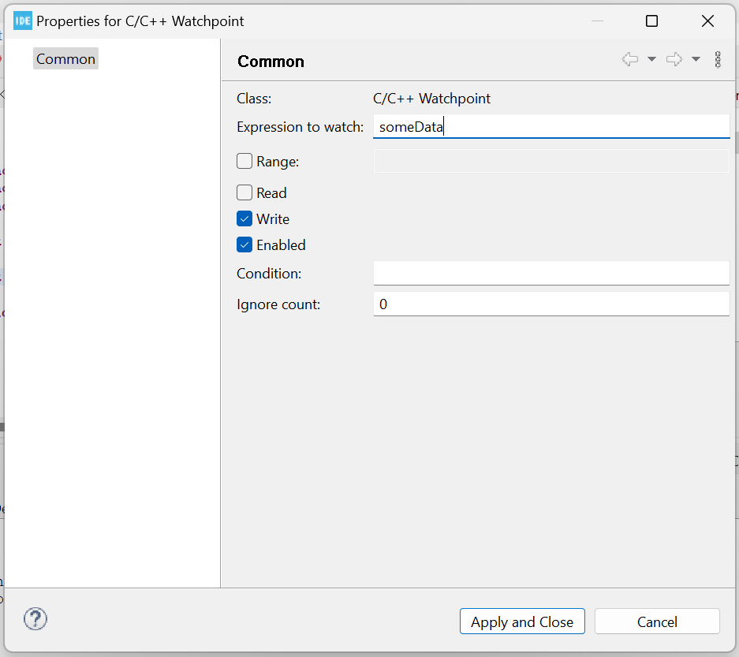

A questo punto, quando qualche istruzione tenterà di modificare il valore presente nell’*address memory* in cui è salvata tale variabile, sarà generato un ***debug event*** dal processore, e, di conseguenza, il processore fermerà la sua esecuzione su quel ***watchpoint***.

Eseguendo il programma, avremo quindi che questo si bloccherà nella riga di codice successiva a quella che tenta di modificare il valore della variabile ***someData***:

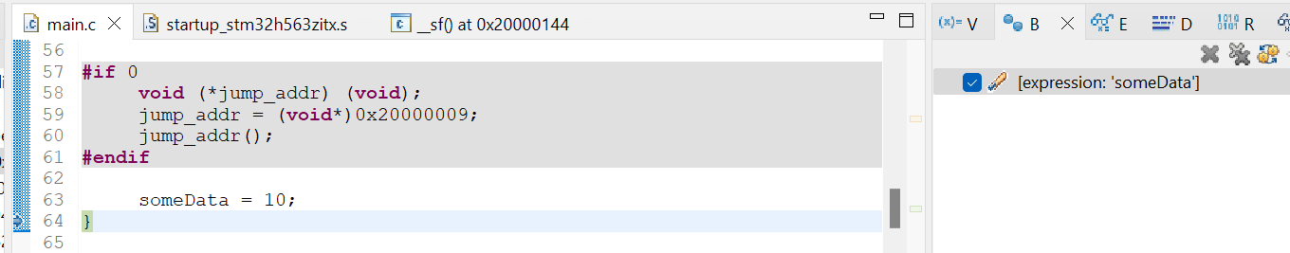

E’ possibile utilizzare un ***data watchpoint*** anche per un ***address memory***:

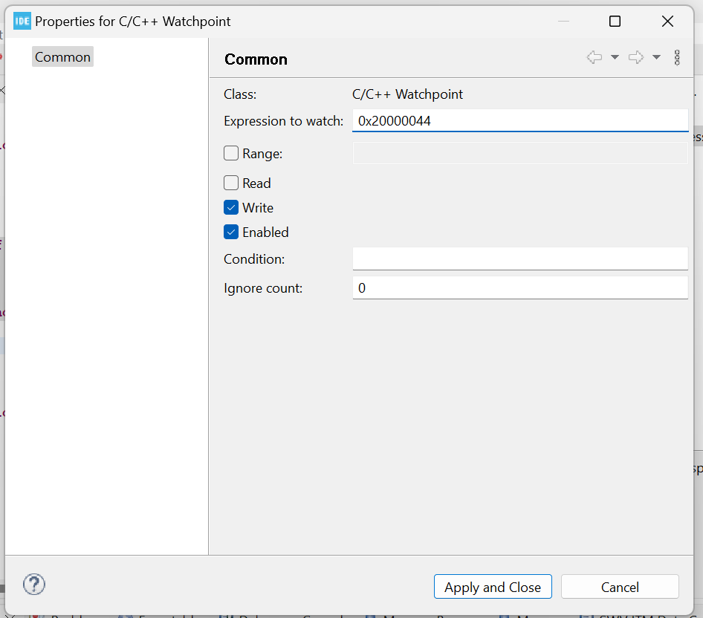

## 25. SFR windows (Peripheral Registers)

***SFR*** (***Special Function Registers***) ***window*** viene utilizzata per ottenere informazioni relative alla ***memory map registers*** delle differenti ***periferiche*** del microcontrollore.

Infatti, il microcontrollore possiede diverse *periferiche*, incluse ***CAN, TIMERS, SPI, ADC, DAC*** e altre periferiche relative alla *comunicazione,* all’*alimentazione*, ecc. tramite le quali è possibile controllare le molteplici funzionalità del micro.

Tutti i ***registri*** specifici del micro sono elencati nella ***SFRs window*** (NON ***Registers***):

* ***SFRs -> microcontroller specific registers***

Quindi, aprendo la ***SFRs window****,* possiamo avere informazioni relative ai ***registri*** delle varie ***periferiche***del micro:

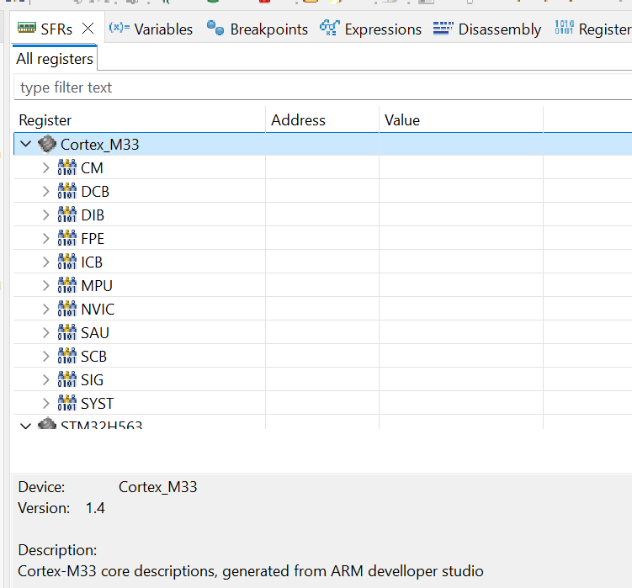

Selezionando un *registro* possiamo ottenerne il contenuto in questo formato:

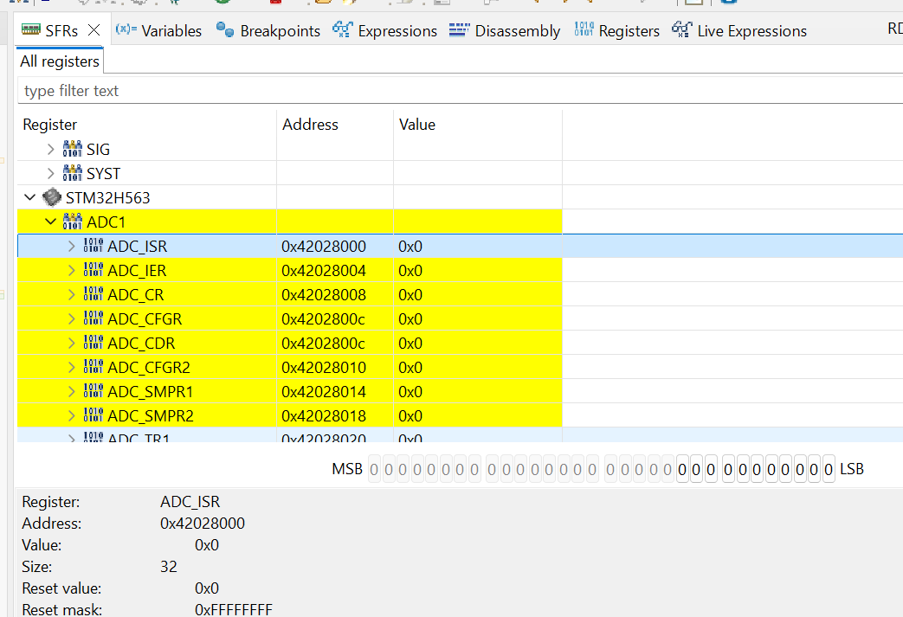

Possiamo ottenere l’***address*** del registro, il ***value***, e tante altre informazioni.

Utilizzando la ***SFRs window*** possiamo inoltre comandare le varie *periferiche* senza dover scrivere del codice.

## 26. Other basic feature of IDE

***Terminate and relaunch***: questo pulsante è disponibile quando si è nella modalità di *debug* e permette di terminare il *debug* corrente, effettuare un *rebuild* del codice, caricare il nuovo FW all’interno del micro e rieseguire il programma in modalità di *debug*.

***Ctrl + o***: è una shortcut che permette di ottenere una lista di tutte le funzioni, degli *header files* e delle variabili globali presenti nel file corrente.

# Sezione 7: Understanding MCU Memory Map

## 27. Understanding Memory Map of the MCU: Part 1

In questa sezione considereremo il micro ***STM32F407X*** (***discovery board***)***.***

Questo micro utilizza un ***processore ARM Cortex M4***.

Questo *processore* ha diverse ***bus interfaces*** ed ha un ***system bus*** a ***32 bit***: questo vuol dire che il *processore* può produrre fino a ***232 address*** differenti (***4 GB***).

* Da ***0x0000 0000*** fino a ***0xFFFF FFFF***

Questo vuol dire che la ***memory map*** di questo processore inizia dall’*address memory* ***0x00000000*** e finisce all’*address memory* ***0xFFFFFFFF***.

I produttori del *micro* vanno ad inserire diverse *periferiche* all’interno di questo *memory range*.

Per vedere la suddivisione delle diverse *periferiche* all’interno della *memory map*, dobbiamo esaminare il ***Reference Manual*** del produttore del *micro* e andare a guardare la sezione ***Memory Map***.

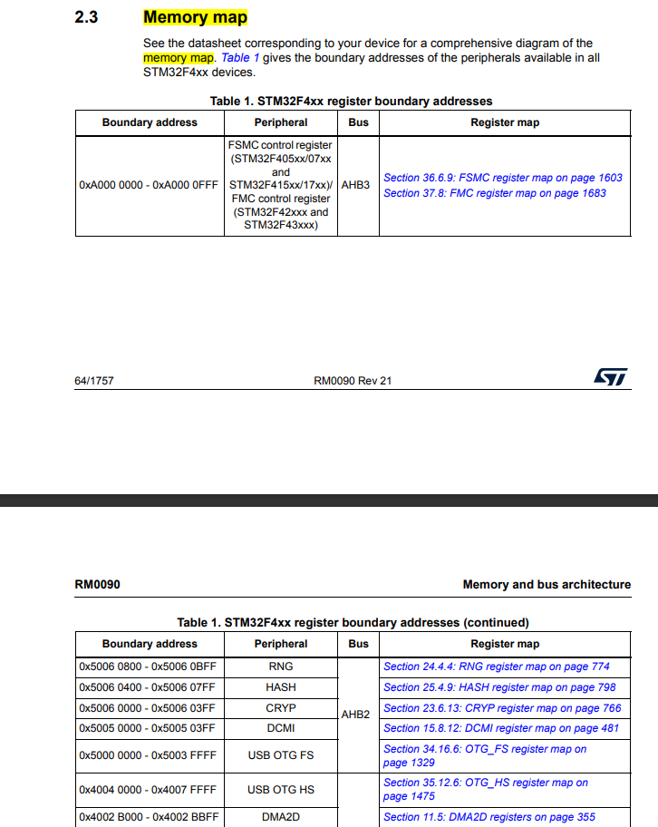

Da qui possiamo vedere quindi quali sono i ***boundary addresses*** all’interno dei quali i produttori hanno implementato le varie ***periferiche***.

Facciamo un esempio: prendiamo il ***GPIOA*** (GPIO port A). Quello che hanno fatto i produttori è stato mantenere tutti i ***registri*** relativi a questa periferica all’interno del *memory range* qui descritto:



Quindi, quando il *processore* produce *l’address memory* ***0x4002 0000*** nel *system bus*, vuol dire che si sta riferendo ai *registri* del ***GPIOA***.

Quindi, la ***Memory Map*** di un microcontrollore ci da come informazione quali sono i *memory address* *range* relativi ai ***registri*** delle varie ***periferiche*** presenti all’interno del *micro*.

## 28. Understanding Memory Map of the MCU: Part 2

Prendiamo adesso come esempio un *microcontrollore* di un altro produttore. In questo caso analizzeremo il micro ***TM4C123GH6PM*** della ***TI*** (***Texas Instruments***).

[Tiva™ C Series TM4C123GH6PM Microcontroller Datasheet datasheet (Rev. E)](https://www.ti.com/lit/ds/symlink/tm4c123gh6pm.pdf)

In questo caso la ***Memory Map*** del processore si trova all’interno della sezione ***Memory Model***:

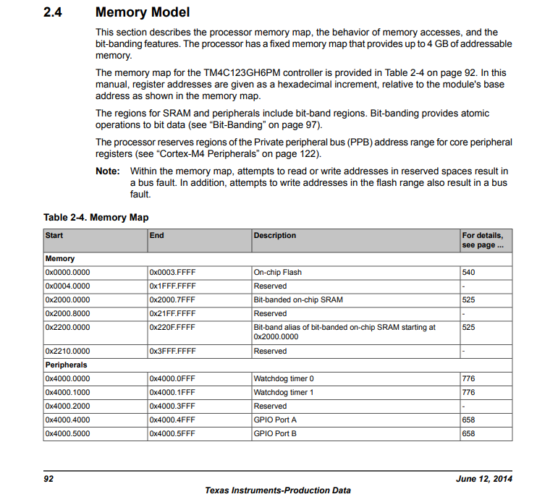

Per questo micro, la ***flash memory*** inizia al *memory address* ***0x00000000***, mentre sul micro dell’***STM32***, la ***flash*** iniziava al *memory address* ***0x08000000***.

Per quanto riguarda la ***SRAM***, invece, per entrambi i micro inizia al *memory address* ***0x20000000***.

## 29. Understanding Memory Map of the MCU: Part 3

In base a ciò che abbiamo studiato nelle lezioni precedenti cercheremo di rispondere ad alcune domande relative al micro ***STM32F407X***.

1. ***What’s the base address of AHB1 BUS peripheral registers?***

Nella ***Memory Map***vi è una 3a colonna chiamata ***BUS***: quindi cercheremo l’***AHB1 BUS*** nella 3a colonna.

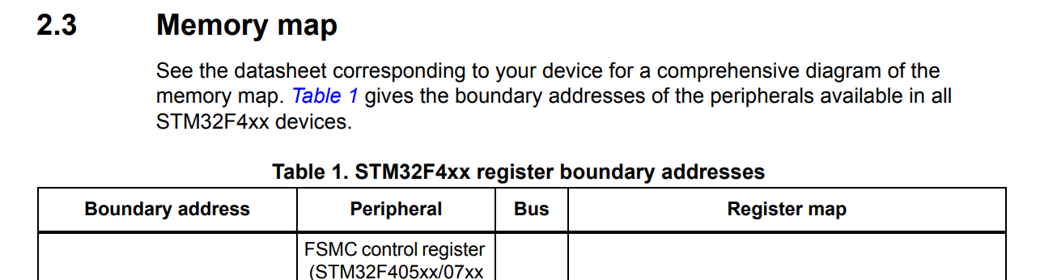

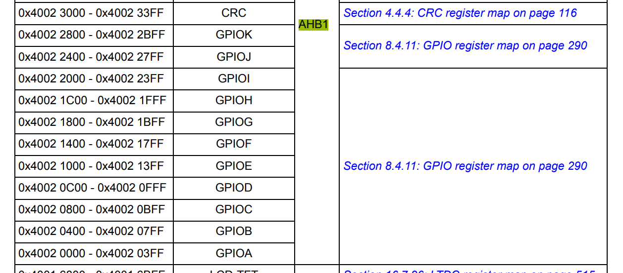

Guardando la ***Memory Map*** presente all’interno del ***Reference Manual*** possiamo vedere che il *base address* dell’***AHB1 BUS*** è ***0x4002 0000***.

***N.B.*** Il *base address (start address)* si trova nell’ultima *periferica* elencata nella *Memory Map*, infatti, i *memory address* sono inseriti in ordine decrescente in questa *Memory Map*.

Quindi:

* + ***AHB1_PERI_START_ADDRESS : 0x4002 0000***
  + ***AHB1_PERI_END_ADDRESS : 0x4007 FFFF***

1. ***What’s the base address of GPIOA registers?***

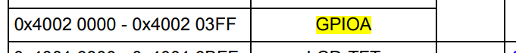

***GPIOA_PERI_START_ADDRESS : 0x4002 0000***

***GPIOA_PERI_END_ADDRESS : 0x4002 03FF***

1. ***What’s the base address of RCC engine registers of the MCU?***



1. ***What’s the base address of APB1 peripheral registers?***

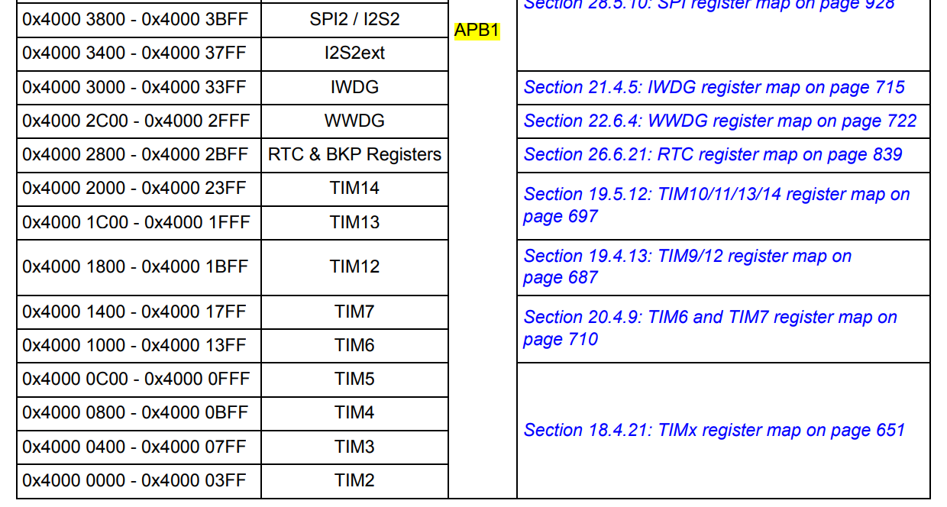

***APB1_PERI_START_ADDRESS : 0x4000 0000***

***APB1_PERI_END_ADDRESS : 0x4000 7FFF***

1. ***What’s the base address of FLASH memory?***

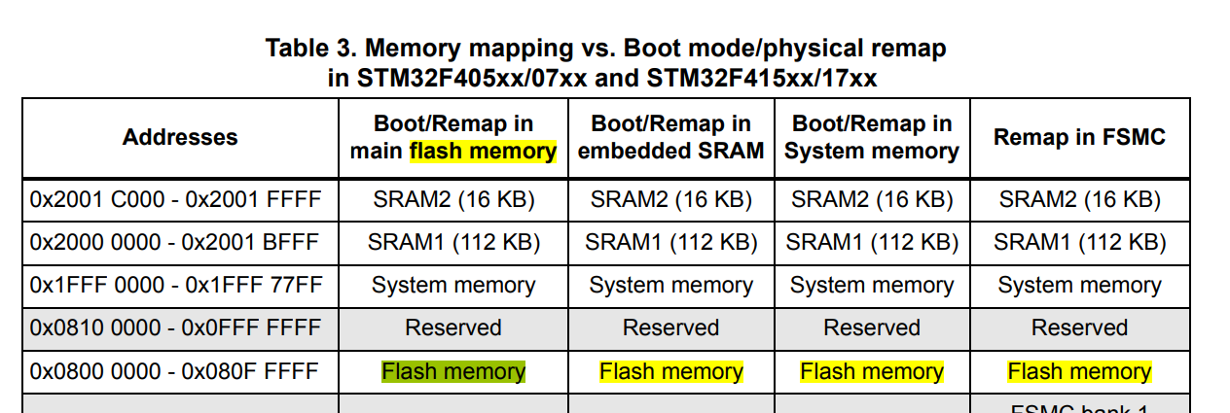

***FLASH_MEM_START_ADDRESS : 0x0800 0000***

***FLASH_MEM_END_ADDRESS : 0x080F FFFF***

1. ***What’s the base address of SRAM2?***

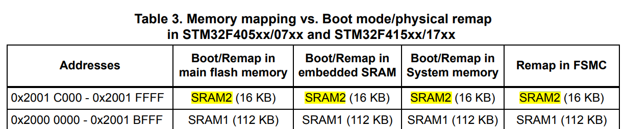

***SRAM2_START_ADDRESS : 0x2001 C000***

***SRAM2_END_ADDRESS : 0x2001 FFFF***

Nel caso in cui non fosse presente questa tabella, possiamo ricavare il *base address* dell’***SRAM2*** in questo modo:

***BASE_ADDRESS_OF_SRAM2 = BASE_ADDRESS_OF_SRAM1 + SIZE_OF_SRAM1***

1. ***What’s the base address of ADC registers?***



Volendo potremmo calcolare lo *start address* di ogni *ADC* andando a vedere la ***ADC register map*** in cui sono presenti tutti gli *offset* per ogni *ADC*:

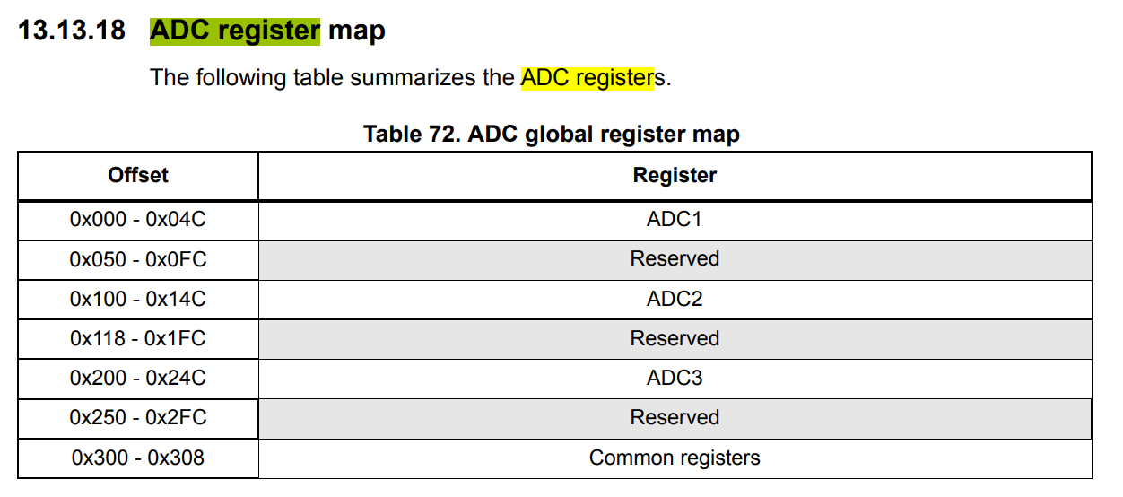

# Sezione 8: MCU Bus Interfaces

## 30. MCU Bus Interfaces Explanation Part 1 : I-Code / D-Code / S-Bus

Tutto quello che vedremo in questa sezione relativa alle ***MCU Bus Interfaces*** sarà valido per ogni *microcontrollore* di tipo***ARM Cortex***, e non solo per l’***STM32F407*** utilizzato in questo corso.

In questa lezione analizzeremo 2 differenti micro:

* ***STM32F446RE***
* ***TM4C123GH6PM (Texas Intruments)***

Guardando il ***Datasheet*** dell’***STM32F446RE*** abbiamo questo *block diagram:*

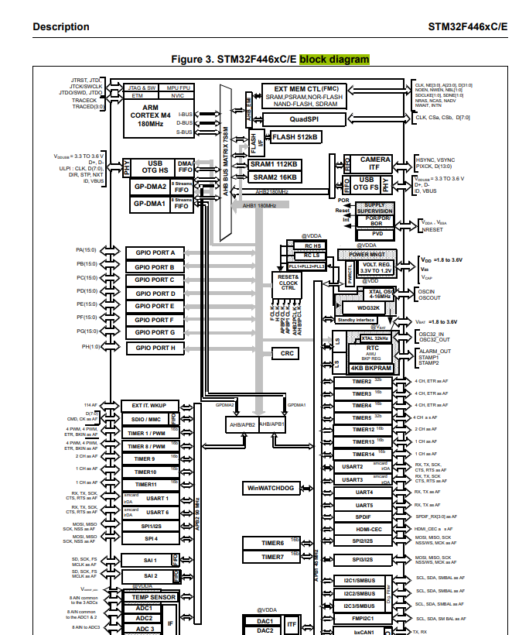

Da questo possiamo notare come il ***processore*** presente sia un ***ARM Cortex M4*** a ***180MHz***.

Il ***processore*** e le ***periferiche*** comunicano attraverso le ***Bus Interfaces***: in questo diagramma possiamo vedere diverse *bus interfaces*:

* ***I-Bus : Instruction Bus***
* ***D-Bus : Data Bus***
* ***S-Bus : System Bus***

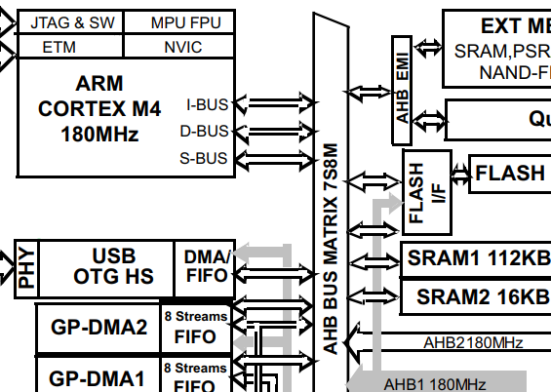

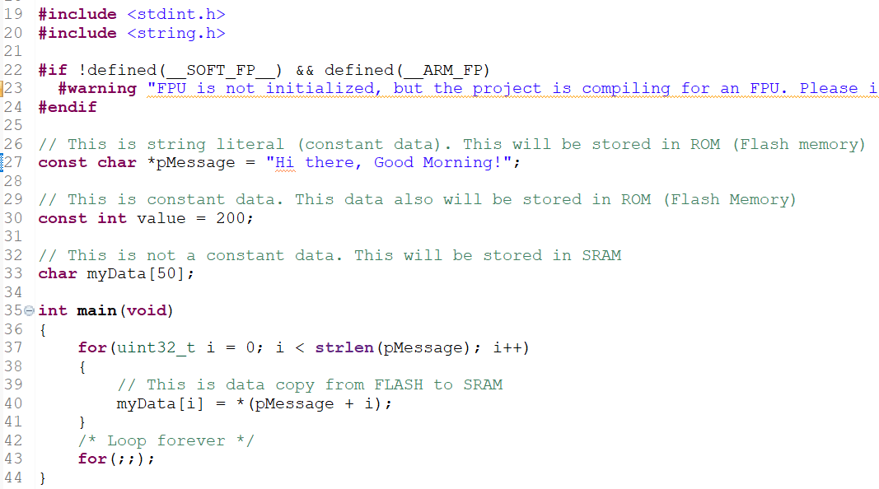

Da notare la ***memoria*** in cui vengono salvate le diverse variabili:

* ***Constant data*** : vengono salvate nella ***ROM***, ossia nella ***Flash Memory*** (memoria non volatile)
* ***Not constant data*** : vengono salvate nella ***SRAM*** (memoria volatile)

Quindi, quando si compila il progetto, le variabili ***pMessage*** e ***value*** andranno a finire in una ***read only section memory***, ossia in una sezione di ***read only*** della ***Flash Memory***.

La variabile ***myData***, invece, è una variabile il cui contenuto può cambiare a *runtime*, ossia è una ***variable data***, di conseguenza tale variabile sarà salvata nella ***data memory***, la quale nel nostro caso è la ***SRAM***.

Quando si esegue una ***build*** di un progetto e si carica il FW all’interno del micro, le **istruzioni** del programma vengono salvate all’interno della ***Flash Memory*** del micro, così come le ***constant data***.

La ***Flash Memory*** può essere suddivisa in 3 sezioni:

* ***Instructions Data*** : qui vengono salvate tutte le **istruzioni**
* ***Constant Data*** *(****Read Only****)* : qui vengono salvate tutte le ***constant data*** il cui valore non può essere modificato a *runtime*. Di conseguenza saranno solo ***read only.***
* ***Vector Tables*** : ne parleremo nelle lezioni successive

Come detto precedentemente, il ***processore*** ***ARM Cortex M4*** ha a disposizione 3 *bus interfaces*:

* ***I-Bus*** : utilizzato dal *processore* per ottenere le ***instructions*** dalla ***FLASH***
* ***D-Bus*** : utilizzato dal *processore* per ottenere i ***data*** salvati nella ***FLASH***
* ***S-Bus*** : utilizzato dal *processore* per ottenere i ***vector-tables***

Quindi, il processore ***ARM*** andrà a leggere le ***instructions*** dalla ***FLASH*** attraverso l’***Instruction Bus*** (***I-Bus***). Quindi, il produttore del micro assicurerà il fatto che la ***FLASH*** sia connessa all’***I-Bus***.



Quello che avviene in questa riga di codice è questo:

* L’***istruzione*** viene presa tramite l’***I-Bus*** dalla ***FLASH***
* La ***constant data*** (*pMessage*) viene presa tramite il ***D-Bus*** sempre dalla ***FLASH***

Per questo motivo, sia l’***I-Bus*** sia la ***D-Bus*** devono essere connesse alla ***FLASH***.

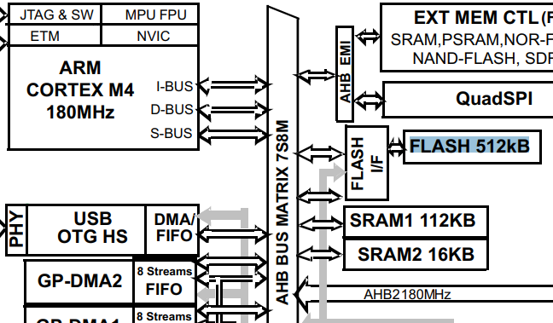

Da questa immagine possiamo notare come la ***FLASH*** da ***512kB*** è collegata al ***processore ARM*** tramite l’***AHB BUS Matrix*** e vengono sfruttati proprio i ***3 bus interfaces*** visti in precedenza (***I-Bus, D-Bus, S-Bus***).

Da notare, inoltre, come la ***FLASH*** non è connessa direttamente, ma la connessione avviene tramite un ***Flash Controller*** (***FLASH I/F***), il quale aiuta nelle operazioni di ***read & write*** nella ***FLASH***.

Per comprendere meglio come funzionano l’***I-Bus, D-Bus, S-Bus***, i quali sono parte del ***processore ARM***, andiamo a vedere il ***Technical Reference Manual*** del ***processore ARM***:

arm_cortexm4_processor_trm_100166_0001_04_en.pdf

Andiamo quindi nella sezione ***Interfaces***:

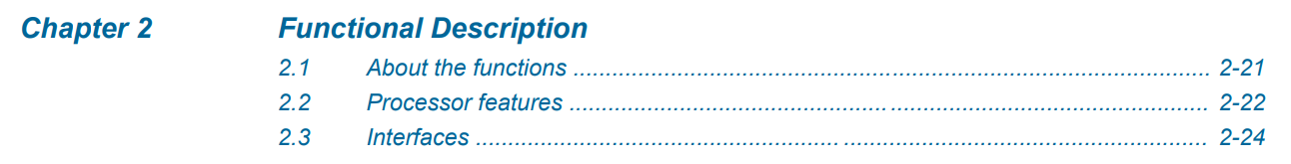

E troveremo quindi la sezione ***Bus Interfaces***:

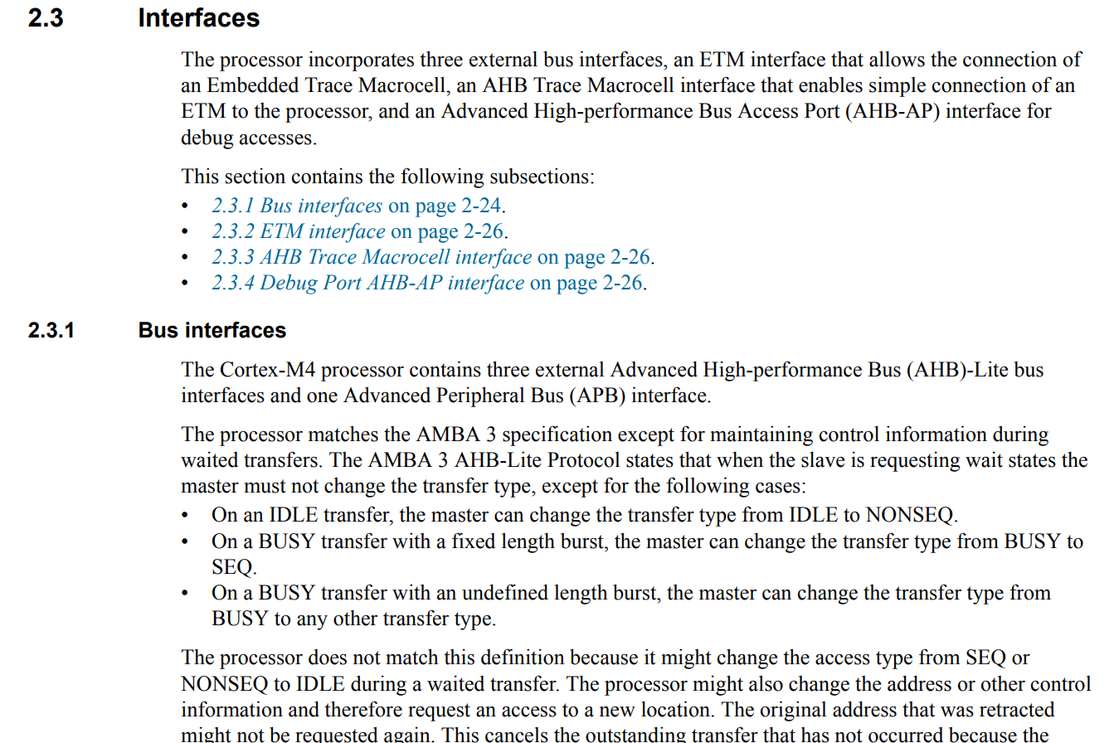

Proprio nelle prime righe troviamo scritto che tale processore contiene ***3 external Advanced High-performance Bus (AHB)-Lite bus interfaces***.

L’***AHB-Lite*** è un protocollo nativo della ***ARM*** di come fare il *design* di un *bus*.

Scorrendo troveremo quindi la menzione fatta per l’***ICode, DCode, System interfaces***:

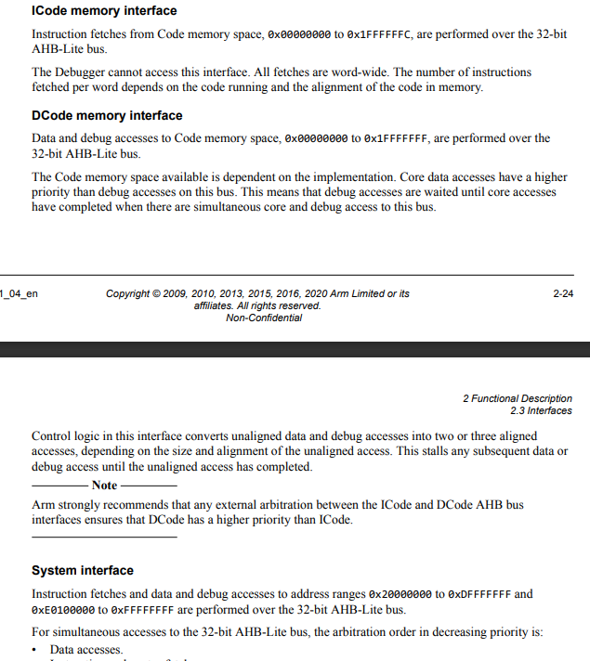

Leggiamo attentamente la parte relative all’***ICode memory interface***:

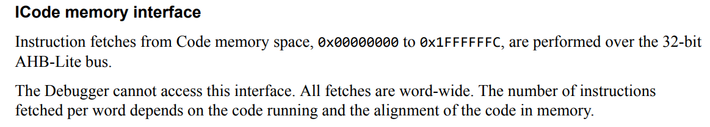

Notiamo subito che le ***istruzioni*** devono essere presenti nel ***memory address range*** ***0x0000 0000 – 0x1FFF FFFC***: quindi, qualsiasi **istruzione** presente al di fuori di questo *range*, non verrà prelevata dall’***I-Bus***.

Anche le altre 2 ***interfaces*** hanno dei ***memory address range***.

***N.B.*** Per il ***DCode*** si fa riferimento sia ai ***data*** sia al ***debug***.

Leggiamo adesso la parte relativa al ***System interface***:

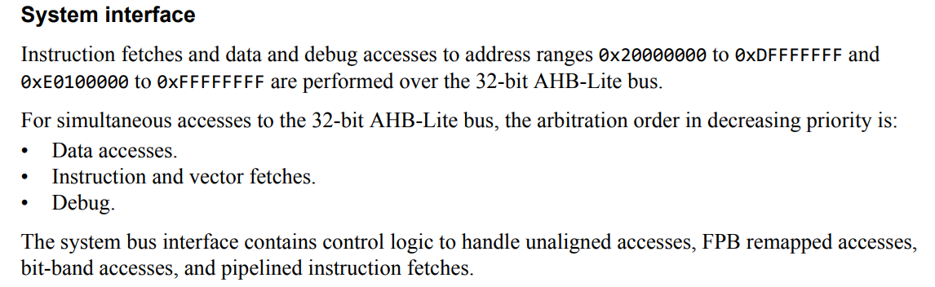

In questa parte troviamo scritto quanto segue: per ottenere le **istruzioni** o effettuare un ***data & debug access*** ad un *memory address* presente all’interno dei 2 *range* indicati, non sarà possibile utilizzare l’***I-Bus*** o il ***D-Bus***, ma bisognerà necessariamente utilizzare il ***System Bus*** (***S-Bus***).

## 31. MCU Bus Interfaces Explanation Part 2 : AHB / APB1 / APB2

Quindi, riassumendo ciò che abbiamo visto nella lezione precedente:

* Se le ***istruzioni*** sono presenti in un *memory address* tra ***0x0000 0000*** e ***0x1FFF FFFC***, allora l’***ARM Cortex processor*** prenderà le **istruzioni** dalla ***FLASH*** utilizzando l’***ICode Interface***.
* Se le ***istruzioni*** si trovano al di fuori di quel *memory address range,* allora il ***processore*** prenderà le ***istruzioni*** attraverso il ***System interface*** (***System Bus***).
* Se i ***data*** si trovano in un *memory address* nel range***0x0000 0000*** e ***0x1FFF FFFF***, allora il ***processore*** prenderà i ***data*** tramite il ***D-Code bus interface***.
* Se invece i ***data*** si trovano al di fuori di tale *range*, allora il ***processore*** li prenderà utilizzando il ***System Bus***.

Dato che la ***flash memory*** ha come *start address* ***0x0800 0000***, vuol dire che le ***istruzioni*** saranno all’interno del *range* ***0x0000 0000*** *–* ***0x1FFF FFFC***, di conseguenza le ***istruzioni*** verranno prese dalla ***flash*** tramite l’***I-Code Bus interface***.

La stessa cosa vale per i ***data*** salvati in ***flash memory***, di conseguenza questi verranno presi utilizzando il ***D-Code Bus interface***.

Adesso apriamo nuovamente il ***Reference Manual*** in quanto vogliamo visualizzare nuovamente la ***Memory Map*** del micro:

[STM32F405/415, STM32F407/417, STM32F427/437 and STM32F429/439 advanced Arm<Sup>®</Sup>-based 32-bit MCUs - Reference manual](https://www.st.com/resource/en/reference_manual/rm0090-stm32f405415-stm32f407417-stm32f427437-and-stm32f429439-advanced-armbased-32bit-mcus-stmicroelectronics.pdf)

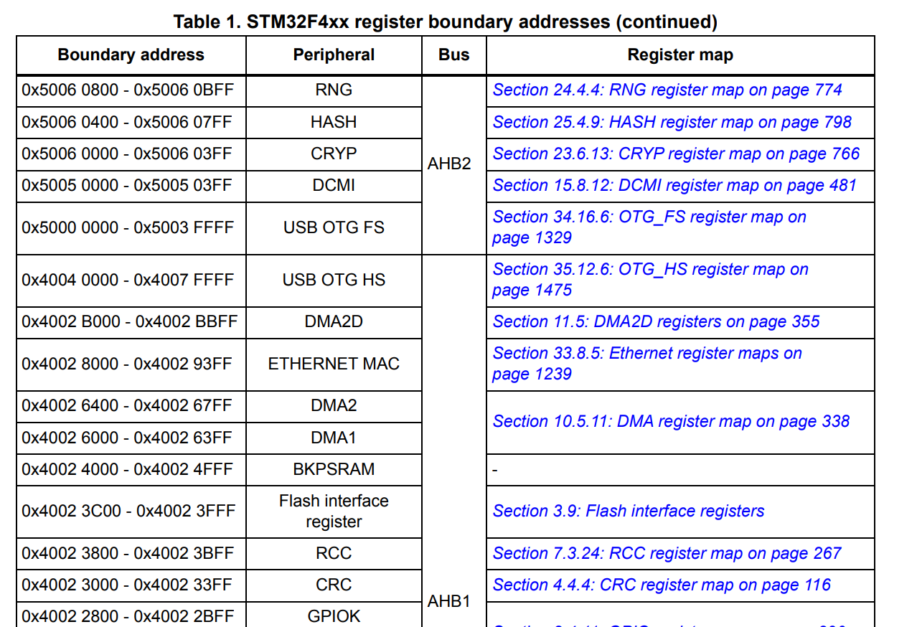

Guardando la ***Memory Map*** possiamo notare che i vari ***Bus*** e quindi le varie ***periferiche*** hanno tutti un ***memory address*** che inizia con ***0x4000 0000*** oppure ***0x5000 0000***, di conseguenza questi *memory address* sono al di fuori del *range* ***0x0000 0000 – 0x1FFF FFFF***. Perciò, tutte le ***periferiche*** che sono presenti in questo *micro*, saranno accessibili tramite il ***System Bus interface***.

Quindi, non è possibile utilizzare l’***I-Code*** o il ***D-Code*** per comunicare con queste ***periferiche***.

Quindi, il ***System Bus*** in questo micro viene utilizzato per comunicare con:

* ***SRAM1, SRAM2***: in quanto l’SRAM parte dal memory address 0x2000 0000
* Tutte le ***periferiche***: in quanto partono dal memory address 0x4000 0000 oppure 0x5000 0000.

Guardando il *block diagram* presente nel ***Datasheet*** possiamo notare come, ad un certo punto, il ***System Bus*** abbia una ramificazione:

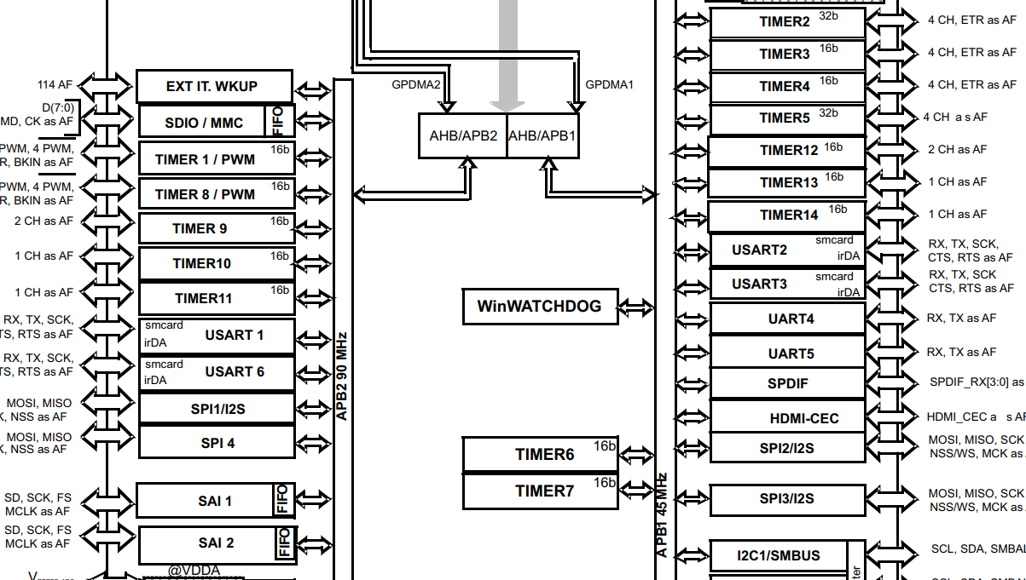

In questa ramificazione vi è una conversione dall’***AHB protocol*** all’***APB protocol***. Quindi, tale ramificazione funziona come se fosse un *convertitore*, in quanto converte un ***AHB Bus*** in ***2 APB Bus***.

***AHB Bus*** -> è un protocollo molto veloce, infatti può arrivare fino a ***180MHz***.

***APB Bus*** -> è un protocollo più lento rispetto all’***AHB Bus***, in quanto può arrivare fino ad un massimo di ***45MHz*** per l’***APB1*** e fino a ***90MHz*** per l’***APB2***.

Tutte le ***periferiche*** che vi sono nel *block diagram* sono quindi gestite dall’***APB Bus*** e NON dall’***AHB Bus***.

Tutte le ***GPIO Port***, invece, sono tutte gestite dall’***AHB1 Bus***:

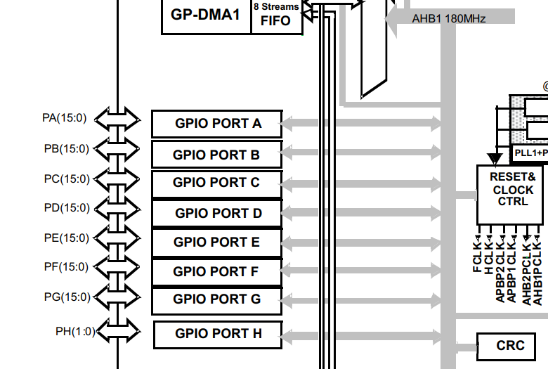

Questo vuol dire che le ***GPIO Port*** possono andare ad una velocità max di ***180MHz***.

Vi è, inoltre, un ***AHB2 Bus*** che deriva dall’***S-Bus*** che è collegato ad alcune *external interfaces* come una *CAMERA ITF* e una *USB*, in quanto tali interfacce hanno bisogno di una ***high speed data transfer***, di conseguenza non possono essere connessa all’***APB Bus*** che invece ha velocità inferiori.

Quindi, in base al tipo di ***Bus Interface*** alle quali sono collegate, abbiamo:

* ***High Speed Peripherals***: sono le ***GPIO Ports*** in quanto sono collegate all’***AHB1 Bus***
* ***Slow Peripherals***: sono tutte le *periferiche* collegate all’***APB1 / APB2 Bus***

Ovviamente, ogni *micro* potrebbe avere connessioni diverse tra le varie ***Bus Interfaces***, di conseguenza quello che abbiamo visto è valido solo per l’***STM32F446RE***.

## 32. MCU Bus Interfaces Explanation Part 3: Q/A session

Vediamo alcune domande che sono state fatte relative all’***STM32F446RE MCU***:

[Datasheet - STM32F446xC/E - Arm® Cortex®-M4 32-bit MCU+FPU, 225 DMIPS, up to 512 KB Flash/128+4 KB RAM, USB OTG HS/FS, seventeen TIMs, three ADCs and twenty communication interfaces](https://www.st.com/resource/en/datasheet/stm32f446re.pdf)

1. ***Is it true that, System Bus is not connected to Flash Memory?***

La ***Flash Memory*** ha il seguente *memory address range* ***0x0800 0000 – 0x0807 FFFF***.

Considerando invece che l’***S-Bus*** in un ***ARM Cortex M4*** ha come *range*:

* + ***0x2000 0000 – 0xDFFF FFFF***
  + ***0xE010 0000 – 0xFFFF FFFF***

Di conseguenza abbiamo che è vero che il ***System Bus*** non è connesso alla ***Flash Memory***. Inoltre, nel ***Reference Manual*** del micro possiamo trovare questo diagramma:

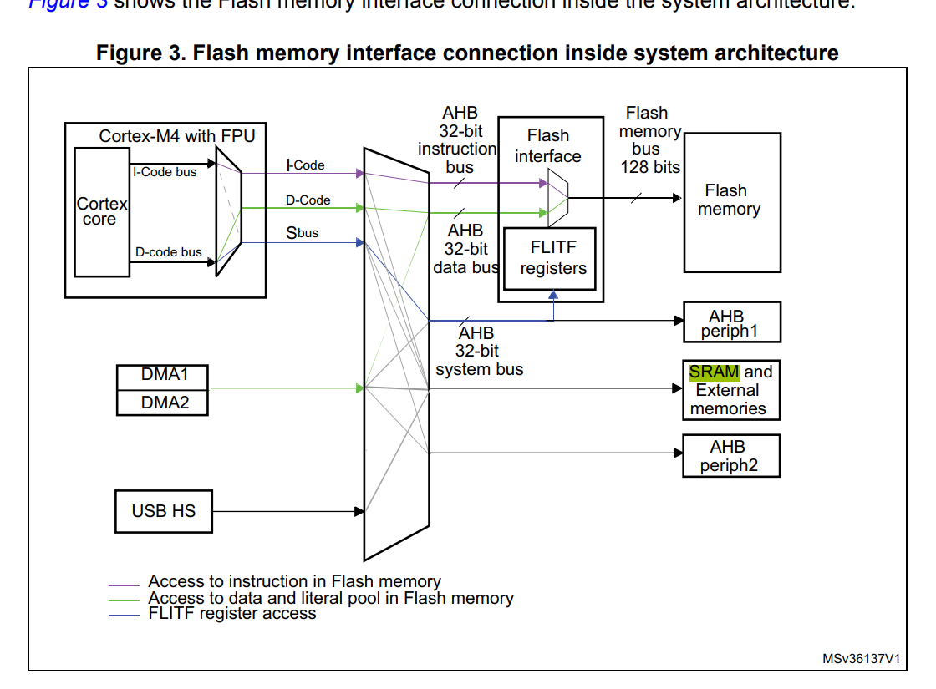

Nel quale possiamo vedere come la ***Flash Memory*** sia collegata solamente all’***I-Bus*** e al ***D-Bus***.

1. ***Processor can fetch instructions from SRAM over I-Code Bus interface?***

Dal ***Reference Manual*** dell’STM32F446RE abbiamo questa tabella:

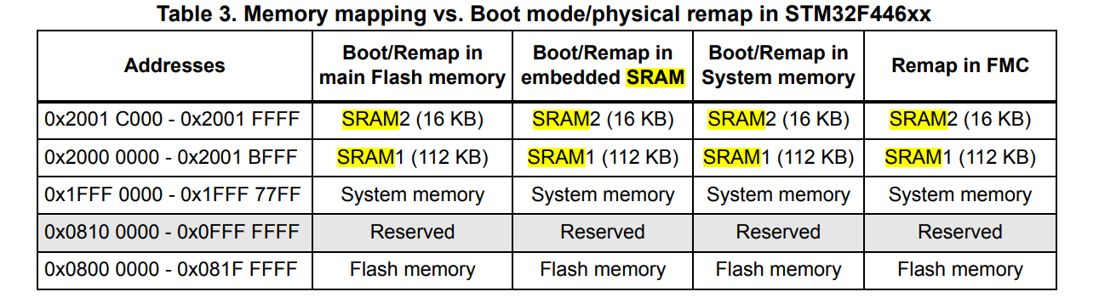

Quindi, l’***SRAM*** ha come *memory address range* ***0x2000 0000 – 0x2001 FFFF***.

Dal manuale del processore ***ARM Cortext M4*** abbiamo invece questo:

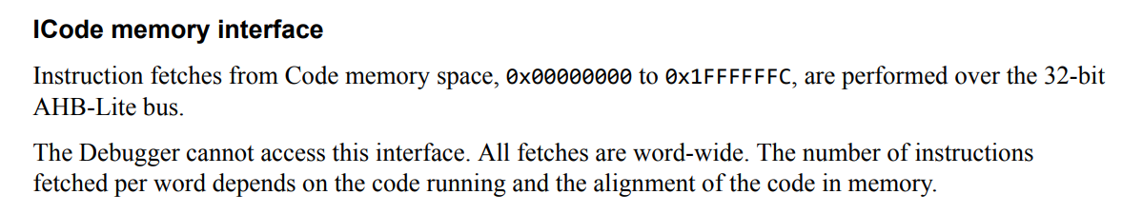

Quindi, l’***I-Code Bus interface*** prende le ***istruzioni*** che si trovano nel range ***0x0000 0000 – 0x1FFFF FFFC***.

Perciò, dato che il *memory address range* dell’***I-Code*** non va a prendere le ***istruzioni*** dal range di memoria dell’***SRAM***, abbiamo che la risposta è: ***FALSO***.

***N.B.*** In realtà, per quello che abbiamo visto ora la risposta è ***falso***, ma esistono delle tecniche avanzate che vedremo in seguito con le quali è possibile prendere le ***istruzioni*** dalla ***SRAM*** tramite l’***I-Code interface***.

1. ***System Bus can operate at the speed up to 180MHz?***

Abbiamo visto in precedenza come il ***S-Bus*** sia utilizzato dall’***AHB1 / AHB2 Bus***, i quali arrivano entrambi ad una velocità max di ***180MHz***, quindi la risposta è: ***Sì***.

***Attenzione***: la risposta data dall’insegnante è la seguente: sempre guardando il *block diagram* abbiamo che il processore può arrivare fino a 180MHz, di conseguenza anche il ***S-Bus*** potrà arrivare a tali velocità:

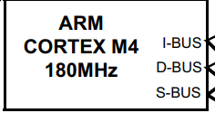

1. ***SRAMs are connected to System Bus?***

Dal ***Reference Manual*** dell’STM32F446RE abbiamo questa tabella:



Quindi, l’***SRAM*** ha come *memory address range* ***0x2000 0000 – 0x2001 FFFF***.

Dal manuale del processore possiamo leggere che l’***S-Bus*** in un ***ARM Cortex M4*** ha come *range*:

* + ***0x2000 0000 – 0xDFFF FFFF***
  + ***0xE010 0000 – 0xFFFF FFFF***

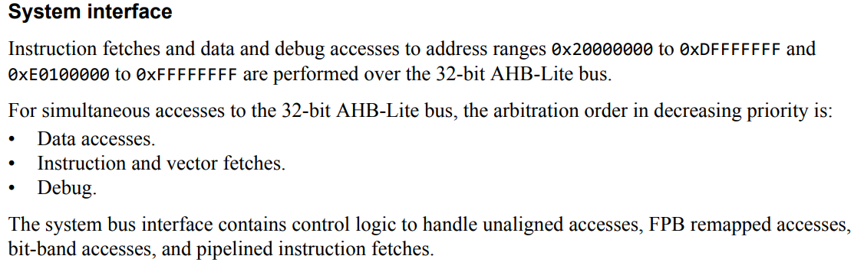

Quindi, in conclusione, possiamo dire che le ***SRAMs*** sono entrambe connesse al ***S-Bus***.

1. ***APB1 Bus can operate at the speed up to 180MHz?***

Dal *block diagram* presente nel ***Datasheet*** abbiamo già visto in precedenza che l’***APB1 Bus*** può operare fino ad un max di ***45MHz***:

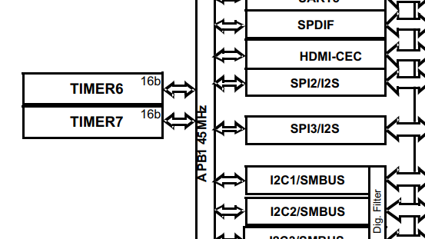

Quindi, la risposta è: ***falso***.

1. ***Let’s say I have a peripheral whose datasheet says that, its operating frequency or speed must be above 95MHz, can I connect that peripheral via APB2 Bus?***

Sempre dal *block diagram* presente nel ***Datasheet*** abbiamo visto come l’***APB2 Bus*** può arrivare fino ad una frequenza max di ***90MHz***, di conseguenza la risposta è: ***NO***.

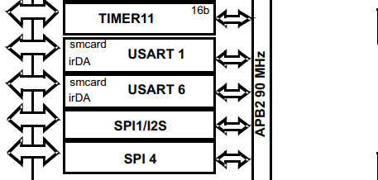

1. ***Processor can fetch instructions as well as data simultaneously from SRAM?***

***Falso***, in quanto vi è solamente 1 *bus* collegato all’***SRAM***, ed è il ***S-Bus***. Perciò questo deve prima leggere l’***istruzione*** e poi leggere il ***data***, e NON potrà leggere entrambi simultaneamente.

1. ***Processor can fetch instructions as well as data simultaneously from FLASH?***

***Vero***, in quanto abbiamo visto in precedenza che la ***FLASH*** è collegata al ***processore*** tramite ***2 Bus: I-Bus*** e ***D-Bus***.

Perciò, l’***I-Bus*** prenderà l’***istruzione*** mentre il ***D-Bus*** prenderà i ***data*** dalla ***FLASH***.

Dal ***Reference Manual***:

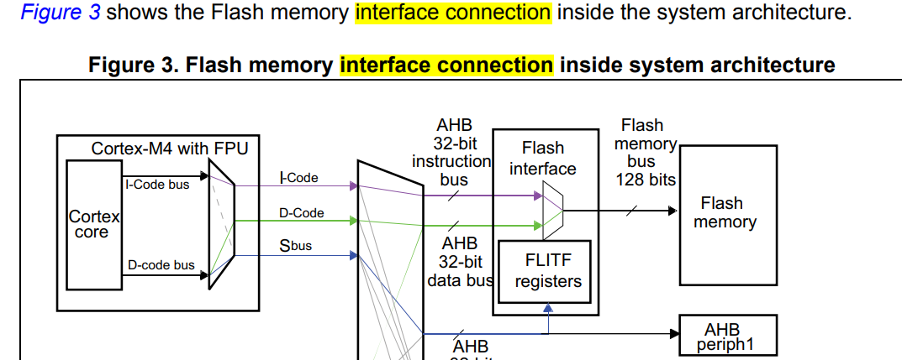

1. ***What is the max HCLK value of your MCU?***

Per rispondere a questa domanda dobbiamo prima ricordare che ***HCLK*** (***High Speed Clock***)è un’abbreviazione per descrivere la ***max frequenza*** alla quale può lavorare l’***AHB Bus***.

Abbiamo visto in precedenza come l’***AHB Bus*** può lavorare fino ad un max di ***180MHz***, quindi l’***HCLK*** può avere un valore max pari a ***180MHz***.

1. ***What is the max P1CLK value of your MCU?***

L’acronimo ***P1CLK***, invece, viene utilizzato per riferirsi alla ***operating clock frequency*** dell’***APB1 Bus***.

Di conseguenza, dato che in precedenza abbiamo visto che l’***APB1 Bus*** può lavorare fino ad una max frequenza di ***45MHz***, avremo che il max valore per il ***P1CLK*** è pari a ***45MHz***.

1. ***What is the max P2CLK value of your MCU?***

Il ***P2CLK***, invece, si riferisce alla ***operating max frequency*** dell’***APB2 Bus***, di conseguenza sarà pari a ***90MHz*** in quanto in precedenza dal *block diagram* presente nel ***Datasheet*** abbiamo visto che l’***APB2 Bus*** può operare fino ad una frequenza max di ***90MHz***.

1. ***GPIOs and processor communicate over AHB1 Bus?***

Dal *block diagram* precedente abbiamo visto come le ***GPIO Ports*** e il ***processore*** comunicano proprio tramite l’***AHB1 Bus***, quindi la risposta è: ***vero***.

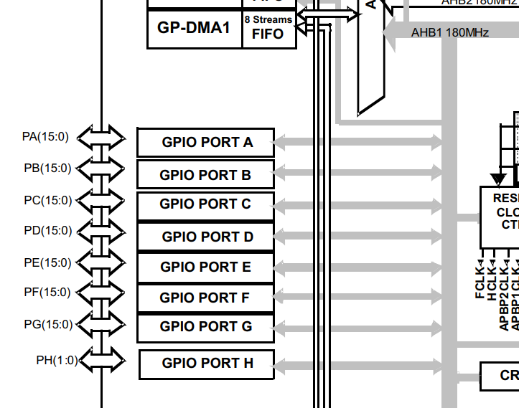

Inoltre, possiamo aggiungere che questa comunicazione avviene attraverso il ***System Bus***, in quanto le GPIOx ports si trovano in un memory address range 0x4002 0000 – 0x4002 2BFF e il ***System Bus*** lavora nel memory address range 0x2000 0000 – 0xDFFF FFFF.

1. ***USB OTG and processor communicate over AHB2 Bus?***

Sempre guardando il *block diagram* presente nel ***Datasheet*** del micro vediamo che la risposta è: ***vero***.

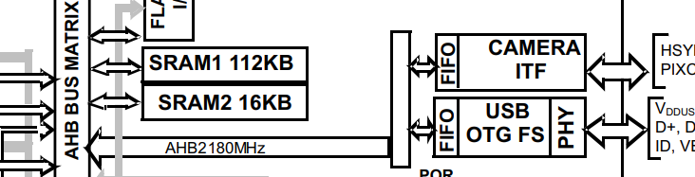

1. ***USB OTG and GPIOs can communicate to processor concurrently or simultaneously?***

La risposta è ***FALSO***, in quanto anche se l’***USB OTG*** e le ***GPIOs*** sfruttano rispettivamente l’***AHB2 Bus*** e l’***AHB1 Bus***, quando dovranno comunicare con l’***S-Bus*** vi sarà l’***AHB Bus Matrix*** che dovrà serializzare le comunicazioni, di conseguenza queste non potranno avvenire in simultanea.

1. ***Processor can talk to Flash Memory and SRAM simultaneously?***

Dalla risposta alla domanda ***4*** abbiamo visto come il ***processore*** comunichi con l’***SRAM*** tramite l’***S-Bus***, mentre dalla risposta alla domanda ***8*** abbiamo visto come il ***processore*** comunichi con la ***Flash Memory*** sia tramite l’***I-Bus*** sia tramite il ***D-Bus***.

Quindi, dato che il ***processore*** sfrutta ***Bus Interfaces*** differenti per comunicare con la ***Flash Memory*** e con l’***SRAM***, vuol dire che può comunicare simultaneamente con entrambe.

## 33. Understanding MCU Bus Matrix

Per questa lezione utilizzeremo il file ***Application Note*** dell’***STM32F407.***

Using+the+STM32F2+and+STM32F4+DMA+controller.pdf

In questo file vi è un diagramma che ci aiuterà a spiegare più facilmente come funzione il ***Bus Matrix***:

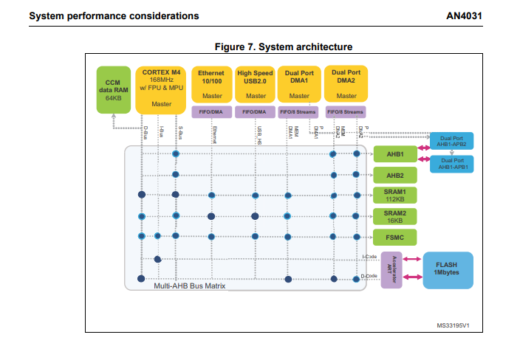

I blocchi in giallo sono comunemente chiamati ***Masters***.

I blocchi verdi e blu che ci sono sulla destra, invece, sono comunemente chiamati ***Slaves***.

Il box con tutti i collegamenti e i pallini blu è invece chiamato ***Bus Matrix***.

Questo viene chiamato anche ***Multi-AHB Bus Matrix*** in quanto vi sono multipli ***AHB Bus*** nella parte degli ***Slaves***.

I vari pallini blu sono dei punti di connessione, i quali stanno a significare che vi sono diversi percorsi di comunicazione tra i ***masters*** e gli ***slaves***.

Nei *microcontroller*, la comunicazione tra il *processore* ed una *periferica* è vista come una comunicazione da un *master* ad uno *slave*.

Un *micro* ha almeno 1 ***master***, che sarà il ***processore*** stesso (***ARM Cortex M4*** in questo caso).

Un *micro* può avere anche altri ***masters***: in questo caso abbiamo ad es. ***Ethernet, Dual Port DMA1, ecc.***

In questo caso ci concentreremo sul ***main master*** che è l’***ARM Cortex M4 processor***.

Anche da questo diagramma vediamo che il ***processore*** può comunicare con gli ***slaves*** attraverso ***3 Bus Interfaces***:

* ***I-Bus***
* ***D-Bus***
* ***S-Bus***

Consideriamo per primo il ***D-Bus***:

Sotto tale percorso vediamo che ci sono 4 pallini: da questi percorsi possiamo quindi capire che il ***processore*** (***master***) può comunicare usando il ***D-Bus*** con ***4 slaves***:

* ***SRAM1***
* ***SRAM2***
* ***FSMC***: è un *external memory controller*
* ***Flash Memory*** (attraverso la ***D-Code interface***).

Consideriamo adesso l’***I-Bus***:

Sotto questo percorso vi sono solamente 2 pallini, quindi il ***processore*** (***master***) può comunicare attraverso l’***I-Bus*** solamente con ***2 slaves***:

* ***FSMC***
* ***Flash Memory*** (attraverso l’***I-Code interface***).

Consideriamo per ultimo l’***S-Bus***:

Sotto questo percorso vediamo che ci sono 5 pallini, quindi il ***processore*** può sfruttare l’***S-Bus*** per collegarsi con ***5 slaves***, ma NON con la ***Flash Memory***.

# Sezione 9

## Understanding MCU Clocks and Details

Un *microcontrollore* non è altro che un circuito digitale sincrono rispetto al ***clock***.

Quindi, senza il ***clock***, tutti i vari componenti digitali del *micro* che lavorano in maniera sincrona non funzionerebbero.

I ***clocks*** sono dei segnali ad onde quadre con una certa frequenza.

Per ogni applicazione è molto importante selezionare il tipo di ***clock*** adeguato, in quanto se l’applicazione è una *low power application* vuol dire che si sta lavorando in un *low power domain*, quindi bisogna stare molto attenti alla ***frequenza*** del ***clock*** che si vuole utilizzare per l’applicazione.

Infatti, vi è una relazione tra il ***consumo di potenza*** e la ***frequenza del clock.***

In questa sezione utilizzeremo come *micro* l’***STM32F407*** (***discovery board***).

Dal ***Reference Manual***:

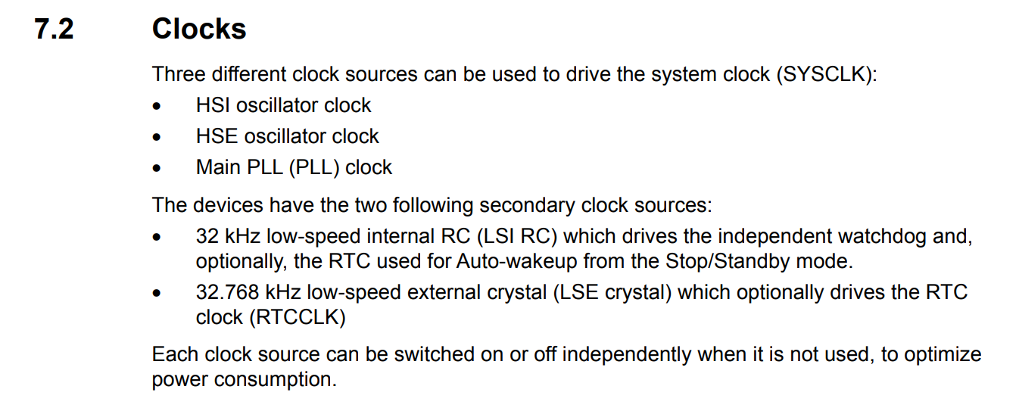

Quindi vi sono 3 differenti ***clock sources***:

* ***Crystal Oscillator*** (*external to the MCU*): è un componente esterno al quale ci si deve collegare dall’esterno in modo tale da alimentare il *clock*.
* ***RC Oscillator*** (*internal to the MCU*): questo, invece, è un componente interno al *micro*, quindi non bisogna connettere nessuna *clock sources* all’esterno del micro

***RC = Resistive & Capacitive*** *circuit*

* ***PLL (Phase Locked Loop)*** (*internal to the MCU*): anche questo è un componente interno al *micro*. Possiamo generare un ***clock ad alte frequenze*** prendendo come input un ***clock a basse frequenze***.

Quindi, un *micro* per lavorare ha bisogno di un ***clock***, il quale può essere preso dalle differenti ***clock sources*** disponibili.

Il tipo di ***clock source*** più utilizzato è il ***crystal oscillator***.

## Understanding MCU clock sources and HSE

Sempre all’interno del ***Reference Manual*** possiamo trovare il ***clock tree***:

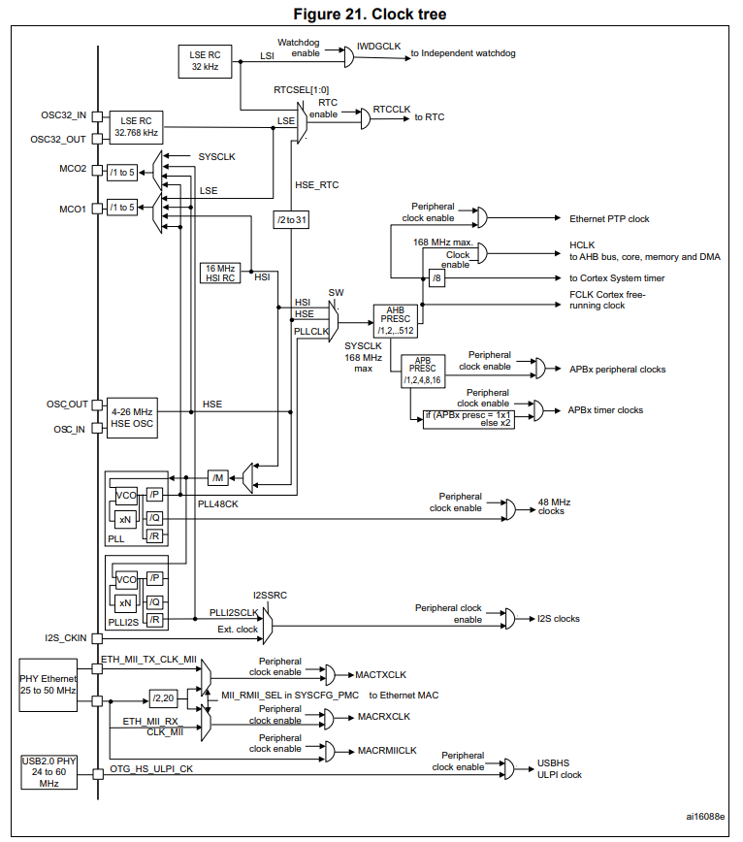

Per capire meglio il funzionamento di questo *block diagram* crearemo un progetto su ***STM32CubeIDE***.

In questo caso, però, utilizzeremo ***STM32Cube*** come ***Targeted Project Type***:

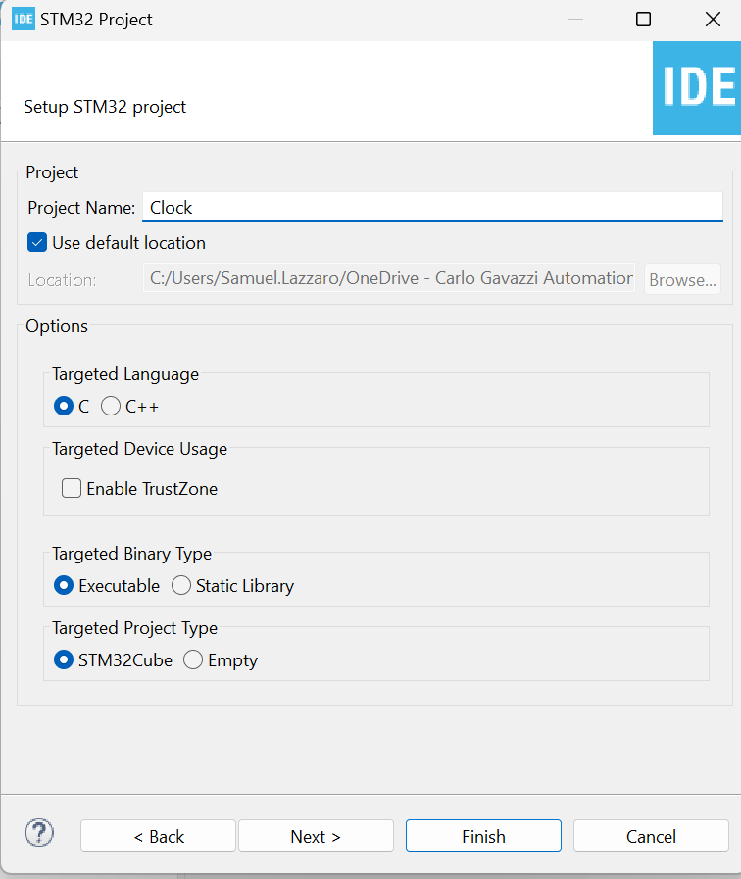

Utilizzando tale opzione, infatti, possiamo ottenere una ***GUI*** attraverso la quale fare la ***clock configuration***.

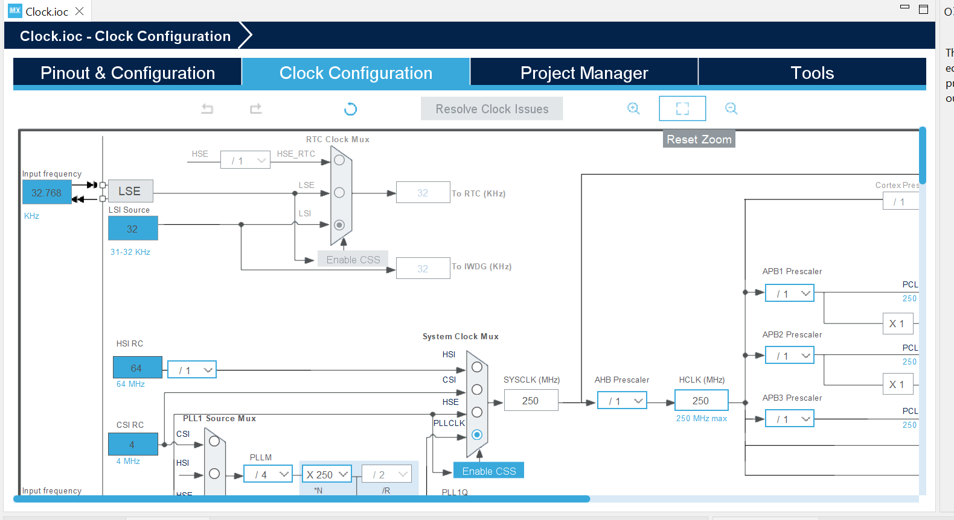

In questo diagramma possiamo vedere che possiamo selezionare differenti tipologie di ***clock***:

* ***PLLCLK***
* ***HSI (High Speed Internal)***: corrisponde all’***RC oscillator***
* ***CSI***: non vi è sul *micro* usato nel corso
* ***HSE (High Speed External)***: corrisponde al ***crystal oscillator***

***N.B.*** La ***frequenza*** alla quale può lavorare l’***HSE*** NON dipende dal *micro*, ma dipende dalla ***board***. Quindi non è un valore che possiamo trovare sui documenti del *micro*.

Ma, il *micro* fornisce comunque alcune *guidelines* relative ai valori limite di ***frequenza*** che si possono utilizzare per l’***HSE***. Infatti, nel diagramma del ***clock configuration*** possiamo trovare questo:

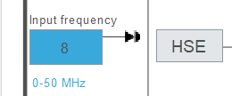Il *micro* ci dice che l’***HSE*** può avere una *input frequency* che abbia un valore compreso tra ***0 – 50 MHz***

Se andiamo nella sezione ***HSE Clock*** del ***Reference Manual***, abbiamo questo schema:

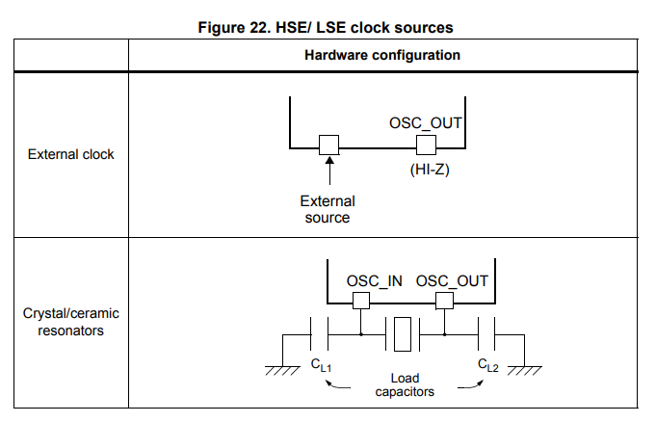Qui ci viene mostrato come dovrebbe essere collegato il ***crystal / ceramic oscillator***.

Un altro modo di fornire un ***HSE*** al *micro* è usando un ***external clock***: in questo caso non è necessario collegare un ***crystal oscillator***, ma si può collegare un ***external clock*** tramite l’***external sources***. Ad esempio, un altro micro, oppure un altro circuito, oppure un’altra parte di un *PCB*.

Se si sta usando una ***discovery board***, non ci si deve preoccupare dell’***external clock*** in quanto tutte le ***discovery board*** hanno un ***crystal oscillator*** installato sulla *board*. Se invece si sta usando una ***nucleo board***, allora non si ha questo vantaggio in quanto tale *board* non ha un ***crystal oscillator*** installato sulla *board*. Quindi, con una ***nucleo board*** bisogna utilizzare un ***external clock***, il quale viene fornito direttamente dal circuito ***ST-Link***.

Infatti, il circuito ***ST-Link*** ha un suo *micro* installato a bordo dal quale preleveremo la ***input frequency*** di ***8MHz*** e la utilizzeremo come ***HSE***.

Per quanto riguarda il ***crystal / ceramic oscillator***, bisogna far riferimento all’***User Manual*** della *discovery board* ***STM32F407***:

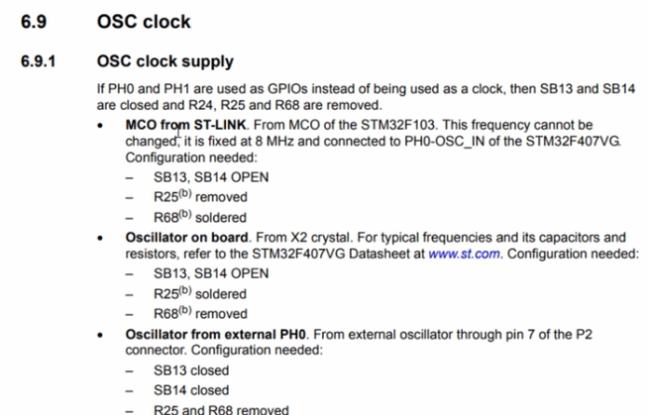

Da qui possiamo vedere che ci sono 3 modi per fornire un ***external clock*** per l’***HSE***:

1. ***MCO from ST-Link***: dove *MCO* è l’acronimo di *MicroController Output*. Quindi il *clock* viene fornito dall’***ST-Link*** come ***HSE***.
2. ***Oscillator on board***: dall’*X2 crystal*. Questo può essere utilizzato nel caso della *discovery board* in quanto su di essa vi è un *oscillator on board*. Andiamo quindi a vedere lo ***schematic*** della *discovery board* per capire quali sono i vari collegamenti con questo *oscillator on board*.

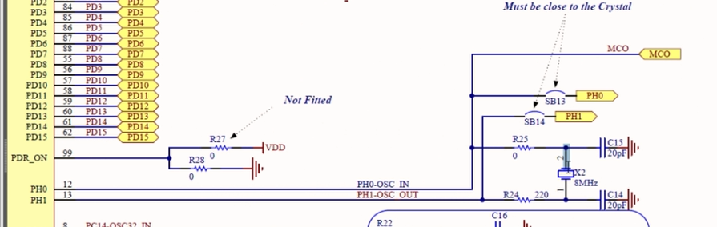

1. ***Oscillator from external PH0***

In realtà, anche la ***nucleo board*** ha una ***OSC (Oscillator) clock*** *section* nel suo ***User Manual***.

[STM32 Nucleo-64 boards (MB1136) - UM1724](https://www.st.com/resource/en/user_manual/um1724-stm32-nucleo64-boards-mb1136-stmicroelectronics.pdf)

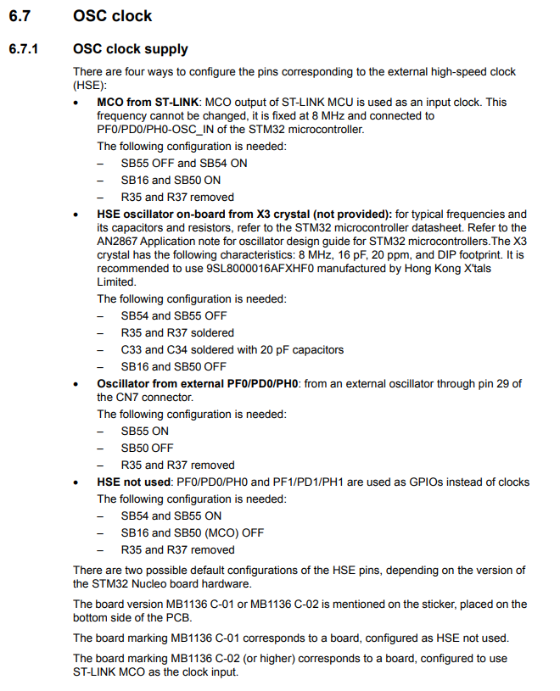

Da qui possiamo vedere come sia possibile fornire l’***HSE*** da un ***oscillator on board from X3 crystal***, ma che questo non è fornito insieme alla *board*.

Aprendo lo *schematico* della ***nucleo board*** possiamo notare che l’***X3*** è ***N / A (Not Applicable)***, e che l’***HSE*** viene fornito tramite il ***MCO from ST-Link***. Se poi in futuro si vorrà usare un ***X3*** bisognerà aprire lo *switch SB50* per eliminare l’***MCO from ST-Link***.

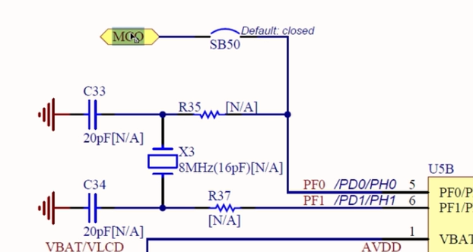

## 36. HSI and RCC registers

In questa sezione vedremo l’***HSI*** e gli ***RCC registers (RCC = Reset & Clock Control)***.

Dal ***Reference Manual*** abbiamo questa descrizione:

[STM32F405/415, STM32F407/417, STM32F427/437 and STM32F429/439 advanced Arm<Sup>®</Sup>-based 32-bit MCUs - Reference manual](https://www.st.com/resource/en/reference_manual/rm0090-stm32f405415-stm32f407417-stm32f427437-and-stm32f429439-advanced-armbased-32bit-mcus-stmicroelectronics.pdf)

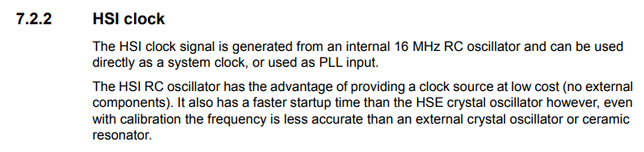

L’***HSI*** è il ***default clock*** del micro, quindi quando il micro viene resettato viene utilizzato l’***HSI*** come *main system clock* al suo riavvio. Quindi, nel caso in cui si voglia utilizzare un altro *clock* come *main system clock*, bisogna aggiungere tale impostazione nel codice.

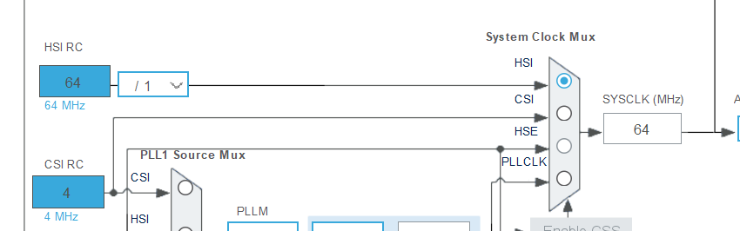

Per quanto riguarda l’***HSI*** vediamo che viene utilizzato un blocco che è interno al micro.

Attraverso il ***System Clock Mux*** è possibile selezionare quale ***clock source*** utilizzare tra quelle disponibili.

Quindi, dopo un *reset* il micro seleziona in maniera automatica l’***HSI*** in questo ***mux***.

Quindi, anche se non viene utilizzato nessun ***crystal*** per il micro, è possibile far funzionare il micro utilizzando l’***internal RC oscillator***, ossia l’***HSI***.

Inoltre, se non vi è nessun ***external oscillator*** collegato, non è possibile selezionare l’***HSE***, ossia tale pulsante sarà proprio disabilitato.

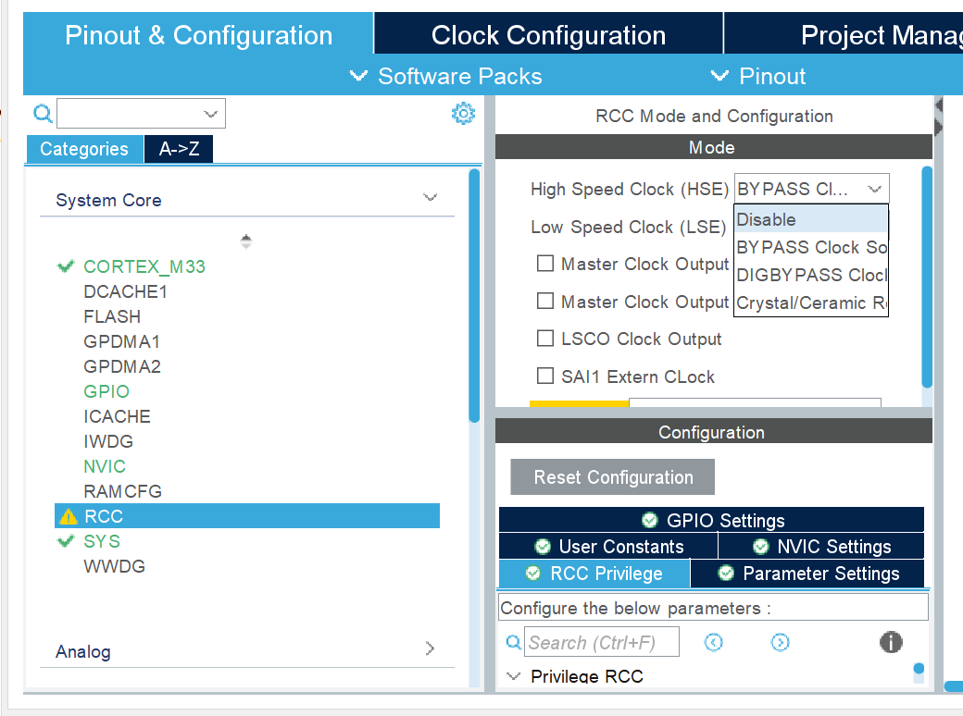

Per disabilitare l’***HSE*** posso andare nella ***Pinout & Configuration***, cliccare su ***System Core -> RCC*** e modificare il valore dell’***HSE*** in *disabled.*

Così facendo, una volta tornato nella ***Clock Configuration***, avrò che il pulsante dell’***HSE*** nel ***System Clock Mux*** sarà disabilitato:

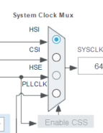

Vediamo adesso tutti gli altri parametri del *clock* utilizzando un ***HSI***:

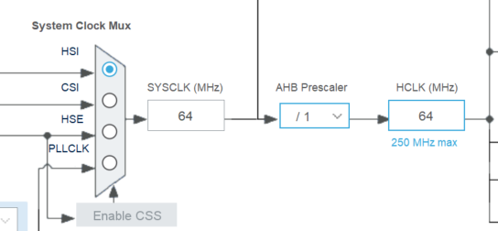

Possiamo vedere come, utilizzando l’***HSI***, si avrebbe un ***SYSCLK*** di ***64MHz***, al quale segue un blocco di ***AHB Prescaler*** necessario in quanto l’***HCLK*** non può superare i ***250MHz***.

Di conseguenza, se il ***SYSCLK*** fosse maggiore di ***250MHz***, bisognerebbe utilizzare un certo ***AHB Prescaler*** in modo tale da avere un ***HCLK*** inferiore ai ***250MHz***.

Ricordiamo che l’***HCLK*** è il ***clock***, ossia la ***frequenza***, dell’***AHB Bus***.

Dall’***HCLK*** derivano poi tutti i ***clock*** successivi:

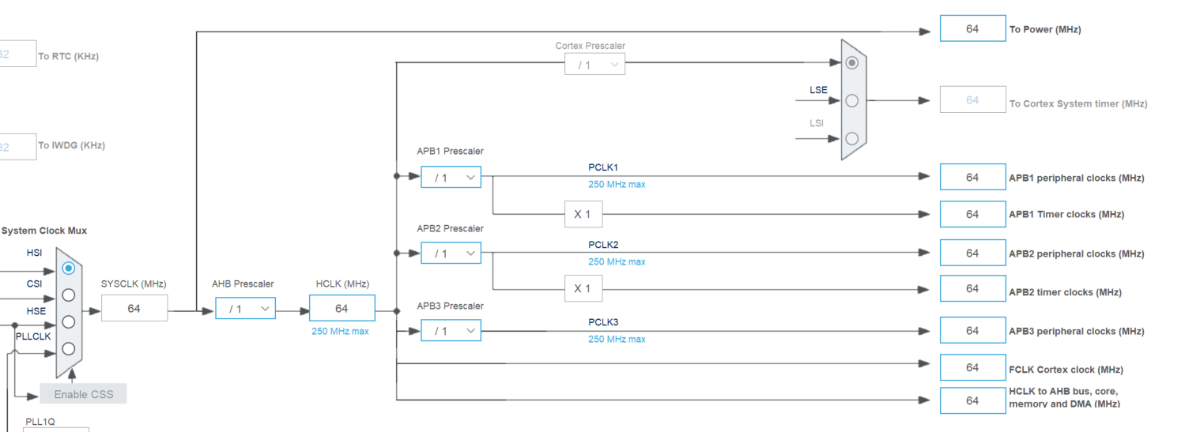

Possiamo ad esempio vedere che il ***clock*** per l’***AHB Bus*** viene direttamente preso dall’***HCLK*** senza nessun altro ***prescaler***. Questo vuol dire che i ***GPIOs*** utilizzeranno proprio quella ***frequnza***.

***FCLK Cortex clock***: corrisponde alla ***frequenza*** del ***processore***.

Per l’***APB1*** e ***APB2*** vi è invece un ***prescaler*** rispetto all’***HCLK*** in quanto vi è un ***limite*** per questi *bus* pari a ***250MHz*** (vedi sulla linea di collegamento), il quale è un limite imposto dal design del micro.

Parliamo adesso brevemente del ***PLL***, il quale non viene trattato in questo corso ma viene trattato nel corso ***MCU2***.

***PLL*** è l’acronimo di ***Phase Locked Loop*** ed è una sorta di *multiplier engine* del *micro*, in quanto permette di incrementare il *clock* ad un valore più elevato di quello permesso dall’***HSI*** / ***HSE***.

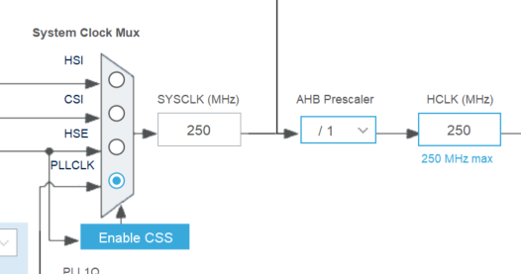

Possiamo infatti vedere come, selezionando il ***PLLCLK***, il ***SYSCLK*** aumenti a ***250MHz*** rispetto ai ***64MHz*** che si avevano utilizzando l’***HSI***.

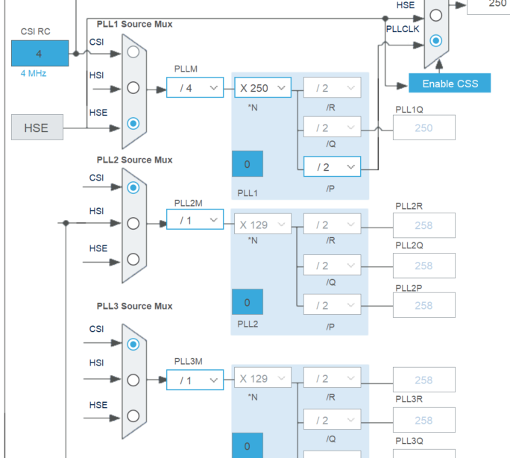

Il ***PLLCLK*** ha tutta una sua serie di ***moltiplicatori*** e ***divisori***.

Il ***PLL*** funziona prendendo un input da un ***PLL Source*** ***Mux*** dal quale si possono avere diverse opzioni in *input*:

* ***CSI***
* ***HSI***
* ***HSE***

In questo caso possiamo vedere come, selezionando l’***HSE*** nel ***PLL1 Source Mux***, partendo dagli ***8MHz*** dell’***HSE***, sfruttando il ***PLL*** è possibile incrementare il ***SYSCLK*** fino a ben ***250MHz***:

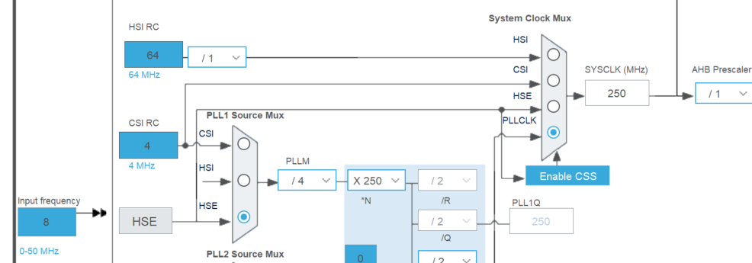

Quindi, se si vuole avere una ***SYSCLK*** maggiore rispetto a quella che possono fornire le altre ***clock sources***, si può utilizzare il ***PLLCLK***, ossia il ***PLL*** come ***clock source***.

Adesso vediamo come è possibile configurare tutti i valori dei ***prescaler***: questo può essere fatto negli ***RCC peripheral register***.

Andiamo quindi nell’***RCC clock control register*** del ***Reference Manual***.

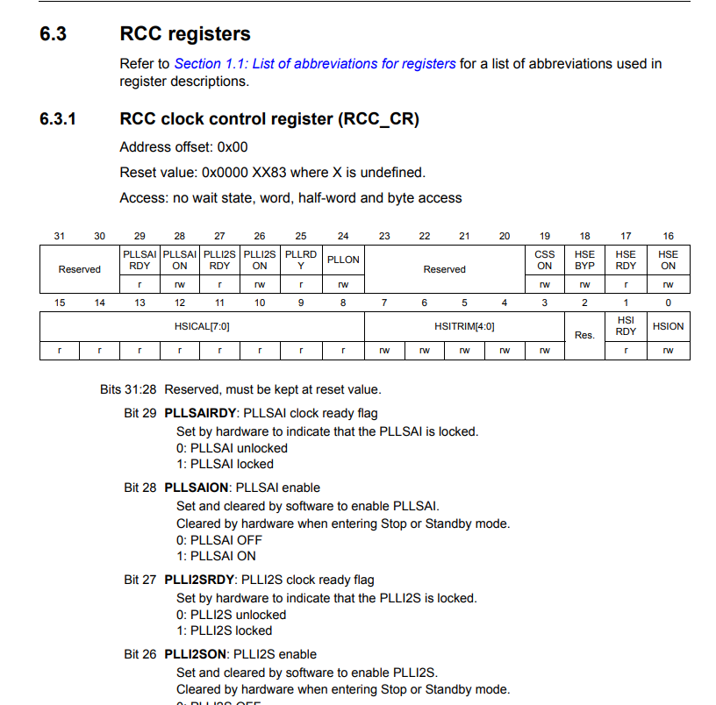

Leggere questa sezione per capire come sfruttare l’***RCC clock configuration register***.

## 37. Peripheral clock configuration

* In modern MCUs, before using any peripheral, you must **enable** its **peripheral clock** using peripheral clock registers.
* By **default**, peripheral clocks of all most peripherals will be **disabled** to save power.
* A peripheral won’t take or respond to your configuration values until you enable its peripheral clock.
* In STM32 microcontrollers, peripheral clocks are managed through ***RCC registers***.

Andiamo nel ***Reference Manual*** e apriamo la sezione ***RCC registers*** per vedere come configurare i ***peripherals clocks*** in modo tale da poter utilizzare determinate ***periferiche***.

Vediamo per prima la parte relativa all’***ADC control register 1***:

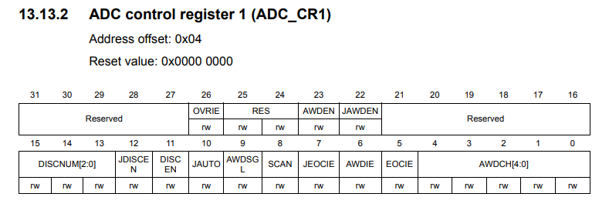

Immaginiamo di voler abilitare lo ***SCAN***: andiamo quindi al ***Bit 8 SCAN***:

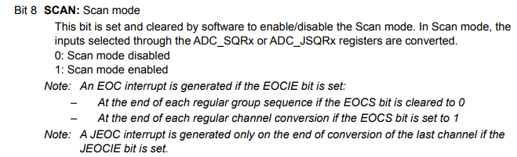

Quindi, dobbiamo settare a 1 il *bit 8* dell’***ADC control register 1*** (***ADC_CR1***). Per far questo dobbiamo prima calcolare qual è il *memory address* di tale *registro*: dobbiamo quindi aggiungere l’*offset* al ***base address*** dell’***ADC control register 1***.

Nel ***Reference Manual*** andiamo quindi all’interno della ***Memory Map*** e cerchiamo ***ADC1*** per ottenerne il ***base address***:

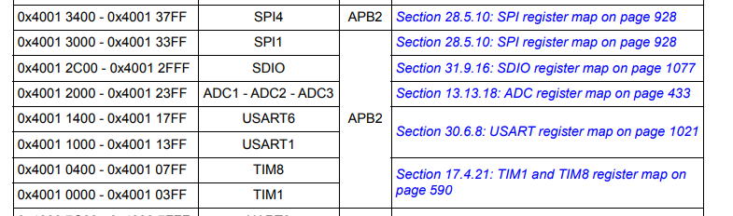

L’***offset*** da utilizzare lo troviamo qui ed è pari a ***0x04***:

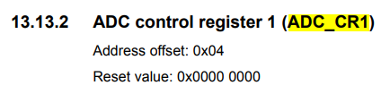

***N.B.*** Tutto questo è valido con la ***STM32F407***, NON con la *nucleo board*.

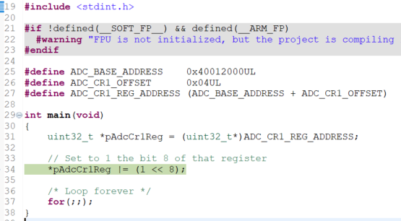

Pur avendo settato tale bit a 1, in realtà il bit è ancora a 0, perché?

Il motivo è che il ***clock*** di quella ***periferica*** NON è *abilitato*.

Quindi, prima di configurare qualsiasi ***peripheral register*** bisogna prima di tutto ***abilitare*** il suo ***peripheral clock***, altrimenti qualsiasi modifica fatta nella configurazione non verrà presa.

Vediamo quindi come ***abilitare*** il ***clock*** della ***periferica ADC***.

Prima di tutto bisogna capire su quale ***bus*** è connessa la ***periferica ADC***. Tale informazione può essere ottenuta dalla ***Memory Map*** presente nel ***Reference Manual***, dalla quale possiamo notare che l’***ADC*** è connessa all’***APB2 Bus***:



In realtà, possiamo ottenere la stessa informazione anche dal *block diagram* presente nel ***Datasheet***:

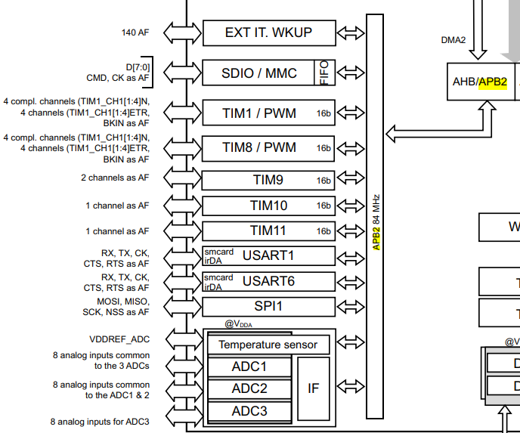

Successivamente, sempre nel ***Reference Manual***, dobbiamo andare nella sezione ***RCC Registers*** e trovare l’***RCC APB2 peripheral clock enable***, in quanto la ***periferica ADC*** è connessa all’***APB2 Bus***:

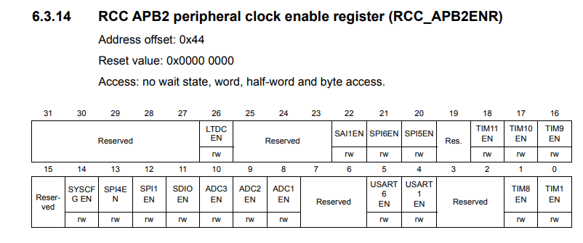

Per abilitare il ***clock*** dell’***ADC1***, bisogna settare a 1 il ***Bit 8 (ADC1 EN)***.

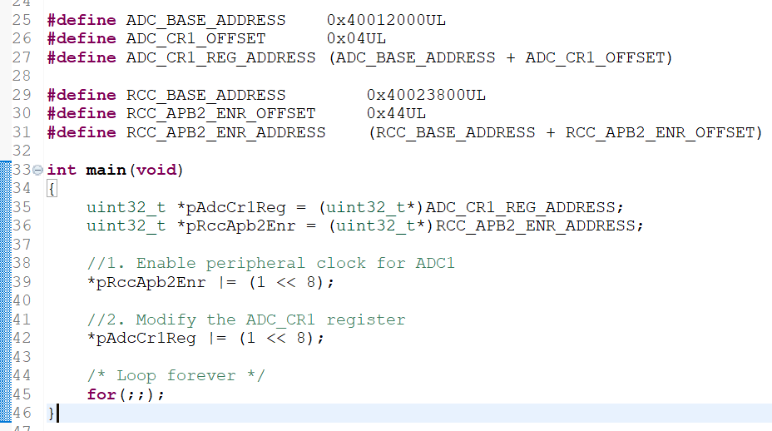

In questo modo riusciamo ad abilitare correttamente lo ***SCAN*** per l’***ADC1***, ossia a settarne il *bit* a 1.

Questo esempio dimostra che se non si abilita prima il ***peripheral clock***, non è possibile applicare una nuova configurazione ad una *periferica*.

## 38. Exercise: HSI measurements

Write a program to output HSI clock on microcontroller pin and measure it using oscilloscope or logic analyzer.

Steps to output a clock on MCU pin:

1. Select the desired clock for the MCOx signal (Microcontroller Clock Output)
2. Output the MCOx signal on the MCU pin

Per la *nucleo board* abbiamo 2 possibili segnali: ***MCO1 & MCO2***

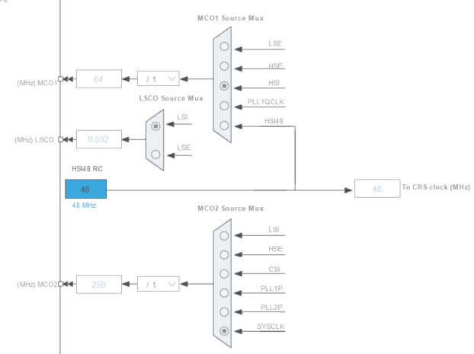

In questo caso abbiamo che per l’***MCO1*** l’input arriva dall’***HSI***, proprio come vogliamo noi per questo esercizio. Attualmente però è tutto disabilitato, quindi per abilitarlo dobbiamo andare in ***Pinout & Configuration***, cliccare su ***System Core -> RCC*** e cliccare su ***Master Clock Output 1 / 2***.

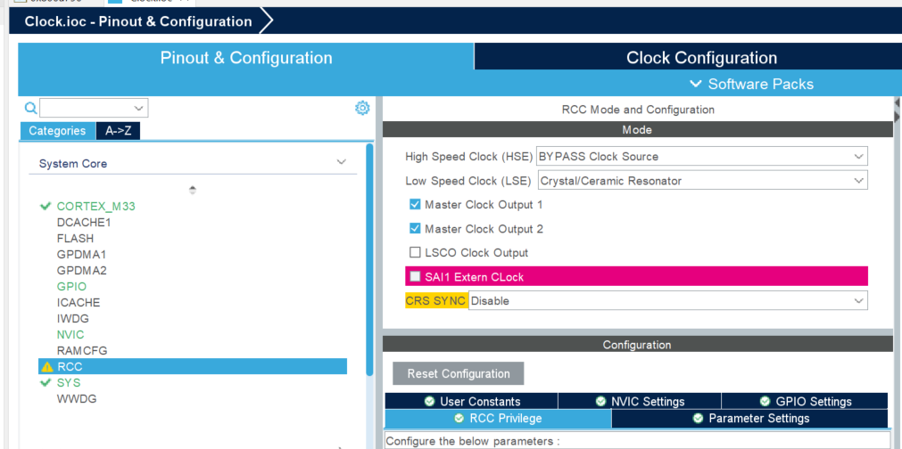

Una volta effettuata questa modifica, tornando nella ***Clock Configuration*,** vedremo tali campi abilitati:

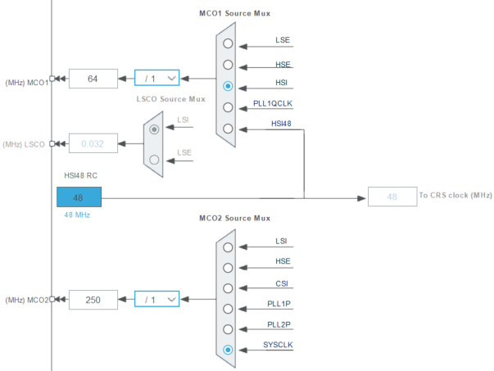

***N.B.*** ***MCO1*** non è un *pin* del *micro*, ma è un ***segnale*** interno al *micro*. Di conseguenza dovremo prendere tale *segnale* e portarlo verso un ***output pin*** del *micro*.

Il ***segnale MCO1***può anche essere usato come ***external clock*** per altri *micro*.

Tale ***segnale*** ***MCO1*** è configurato tramite un ***registro***: andiamo quindi nel ***Reference Manual*** nella sezione ***RCC registers***, precisamente nella ***RCC clock configuration register (RCC_CFRG)*** e andiamo nella parte relativa all’***MCO1***:

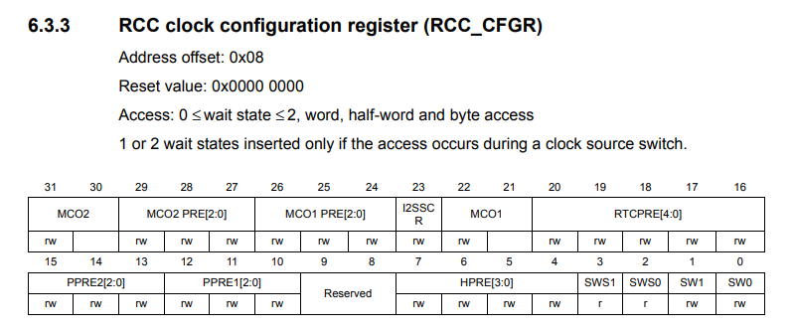

Andiamo quindi ai *bit 21-22*:

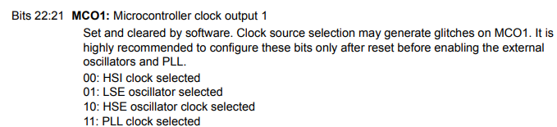

In base al valore assegnato a questi 2 bit verrà selezionato una di queste 4 *clock sources*. Nel nostro caso, volendo utilizzare l’***HSI***, dovremmo usare ***00*** e quindi mettere entrambi i bit a 0.

Con questo abbiamo concluso lo ***step 1***.

Per quanto riguarda lo ***step 2*** dobbiamo invece portare il ***segnale MCO1*** ad un ***output pin*** del *micro*: dobbiamo quindi andare a vedere il ***pin details*** del micro tramite il documento ***Datasheet*** del micro.

Dal ***Datasheet*** andiamo quindi nella sezione ***Alternate function mapping*** e cerchiamo l’***MCO1***:

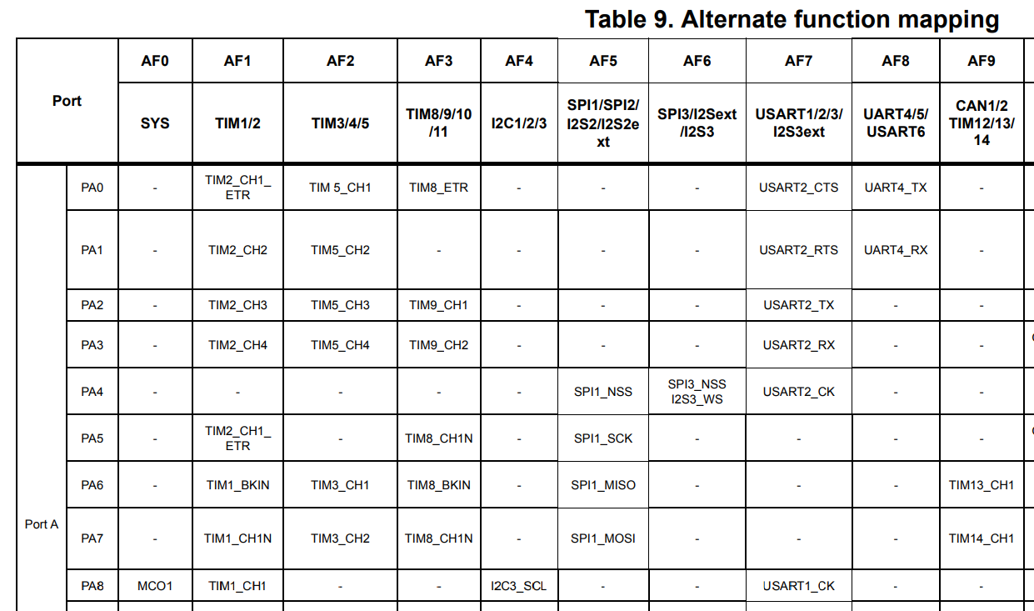

Da qui possiamo vedere come il ***segnale MCO1*** può essere mappato dalla ***GPIO Port A pin number 8 (PA8)*** se si mantiene una ***Alternate Function mode 0 (AF0)***.

Se invece si usasse una ***AF4***, al pin 8 della ***Port A*** si avrebbe il segnale dell’***I2C3_SCL***.

Quindi, ciò che *vediamo* nella tabella sono i vari ***pin*** disponibili nella ***GPIO Port A***.

Ciascuna **porta**(*GPIOx port*)in un micro STM32 ha ***16 pins***: un micro comunica col mondo esterno attraverso diverse *porte (A, B, C, ecc.*).

***N.B. PA8*** non fa riferimento al numero del pin del micro, ma fa riferimento al numero del pin della ***GPIO Port A***. Per sapere a quale *pin* del micro fa riferimento il *pin 8* della *Port A*, bisogna andare nella sezione ***Pin and ball definitions*** del ***Datasheet***.

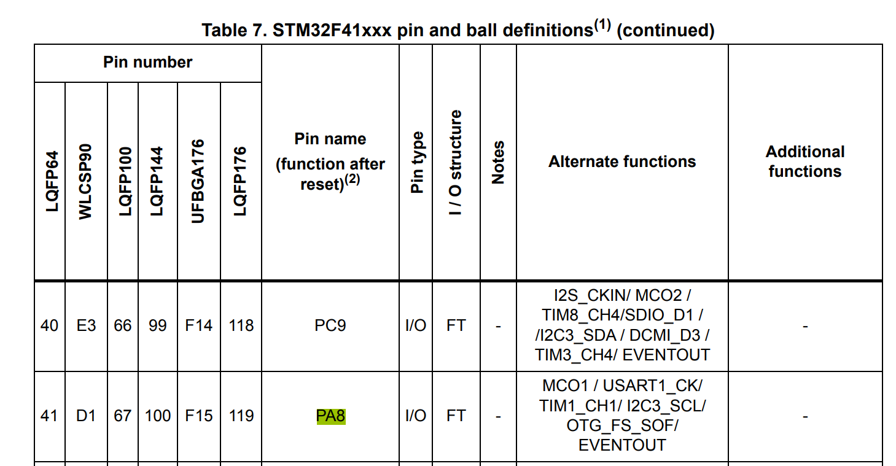

Quindi, nel ***pacchetto LQFP64***, il pin numero 8 della *GPIO Port A* corrisponde al ***pin 41***.

Il micro ha diversi pacchetti come ***LQFP64, LQFP100, LQF144,*** ecc.

Nel caso della *discovery board* viene usato il *package* ***LQFP100***, quindi, il *pin 8 della Port A* corrisponde al ***pin 67*** del micro.

## 40. Code implementation

È possibile modificare un ***prescaler*** non solo tramite la ***Clock Configuration*** ma anche tramite l’***RCC register***.

Infatti, l’***USB Logic Analyzer*** usato nella lezione poteva rilevare fino ad una frequenza max di ***8MHz***, ma l’***HSI*** ha un clock che va a ***16MHz***. Per questo motivo si otteneva un’onda quadra con una frequenza di ***8MHz***.

Per questo motivo si è deciso di utilizzare un ***prescaler*** per diminuire l’***HSI clock*** andando a vedere l’***MCO1 PRE*** nell’***RCC clock configuration register***:

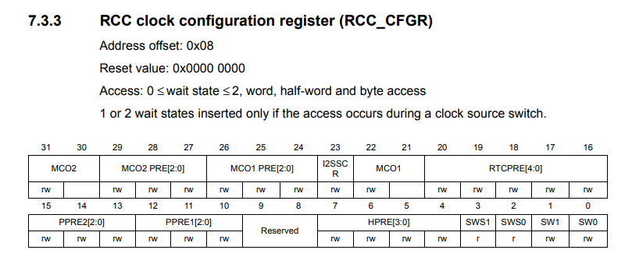

Bisogna quindi modificare il valore nei ***bit 24 – 26***:

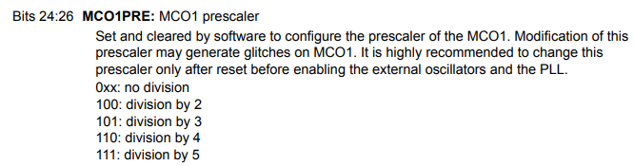

***N.B.*** Vi è un ***errore*** nel ***Reference Manual***: infatti, i *bits* devono essere in ordine ***Bits 26:24*** e NON ***Bits 24:26***, quindi per effettuare una divisione per 4 dovrò avere:

* Bit 26 = 1
* Bit 25 = 1
* Bit 24 = 0

Per effettuare una *divisione 4*, bisogna inserire in tali bit i valori ***110***.

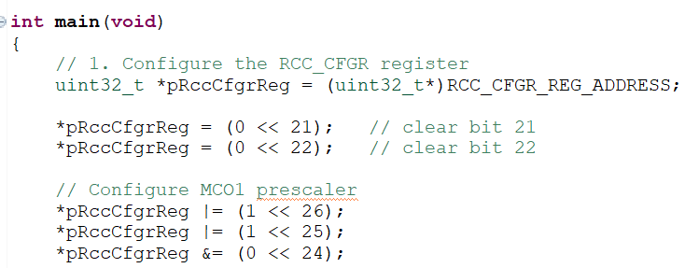

Usando come ***prescaler*** ***/4*** avremo che la frequenza dell’***HSI*** pari a ***16MHz*** viene divisa per 4, quindi si avrà una frequenza di ***4MHz*** del ***segnale MCO1*** che viene mostrata in output.

## 41. Exercise: HSE measurement

Write a program to switch HSE as system clock and measure it.

Noi sappiamo che il ***system clock*** di *default* è l’***HSI*** per la *discovery board* (***STM32F407***).

Steps for *discovery board*:

1. Enable the HSE clock using HSEON bit (***RCC_CR***)
2. Wait until HSE clock from the external crystal stabilizes (only if crystal is connected) (indicates if the high-speed external oscillator is stable or not).
3. Switch the system clock to HSE (***RCC_CFGR***).
4. Do MCO1 settings to measure it

Steps for *nucleo board*:

1. Enable the HSEBYP bit (***RCC_CR***) (bypass the oscillator with an external clock, in quanto sulla *nucleo board* non vi è un crystal oscillator integrato come nel caso della *discovery board*).
2. Enable the HSE clock using HSEON bit (***RCC_CR***).
3. Switch the system clock to HSE
4. Do MCO1 settings to measure it

Il codice verrà scritto per la *discovery board*:

1. Enable the HSE clock using HSEON bit (***RCC_CR***)

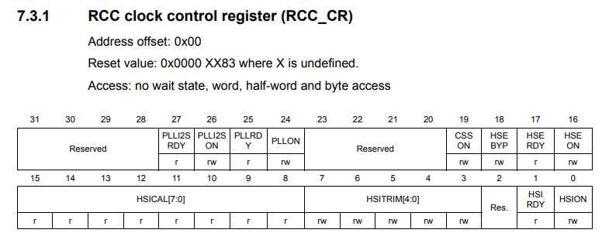

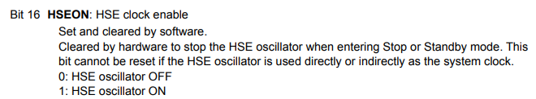

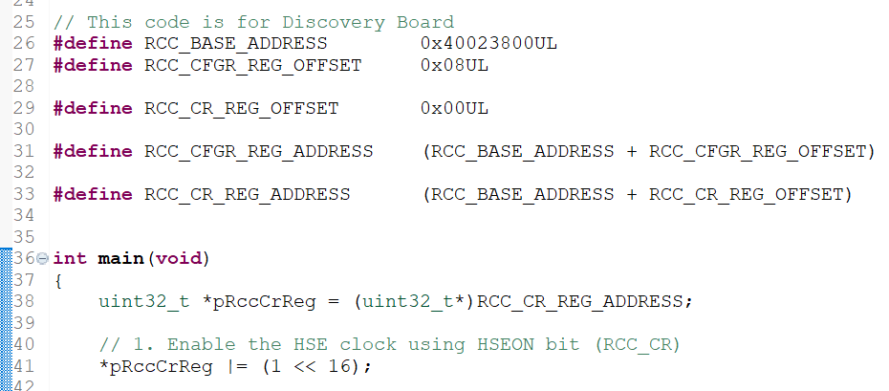

1. Wait until HSE clock from the external crystal stabilizes

Per lo *step 2* bisogna utilizzare l’***HSE clock ready flag*** (***HSERDY***), sempre appartenente all’***RCC_CR***:

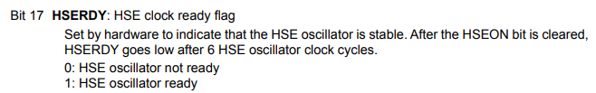

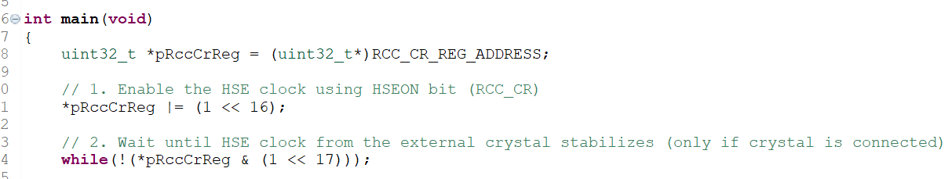

In questo modo, fino a quando il bit relativo all’***HSERDY*** rimane 0, si rimane all’interno del *while loop*.

1. Switch the system clock to HSE (***RCC_CFGR***).

Per il ***system clock switch*** bisogna guardare ***SW0 / SW1*** all’interno dell’***RCC_CFGR***:

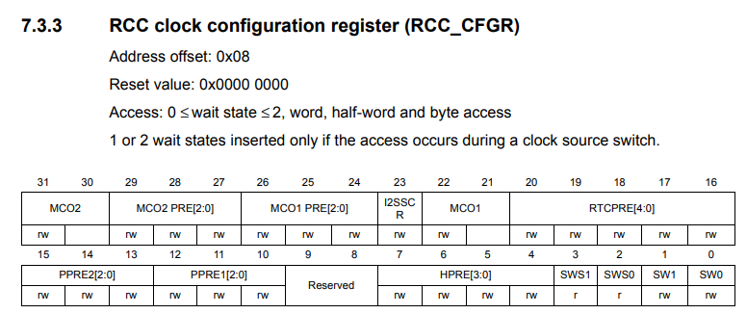

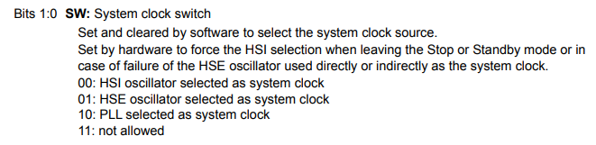

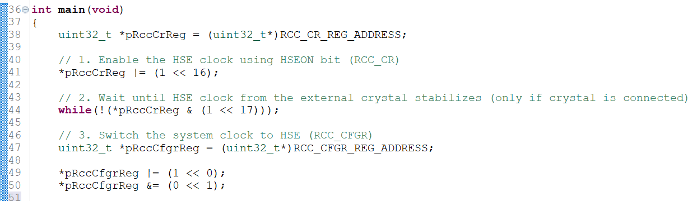

***N.B.*** In realtà, dato che il ***reset value*** di questo registro è ***0x0000 0000***, potremmo anche fare solamente il set a 1 del bit 0 (SW0), in quanto il bit 1 (SW1) verrà messo in automatico a 0 ad ogni reset.

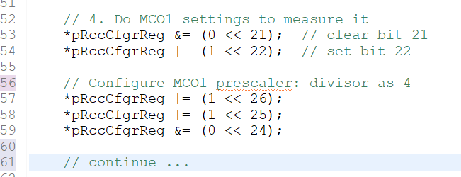

# Sezione 11: Understanding MCU Vector Table

## 42. Understanding MCU Vector Table

*What is a vector table? It’s a table of vectors.*

*What are vectors? Vectors as something related to direction, that in case of microcontroller is something about pointers or addresses.*

*So a vector table is a table of addresses or pointers.*

*Addresses of what? Addresses of* ***exception handlers*** *(system exceptions + interrupts).*

*Then, a vector table is a table of addresses of exception handlers.*

*We have 15 system exceptions + 240 interrupts.*

*Then, a vector table should include the addresses of handlers for all these exceptions.*

*The* ***vector table*** *is inside the* ***Reference Manual:***

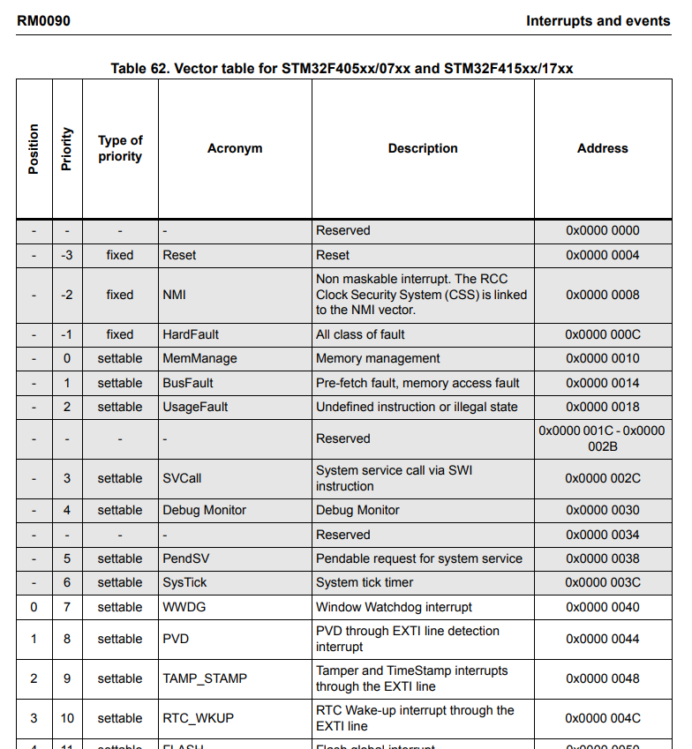

*This table has 6 columns:*

* ***Position***

*The position is kept empty for all* ***system exceptions****. So the microcontroller cannot change the position for the system exceptions because they come from the processor (ARM Cortex). The position is related to the NVIC.*

*Another name for this* ***Position*** *column is* ***IRQ number.***

*For example we can say that the IRQ number for Watchdog is 0.*

*The rows without the Position are the* ***system exceptions****, while the other ones are the* ***interrupts.***

* ***Priority***

*If the priority is fixed, then it cannot be changed.*

*If the priority is settable, then it can be changed with the programming code.*

*The priority number explain what is the priority of the exception. The lower priority is the must important.*

* ***Description***

*It is the description of the system exception or of the interrupts.*

* ***Address***

*It is the address memory inside the processor memory map.*

*In an STM32 project there is a folder called* ***Startup*** *in which there is a file with a* ***.s*** *file extension. Inside this file there is the* ***vector table****.**This is an* ***assembly file (.s).***

*In this file it is implemented the* ***reset handler****:*

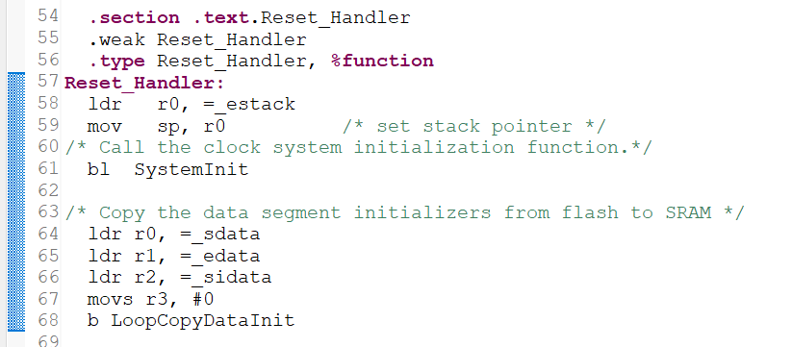

*Whenever the processor undergoes reset, this is the first function that is going to be executed.*

*This handler’s address must be stored at this location:*

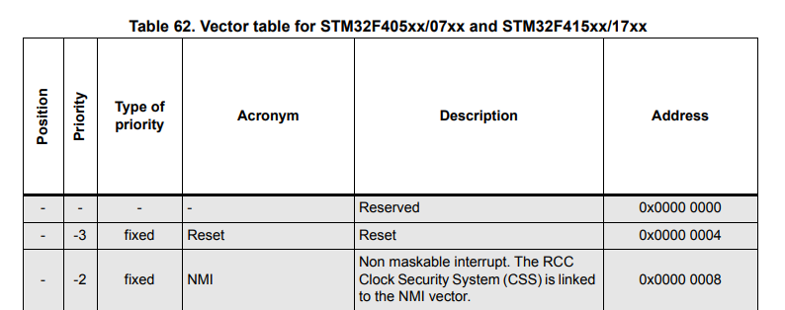

*Then, when the processor undergoes reset, the processor read this memory address and it loads whatever is stored into this address.*

*So, all the addresses inside the vector table act like a* ***link*** *to the various exception or interrupt handlers.*

*The vector table is stored in this global array:*

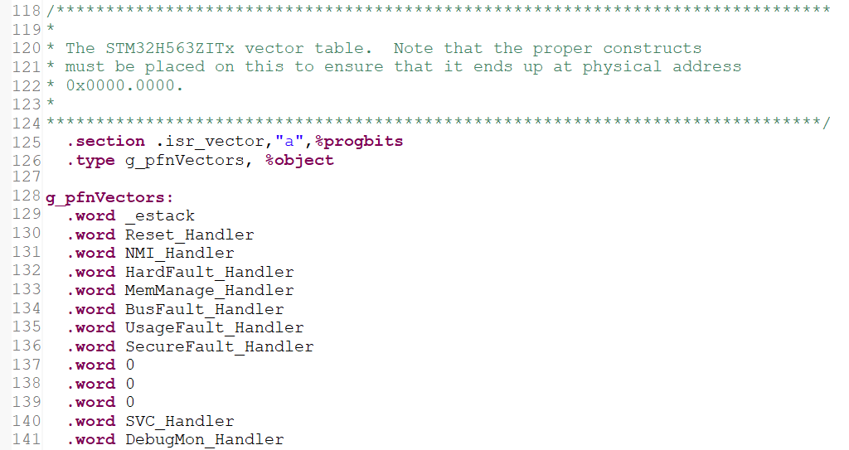

*This is a global array of constant values.*

***_estack*** *is the value of the initial stack pointer.*

*This vector is coded by referring to the vector table. So these constants are defined by referring to the vector table of the microcontroller.*

Guardare Corso ***Embedded System Programming on Cortex M3 or M4 (youtube)*** per capire come scrivere completamente da 0 un file di *startup* come questo***.***

[Bare metal embedded - YouTube](https://www.youtube.com/playlist?list=PLERTijJOmYrDiiWd10iRHY0VRHdJwUH4g)

*This global array is stored into the .isr_section, which is a section stored into the FLASH according to the linker script file:*

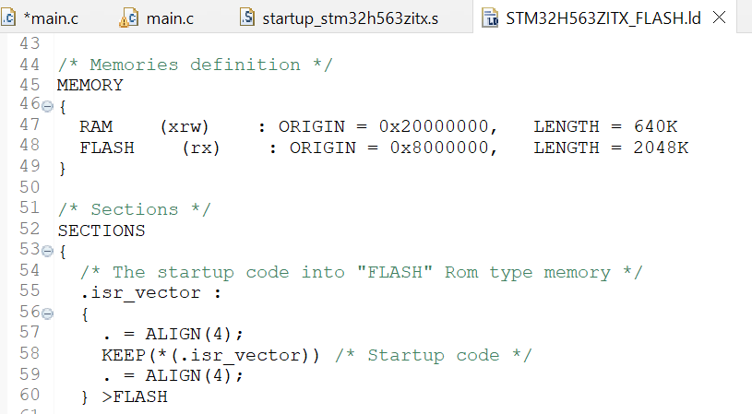

*The FLASH starts from the memory address = 0x0800 0000 as specified above.*

*Then, the isr_vector is stored at the beginning of the FLASH memory.*

*So, once you build your project and download it into the microcontroller, the vector table will be placed at the initial addresses of the FLASH memory.*

*The vector table contains* ***ISR addresses*** *of all system exceptions and interrupts supported by the microcontroller.*

*In STM32F407x microcontroller there are 15 processor system exceptions + 82 interrupts (IRQs) = 97.*

*So, 97 handlers addresses must be stored into the VT (Vector Table).*

*Total space consumed by the VT = 97 + 1 (to store initial stack address) = 98 words = 392 bytes.*

*So, for this microcontroller, the VT is going to consume 392 bytes of the initial FLASH memory.*

*If during debug on a nucleo board I add into Expressions window the* ***Reset_Handler****, I can get the memory address of this handler:*

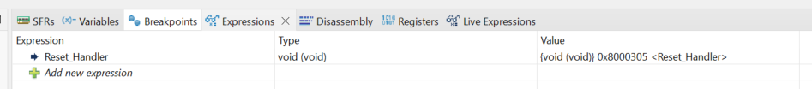

*For the nucleo board, the Reset Handler has a value of 0x0800 0305, then inside the memory address of the Reset exception it is stored the value 0x0800 0305.*

*For the discovery board, the Reset exception has an address of 0x0000 0004 in the Vector Table, while the Reset_Handler value is 0x0800 0264. So when the program starts, it goes to the memory address 0x0000 0004, where the value stored is 0x0800 0264, which corresponds to the memory address of the Reset_Handler. Then the reset is performed.*

*Inside the startup file there are a lot of dummies implementations:*

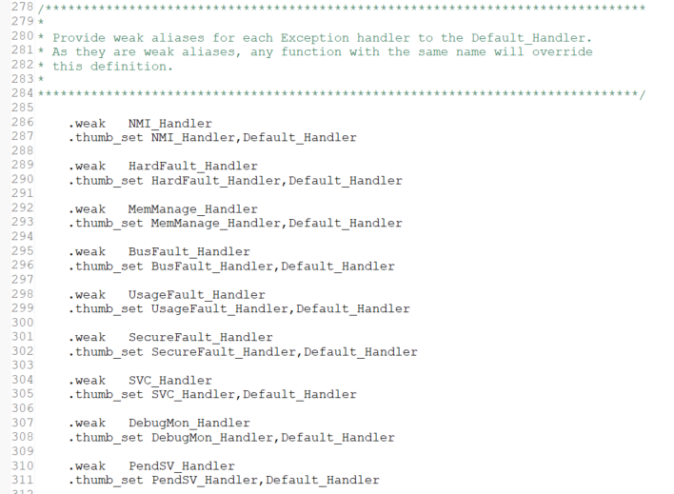

*These are all weak functions.*

*Weak functions can be overridden by the programmer in the main code.*

Vuol dire che queste sono delle implementazioni iniziali di tutte queste funzioni per gestire gli *handlers*, ma è possibile sovrascrivere ciascuna di queste funzioni implementandone una nuova con lo stesso nome, così come fatto per la funzione ***I2C2_EV_IRQHandler()***.

*These are all dummies implementations of various exceptions and interrupts of the microcontroller.*

*For example, let’s say you want to implement the I2C1 Event IRQ Handler, then all you need to do is just copy this function name (I2C1_EV_IRQHandler) and implement it in main code:*

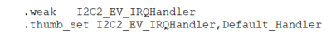

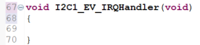

*Whenever I2C interrupt triggers, the control will come to your function implemented.*

*For the discovery board, the I2C1_EV has an address of 0x0000 00BC inside the Vector Table, so when the processor call this interrupt, it goes to this memory address in which is stored the memory address of the I2C1_EV_IRQHandler() that you implemented, and the processor jumps to its memory address in order to run this handler function.*

*Then, if I put the address 0x0000 00BC inside the* ***Memory Browser window****, I can see that in this memory address it is stored the memory address of the function I2C1_EV_IRQHandler(), which is 0x08000264 in the lesson example.*

## NVIC (Nested Vector Interrupt Controller)

La **NVIC** (**Nested Vector Interrupt Controller**) è il modulo integrato nei microcontrollori STM32 che gestisce le interruzioni, ossia gli ***interrupts***. La NVIC è parte dell'architettura ARM Cortex-M, di cui gli STM32 fanno uso, e consente di configurare, abilitare e gestire le interruzioni di sistema in modo efficiente. Ecco alcune delle sue principali caratteristiche:

* Priorità delle interruzioni: La NVIC supporta la gestione di priorità delle interruzioni, permettendo di assegnare un livello di priorità diverso a ciascuna interruzione. Questo consente di stabilire quali interruzioni devono essere servite prima in caso di conflitti o sovrapposizioni.
* Nested Interrupts: La NVIC consente di annidare le interruzioni (da cui "Nested" nel nome), quindi un’interruzione di priorità più alta può interrompere una di priorità inferiore. Questo permette al sistema di rispondere rapidamente a eventi critici.
* Vectored Interrupts: Ogni interruzione ha un vettore dedicato, che punta all'indirizzo della routine di gestione (ISR) specifica per quella interruzione. Questo consente un accesso più veloce alla routine corretta, migliorando le prestazioni.
* Configurabilità: La NVIC consente di abilitare, disabilitare e configurare le singole interruzioni in base alle esigenze dell’applicazione. Ad esempio, puoi configurare maschere di interruzione per disabilitare temporaneamente certi eventi.

La NVIC, in combinazione con il SysTick timer e altre risorse del microcontrollore, rende gli STM32 molto reattivi ed efficienti nella gestione delle interruzioni.

# Sezione 12: Understanding MCU interrupt Design, NVIC, Interrupt handling

## 43. MCU Interrupt Design, NVIC, Interrupt handling: Part 1

Hey, welcome back to the lecture. So, in this lecture what we are going to do is, we are going to see practically how a ***user button*** delivers it's *interrupt* to the ***processor*** and how exactly our ***interrupt handler*** gets executed. And once you understand that the mechanism can be applied to any microcontroller you have at your hand.

Now, let's gets started without wasting any time and I'll be doing this experiment on my ***STM32F407*** *discovery board* and you can also try it on your board.

So, now what I do is, I first open my ***User Manual*** ([MB997](https://www.st.com/resource/en/schematic_pack/mb997-f407vgt6-e01_schematic.pdf)) and I just go to the ***schematic*** at the end in order to know how exactly my *user button* is connected to the microcontroller, because without understanding that you don't know how actually *user button* interacts with the microcontroller.

So, here it is a ***USER & WAKE UP button***.

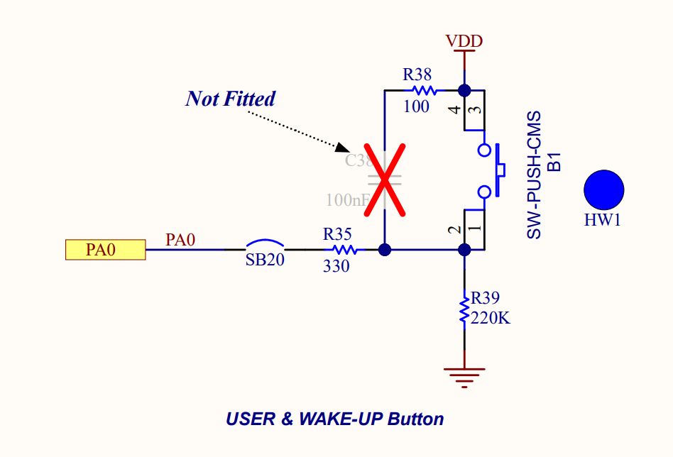

All right. So, if you observe this button carefully. OK. So, this button is actually connected to ***GPIO Port A 0th pin***. So, that we can see here. In the microcontroller, if you go of this is a microcontroller and ***PA0***, this one PA0.

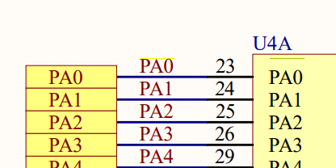

So, which happens to be the ***23rd pin*** of the microcontroller. So, your ***button*** is connected over here at ***PA0***.

Watching the previous image with ***User & Wake Up button,*** the capacitor C38 is not present, that means that the circuit is open there. And when you push the button what happens, when you push the button. So, the VDD connects to this point here. Right? So, but here you can see that it's actually a voltage divider circuit wire, this is of higher resistance 220K (R39) compared to a small resistance R35. So, that means the PA0 is almost like pull to high. Right? If you close this button. And if you release this button then it's like pulling this PA0 pin to the ground. So, that means if you push the button the PA0 pin is pulled to high and if you release the button a the PA0 is actually pulled to ground.

So, now our goal is when I push this button I should get a ***interrupted*** in my application. So, let's see how we can do that. Great!! So, before going to the implementation part we have to understand so many things related to this small task. All right.

So, now we have to understand *how GPIO pin interrupts the processor? That mean, what’s the design?* So, you have to understand the design. *The design means, how the vendor delivers the GPIO interrupt to the processor?* Because, it is highly dependent on the vendor. Because, you already know that somehow all the ***interrupts*** must come to ***NVIC***. But the way they deliver to the NVIC is different. So, you have to understand the design.

All right. So, now I will like take you to the ***Reference Manual*** of the microcontroller:

[STM32F405/415, STM32F407/417, STM32F427/437 and STM32F429/439 advanced Arm<Sup>®</Sup>-based 32-bit MCUs - Reference manual](https://www.st.com/resource/en/reference_manual/rm0090-stm32f405415-stm32f407417-stm32f427437-and-stm32f429439-advanced-armbased-32bit-mcus-stmicroelectronics.pdf)

So, here open the section called ***Interrupts and events***. Just open that and under that open the section ***External interrupt / event controller***. And under that just open ***External interrupt/event line mapping:***

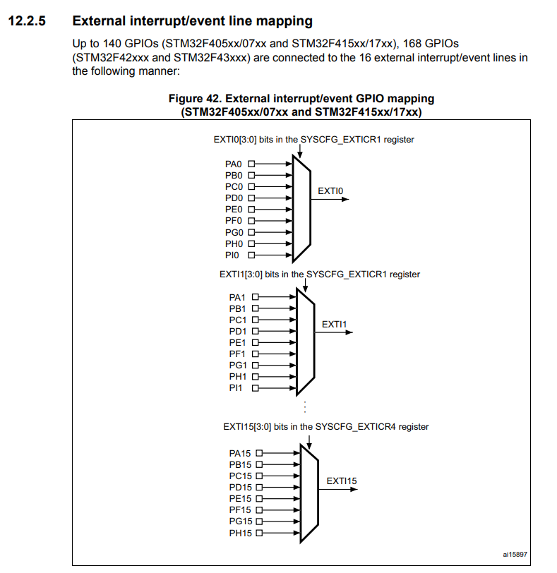

Great!! Yes, this is the one we wanted. So, now what I'm going to say is specific to ***ST***. So, though ST micro-controller has an engine called ***EXTI*** (***External Interrupt controller***). So, if you want to see how that looks like you can click on the ***EXTI block diagram***:

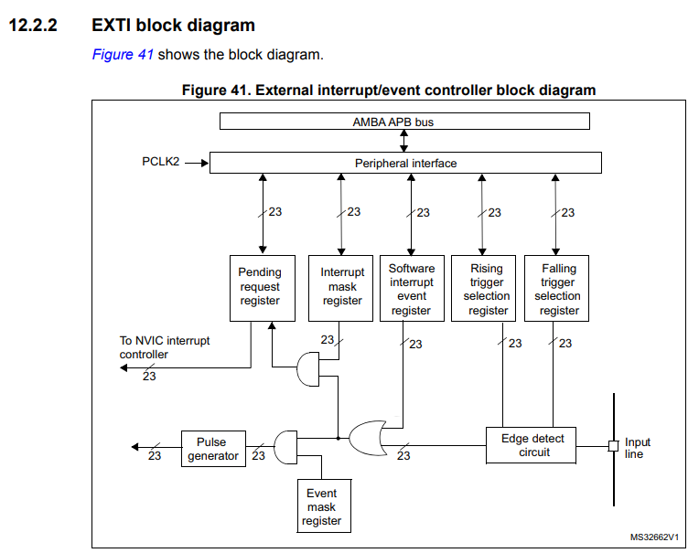

So, the EXTI engine looks something like this. So, this engine is actually hanging on the ***APB bus***. So, strictly speaking you have to take a look into the block diagram in ***Datasheet*** and search the ***EXTI:***

[DS8597_STM32F41xxx.book](https://www.st.com/resource/en/datasheet/stm32f415rg.pdf)

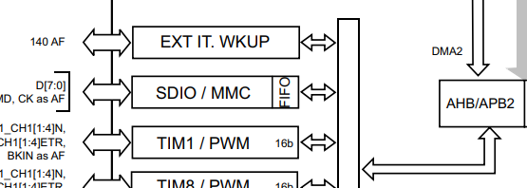

So, that's why it drives the clock from ***PCLK2***. That is an ***APB CLK2***. All right. So, now if you look at this diagram (Figure 41) very carefully this engine finally connected to the ***NVIC***. They are saying that it is going to ***NVIC interrupt controller***. So, NVIC is actually part of the processor. Isn't it?

So, that means this engine is giving it's 23 lines. So, this is 23 lines to the NVIC. That means, this engine itself captured 23 different positions of NVIC. So, that means 23 different ***IRQ numbers***. Isn't it?. So, that means we have to see now in the ***vector table*** whether these 23 entries are there or not.

Now let me take it to the ***vector table***, here is a vector table. And if you search in the acronym table you should find 23 entries related to ***EXTI*** block. So, this is EXTI0 line,1, 2, 3, 4. So, like that you should find 23. Isn't it? So, let's see whether it is there or not.

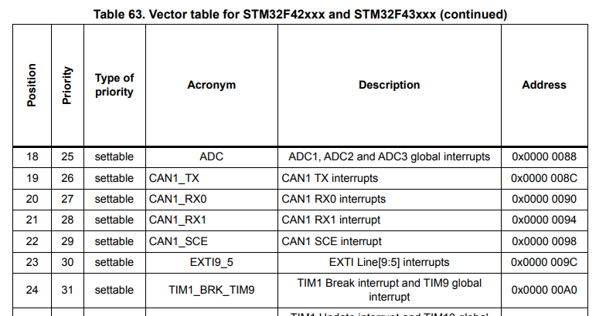

So, here it is 5. Right? OK we have to search 18 mode. Here it is 9 to 5. So, that means 5. So, that means EXTI 5 to 9 lines are issuing interrupt on the same IRQ number 23. So, that means totally 5 lines are they don't have a separate IRQ number.

Quindi, ***EXTI9_5*** vuol dire che tutte le linee dalla 5 alla 9 hanno lo stesso IRQ number, a differenze delle EXTI0, EXTI1, ecc. che hanno tutte un IRQ number individuale.

Now, we actually traced out 10 EXTI lines. Right? Now, we have to search for another 13 and here it is 10 to 15.



OK another 5. So, 15 still 8 are remaining. OK. So, here it is. Ethernet Wakeup through EXTI line. So, we have to see how many such entries. So, we are trace 8 now. One here it is. So, like that if you search you can trace out all 23 lines which are coming to NVIC. Here it is. So, that means the RTC issues its interrupt not directly to the NVIC, but the RTC peripheral issues it's interrupt through the EXTI controller what we just saw. It issues on IRQ3. So, here they have mentioned that RTC wake up interrupt.

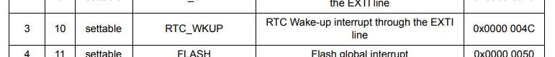

So, that means RTCs wake up interrupt comes over ***EXTI line***. RTCs wake up interrupt is not connected directly to the NVIC, but through the EXTI line. So similarly, if you come down you can see that let me come down here we can see that USBs wakeup signal or interrupt is not directly connected to the NVIC but to the EXTI line.

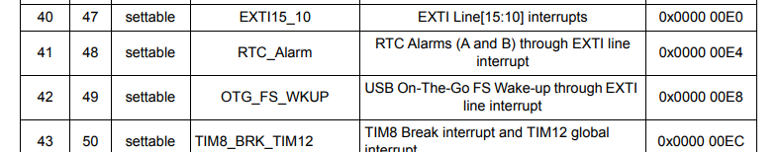

So, like that EXTI helps to deliver a different peripherals interrupt to the NVIC. OK

So, you may ask *why the RTC interrupt is not directly connected to the NVIC? Why it should go through this block over this line?*

I really don't know the answer for this. That may be due to some design issues are handling through this the EXTI controller is more beneficial or it may add some advantageous. So, that's the reason they bringing this controller between some of the peripherals. So, not all peripherals to go through EXTI controller remember. EXTI controller has only 23 lines which is going to NVIC.

For example, let's if I looks at SPI.

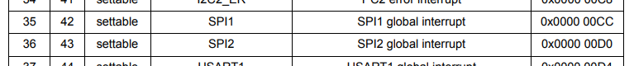

SPI go and directly touch the NVIC. You can see a SPI interrupt is directly connected to the NVIC. Its not through the EXTI line. So, but some peripherals they deliver the interrupt to the processor via the EXTI controller block. All right. Great.

So but, How about our GPIO? So, if you search this entire table you don't find even the GPIO name mentioned in the column ***Acronym***. So, there is no GPIO mentioned. Then, *how does GPIO delivers it's interrupt to the NVIC?* If the answer is through again in the EXTI lines. So, that will discuss in the next lecture.

## 44. MCU Interrupt Design, NVIC, Interrupt handling: Part 2

In the previous lecture, we saw that some ***peripherals*** deliver their ***interrupts*** to the ***NVIC*** over the ***EXTI*** line. And some ***peripherals*** deliver their ***interrupts*** directly to the ***NVIC***. And you should remember that this is the ***design*** of ***ST***. So, you may find some other design in TI (Texas Instruments). But, as I said again and again at the end everybody should come and touch NVIC. Great!

Quindi, tutti gli ***interrupts*** dovranno comunque essere inviati all’***NVIC***: gli ***interrupts*** potranno essere inviati direttamente all’***NVIC*** (come per l’***SPI***) oppure potranno essere inviati all’***NVIC*** tramite l’***EXTI lines***.

So, now let's see how the GPIOs are actually delivering their interrupt to the NVIC. So, now the answer for that is you have to go and check the ***External interrupt*** section in this *EXTI section*.



So, here you can see this diagram which explains how exactly the ***GPIOs*** are delivering their ***interrupts*** to the ***NVIC***. All the ***0th pin*** of ***GPIO ports*** are actually connected to ***EXTI0 line*** over this multiplexer. So, that means PA0. That means, GPIO port A pin 0. So, if we want to match this with our schematic. So, let me open the schematic. So, let me just open that ([MB997](https://www.st.com/resource/en/schematic_pack/mb997-f407vgt6-e01_schematic.pdf)).

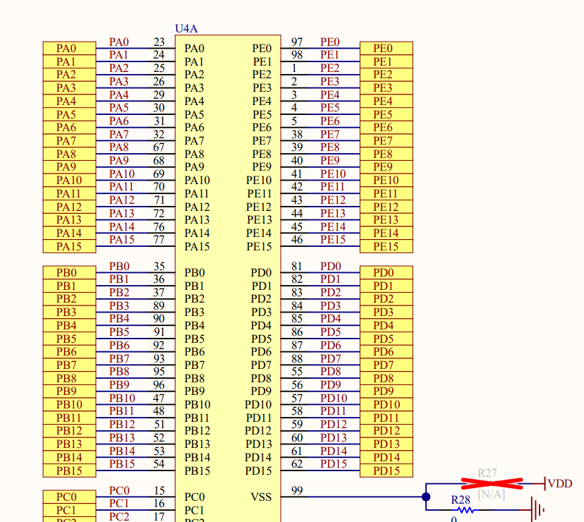

So, if you want to match this with our STM32F407 microcontroller, all these pins PA0, PE0, and PB0, PD0, they deliver interrupt via the ***EXTI0*** line through this multiplexer. So, that means, at any given point in time you can only touch only one input to the output, isn't it? Because, it's a multiplexer. So, which one you should select is determined by this register (***SYSCFG_EXTICR1***) which will explore later. Here, you have to configure in your application this *register* in order to select which among these inputs should come over the ***EXTI0*** line.

Similarly, so all the ***GPIO ports 1st pin*** is connected to ***EXTI1*** line over this multiplexer and again you have to configure this *register* (***SYSCFG_EXTICR1***) by your application in order to select which input should issue it's interrupt over ***EXTI1*** line. There are up to ***EXTI15*** line dedicated to issue your ***GPIO*** interrupts to the NVIC. So, that covers ***GPIO pin 0*** to ***GPIO pin 15***:

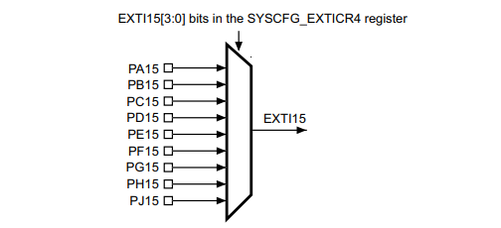

As we know our user button is actually connected to ***PA0***. So, that means, if I press the ***user button***, then my ***interrupt*** will come over ***EXTI0*** line. So, that means, I have to implement ***EXTI0 handler***. Right? So, that is actually my *interrupt handler* for the *user button*.

So, in summary, how does a button issue interrupt to the processor in STM32?

1. The button is connected to one of the GPIO pin of the microcontroller.
2. The GPIO pin should be configured to input mode: don't worry about this point, because we have a whole different lecture series to understand different operational mode of the GPIO pin. This you will learn when you go through the driver development section in the course.
3. The link between a **GPIO port** and the relevant **EXTI line** must be established using the **SYS config register** (***SYSCFG_EXTICRx***). Again, how to do this? You'll learn later. But for a time being, just note that, there are different EXTI lines and let's say if you have connected your button at PD0, then you should establish that link with the EXTI0 line. That selection you can do by using SYS config register (***SYSCFG_EXTICR1***). By default, SYS config register links this Port A to the EXTI line. That linking can be changed by using the SYS config register. Suppose, if you have connected your button to a let's say a PD15, then the interrupt will come over EXTI line 15. But that link must be established by using the relevant SYS config register (***SYSCFG_EXTICR4***). Don't worry, all these things you will learn while coding practically in the driver development exercises.

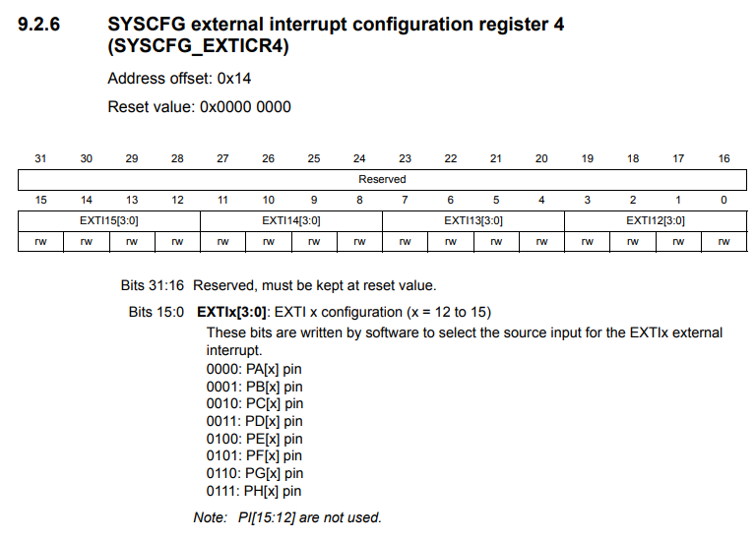

Infatti, l’**EXTI15** fa riferimento al **SYSCFG_EXTICR4.** Quindi, bisognerà settare il valore **0011** (**PD**) nella **EXTI15[3:0]** per linkare lo user button che è collegato al PD15 (GPIO Port D) all’EXTI15 line.

1. Configure the trigger detection (*falling/rising/both*) for relevant EXTI line (This is done via EXTI controller registers). For example, if you open the EXTI controller block diagram, you can see that, there are various registers, right? Pending register, Interrupt mask register, a rising trigger selection register, falling trigger selection register, so all these registers will configure at these lines (*EXTI0, EXTI1, ecc.*).



1. Implement the handler to service the interrupt.

This is a summary, or I can say it is an overview, but if you don't understand something here then don't worry, we have more discussions which are pending related to GPIOs. Because, in later lectures we are going to understand GPIOs, its port, its various operation modes, and various other things. Just take it as an overview. So, I'll see you in the next lecture.

## 45. MCU Interrupt Design, NVIC, Interrupt handling: Part 3

In this lecture, let's understand some of the registers of the **EXTI controller**. For that, just open your ***Reference Manual*** and go to ***Interrupts and events***. And here go to ***External interrupt*** and then to ***External interrupt/event controller***.

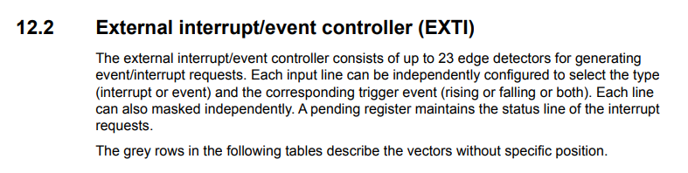

If you just browse through this document, you will get this diagram:



This is an ***External interrupt/event controller block***. You already know that, this controller actually produces 23 different lines and those 23 lines are actually connected to the ***NVIC*** of the processor. Out of these 23 lines, 16 lines are used for ***GPIO*** ***pins*** to deliver *interrupt* to the processor. If you just observe this controller block, you see there are lots of a registers like *pending register, interrupt mask register, software interrupt event register*, and the *rising* and *falling trigger selection register*. These registers you can used to configure the different EXTI lines. That means, these 23 lines of ***NVIC interrupt controller*** are controlled by these registers. For example, if you consider interrupt mask register, then this register is used to control interrupt delivery of these 23 lines of ***NVIC interrupt controller***. By default, this EXTI controller doesn't produce or it doesn't poke the NVIC. It doesn't send any signals to the NVIC. Unless you unmask the interrupt delivery through this interrupt mask register.

This EXTI controller also has edge detection (***Edge detect circuit***). Let's say, you want the button interrupt at rising edge. That means, whenever there is a transition from low to high. How do you think the microcontroller is going to detect that edge? So, detect that transition. That is done by the ***edge detection circuitry*** of the ***EXTI controller***: the ***Edge detect circuit***,and this circuitry can be configured by using ***Rising trigger selection register*** and ***Falling trigger selection register***.

If you want this controller to detect ***rising edge***, then you have to configure the ***Rising trigger selection register***. Or if you want this edge detection circuitry to detect a ***falling edge***, then you should configure the ***Falling trigger selection register***.

By using these registers you can configure the ***edge detection***. If you want to understand more on these registers, then you just have to open the same section and go to the ***EXTI registers*** section. Here it is:

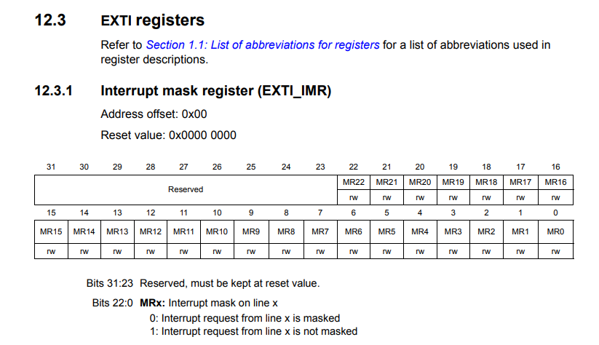

The first one is ***Interrupt mask register***. This is used to mask the interrupt. By default, its value is 0x00000000. So here, you can see that, this is actually a 32 bit long register, but only 23 bits are valid. 0 to 22. Why? Because EXTI supports 23 lines. So, each bit of this register is going to control one EXTI line. That makes sense.

For example, so the first bit controls the EXTI0 line. By using this register (***Interrupt mask register***) you mask or unmask interrupt delivery of EXTI lines. By default, this is 0. That means, *interrupt request from line x is masked*. That means, by default, EXTI lines don't poke the NVIC, they don't send any signal to the NVIC. You have to enable that using *Interrupt mask register*. You have to make this as 1, *interrupt request from line x is not masked*, then it will send signal to the NVC. And after that, we are not interested in ***Event mask register***, let's just forget it.

Let’s go to ***Rising trigger selection register***.

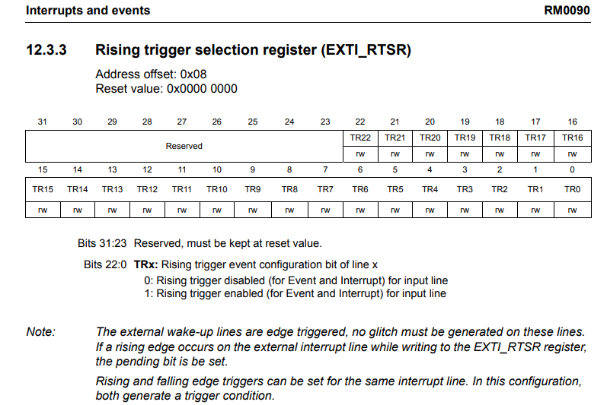

As I said, this actually controls the edge detection. If you want a ***rising edge*** to be detected, then you should configure appropriately this register. You have to choose the appropriate value here.

For example, if you want a rising edge to be detected on the *EXTI0* line, then you have to make ***TR0***, the 0th bit of this register as 1 -> *rising trigger enabled* like that.

So similarly, ***Falling trigger selection register***. And similarly ***Software interrupt event register***.

So, the next one is ***Pending register***.

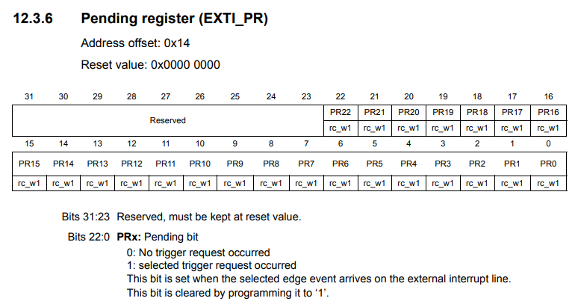

This is one of the important registers of the EXTI controller. You are going to use it in this course whenever you code for the EXTI block in future lectures. Basically, this register updates the event which takes place on the EXTI lines. *This bit is set when the selected edge event arrives on the external interrupt line*.

Remember that: *This bit is cleared by programming it to '1'*. So, you know that PA0 delivers its interrupt to the processor over EXTI0 line. Now, let's say the EXTI controller is configured for rising edge detection on this pin. And let's say, you press a button and you make a low to high transition on this button, so which is a rising edge, isn't it? Whenever the rising edge happens on the button, the EXTI controller detects it. Okay. When that detection is successful, the corresponding bit in the pending register goes high. Indicating the selected edge event has occurred on the EXTI line. When the selected edge event happens, the EXTI control makes this EXTI0 line as 1. Now, let's assume that these two lines (*EXTI0* & *EXTI Pending Register bit 0*) are connected to a simple ***OR*** gate here and when both the inputs are one and one, the output will be one, that output is actually connected to the NVIC. So, NVIC gets the signal, isn't it? So, when NVIC gets the signal interrupt is triggered. Right? CPU runs your interrupt service routine. So, now when this signal goes away EXTI controller the asserts this EXTI0 line, it makes it zero. You can see that, still this OR gate produces 1, isn't it? Because, the ***Pending register*** is still holding 1 here (*bit 0th*). It is indicating the past event. Basically, the EXTI controller doesn't clear this bit. This bit is not cleared automatically, *programmer should clear it*. And how to clear this bit is also mentioned in the ***Reference Manual***. You can see that: *This bit is cleared by programming it to '1'*.

Suppose, if this bit is set, then you have to write 1 to it, to clear it. OK, not 0 remember that's a design. To clear this bit you have to write 1.

So, once the ISR handler runs you do whatever you want to do in the ISR handler, and then clear this bit. So, *what happens if you don't clear this bit?* So, if you don't clear this bit, you can see that this OR gate produces always 1, isn't it? So, that means, this line will be high always. So, that means the processor will get continuous infinite interrupt. So, once you exit the ISR again interrupt happens and there will be spurious interrupt. So, that's why, you should clear this bit once it is set.

Now, let me demonstrate this with small example of button interrupt. Here, I have a project. So, you are not expected to understand any code here, because we have not yet explore the GPIO controllers and other programming things, those things will be covered later. Just for the demonstration purpose I'm going to show you a couple of things. This program is coded to receive the button interrupt. You can see that, there is a interrupt handler return. Look at the name of this interrupt handler: **EXTI0_IRQHandler()**.

Why? You cause the button which is there on the STM32 discovery board issues interrupt on PA0. Right? So, PA0 interrupt comes over EXTI0 line. So, that's why, I have to write **EXTI0_IRQHandler()**. If you are wondering how did I get this name. It's very simple. You can go to your startup file here and you can browse through this and you get the name here. For example, here it is **EXTI0_IRQHandler()**. You actually see a dummy implementation of this **EXTI0_IRQHandler()** here. This is a dummy implementation, which is attributed as **weak**, so I'm just overriding this dummy implementation of this ISR in my code.

So, whenever the button interrupt happens, the control will come to this point. So, I'm going to keep a breakpoint here. And I'm going to the debug mode here and I'm going to hit run. Code is running. By suspend this execution you can see that the code is in the while loop. Code is running now. I'm going to press the button on my board and you can see that the interrupt is triggered and the processor jumped to my IRQHandler, isn't it?

Here, let's examine this register: ***EXTI_PR***.



How do you get the address of this register? So, you have to add this ***offset 0x14*** to the ***base address*** of the EXTI peripheral, isn't it? You have to add this offset to the base address of the EXTI controller register.

For that, let's go to the ***Memory Map***.

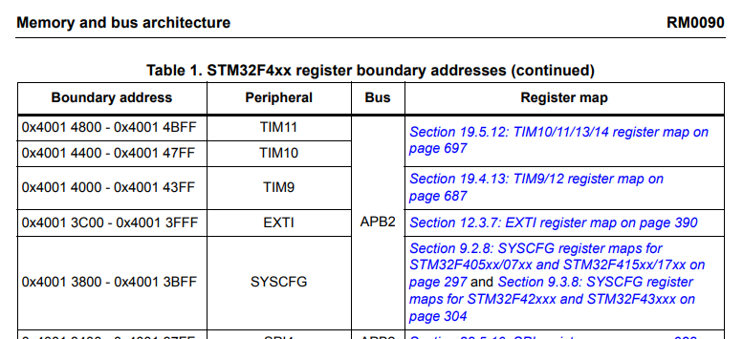

In a ***Memory Map***, you can see that, so ***EXTI controller*** is hanging to the ***APB2 Bus*** you can see that. EXTI controller is connected to the APB2 bus. This is a base address of EXTI registers: ***0x4001 3C00***.

Let's check this register. I'm going to copy this. And let's go to the *Memory Browser* and let's paste here. And for that, let's add this offset. Because, we are going to check this pending register plus 0x14. Right? here it is. Now you see here, the 0th bit is set, because the selected event has happened on that line. Once a selected event has happened, the interrupt triggers, as you can see here we are in the interrupt handler, and I'm going to do some work here. And before leaving the interrupt handler you have to clear this bit by writing 1 to this position. This is actually the address of the pending. Once I do that, I'm going to do a step over. Right? Here it is.

This code has cleared that bit.

Sostanzialmente, il bit 0 di quel registro (**EXTI_PR -> PR0**), dopo che viene premuto il pulsante, diventa 1. Ma per cancellare tale bit e portarlo a 0, tramite il codice non bisogna inserire uno 0 in quel bit, ma bisogna inserire 1 e in automatico quel bit verrà riportato a 0. È una cosa senza senso perché sto inserendo ***1*** in un bit che è già ad ***1*** con l’obiettivo di portarlo a ***0***, ma funziona così e nell’esempio lo fa vedere bene.

So now, everything is normal. The interrupt has exited and there are no more interrupt. If we don't clear this bit, then as I said, there will be continuous interrupts will be delivered to the NVC, then the processor will keep on a triggering this ISR execution. So, I hope you got little idea about how the GPIOs deliver their interrupt to the processor. In between there is a EXTI controller and all these points are required later in this course when you write your own ***GPIO interrupt APIs***. With that note, I would like to end this discussion on interrupts and we will surely see some more points when we code for our ***driver APIs***. Let me know if you have any questions and I'll see you in the next lecture.

# Sezione 13: Importance of “Volatile” keyword

## 46. Importance of “Volatile” keyword: Part 1

Consideriamo questo codice molto semplice:

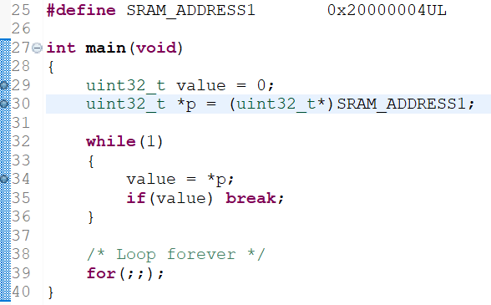

Vediamo adesso la differenza che c’è dal punto di vista dell’***assembly code*** che si ottiene con 2 differenti livelli di ***ottimizzazione di compilazione (build optimization)***:

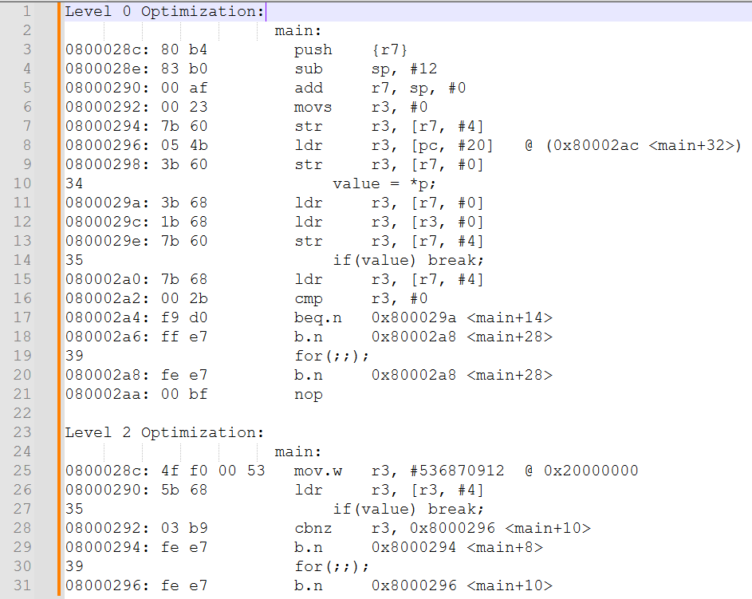

Da questa immagine possiamo notare come l’***assembly code*** che si ottiene con un ***level 2 optimization*** sia molto più piccolo rispetto all’***assembly code*** che si ottiene con un ***level 0 optimization.***

Quindi, con un ***level 2***, il compilatore comprime in un’unica riga di codice più istruzioni in modo tale da risparmiare memoria sulla ***flash memory***.

Vi è però un problema, ossia che adesso lo stesso codice non si comporta nello stesso modo in cui si comportava quando abbiamo effettuato il debug dopo aver effettuato una *build* con un ***level 0***.

Infatti, in questo caso, anche se modifico il valore salvato all’interno del *memory address* ***0x2000 0004***, il programma non esce dal *while loop* come invece aveva fatto nel caso del ***level 0***.

Perciò, il programma non si comporta in maniera corretta, e per sistemare questo *bug* bisogna utilizzare la *keyword* ***volatile*** che vedremo nella lezione successiva.

## 47. Importance of “Volatile” keyword: Part 2

Il problema evidenziato nella lezione precedente avviene in quanto quando viene eseguita la riga di codice utilizzata per assegnare alla variabile ***value*** il valore che si trova nel *memory address 0x20000004* a cui sta puntando il puntatore ***p***, tale valore viene salvato nel ***registro r3***. Lo si può vedere anche dall’***assembly code*** del ***level 2 optimization***.

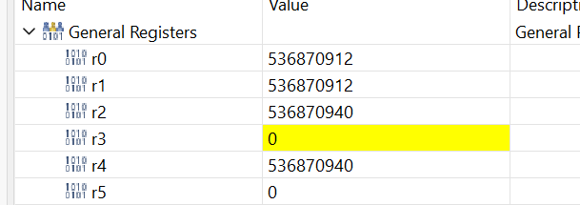

Guardiamo adesso l’*assembly code* del ***level 0***:

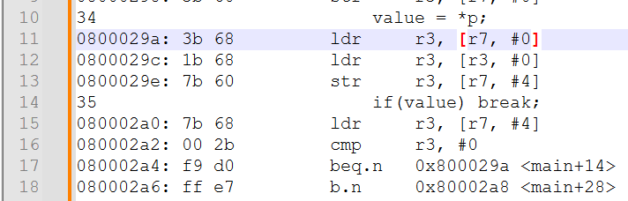

Da qui possiamo vedere che all’interno del codice relativo all’***if(value) break***, il codice esegue un salto al *memory address* ***0x0800 029a***, il quale corrisponde all’istruzione che riassegna ***value = *p***. Di conseguenza, quando andiamo a cambiare il valore al *memory address 0x20000004*, si ha che successivamente la variabile ***value*** viene ricalcolata assegnandole il valore di ***\*p***.

Nell’*assembly code* del ***level 2***, invece, questo salto non avviene, o meglio, il salto avviene andando però a rieseguire la riga di codice ***if(value) break;***, di conseguenza, anche se cambiamo il valore presente al *memory address 0x20000004*, la variabile ***value*** non viene più aggiornata in quanto non viene rieseguita la riga di codice ***value = *p***, per questo motivo non si esce dal *while loop*:

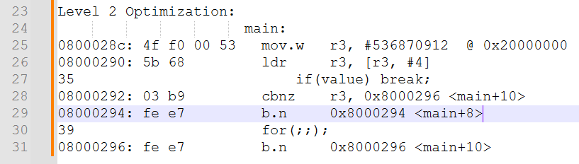

Possiamo infatti notare come il *jump* avviene andando a puntare nuovamente alla riga di codice al *memory address 0x0800 0294,* di conseguenza il valore presente nel registro ***r3*** non viene aggiornato in quanto non viene rieseguita l’istruzione evidenziata in *verde*.

Questo avviene a causa dell’***ottimizzazione*** effettuata dal ***compilatore***, in quanto il compilatore cerca di ottimizzare il nostro codice evitando di effettuare continue *read* della *memoria*, in quanto le operazioni di ***memory reading*** richiedono molti ***clock cycles*** e sono abbastanza lente, di conseguenza rallentano il programma (es. In *Custom* evitavo di effettuare continue ***read*** nella ***flash memory*** della *memoria fiscale* ma effettuavo delle *read* di variabili salvate in *RAM* che contenevano lo stesso valore che doveva essere salvato nella ***flash***).

Da questo esempio possiamo quindi capire che i ***data registers*** in applicazioni *embedded* devono essere continuamente aggiornati in quanto vi sono delle *addess location* che sono *altamente* *volatili*, ossia i valori in essi salvati possono cambiare a *runtime* in quanto potrebbero esserci ad es. delle *periferiche* che vanno a scrivere dei nuovi valori in quei *memory address*.

Perciò, il contenuto di questi ***data registers*** può cambiare in qualsiasi momento durante l’esecuzione dell’applicazione. Per questo motivo gli ***address*** di questi ***data registers*** devono essere trattati come ***volatili*** in natura.

*Come si risolve questo problema?*

Bisogna dire al compilatore che il puntatore ***p*** è ***volatile***, in modo tale da dirgli che il contenuto di quel *memory address* può cambiare in qualsiasi momento.

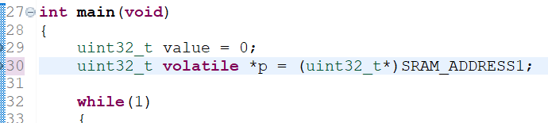

Una volta compilato il codice, effettuato il download del FW e andati in debug, otteniamo quindi il nuovo ***assembly code***:

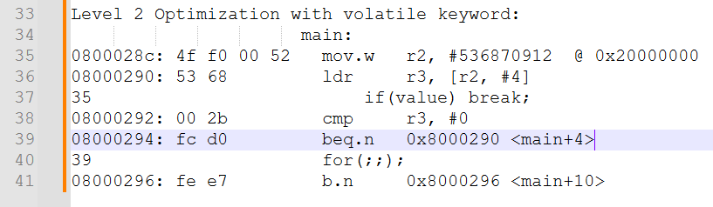

Possiamo quindi notare come adesso avvenga il *jump* al *memory address* ***0x0800 0290*** in cui effettivamente viene rieseguita l’assegnazione ***value = *p***.

Adesso, se a *runtime* andiamo a cambiare il valore presente al *memory address 0x2000 0004* avremo che il codice funzionerà correttamente e che uscirà dal *while loop*.

Questo in quanto viene aggiornato il valore presente nel registro ***r3***, ossia il valore della variabile ***value***.

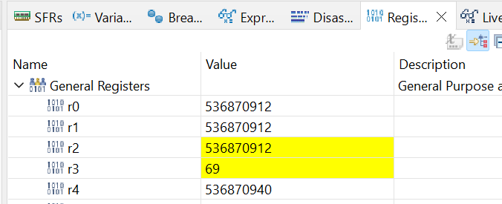

Quindi, quando stiamo maneggiando direttamente delle ***memory locations***, per operazioni di *read / write*, è sempre meglio utilizzare la *keyword* ***volatile*** nella dichiarazione dei ***pointer*** utilizzati per accedere a quelle *memory locations*, in modo tale da evitare questi possibili problemi che si potrebbero avere utilizzando una ***compilazione ottimizzata***.

La *keyword* ***volatile*** può essere utilizzata anche con le normali *variabili*, e non solo con i *pointer*.

# Sezione 14: GPIO must know concepts

## 48. GPIO pin and GPIO port

When getting started in embedded programming, ***GPIO pins*** which stand for ***General Purpose Input Output*** are one of the first things played with. It's also quite evident that the most popular *“Hello World”* program in embedded system programming is *Blinking*, that is a LED connected to pin onthe microcontroller that keeps blinking.

The use of GPIO is not limited to driving LEDs, but can be also used for:

* reading digital signals
* generating triggers for external components
* issuing interrupts
* waking up the processor
* ecc…

In this section, let's begin with some of the must known concepts of GPIOs. These concepts are generic and can be applied to whatever micro-controller you have at your hand.

A ***GPIO Port*** is a collection of some fixed numbers of ***I/O pins***, which are analogous to a seaport which is having few boats. In this figure, you can see that GPIO port A is a collection of 16 I/O pins.

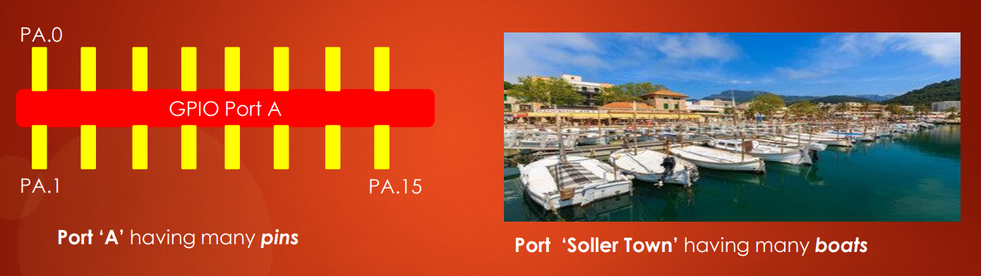

We can say that GPIO port A is 16 bit wide and each *pin* refers to a corresponding *bit* of the *GPIO port registers*.

GPIO port of different microcontrollers may have a different number of pins.

For example, 8051 based microcontroller supports port of 8 I/O pins. In the case of LPC2148 NXP micro-controller support GPIO port of 32 I/O pins. STM32F4xx based microcontrollers support GPIO port of 16 I/O pins.

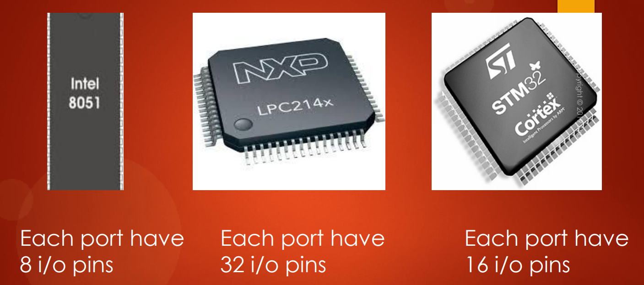

## 49. GPIO behind the scenes

Now, let's understand behind the scenes working of a GPIO pin. Have you ever wondered, how does a GPIO pin is implemented inside the microcontroller?

You might have seen a GPIO pin on the micro-controller or on the development board. But let me explain in a simple way how it's implemented inside to the microcontroller.

This is how ***GPIO pin*** looks like behind the scenes.

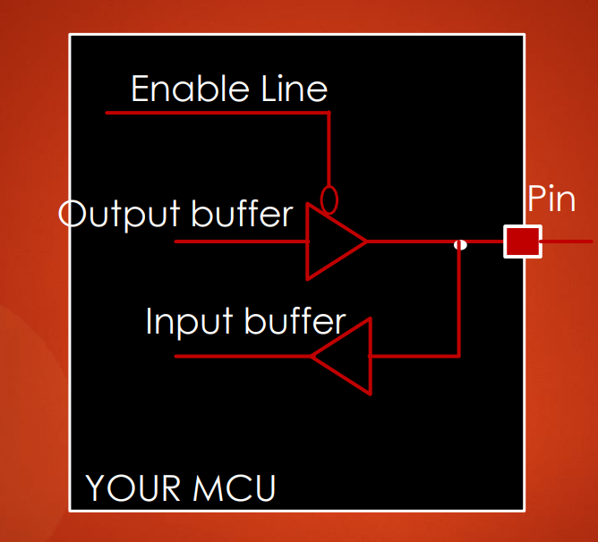

There are usually 2 buffers: one is ***output buffer,*** and another one is ***input buffer***, along with the ***enable line***.

### GPIO pin: output mode

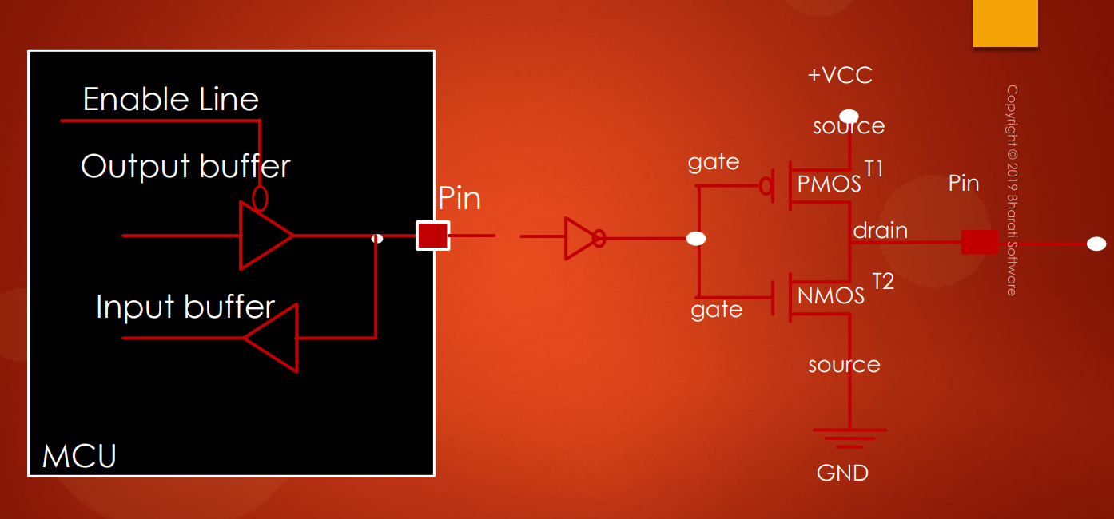

NOT

0

1

= 0

Pulled to high (1)



When the ***enable line*** ***= 0***, the *output buffer* will get *activated* and *input buffer* will get *deactivated*, therefore we are working with a *pin* in ***output mode***.

If you are wondering what a *buffer* is, it is nothing but 2 *CMOS transistors* connected in this fashion. The top one is called a ***PMOS transistor*** and the bottom one is ***NMOS***.

Quindi, tutto il circuito sulla destra non è altro che l’***output buffer***.

So, when you want to write 1 to this pin, which actually feed 0 to this transistors, because of this *inverter* logic (*NOT*), *T1* will get *activated* and *T2* gets *deactivated* and you get 1 on this microcontroller pin.

Questo penso avvenga in quanto attivando il ***PMOS*** stiamo chiudendo il circuito e stiamo facendo passare la tensione grazie al ***+Vcc***.

Inoltre, il pallino sul morsetto del *T1* identifica un *NOT*, mentre il *T2* non ha tale pallino quindi prende in input il segnale logico così com’è.

So similarly, if you want to write 0 to this pin, then *T2* gets *activated* and *T1* will get *deactivated* and your pin will be *pulled to the ground* which gives out 0 onto the *pin*.

Questo avviene, invece, in quanto stiamo chiudendo il circuito con il ***GND*** e quindi non abbiamo tensione, di conseguenza otteniamo 0 in output sul pin.

That's how the ***output buffer*** of a GPIO works.

### GPIO pin: input mode

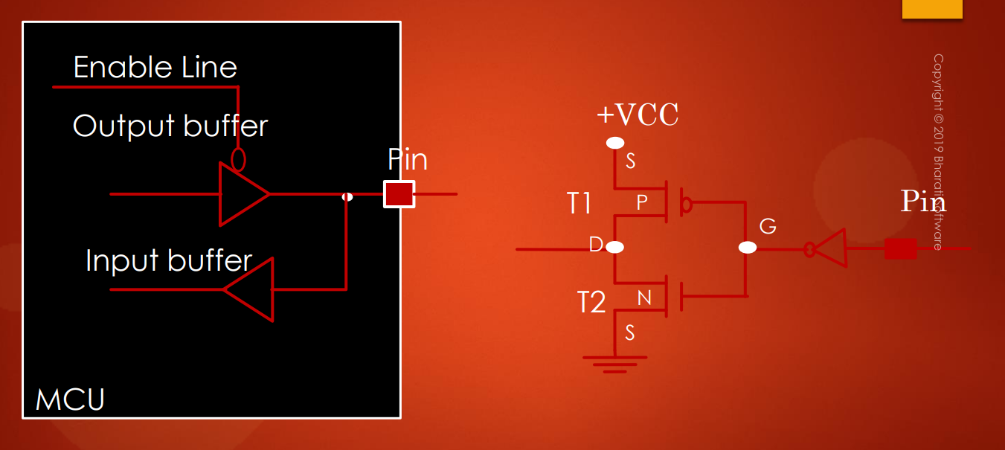



= 1

On the other hand, if you make ***enable line = 1*** then you are making a pin to work in ***input mode*** by *activating* the *input buffer* and *deactivating* the *output buffer*. The *input buffer* is nothing but a rotation of an *output buffer* of 180 degrees. Isn't it? So, let's see how input mode works.

Infatti, il circuito che rappresenta l’***input buffer*** non è altro che lo stesso circuito che rappresentava l’***output buffer*** MA ruotato di 180°.

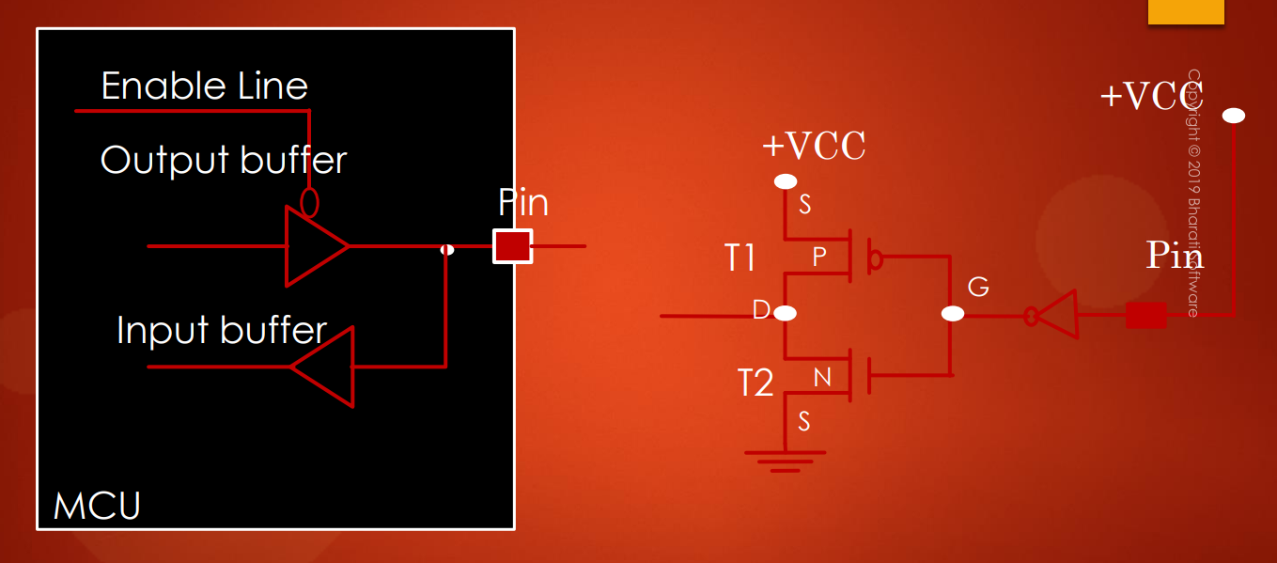

1

NOT

1

0



When the pin is driven to *higher voltage* (+*Vcc* sulla dx), *T1* will be *ON* and *T2* will be *OFF*. So, you read 1 on this pin (*freccia gialla*).

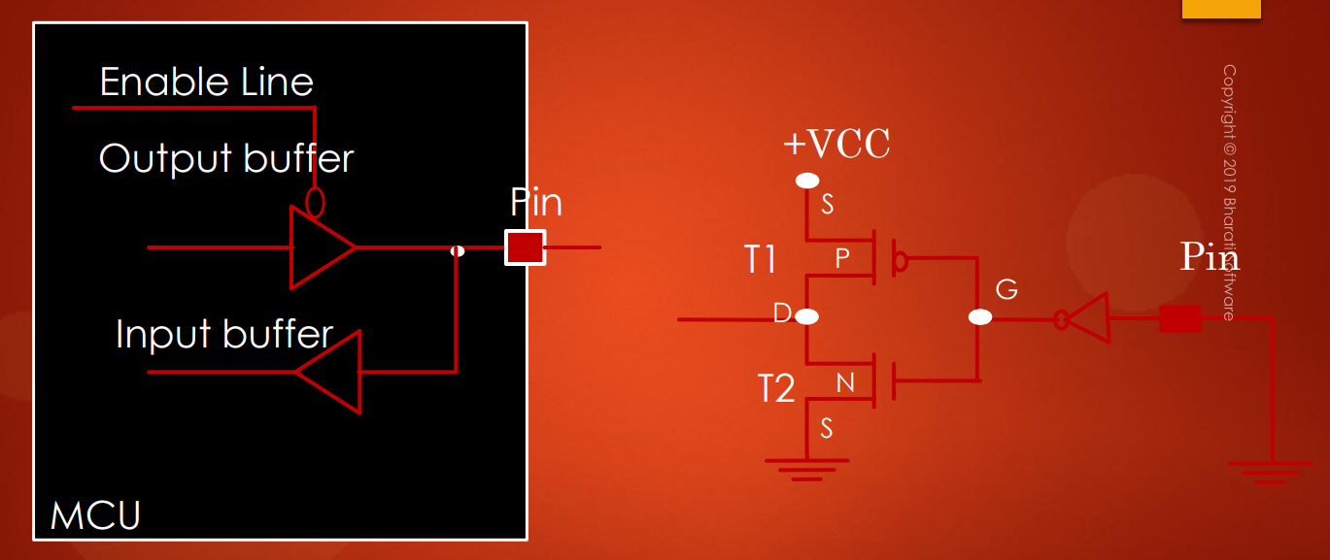

0

NOT

0

1

GND



And when the pin is driven to *low* (*to the GND*), *T1* turns *OFF* and T2 conducts because of that you will read ***low*** (***0***) on this pin.

Great!! That's how the ***input*** and ***output mode*** of a ***GPIO pin*** works behind the scenes by using respective *buffer logic* along with its *enable line*.

This ***enable line*** is usually configured by your ***GPIO control registers***, which you will see in the later lectures.

## 50. GPIO input mode with high impedance state

***GPIO input mode*** with ***high impedance state***.

Let's understand, what exactly is this ***high impedance state***, that people talk about when the pin is in ***input mode***.

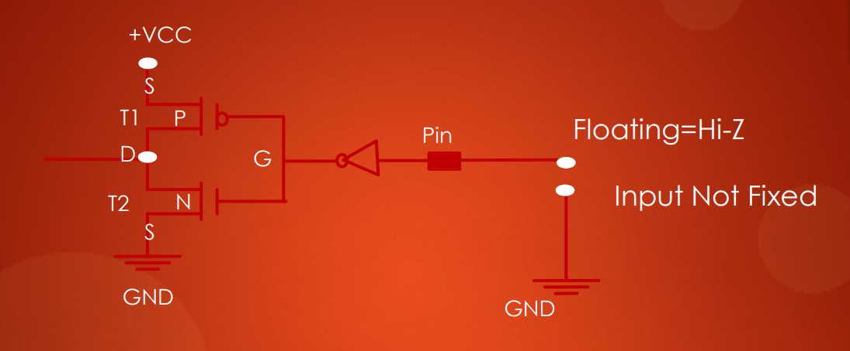

***High impedance*** is also called as ***Hi-Z state***.

***Hi-Z state*** of an ***I/O pin*** is keeping pin ***floating*** by not connecting to either high voltage or to the ground. So, that is why this is also called a ***floating state***.

Remember after you power up the MCU, by ***default***, all the *GPIO pins* will be in ***input mode*** with *HIGH-Z state* or ***floating state***. This is true with almost all microcontrollers.

Keeping a pin in *floating state* can lead to ***leakage current*** which may lead to ***higher power consumption***. This is because a ***floating pin*** is highly susceptible in picking up ***circuit voltage noise*** and may result in *leakage current*.

In the coming lectures we will explore how a floating pin may lead to leakage current!!

## 51. GPIO input mode with pull-up/down state

***GPIO input mode*** with ***pull up/pull down*** state.

OK. Let's understand GPIO pin in ***input mode*** with ***external*** or ***internal pull up/pull down resistor*** activated.

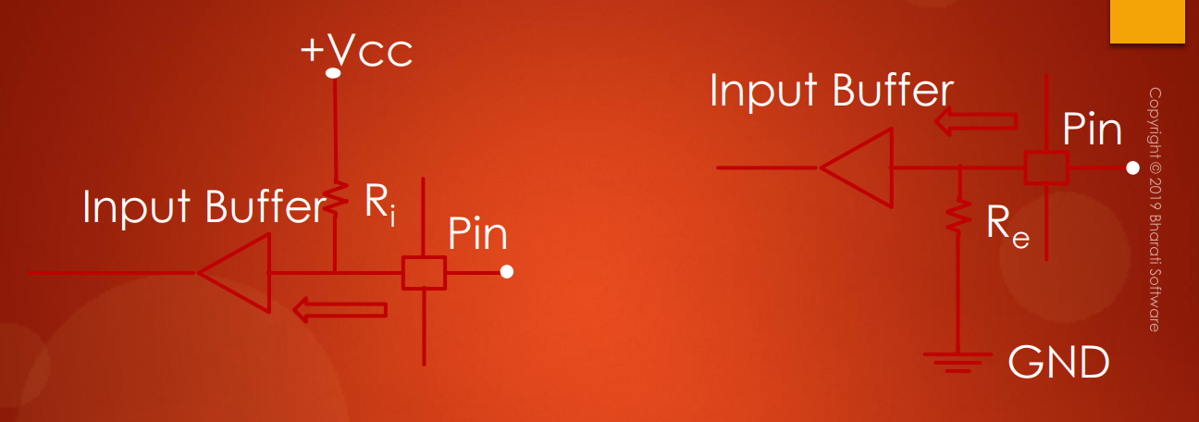

Here you can see, it's a simple circuit in which the *floating state* is avoided by introducing or activating an ***internal*** ***pull up*** or ***pull down*** ***resistor***.

In the first figure (*left*), you can see internal ***pull up resistor Ri*** is activated, which drives pin to the high voltage *+VCC*.

In the second figure (*right*) we can see the internal ***pull down resistor Re*** is activated, which pulls the pin to the ground. If you are wondering how to activate internal pull up or pull down resistor, please remember that there are ***configuration registers*** for every ***GPIO port*** which enables you to handle internal pull up or pull down resistors.

***N.B.*** It is always safe to keep the *unused GPIO pin* in one of these states so that they are reluctant to voltage fluctuations which may lead to leakage of current.

## 52. GPIO output mode with open drain state

So, now let's understand the ***GPIO output mode*** with ***open-drain*** output configuration.

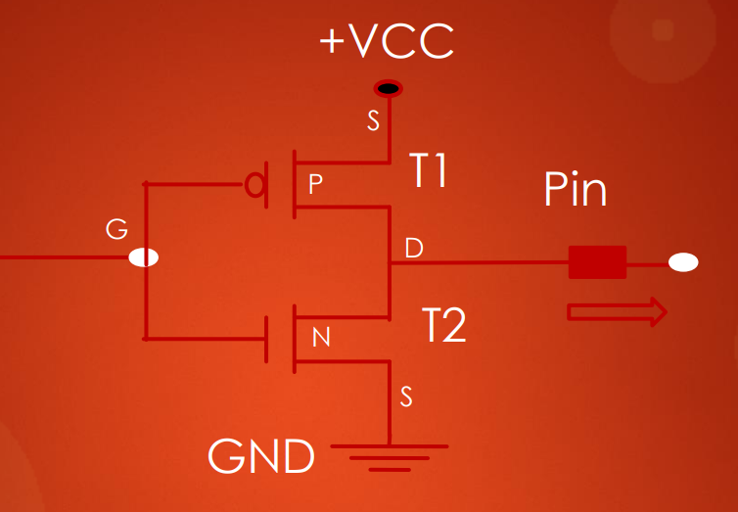 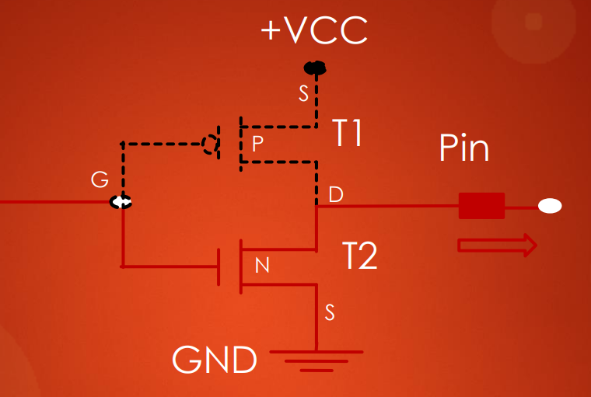

**ON**

As you know when the GPIO is in ***output mode*** it looks something like this. ***Open-drain*** output configuration is nothing but this top ***PMOS transistor T1*** is ***deactivated***, it is simply **not present**. So, what do you left with these, just a single NMOS transistor *T2*.

When the transistor *T2* is switched ON, the pin is pulled to ground.



floating

**OFF**

And when this transistor *T2* is OFF, the drain of the transistor will be *open*, hence the output will be *floating* (***D***). That's the reason it is called ***open-drain***. So, as a result ***open drain output configuration*** can only ***pull down*** the pin, but it lacks *pulling up* capability.

That means it has 2 state:

1. ground (GND)
2. float: which is absolutely useless.

The ***open drain output*** is useless until you provide the ***pull up*** *capability*. By introducing using ***pull-up resistor*** by either activating an *internal pull up* or *external pull up resistor*. So, without the *pull up resistor* applied to *open drain* this mode is completely useless.

***Pull-up resistor -> Vcc + R***

So, that leads to our next discussion that is ***open-drain*** with ***pull up resistor***.

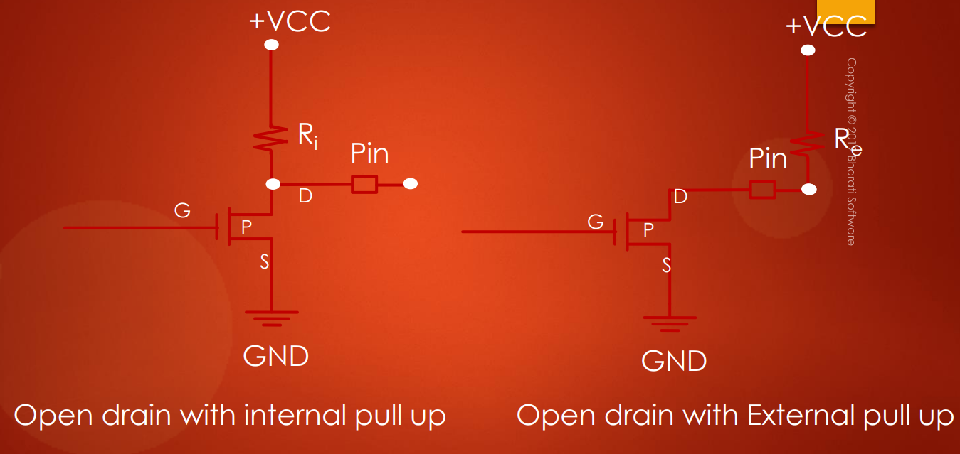

Output buffer

Output buffer

Here you can see, it's actually an ***open drain pin with the internal pull up*** activated. Similarly, this figure shows an ***open drain output with external pullup*** connected.

***Open-drain ->*** non è presente il ***PMOS Transistor (T1)***

***Internal pull-up resistor -> internal*** in quanto il *pull-up resistor* è interno al circuito dell’***output buffer***

***External pull-up resistor -> external*** in quanto il *pull-up resistor* è esterno al circuito dell’***output buffer***

So, what I want to convey from this discussion is that to make use of *open drain* in a real world application, it has to be used along with either *internal pull up* or *external pull up resistor*.

These days almost all MCU support ***internal pull up resistors*** for every *GPIO pin*. So, you just need to use the ***GPIO configuration register*** to activate or deactivate them. If your MCU doesn't support internal pull up which is most unlikely for modern MCUs, then you may think of adding an *external pull up resistor* by your hand.

Now, let's see some of the practical usage of ***open drain mode***. Let's see, how to drive an LED from GPIO which is in ***open drain output mode***. Here, you have a GPIO pin with ***open drain*** configuration.

In order to drive an LED, first activate the *internal pull up resistor,* then connect the LED to the pin.

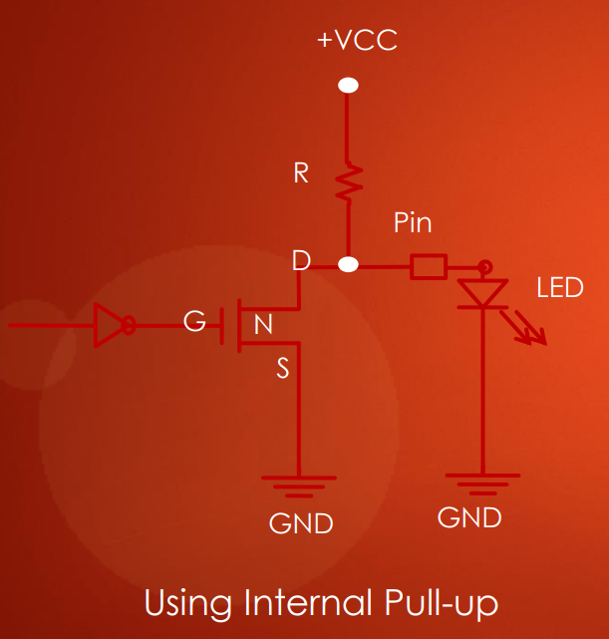 

OFF



ON

1

0

NOT

1

0



So, when you want to turn *ON* the LED you write 1 to this input, which is inverted to 0 and this transistor will be turned OFF (*X gialla*). When this transistor is turned OFF, LED will be driven to *Vcc* by this ***internal pull up resistor***. So, it will turn ON the LED.

On the other hand, if you want to turn OFF the LED, you write 0 to this input as a result this transistor will be ON, which actually drives your LED to the ground (*left GND*) as a result LED will be turned *off*.

Remember here that the value of the ***internal pull up resistor R*** is fixed. The internal pull up resistor will be in the range of 10 kOhms to 50 kOhms which is reasonably sufficient for most of the applications. To know what is the value of internal pull up resistor, please go through the *Datasheet* of your MCU.

So, here we have another circuit which is very similar to the first one.

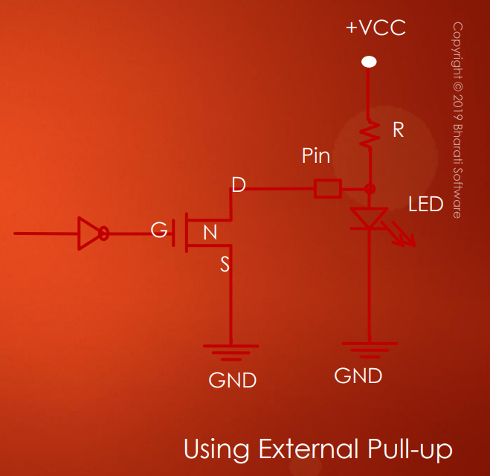

The only difference is instead of using the *internal pull up resistor*, we have used an ***external pull-up resistor*** along with the LED. All right. This is how you drive a LED when your GPIO pin is in ***output mode*** with ***open drain*** configuration.

Let's see, another practical use of an open drain which you might have used already either knowingly or unknowingly. Whenever you used a ***I2C bus***.

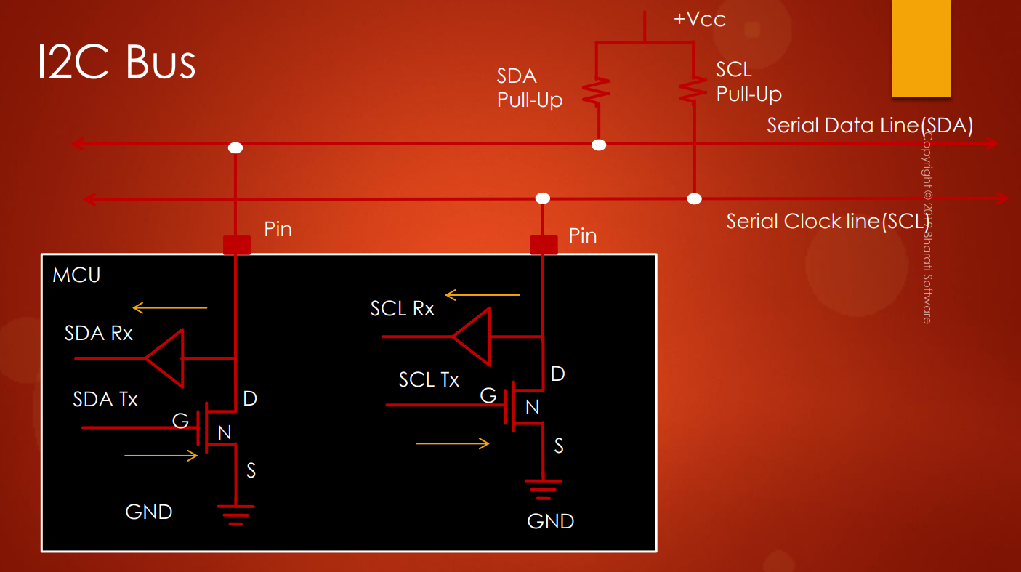

external

SCL

SDA

The ***Serial Data*** pin (***SDA***) and ***Serial Clock*** pin (***SCL***) of a ***I2C peripheral*** in a micro-controller are basically in ***open drain*** *configuration*. In order to use the bus properly you have to provide *pull up resistor* for each pin either internally or externally. In this case, you can see we have used an ***external pull up resistor***.

Infatti, il *pull-up resistor* è direttamente collegato al *pin* al di fuori dell’*output buffer*, di conseguenza è un ***external pull-up resistor.***

You can also simply activate the *internal pull-up resistor* inside the MCU for these 2 pins and make your life easier instead of adding external pull up resistor by your hand.

The correct value of pull-up resistors for the I2C bus depends on the total capacitance on the bus and the frequency at which the bus works. You may explore more about how to find out the exact value of pull up resistors by taking into consideration of I2C bus speed, capacitance etc.., but generally resistor value in the range of 4.7 kOhms to 10 kOhms works.

## 53. GPIO output mode with push-pull state

***GPIO output mode*** with ***push-pull*** state.

All right. Let's understand ***GPIO output mode*** with a ***push-pull configuration***.

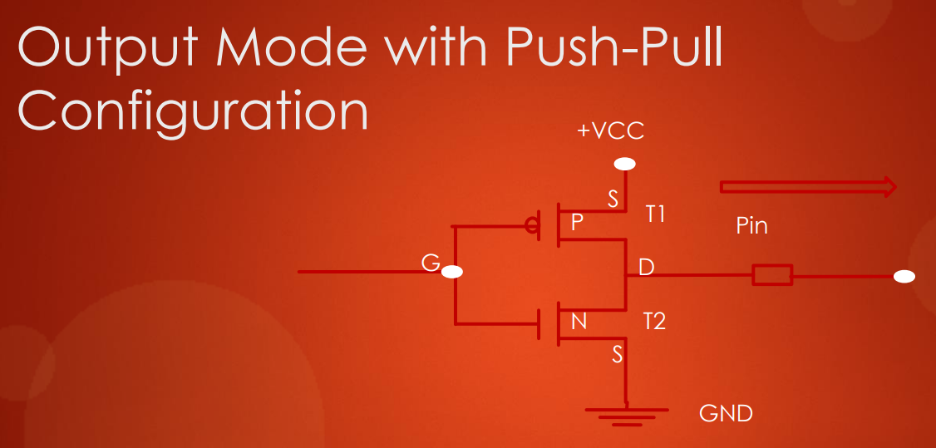

This is the ***default configuration*** of any GPIO pin when you configure the pin for ***output mode***.

Remember when you enable a GPIO port by default, its pins will be in ***input mode***. But if you configure any pin as the ***output mode***, then by default it will be in ***push-pull configuration*** which looks something like this.

This *output configuration* is called a ***push-pull***, because the output will be pulled actively between high and low by using these 2 transistors unlike (*T1* & *T2*).

Other configurations such as ***open-drain configuration***, where the output can be pulled only to low (*GND*) as you saw in the earlier video.

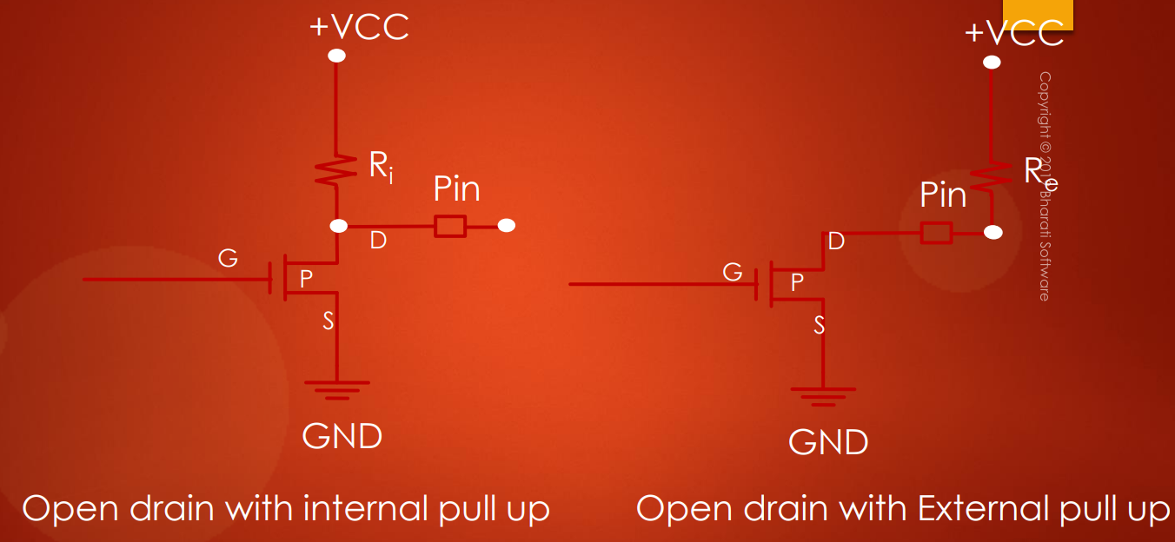

In order to pull the output high (1) in the *open-drain* configuration you need a pull up resistor, otherwise pin will be *floating*. Right?

But, in the ***push-pull configuration*** you don't need any ***pull-up*** or ***pull-down resistor***!

***Push-pull output*** actually uses 2 transistors: each will be on to drive the output to the appropriate level. The top transistor (*T1 – PMOS*) will be ON when the output has to be driven *high* (1)!

And the bottom transistor (*T2 – NMOS*)will be turn ON, when the output has to go *low* (0).

OK. Now, let's see how you can drive an LED from a ***push-pull output configuration***

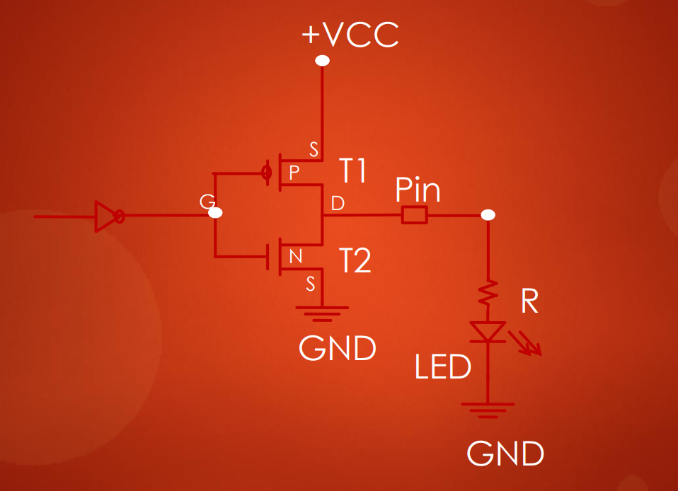



NOT

0

1

The first thing you should notice here is that there is ***no pull-up resistors***. The LED is simply connected to the pin via the ***current limiting resistor R***. This resistor is just used to limit the current which flows across this LED, so that you don't burn out the LED.

So, when I write 1 to the input over here, the top transistor *T1* will be ON and the pin will be pulled to high (1) and the LED will be *forward biased* which makes it to glow, so LED turns ON.





0

1



NOT

On the other hand, when I write to 0, the top transistor T1 will be turned OFF and the bottom one T2 will be turned ON, which pulls the pin to the ground. As a result, LED will be turned OFF (*LED reverse biased*).

This is how the ***push-pull configuration*** actually works.

Quindi:

* **pin output mode**: può essere in 2 configurazioni:
  + **push-pull configuration**: default
  + **open-drain**: non vi è il transistor T1, quindi vi è la necessità di:
    - **internal pull-up resistor**
    - **external pull-up resistor**
* **pin input mode**: di default è in una configurazione:
  + **floating-state**: default, di conseguenza vi è bisogno di:
    - **internal pull-up resistor**
    - **internal pull-down resistor**

## 54. Optimizing I/O power consumption

As I previously mentioned, if an ***input pin*** is ***floating*** it may result in ***leakage current*** from *Vcc* to the ground. In this video, let's see how that could happen.

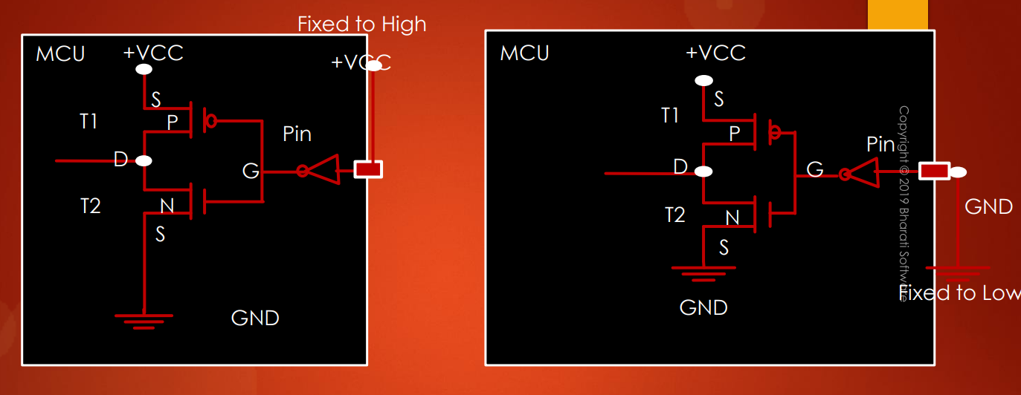



1

0

0

1



First, let's take the case of ***input pin*** which is *not floating*, but ***fixed to VCC*** (*left case*) or ***ground state*** (*right case*). And this is our input buffer circuitry inside the MCU.

***Fixed to Vcc*** *(left)*: when the pin is driven to High voltage, at this point (***G***) its low due to the *inverter*, as a result of that T1 is ON and T2 is OFF. Hence, there is no path for the current to reach the ground. So, in this case *leakage* will not happen, since the current never leaks out from +Vcc to the ground.

***Fixed to GND*** (*right*): in this case when the pin is fixed the low voltage, T1 is OFF and T2 is ON and still current from Vcc cannot able to reach the ground. So, in this case also there is no *leakage*.

Let's come to the ***floating state***.

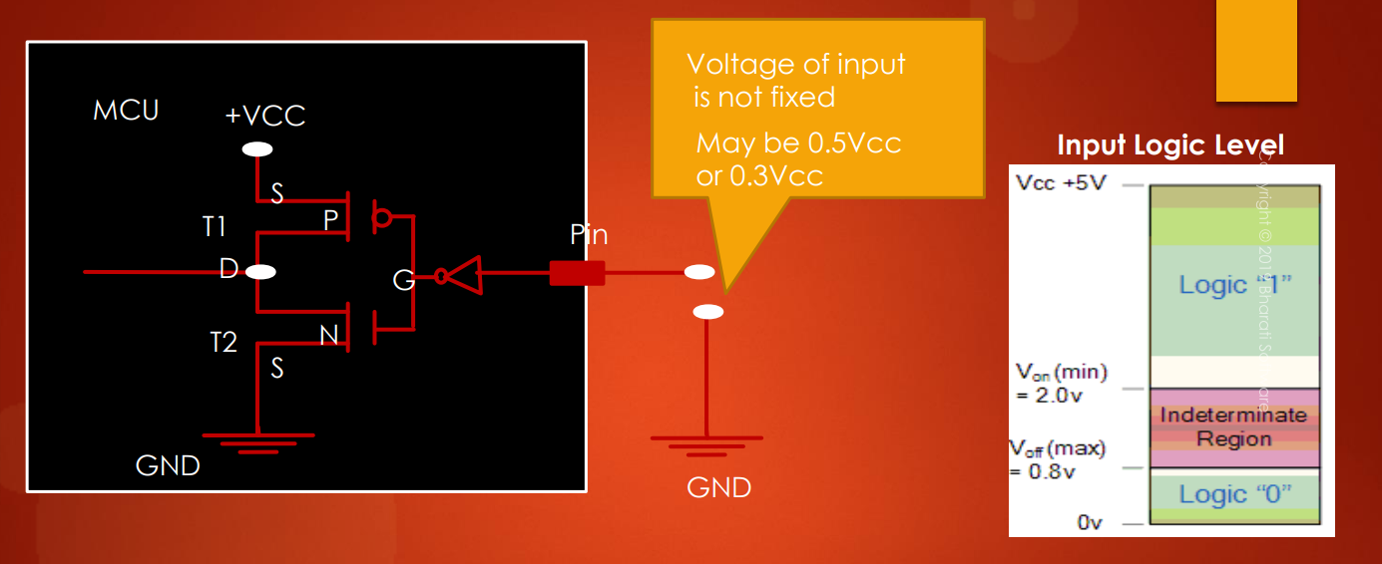



In this case, the *pin input voltage* *is not fixed*. So, due to the ***circuit voltage noise*** what actually happens is that the *input voltage* may toggle between 50% or 70% of the Vcc, to say 30% of the Vcc. That means the voltage on this pin will be somewhere in this region (***Indeterminate region***). Which actually turns ON both the transistors with resistance. So, as a results, small amount of current will sink into the ground taking this path (from Vcc to the GND).

Let's understand this with the tap analogy. Look at this tap analogy.

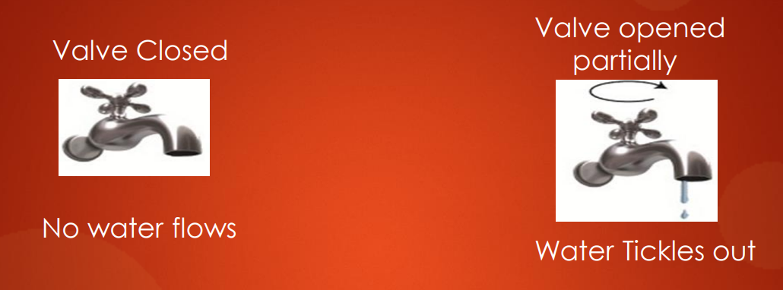

Here the valve is completely closed, so no water leaks. That corresponds to the input which is fixed high or which is fixed to low. Which turns off either one of the transistors completely as a result no leakage.

Look at this valve on the right: water leaks, because, a valve is partially closed, this corresponds to the ***floating input***, which picks up random voltage which turns ON both transistor with the resistance. As a result there will be a small amount of current which leaks from Vcc to the ground.

But all modern microcontroller ***input buffers*** use a ***Schmitt trigger*** to combat the *noise* issues!! If you are really interested you can go through the Schmitt trigger concepts but believe me, for software developers skipping that would be perfectly fine. Grate!! In the next videos will learn about GPIO configuration registers one by one.

# Sezione 15: GPIO Programming structure and registers

## 55. GPIO programming structure

GPIO programming structure.

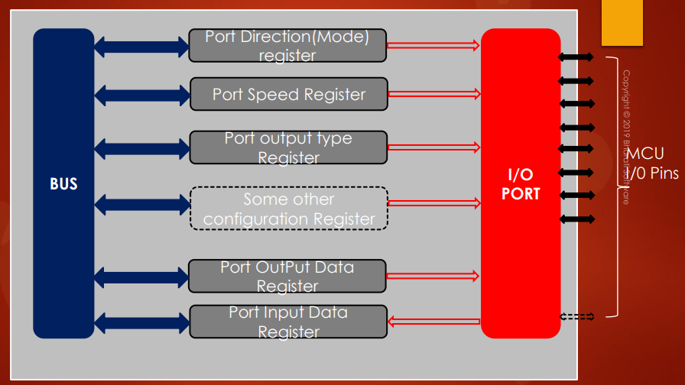

Remember each ***GPIO Port*** is governed by many ***registers*** as shown in the figure here. These registers may vary depending upon the vendor who designs the microcontroller. Generally, in the microcontroller a GPIO port is governed by these registers.

The minimum set of registers which you find in any microcontroller is ***Port Direction register*** which is also called a ***Mode register***.

***Mode register:*** by using this register you can set the direction or mode as an *input*, *output*, *analog* etc...

***Input data register***: it is used to read from a GPIO port.

***Output data register***: it is used to write to a GPIO port.

In STM32F4xx series of microcontrollers, each GPIO port is governed by many configuration registers.

Let me quickly take you to the ***Reference Manual*** of the micro-controller STM32F407x and show it to you. In my micro-controller, which comes under STM32F407xx series, the GPIO port is governed by these many registers: GPIO port mode registers, GPIO port output type register, GPIO port output speed register, GPIO port pull-up/pull-down register, GPIO port input data register and many.

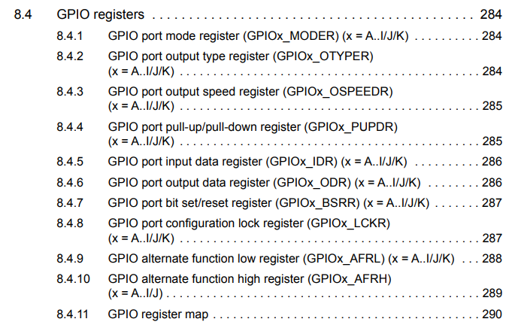

Don't worry about all these registers for now. In the coming videos I will walk you through them one by one. And note that all these GPIO registers are connected over a ***system bus*** (***AHB1 bus***) to the processor (vedi imagine di inizio paragrafo).

If you open the ***Datasheet*** of STM32F4xx microcontroller, then you can see that all these GPIO ports are connected to the processor over ***AHB1 bus***.

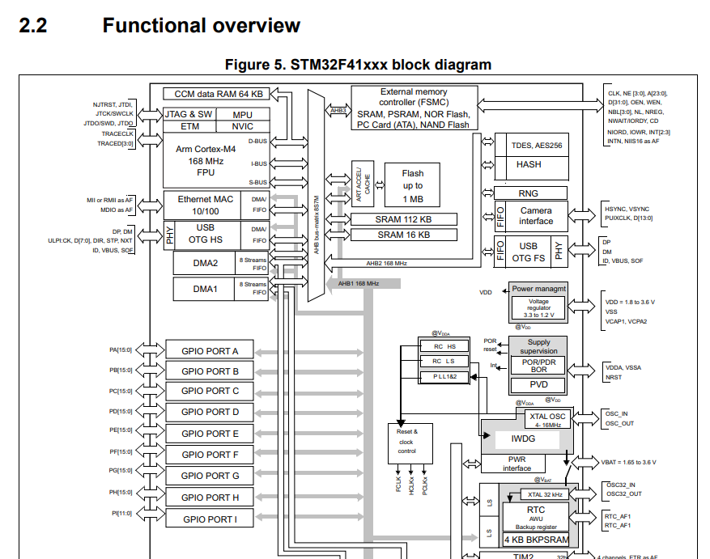

AHB1 is a main system bus which can operate at maximum of 168MHz clock speed. So this bus is AHB1, each of this GPIO ports has all those configuration register which I have just shown to you.

## 56. Exploring GPIO Port and pins of STM32F4xx Discovery Board

The STM32F407VG microcontroller supports up to ***9 GPIO ports***, which is ***GPIOA*** to ***GPIOI***. And each GPIO port is a group of ***16 GPIO pins***. Each port will have its own set of *configuration registers*, which we just saw in the earlier video.

So, totally, the MCU supports ***144 general purpose input/output pins*** (***GPIO pins***).

But on the *development board* the manufacturer has brought out ***5 ports***: ***GPIOA*** to ***GPIOE***. So, totally ***80 pins*** are available. So, in this board, on these 2 headers, 80 GPIO pins are available, which can be used for a wide range of applications.

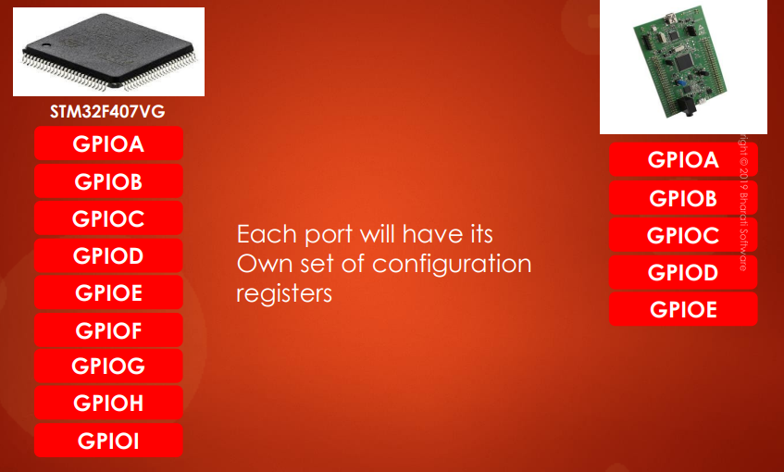

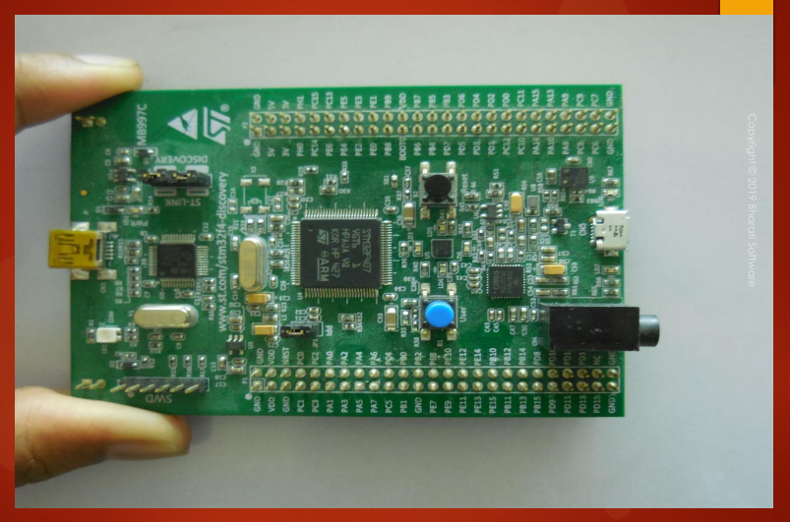

## 57. GPIO Mode register (used to set mode for a pin)

Hey, welcome back to the lecture. In this lecture, let's get started with the register sets of the *GPIO peripheral*. For that, I'll be using the ***Reference Manual*** of the microcontroller. So, if you have the *Reference Manual*, just open it according to your microcontroller and I'll be using the reference manual which is related to my microcontroller, that is 407x. And remember that the register details you should understand from the ***Reference Manual***, not from the ***Datasheet***. So, the Reference Manual is helpful in understanding various bit fields of the register. Because, only when you know the register details, you will get the idea of how to control the peripheral.

If you go to the different sections of this Reference Manual, you will find sections related to each peripheral, right?

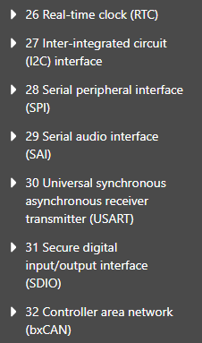

Suppose, if I go to the *RTC section*, if you just expand this section, at the end you will find the register sets. So, it is common for all the peripherals.

For example, if I go to GPIO section, it is right here and if I open that you can see that the last subsection in that section is GPIO registers.

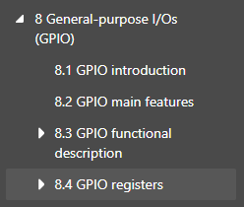

And if you open that, you will find various register details described for that peripheral. And if you again expand this section, at the end, you will get the ***GPIO register map***:

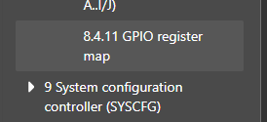

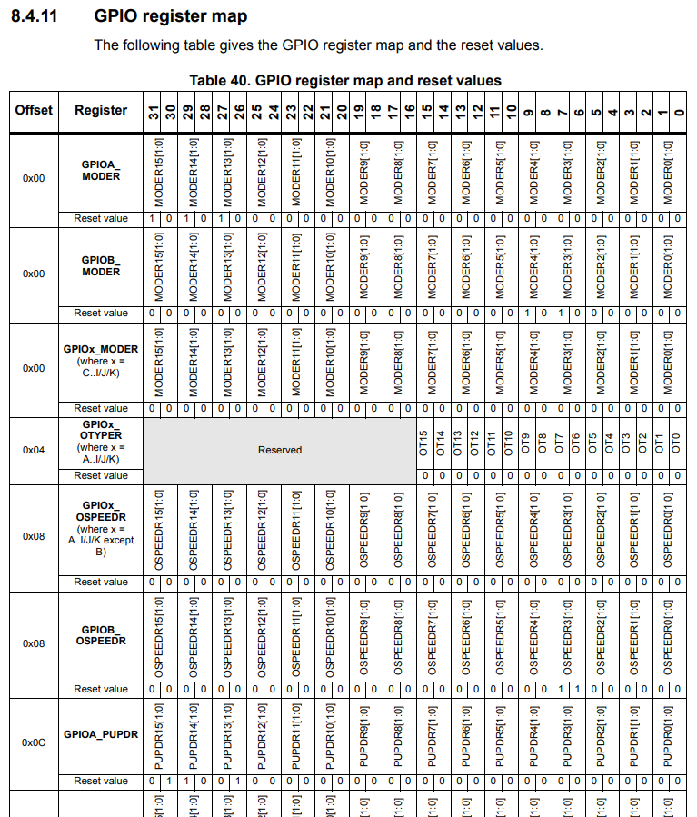

This will help you to quickly understand what exactly is the ***offset address*** of that register from the ***base address*** and various other things. All right.

So, all these things will see as we make a progress.

But, first let's understand the GPIO port ***Mode register***.

For that, let me take you to the ***Reference Manual***, the very first register is a ***GPIO port mode register***, so, let's explore that.

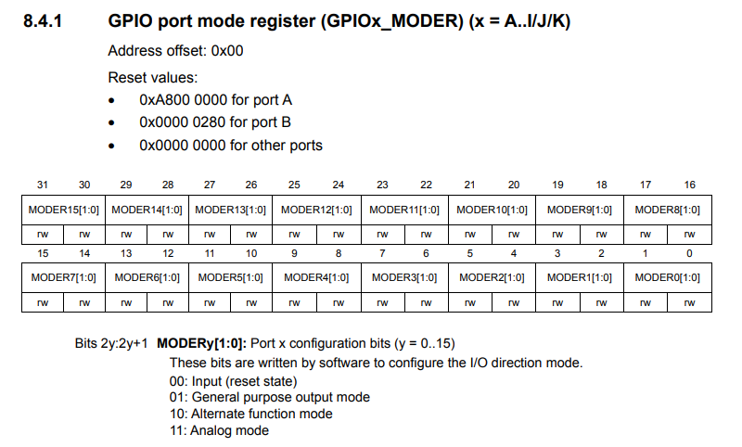

All right. So, now here you can see that the name of this register is ***GPIOx_MODER***. Here you can replace ***x*** by any GPIO port name: ex. GPIO port *A, B, C, D*, all the way to *I*. So, you can visualize something like this:

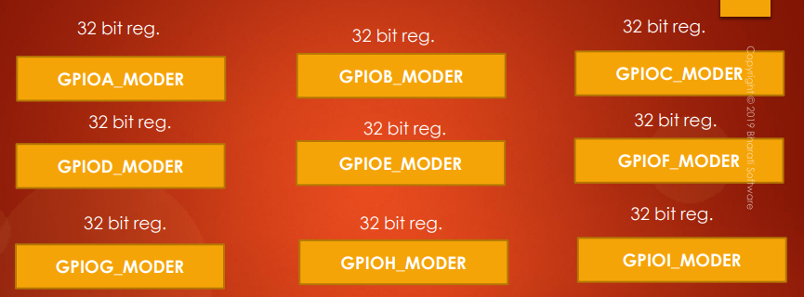

So, we have GPIO port A peripheral, GPIO B peripheral, GPIO port C peripheral, all the way to GPIO port I peripheral. And for each peripheral, there will be one *MODER register*. So, this is the same for all the registers.

*Per ogni* ***periferica*** *vi è una* ***GPIO port*** *e per ogni GPIO port vi è un* ***GPIO Mode Register****, quindi, per ogni periferica vi è un* ***GPIO Mode Register****.*

There are some microcontrollers in this family which may come with some extra GPIO ports like GPIOJ, GPIOK etc... All right. So, that info you have to get from the ***Reference Manual*** or from the ***Datasheet*** of the microcontroller. For this microcontroller, ***A*** to ***I***, 9 different GPIO peripherals and for each peripheral there will be one ***mode register***.

The ***Address offset*** is the offset from the *base address* of the GPIO peripheral. And here you can see that this register is actually used to control the ***mode*** of the GPIO pin. You should also give attention to the ***Reset values***. Remember that, the *reset value* of this register is not 0x00 for *GPIO port A* and also for *GPIO port B* the reset value is not actually 0x00.

So, this is a value mentioned, remember that:

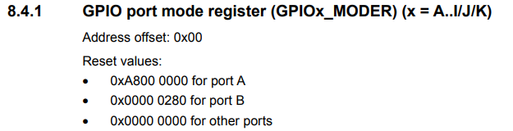

And for all the other ports, the reset value will be 0x00. So, whenever you browse through the register details, you should also pay attention to what exactly is ***reset value*** which is very important.

So, that means when the microcontroller undergoes system ***reset*** or ***power-on reset*** or ***power-down reset***, so this is the ***default value*** of the ***GPIO port mode register***. And as you already know, every GPIO port will have ***16 pins***, right? So, that's why this register is divided into 16 different sections and each section controls a single pin.

For example, if you take this section where the first initial 2 bits are dedicated:

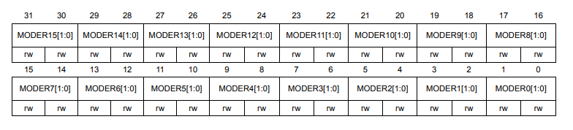

* ***MODER0 [1:0] : controls mode*** for ***pin 0***
* ***MODER1 [1:0] : controls mode*** for ***pin 1***
* ***MODER15 [1:0] : controls mode*** for ***pin 15***

So, for example, if this is ***GPIOA_MODER register***, then these 2 bits will control GPIO port A pin 0, these two bits will control GPIO port A, pin number 1 and these 2 bits will control the mode of GPIO port A pin number 15, like that.

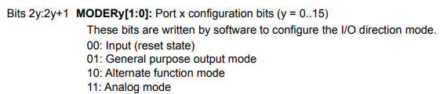

You can put the GPIO pin into *input mode* or *general purpose* *output mode* or you can keep that pin into *alternate function mode* or you can also keep that pin into *analog mode* whenever you want to read the analog signals.

We'll be using all these 3 modes: *input*, *general purpose output* and *alternate function mode*, but in this course, we'll not be using the *analog mode*.

So basically, you'll be using the *analog mode* of the pin whenever you are dealing with ADC or DAC.

Remember that whenever you *reset* the microcontroller, all the pins of the different GPIO ports will be by *default* in ***input state*** -> ***00: Input (reset state)*** (tranne che per la GPIOA e la GPIOB in quanto i ***Mode registers*** di queste 2 porte hanno dei ***reset value*** diversi da 0x0000 0000).

Let's explore, how exactly the ***input mode*** looks like inside the microcontroller.

***N.B.*** Abbiamo visto che il ***MODER*** per la GPIOA e la GPIOB ha dei ***reset value*** differenti da 0x0000 0000:

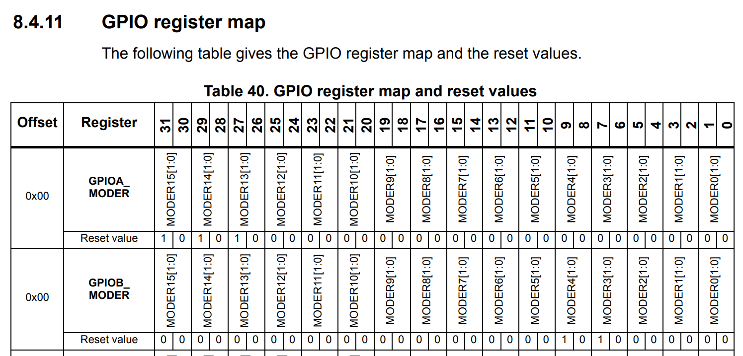

Infatti, per la ***GPIOA_MODER*** i pin PA13, PA14, PA15 hanno dei ***reset value*** ***= 1 0***.

Tale valore corrisponde all’***Alternate function mode***, quindi vuol dire che di **default** questi 3 pin vengono utilizzati con quel tipo di funzionalità.

Per vedere che tipo di ***alternate function mode*** possiamo utilizzare per ciascun pin dobbiamo aprire il ***Datasheet*** del micro e cercare la ***Alternate Function Mapping***:

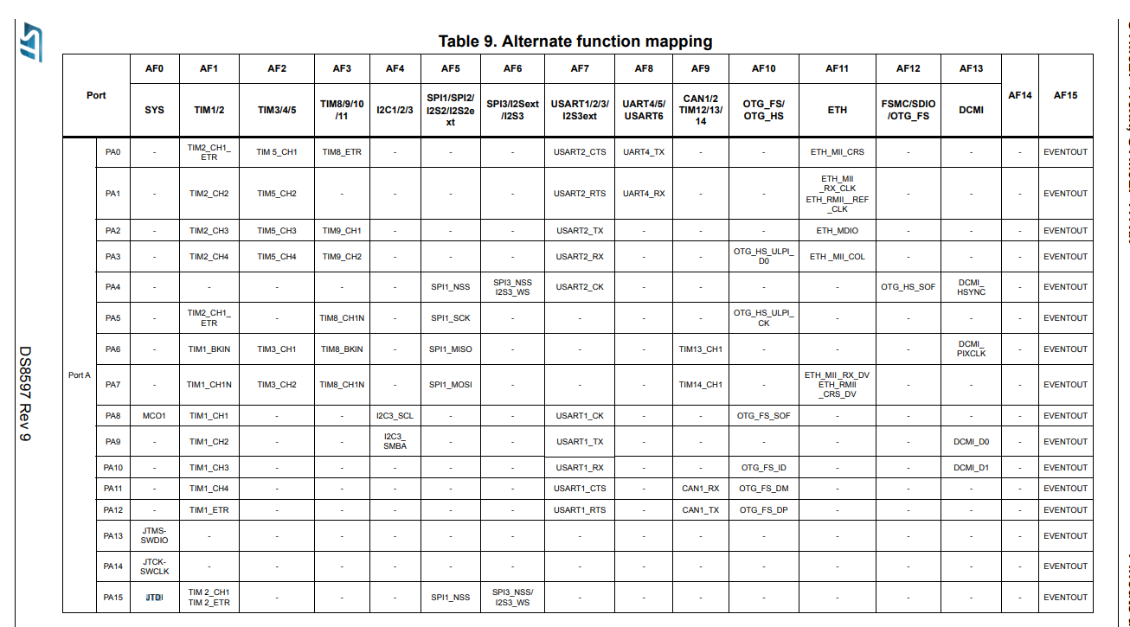

Bisognerà quindi capire per ciascuno di questi 3 pin qual è la **Alternate Function (AFx)** di **default** che viene inserita in fase di reset.

## 58. Input configuration of a Microcontroller’s GPIO Pin

Let's explore how exactly the **input mode** looks like inside the microcontroller.

For that, let me go to the *powerpoint (PPT)* and let's move forward. So remember, before using any GPIO, you must decide its ***mode***. Whether you want to use it as an *input*, *output* or for any *analog* purpose. All right. Now let's move forward.

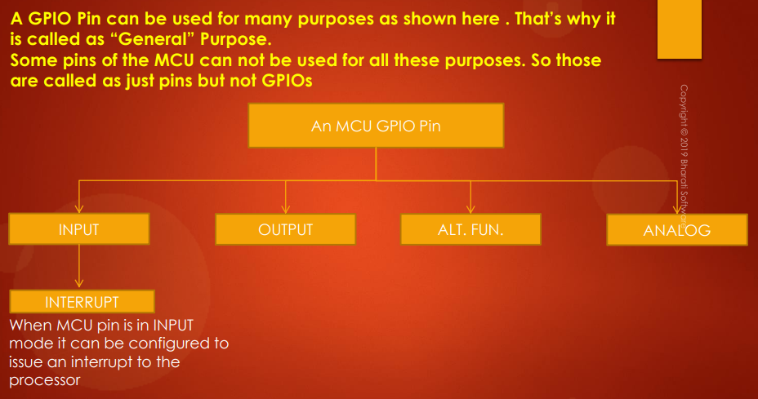

So, a GPIO pin can be used for many purposes as shown in this diagram. So, that's why it is called as *general purpose*. Some pins of the MCU cannot be used for all these purposes. So, those are called as just ***pins*** but ***not GPIOs***. When you call a pin as *general purpose I/O*, then you should be able to configure the way you want like you can keep that pin into *input* or you can keep that pin into *output mode* or you can give some *alternate functionality mode* like you can make that pin behave as some other functionality like video transmission functionality, or you can use it for some signaling like SPI clock signaling, ITC signaling, etc.. So, that we'll see later. And also you should be able to use that pin as *analog mode*, and also, if the pin is in *input mode*, that pin should be able to deliver ***interrupt*** to the processor. So, that is the ***interrupt mode***.

So, when MCU pin is in ***input mode***, it can be configured to issue an ***interrupt*** to the processor.

If a pin gives all these functionalities, then that ***pin*** is called as ***General Purpose I/O pin*** (***GPIO pin***). So, otherwise, that pin may not be called as GPIO. For example, a power pin of the microcontroller, you cannot call it as GPIO, because you cannot use it for all these purposes. All right? So, that's why that is just called as *power pin*.

### GPIO pin: Input mode

So, now the figure what you are seeing here is actually the real implementation of a GPIO pin inside the STM32F4xx based microcontroller:

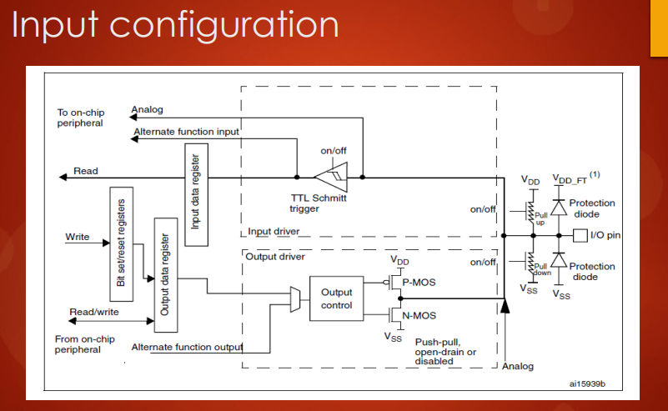

So, this is a real implementation which is present inside your microcontroller. If you want to get this diagram, you have to go to the ***Reference Manual***, you go to the *GPIO section* and right here in the *GPIO functional description*, you can find that block diagram in the *General Purpose I/Os (GPIO)*.

This actually explains how GPIO pin is driven as *input* and how it is driven as *output* and various other things. So, don't worry I will explain all these things as we make a progress in these lecture series.

So, now let's see how exactly the ***input mode*** looks like inside the microcontroller. So, here it is. This is a pin, right? This is a microcontroller pin which is a GPIO pin (***I/O pin***). Here you can see that, when you configure the GPIO pin in ***input mode***, then what happens is the ***output driver*** is **disabled**. So, this engine will not be active and only this engine (***input driver***) will be active, that is the ***TTL Schmitt trigger*** part.

All right?? The I/O state of this pin will be read from the ***input data register*** for every ***AHB1 clock cycle***. Why? Because the GPIOs are connected over the AHB1 bus, right? For every 1 clock cycle of the AHB1 bus this state will be read and the input data register will be updated and from there your firmware can read the value of that GPIO pin state.

Remember that, for each GPIO pin, the ***internal pull-up / pull-down resistors*** will be ***deactivated*** by **default**.

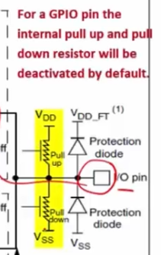

So, you have separate ***registers*** to configure the ***internal pull-up/pull-down resistor***.

So, that's why when you keep the pin into ***input mode***, it looks something like this:

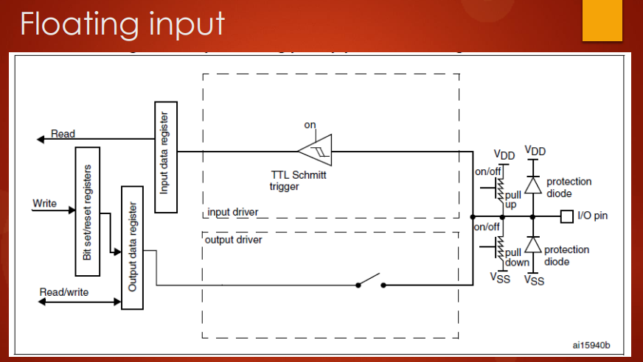

Open circuit

The ***output driver*** will be ***deactivated***, there is an ***open circuit*** here. So, the *mode* I am talking about is ***input mode*** with ***floating scenario*** (because ***internal pull-up/pull-down resistor*** are ***deactivated***).

So, because the ***output driver***, the ***pull-up resistor*** and ***pull-down resistor*** will be all ***deactivated***, that's why you can see that any ***random noise*** of the microcontroller of your board can affect the value which is being read into the ***input data register***.

So, due to the ***circuit noise***, this part can trigger some voltages which may be spurious, so, that's why this *open circuit* has the potential to *corrupt* the *data* which is there in the *input data register*. So, that means whatever you read from this I/O pin may not be correct.

So, what is the significance of these ***internal pull-up*** and ***pull-down resistors***?

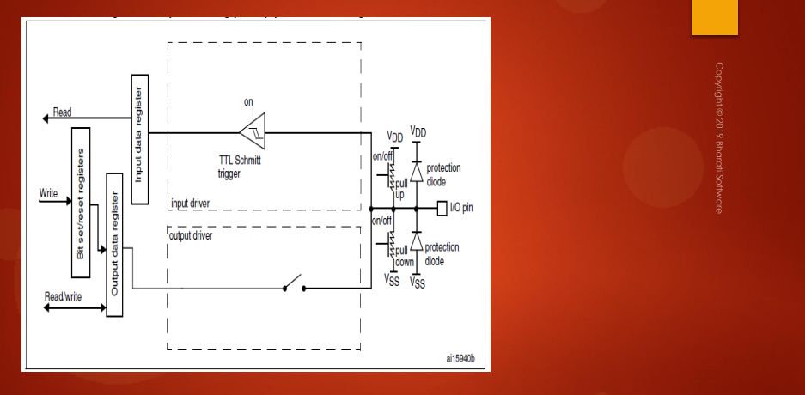

0

T2

T1

switch

GND



We can understand by taking one use case scenario. Let's say, I want to connect a ***switch*** to the I/O pin. So, I take the switch and I connect it to the I/O pin. So, this is a switch and this is a terminal T1 of the switch and this is terminal T2 of the switch and T2 I will make it ground. And we know that by default these ***internal pull-up resistor*** and ***internal pull-down resistor*** will not be there.

* ***Switch closed:***

So, when I close the ***switch***, what happens? So, this will be shorted (ossia si crea un corto circuito tra *T1*e *T2* in quanto lo switch mette in collegamento i 2 terminali) and that's why this state of the I/O pin will be 0 (in quanto chiudendo lo switch l’I/O pin diventa collegato al ***GND***). Right?

So, this is properly **grounded**, right? So, the whole path is properly grounded, isn't it? So, the I/O state will be 0 and that value will be sampled for each AHB1 clock cycle and it will be updated automatically by the microcontroller into the ***input data* *register***. So, whenever you read the input data register, you will always see the value 0. Why? Because the I/O pin is properly grounded.

* ***Switch open:***

Let's see the scenario when the ***switch*** is ***open***. When the switch is open, so, what happens? You can see that the I/O pin is neither grounded nor it is connected to the proper voltage. So, that's why due to the ***circuit noise***, there will always be fluctuation of voltage at the I/O pin. So, that's why for each one AHB1 clock cycle, whatever the state of the I/O pin which is sampled from here will not be 0 or 1, it will be keep changing 0 1 0 1 0 1 like that. So, the *input data register* will keep changing its value due to the ***circuit noise*** present. All right?

So, that's why if I have a code like this in my program: if (I/O_pin == high) {turn_motor_on();}, this will be a ***bug***. Why? Because I/O pin some time it will be *high* and sometimes it will be *low*, right? So, that's why my motor may not work properly.

How to solve this issue?? To solve this issue, you have to ***activate*** the ***pull-up resistor***. So, either you can give the pull-up resistor *externally* or you can make use of *internal pull-up resistor*. What we can do is, let's just ***activate*** this ***internal pull-up resistor***.

So, when the pull-up resistor is activated, when the **switch** is **open**, you can see that the I/O pin is not floating, right? So, the I/O pin is actually held at ***VDD***, right? It is in the proper state.

When the **switch** is **closed**, this whole path will be grounded. So, that's why by providing the ***pull-up resistor***, we actually give proper states to the I/O pin, high and low, right? So, that's the use of the pull-up resistor.

In questo caso abbiamo abilitato il ***pull-up resistor*** in quanto la capacità di scrivere 0 nell’*input data register* veniva già data dal fatto che il T2 dello switch era collegato a GND. Di conseguenza mancava la capacità di scrivere correttamente 1 nell’*input data register*.

Se il T2 dello switch fosse stato collegato a VDD, allora sarebbe mancata la capacità di scrivere 0, di conseguenza si sarebbe utilizzato l’***internal pull-down resistor***.

So, remember that all modern microcontrollers will provide the ***internal pull-up resistors*** for a ***GPIO pin***. Whether a pull-up / pull-down resistor is really exists or not, so, you have to get this info from the ***Datasheet*** or from the ***Reference Manual***. So, some microcontrollers may not have this feature, in that case, you have to give ***external pull-up / pull-down resistor***.

Quindi, attivando il ***pull-up resistor***, quando lo **switch** è **open**, non ho più le fluttuazioni di tensione, in quanto adesso il circuito viene alimentato direttamente dalla tensione VDD del ***pull-up resistor***.

*External pull-up resistor* means so, you have to take one resistor and you have to connect it externally, something like this:

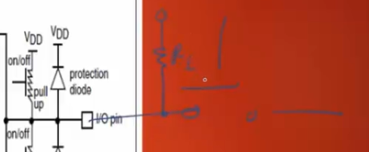

This is ***external pull-up resistor*** or ***pull-down resistor*** (se la ***R*** viene collegata al GND invece che ad una Vcc) you can use.

* ***Pull-up resistor*** -> ***resistor*** is connected to ***VDD***
* ***Pull-down resistor*** -> ***resistor*** is connected to ***GND***

So, while using I/O pin in ***input mode***, you should give importance to the ***pull-up / pull-down resistor***, otherwise, your program may not work properly. All right. So, that's about the ***input mode*** and the ***floating scenario*** of the input pin. And you may be having questions like what exactly the value of this pull-up and pull-down resistors is. So, this is very important information, and you can get this information from the ***Datasheet***.

Go to the ***Datasheet*** of your device and just search for let's say *“****weak pull****”* and it will take you some table right here, ***I/O static characteristics***:

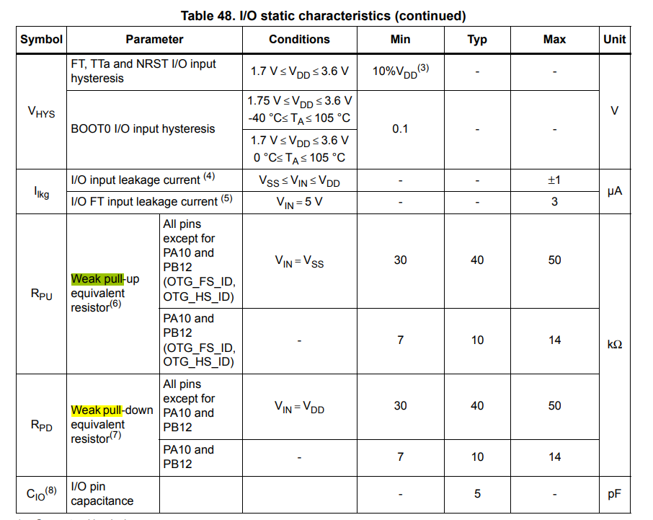

And here you can see that ***RPU*** means ***Resistance Pull-Up*** and its typical value in this microcontroller is around 40 kilo-ohms and ***pull-down*** (***RPD***) is also around 40 kilo-ohms and there is some exception for PA10 and PB12 that may not be true. For PA10 and PB12 it will be around 10 kilo ohms. All right. So, this is actually the microcontroller specific, and you should go through the ***Datasheet*** in order to see what exactly is the value suitable for your microcontroller.

And now, when to use *external pull-up* and when to use *internal pull-up*?

Remember that while you are doing some testing in your project or when you don't want to use some external resistors, then you can turn on the internal pull-up resistor or pull-down resistor and you can get your task done. So, when you are designing some product or during production, then your engineering team let’s say have come up with some resistance values by considering the resistance and capacity delays etc.. So, in that case when you have different recommended value for resistor, then you cannot make use of the internal pull-up resistor which is *fixed*, right? And if you use that internal pull-up resistor, then it is like going against your design. So, it may cause problems with your product.

So, that's why in those cases you can turn off the internal pull-up or pull-down resistor and you can use external pull-up or pull-down resistor according to your product design values. Great!! So, all right!

So, a quick summary of ***input mode*** what we just discussed.

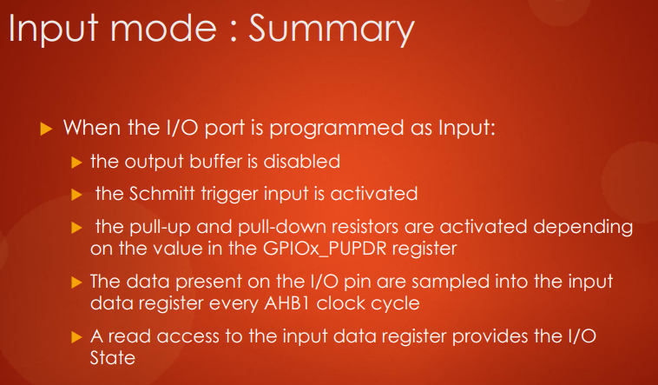

It will be OFF by default

When an I/O pin is programmed as ***input mode***:

When an I/O port is programmed as **input**, the **output buffer** is **disabled**, the Schmitt trigger input is activated, the pull-up and pull-down resistors are activated depending on the value of the ***GPIOx_PUPDR*** register. So, that means that it will be ***OFF*** by **default**, so, later we'll discuss about this register. The data present on the I/O pin are sampled into the *input data register* for each ***AHB1 clock cycle*** and read access to the *input data register* provides the ***I/O state*** of that pin.

So, in the next lecture, let's discuss about ***output mode configuration*** of the I/O pin and I'll see you in the next lecture.

## 59. Output Configuration mode of a GPIO Pin in Push-Pull mode

Hey, welcome back to the lecture and in the previous lecture you understood about the input configuration that is input mode of the GPIO pin.

In this lecture, let's understand the ***output configuration***.

For the GPIO pin there are **2 output configuration modes** as you learned in the previous part of this course:

* **open-drain configuration**
* **push-pull mode configuration**

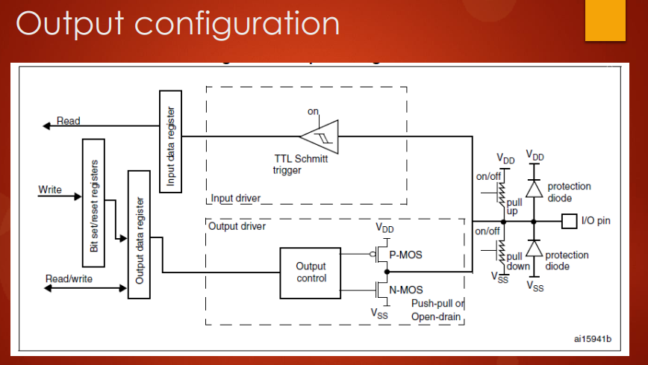

Let's discuss about ***output configuration*** with ***push-pull output type***.

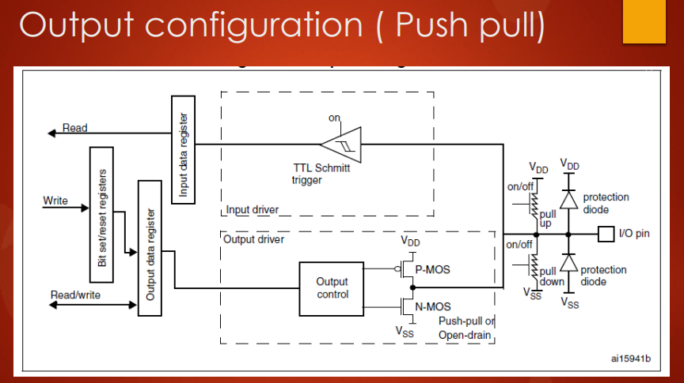

**Current sourcing**



**NOT**

**0**

**1**

**1**

This is the ***output*** type in a ***push-pull configuration***, and what happens is ***P-MOS*** as well as ***N-MOS transistors*** they both exist. So, let's assume that there is a *NOT* gate here (ossia un ***NOT*** dove vi è il blocco ***Output control***). So, if you write 1 into the ***output data register***, then what happens? 1 is negated, so, that is let's say 0 and 0 means this will go into the high impedance state, right? So, the P-MOS transistor will be *ON* and the current flows in this direction. Right?? So, let’s say you have connected an LED over here. So, what happens? So, current flows in this direction, right? So, this is the path of the current. So, this is what we call as ***sourcing of a current*** (***current sourcing***), right?? So, the current actually flows outward from the microcontroller pin into your circuit. So, that's what we call as *sourcing*.

So, now what happens, if you write 0 here?



**OFF**



**0**

**1**

**NOT**

**0**

So, 0 means you want to make the I/O state of this pin as 0. So, you write 0 here, right? So, once you write 0, this will be 1 here, output and 1 means this goes into the high impedance state (???) and the N-MOS will be turned *ON*. So, that means it is grounded, right?

So, basically the ***I/O pin*** will be ***grounded***, right? So, if you have connected an LED, let's say here. So, let's say this is an LED, then that LED will be *reverse biased* so, no current flows and it is like turning *OFF* the LED.

So, that's how you can control an LED or any other output circuit by using the ***push-pull configuration*** of the ***output mode***. So, remember in push-pull as I explained in the previous part of the course, so, there will be 2 states. So, according to that this P-MOS and N-MOS transistor will switch and you will have either *high* or *ground state*.

So, in the next lecture, let's see the ***output configuration*** in the case of ***open-drain output type***. I'll see you in the next lecture.

## 60. Output Configuration mode of a GPIO Pin in open drain mode

Hey, welcome back to the lecture. So, now let's discuss the ***Open Drain Output type***.

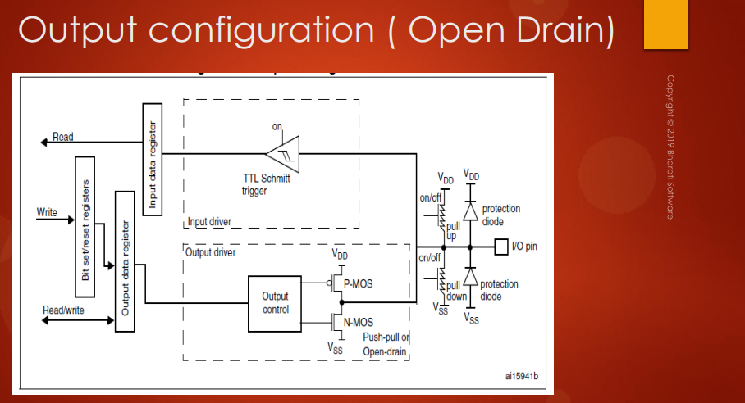

**0**



**NOT**

**1**

**0**

**0**

So, in the ***open drain***, you already know that this **P-MOS doesn't exist** and you have only 2 output possibilities that is ***low*** or ***floating***, right?

So, what happens if you write 0? So, let's assume ***NOT*** get here, then 0 means 1. So, this conducts, and N-MOS is activated. So, basically the I/O is driven to ground. So, 0 gives you 0 to the ***I/O pin***, no problem.

What happens, if it is 1?





**NOT**

**0**

**1**

**1**

So, if it is 1, then this is 1 and this is 0. So, this actually goes into high this stage. That means this switch is open actually. That's why this output (*pallino nero* tra N-MOS e P-MOS, ricorda che il P-MOS in realtà qui non c’è) actually becomes open. So, that what we call as ***open drain***. So, the I/O state is not defined. So, 1 means it is ***floating***, the ***I/O state*** is ***floating***. So, in order to solve this issue, what you have to do is, you have to ***activate*** the ***internal pull-up resistor,*** or you can give an ***external pull-up resistor***.

So, once you give the ***pull-up resistor***either external or internal, you can see that this I/O pin is actually gets valid state, that is ***VDD***.

So, now let's see, how we can drive an LED in the case of ***open drain configuration*** of an I/O pin. Let's say I connect one LED right here, so let's say this is LED.





**VCC**

**R = 1kOhm**



**Not ON**

**R = 40kOhm**



**OFF**



**0**

**1**

**1**

**0**

**1**

**1**

**LED**



**NOT**

**0**

**0**

Let’s say the I/O pin is in ***open drain configuration***, so when I write 0 here, so, 0 means I/O pin will get the state 0, 0 means it is grounded, right? So, that's why the LED will be grounded.

Therefore, if I write 0, then the LED will be *OFF*.

What if I write 1 to the output data register? When you write 1 to the output data register, you cannot expect LED to be *ON*. Right? So, LED will not be *ON*. So, what you have to do in this case to make LED on is, you have to activate the ***internal pull-up resistor***. That means a small current will actually pass from VDD and it will pass through the LED. The LED here is actually forward biased, isn't it? Because it gets the supply VDD. Right? But remember, the ***resistor R*** of the ***pull-up resistor*** is very high value. This is around ***40 kilo-Ohm***. So, a *very small current* actually passes through the LED. So, actually the LED will not be *ON*.

I mean, it is forward biased, but it will not be *ON*, because of this high resistance. So, in order to make the LED *ON* completely, what you have to do is, you have to actually turn *OFF* this ***internal pull-up resistor***. So, instead of this ***internal pull-up resistor***, what you do is, you actually give ***external pull-up resistor*** of let's say value ***1 kilo-Ohm***. So, this is highly application specific.



**OFF**

**ON**

**1**

**0**

**1**

**1**

**0**

**NOT**

**1**

**0**

**0**



**R = 1kOhm**

**VCC**



In this case, you just give 1 kilo-Ohm external pull-up resistor and give the source here ***VCC***. So, whenever you write 0, what happens is, the current from the ***VCC*** actually doesn't take this path, it actually flows in this direction. So, this is case 0.

When you write 1 over here, the current actually takes this path. So, making your LED *ON*, right? So, this is case 1. So, that's how you have to use the ***open drain*** in order to drive the LED or any other circuit.

So, now the big question is when to use ***open drain*** and when to use ***push-pull***?

Remember that this is highly application specific. Whenever you want 2 states like high and low at your output pin in order to drive your circuit (the circuit may be an LED, or relay or any other motor control or whatever it may be) if you want 2 states that is high and low, then there is nothing wrong in using ***push-pull configurations***, so you can always use push-pull configuration if you want high and low states.

And in some applications, you may require that the high this state at the output pin, so, that's why in those cases you can use open drain configuration and in some of the serial communication protocol like I2C communication, it is really required to have the I/O pin configured as open drain output type. So, because the I2C specification itself says that the I/O pin has to be in ***open drain output type*** (*continue in the next lesson*).

## 61. Input stage of a GPIO pin during output configuration

Hey, welcome back. So, in the previous lecture, you understood about the ***open drain output type*** and ***push-pull output type*** of an I/O pin. And remember that when the I/O pin is in ***output mode***, the *input* part that is this circuit (***input driver***) will not be *OFF*, it will also be ***activated*** unlike in ***input mode*** where the ***output driver*** is ***deactivated***, right? So, in **output configuration**, the ***input driver*** will always be *ON*.

So, that means you can read the I/O state of that I/O pin through the *input data register*. ***Read*** is also possible.

Quindi, quando ho un ***pin*** configurato in ***output mode***, in realtà io posso anche effettuare una ***read*** di quel ***pin*** in quanto l’***input driver*** non è disabilitato. Perciò posso effettuare entrambe le operazioni di ***read / write*** su quel ***pin***.

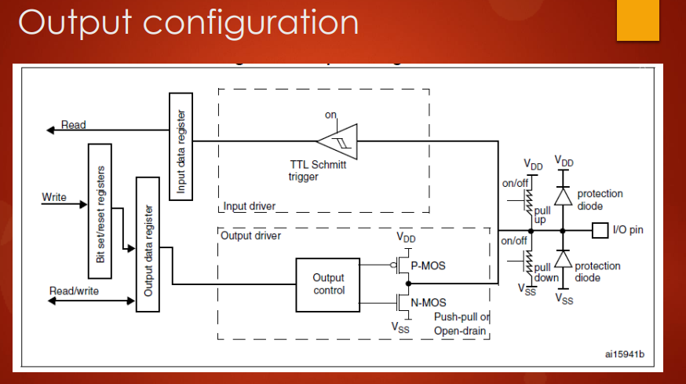

**ON**

**ON**

## 62. Alternate functionality configuration of a GPIO pin

Hey, welcome back to the lecture. So, in the previous lectures, we actually understood about the *input mode* and the *general purpose output mode* of a GPIO pin.

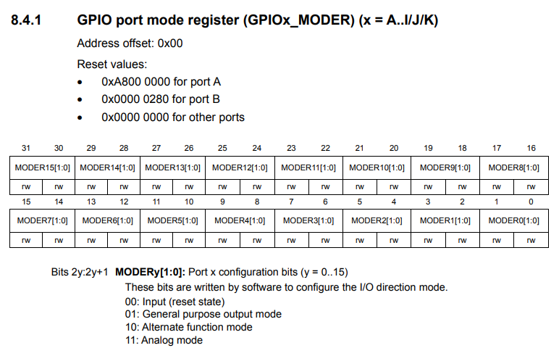

So, if you make these corresponding bit positions as ***00*** then the pin is in ***input mode***. If it is ***01***, then the corresponding pin will be in ***output mode***. And if you make ***10*** to these bit positions, then that corresponding pin will be ***alternate function mode***.

What exactly is the ***alternate function mode***? In the ***alternate configuration mode***, as the name indicates, the pin will be assigned for ***alternate functionality***. The *alternate functionality* can be anything like ***UART-TX***, ***UART-RX***, it can be a timer, input channel, ADC's input channel or it can be used as serial clock of the SPI peripheral or it can be used as a data line of the I2C peripheral like that.

That pin is used by the ***peripheral*** which you assigned to.

If you carefully look at the diagram over here, you can see the output control now actually will be driven by the ***alternate function output*** not from the output which comes from the ***output data register***.

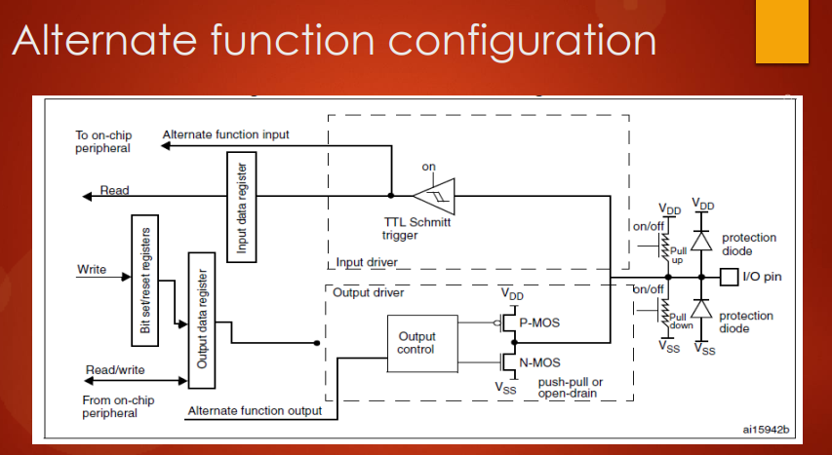

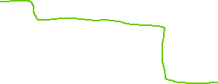

Pin is read by assigned peripheral input functionality (UART_RX, ADCIN, TIMER CHx, CAN_RX, etc.)

Pin is controlled by assigned peripheral output functionality (like I2C_SDA, I2C_CLK, UART_TC, etc.)

So, now here in this diagram *output data register* has no control over the output control block. So, the *output data register* will not influence the state of the I/O pin. So, you have to remember this. So, there is a ***disconnection***, isn't it? So, the ***output control*** will be handled by the ***alternate function output***.

So, this can be anything, this can be UART_TX as I said, it can be from the SPI peripheral, it can be from timer peripheral, whatever the pin is go on by other factors.

If you look at the ***input*** side, then whatever the value you read from that I/O pin actually goes to the ***alternate function input***. So, that is to ***on-chip peripherals***. So, it can be UART_RX or SPI_RX like that. So, it goes to the *on-chip peripheral*. And it also will get updated into the ***input data register***.

So, it goes to both ***input data register***, as well as it goes to the ***alternate function input***.

So, about *alternate function configuration* and its programming to see how we can use pin for different functionalities of different peripherals, we have to cover more lectures in this course and as we make a progress, we'll learn more about that.

In the next lecture, I will explain the ***GPIO port output type register***. I'll see you in the next lecture.

## 63. GPIO output type register explanation

So, in this lecture, let's understand the ***GPIO port output type register***.

So, when a GPIO pin is in the ***output mode***, this register is used to select the output type of that pin.

So, you already know what the output types are: ***push-pull*** or ***open drain***.

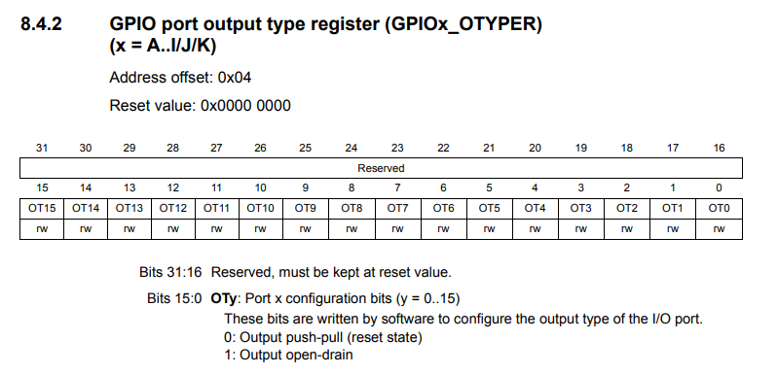

So, that's why in the output type register which is at the ***offset*** = ***0x04***, so, in the output port type register, so you can see that only 16 bits are used and other ***16 bits*** are ***reserved***. So, this bit position can either take 0 or 1, so 0 means *output push-pull* and 1 means *output open drain*.

So, configuring this register make sense, only when the pin in ***GPIOx_MODER*** (***GPIO port mode register***) is in ***output mode***, right? That's about the ***GPIO port output type register*** which is used to select whether the output type is *push-pull* or *open drain*. And now let's move forward.

Our next register is *GPIO port speed register*. I'll cover this in the next lecture.

# Sezione 16: GPIO Registers: SPEED, PULL UP/DOWN, IDR and ODR

## 64. GPIO output speed register and its applicability

Hey, welcome back to the lecture and our third register in configuring our GPIO port is GPIO port **output speed register**.

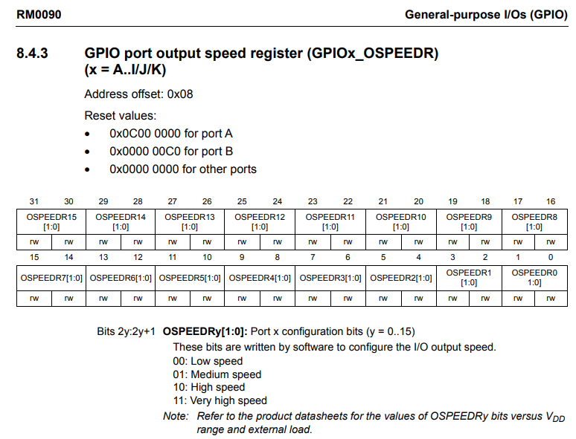

And as this name indicates that configuring the speed register is only applicable or it makes sense when the GPIO pin is in **output mode**. That's why, it is called as output speed register so remember that. The configuration of speed register make sense only when the I/O pin is in **output mode**. So, by using the speed register you can configure "how quick the GPIO transitions from high to low and low to high". That means, in other words you can control the slew rate of a pin by using output speed register of a GPIO port.

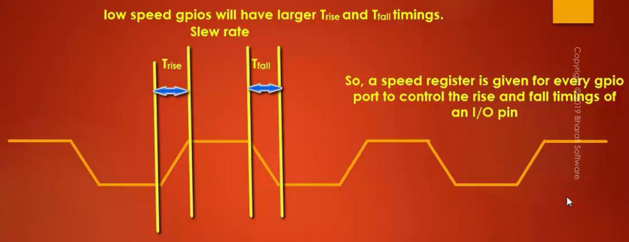

So, basically the output speed register controls the slew rate of the GPIO switching.

**T_rise** is called as the amount of time the GPIO takes to switch from a low to high.

**T_fall** is the amount of time taken from the GPIO pin to switch from high to low.

So, if you want to control this T_rise and T_fall you have to use GPIO speed register. And let's go to the ***Reference Manual*** in order to understand what configurations are available in order to configure the speed register. So, here it is. Actually there are 4 options:

* Low speed
* Medium speed
* High speed
* Very high speed

So, refer to the product ***Datasheet*** for the values of output speed register bits versus VDD range. Basically, if you want to know what exactly is a low speed. I mean, how many megahertz etc.. so you have to consult the ***Datasheet*** of the device. Here again two bits for each pin.

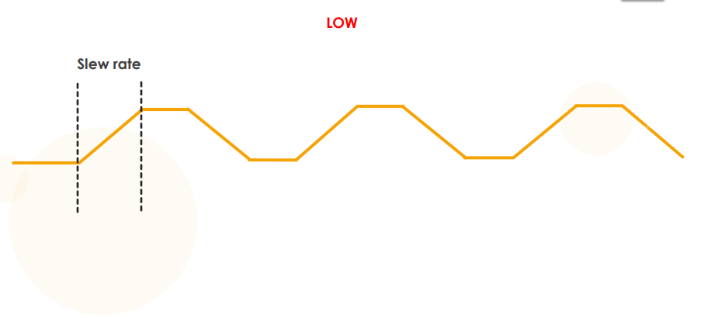

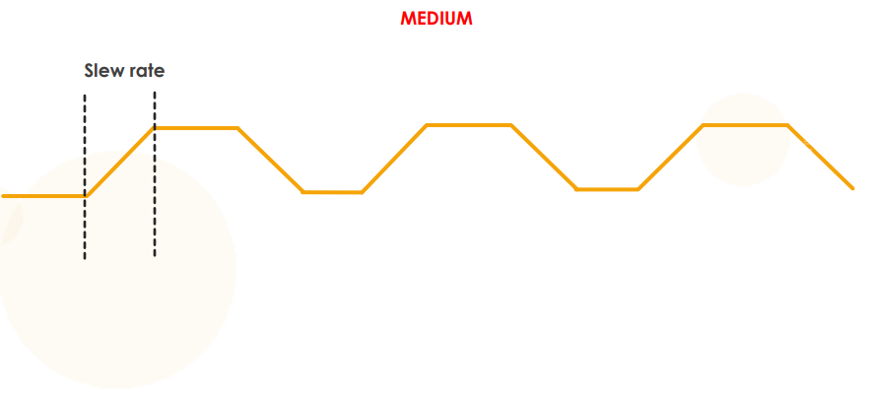

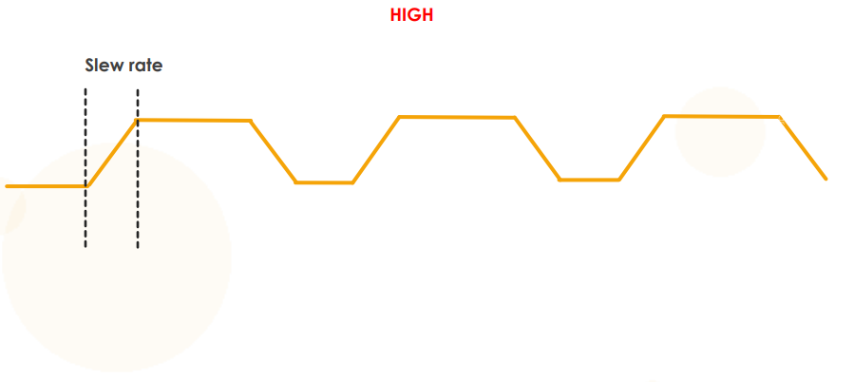

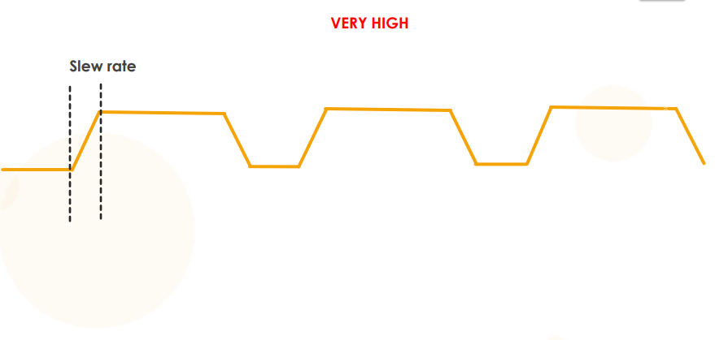

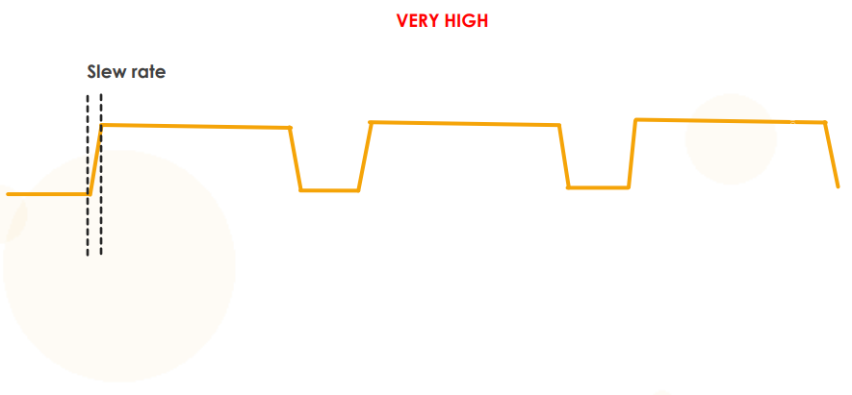

So, based on the speed you select for a particular GPIO pin from this register, the slew rate of that GPIO pin will get affected as shown in this animation. All right.

So, now you may be wondering what exactly is low speed, medium speed, high speed, and very high speed. So, to get this information you have to refer to the ***Datasheet*** and just search for output speed **OSPEEDRy** and you will arrive at this table.

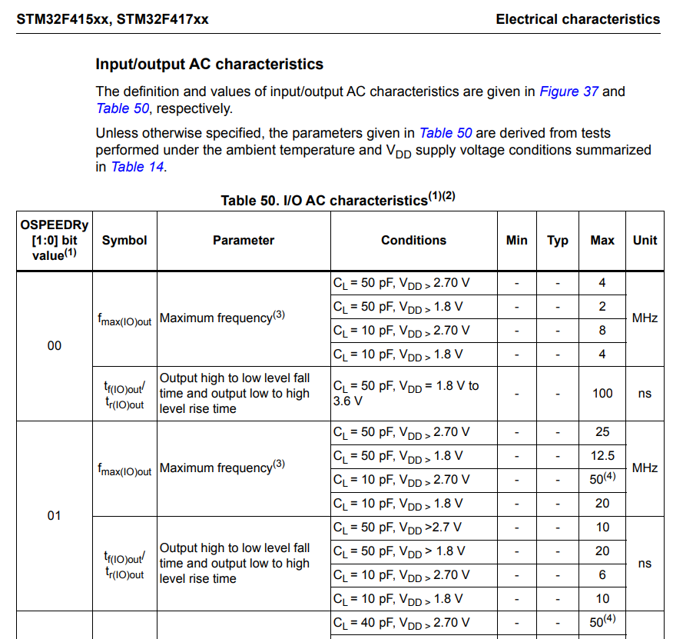

And here you can see that if the speed register is 00, so that means if it is low speed, then these are the possible switching frequency of a particular GPIO pin. The maximum switching frequency which can be achieved in low speed. There are various conditions based on the value of **VDD** that is the **main supply** to the microcontroller and the **load capacitance** **CL** which is there in the clock circuitry.

CL means load capacitance.

In our case, the VDD is actually above 2.7 volt. So, we can consider this scenario where the load capacitance is equal to 10pF and VDD is greater than 2.70 volt. So, if you select this case then pin low speed that is if the speed register is 00, then the maximum achievable switching frequency of that GPIO pin would be 8MHz. So, that will be the maximum you cannot go beyond that. If you are using a medium speed, then the maximum you can reach up to 50 MHz of switching frequency of that particular GPIO pin, and if it is high speed means you can go up to 100 MHz, and if it is very high speed means around 180 MHz.

So, in most of our applications you can safely ignore configuring the output speed register, no problem. So, you can always keep that in **default** state that is **00 low speed**, no problem. There may be some advanced scenarios where you may have to configure this register. For example, consider **bit banging** of **I2C peripheral**. Let's say, your microcontroller doesn't come with I2C peripheral and you have to support the I2C communication using bit banging, that is toggling by using the bit banging technique. In those cases you may have to configure properly the Trise and Tfall, because I2C specification demands certain number of Trise and certain number of Tfall. So, in those cases it may be needed, otherwise for all other applications you can safely ignore configuring this register.

So, applicability of speed register configuration:

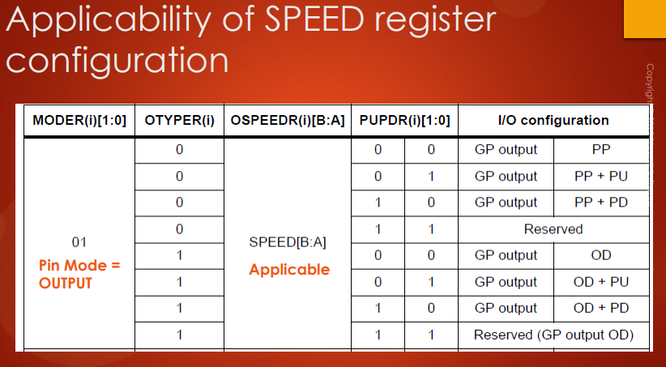

And remember that, the speed configuration is applicable only when the mode register of that pin is in **output mode**. So, for example if the pin mode is input that is 00 MODER register is 00, then the output type register is don't care.

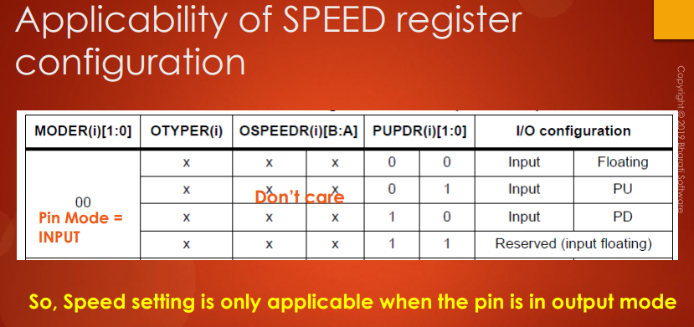

Right? Obviously, and the speed register is also don't care. So, that means speed setting is only applicable when the pin is in output mode. So, you have to remember that. Now, let's move forward.

In the next lecture, let's understand about the GPIO port Pull-up and Pull-Down register. I'll see you in the next lecture.

## 65. GPIO Pull-up and Pull-down register

Hey, welcome back to the lecture. So, let's go to our next register that is **GPIO port Pull-up/ Pull-down register**.

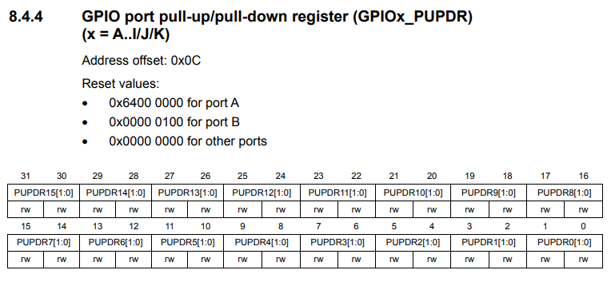

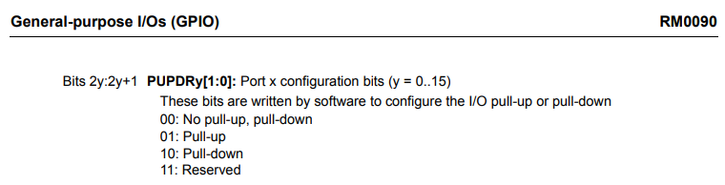

As you may be guessing the GPIO Pull-up and Pull-down register is used to control these resistors.

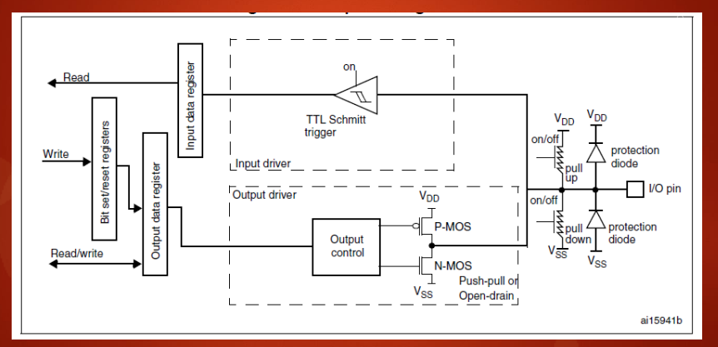

So, again the entire register is divided into 16 groups. So, each group for each pin of that particular port and 00 means no pull-up, no pull-down. So, that means all these 2 resistors are disabled. 01 means only pull up is activated. So, that means only pull up resistor is activated. Pull-down means, only pull-down is activated and 11 you should not use that configuration. So, this is reserved. So, in order to control these pull-up and pull-down resistor, use this register and these appropriate bit positions.

## 66. GPIO input data register

All right. Now, let's move forward. Our next register is **GPIO port input data register**.

So, now let's go back to the ***Reference Manual*** and let's explore the GPIO port input data register.

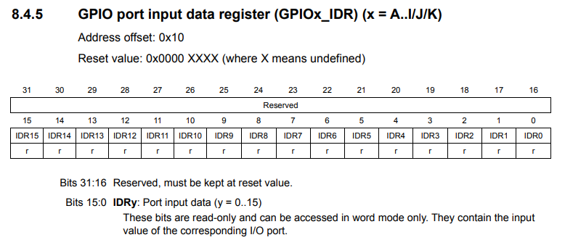

So, this register is used to read the I/O state of a particular GPIO pin or particular GPIO port. Isn't it? So, you already know that GPIO port has 16 pins, so that's why 16 to 31 are reserved. They are not used. So, 0 to 15 are used and here you can also see that you can **only read** this register, you cannot write into this register. Only read permission is given to this register. That register is right here, Input data register.



And whenever firmware or your code reads the value which is there inside this register will be return to the program. Great! And remember that this register will be updated for each one AHB1 bus clock cycle.

Leggere il bit del **GPIO Input Data Register** relativo ad un certo **pin** mi permette di capire se quel **pin** è in stato ***high*** o ***low***, ad esempio se un LED è acceso o spento, oppure per sapere se un pulsante è stato premuto o meno.

## 67. GPIO output data register and summary of various modes discussed

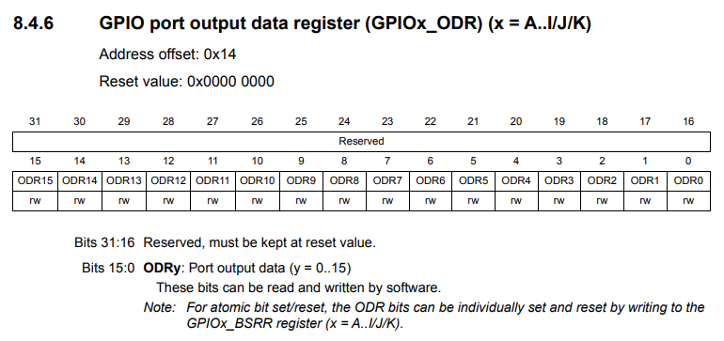

Hey, welcome back to the lecture. So, in this lecture let's learn about **GPIO port output data register**. Let's go to the ***Reference Manual*** and here you can find GPIO port output data register. And as you may be expecting this register is used to control the I/O state of the I/O pins. And here you can see that only 16 bits are used in this register. So, 16 to 31 are reserved and the 0th bit position of this register will control the I/O pin 0. So, this is for I/O pin 1, this is to control the I/O pin 2 and so on. So, you can either write 1 here in order to make the corresponding I/O pin as high and you can write 0 into the corresponding bit position in order to make that I/O pin low. So, these bits can be read and written by the software. So, that's about the output data register.

So, now let me give you a quick summary of various GPIO modes, we have discussed in this course.

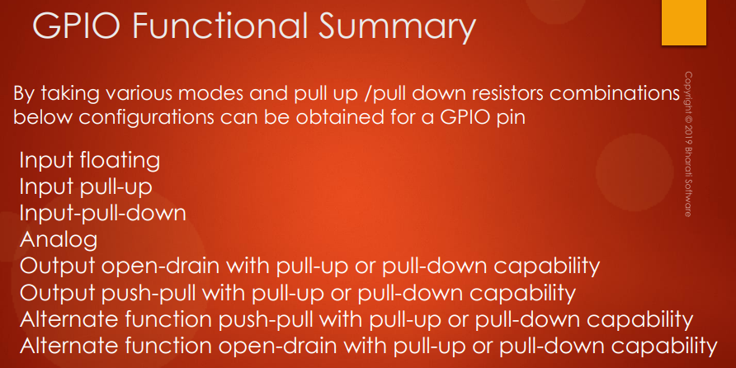

By taking various modes and pull up / pull down registers combinations below configurations can be obtained for a particular GPIO pin. So, these are some of the possible modes what you can use for a particular GPIO pin of GPIO port.

In the next lecture, I will discuss about the alternate functionality configuration of a GPIO pin. So, will discuss more on **alternate functionality** and also will see what are the alternate functionalities possible for a given GPIO pin. And also we will explore the **alternate functionality register**. I will see you in the next lecture.

# Sezione 17: GPIO Alternate functionality register and example of usage

## 68. Alternate functionality settings of a GPIO pin with example: Part 1

Hey welcome back to the lecture, in this lecture let's understand about the ***alternate functionalities*** available for a particular GPIO pin. So, we'll be discussing about the ***alternate functionality mode*** in depth in this lecture and incoming lectures.

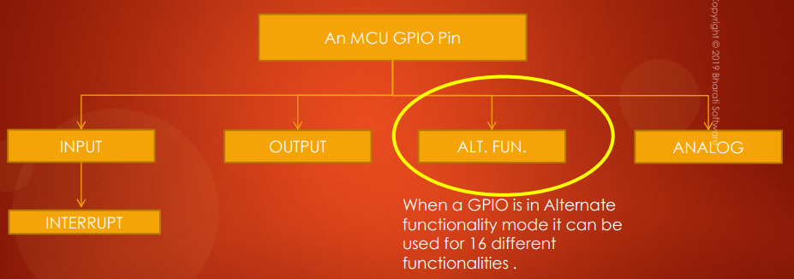

So, when GPIO pin is in ***alternate functionality mode*** it can be used for ***16*** different functionalities. Let's see what those are.

These are the 16 possible alternate functionalities for a GPIO pin:

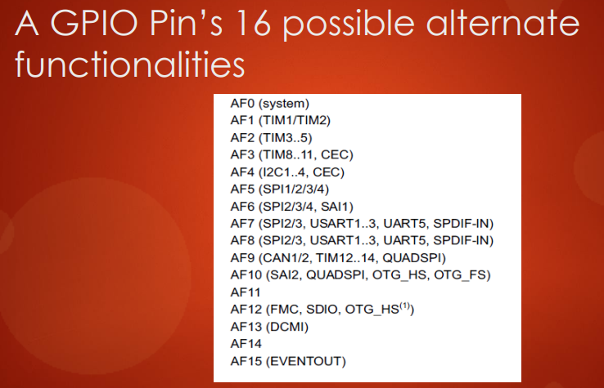

It can be used for system related work. It can be used by the timer peripherals. It can be used from the serial communication protocol, serial communication peripherals such as I2C, SPI peripherals or it can be used by CAN peripherals. So, it can be used for some audio interfaces, so many other things.

So, you should get all these details from the ***Datasheet***. But what I want you to understand here is that for each GPIO pin there will be ***16 possible alternate functionality modes***: from ***AF0*** to ***AF15***.

So, to understand more so let's do an exercise, because this will be the quickest way to understand all these things.

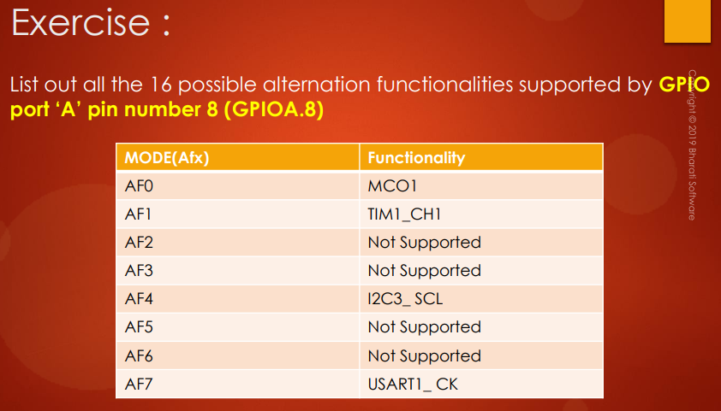

The exercise is list out all the 16 possible alternate functionalities supported by GPIO port A pin number 8. To solve this exercise, you have to refer to the ***Datasheet***, then you cannot get this information from the ***Reference Manual***.

Go in the ***Datasheet*** into the ***Pinouts and pin description*** and go to the ***Alternate function mapping*** section. Here is a table which describes all the alternate functionalities supported for different pins of different ports.

These are the 16 possible alternate functionalities supported by GPIO Port A.

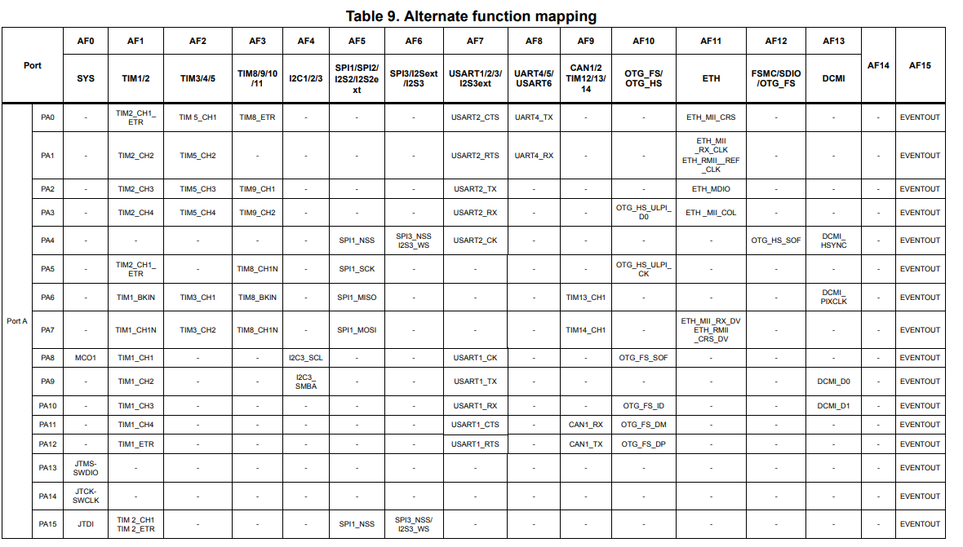

This is for port A related points from PA0 to PA15. And if you browse further you can get port B from PB0 to PB15. We want GPIO A pin number 8. Let's refer this row: Pin number 8 (***PA8***).

Here you can see that when this pin is in alternate functionality 0 mode (***AF0***) it will behave as ***MCO1*** (Microcontroller Clock Output).

When this pin is in ***AF1*** then that pin behaves as a channel for that timer 1 peripheral. So, it will be channel 1 of timer 1 (***TIM1_CH1***).

When that PIN is an ***AF2***, you can see that the alternate functionality is not defined. So, that means it will just behave as normal GPIO. So, no alternate functionality over there.

When you configured this pin as ***AF4*** that pin will behave as clock signal of the I2C three peripheral like that.

So, that means for the pin 8 of GPIO PortA, 6 functionalities are actually defined in this microcontroller.

This may not be true for another microcontroller of the same family. So, you have to check the ***Datasheet***. There is no other way you can get this information. So, you have to check the ***Datasheet***.

The solution to this exercise is this one:

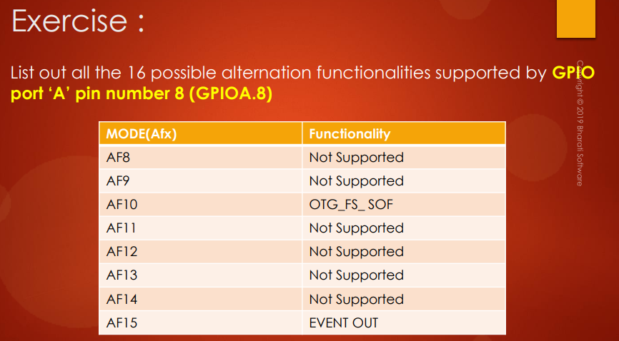

So, the pin will be acting as MCO1 when the alternate functionality mode is 0. And like that…

Where to configure these more settings? So, there is a register for that, that we call ***alternate function register*** so that I will show you in a moment. So, that's about 16 possible alternate functionalities supported for a particular I/O pin. That's the way to derive it. So, you have to consult the ***Datasheet***.

So, I will give you an exercise: list out all the alternate functionality supported by GPIO Port C pin number 6. And I'll see you in the next lecture.

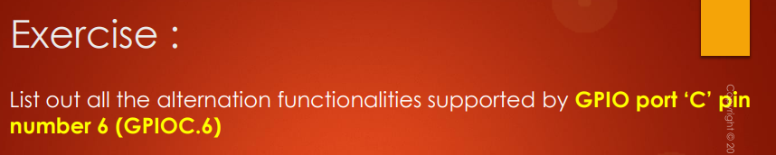

## 69. Alternate functionality settings of a GPIO pin with example: Part 1

Hey welcome back to the lecture. So, did you manage to solve this exercise



The solution is this one:

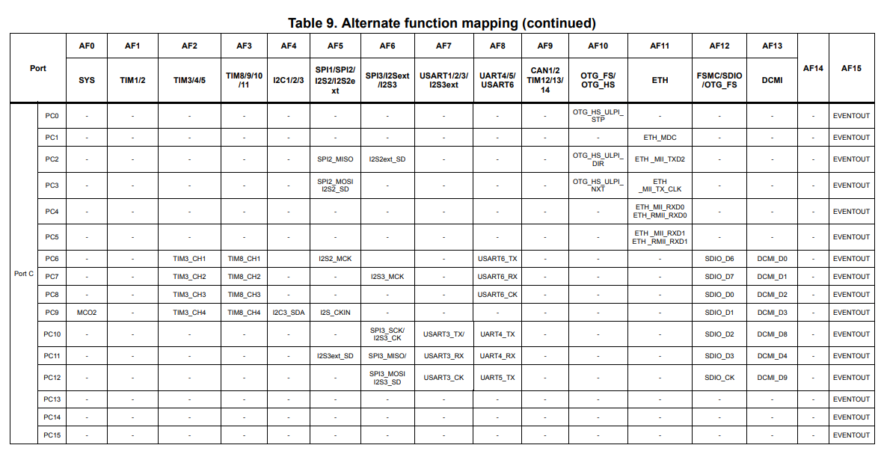

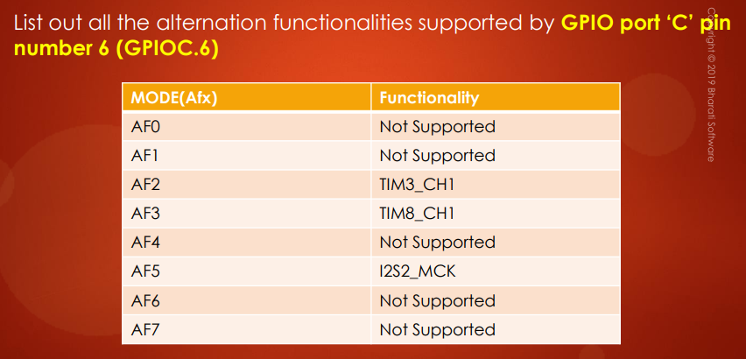 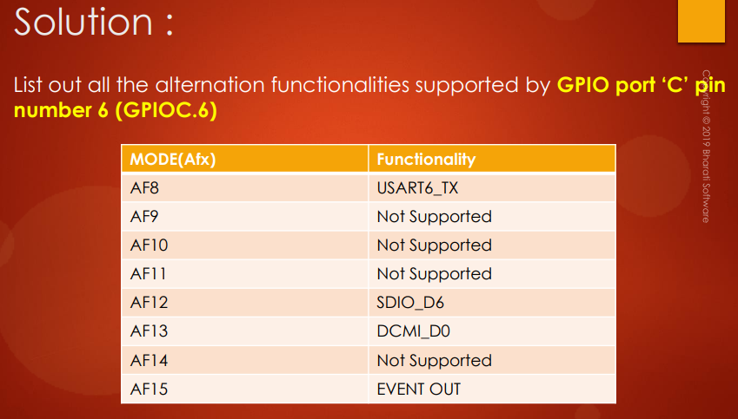

For GPIO C pin number 6 (***PC6***), the ***AF0*** is not defined, ***AF1*** is also not defined. Remember that it is highly microcontroller specific. So, you have to check the ***Datasheet***, and for you it may be different. So, when you keep this pin in ***AF2*** this will act as the channel 1 of timer 3 like that. All right. So, now let's move forward.

You may be wondering where to configure all these modes. So, for that we have a ***GPIO alternate function register***.

So, in the ***Reference Manual*** you will find 2 registers in order to configure the alternate function mode you need for your application. So, here it is. There are 2 registers:

* ***Alternate function low register***
* ***Alternate function high register***

Let's go to the ***alternate function low register***.

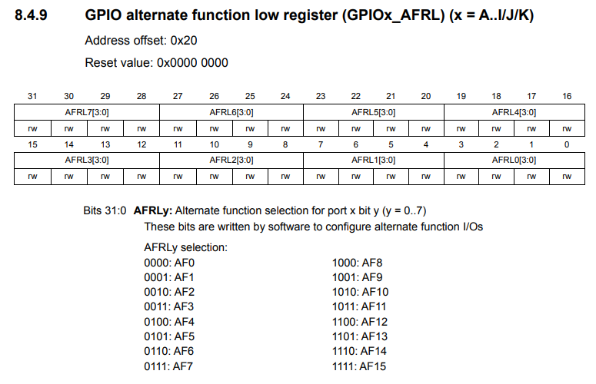

You can see that this register is divided into 8 groups.

So, that means by using low register you can configure the pins from ***0*** to ***7***.

Instead, from ***8*** to ***15*** you have to use ***alternate function high register***.

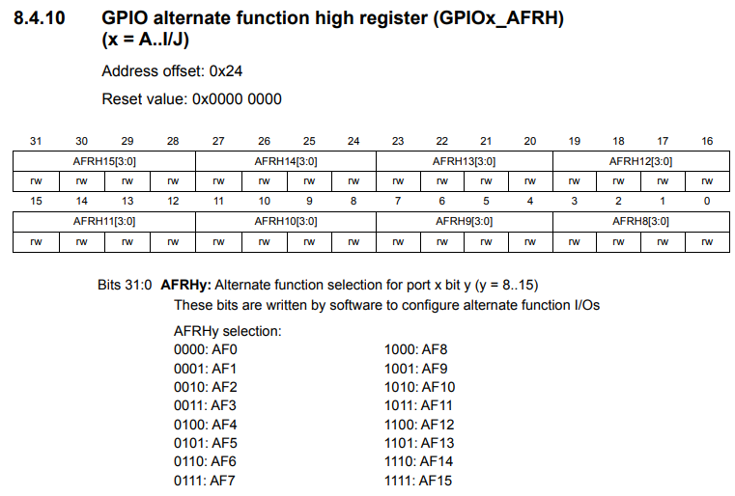

In the ***alternate function high register*** the first place that the first group is to configure the mode for pin number 8. And all the way to 15.

For each pin of each register, 4 bit fields are available. So, because there are 16 possible alternate functionality modes in order to store the value 16 you need at least 4 bits. So, that's why 4 bits for each pin.

Now again let us understand all these things by taking an example. Here it is the example. Find out the alternate functionality mode that is AFX and AFR alternate function register settings to make PA0 as UART4_TX, PA1 as UART4_RX and PA10 as Channel 3 of timer 1.

So, find out the alternate functionality mode and alternate function register settings.

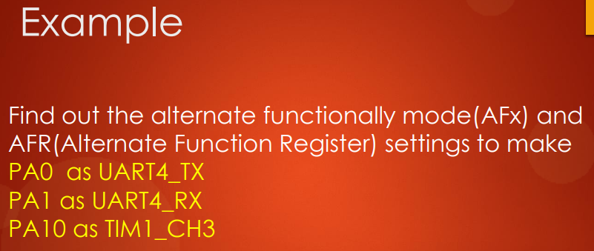

Let's take up this one by one. Let's first talk about PA0 as UART4_TX. Let's go to the ***Datasheet***.

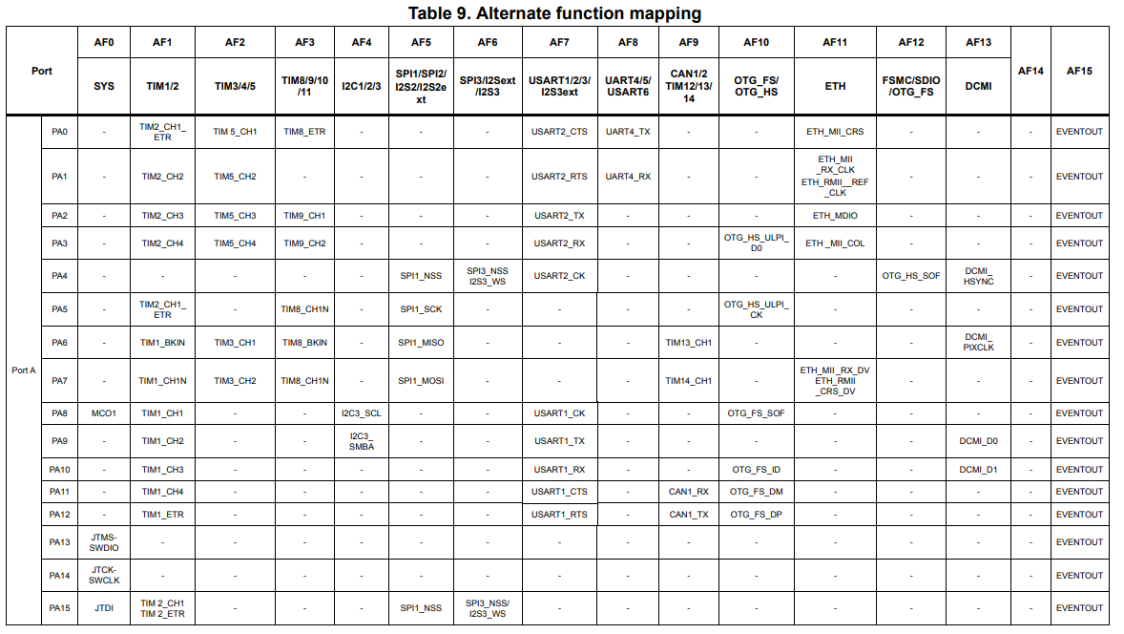

So, we are interested in PA0 as UART4_TX and we get AF8 as ***alternate functionality mode***. So, that's why ***AFX = AF8***.

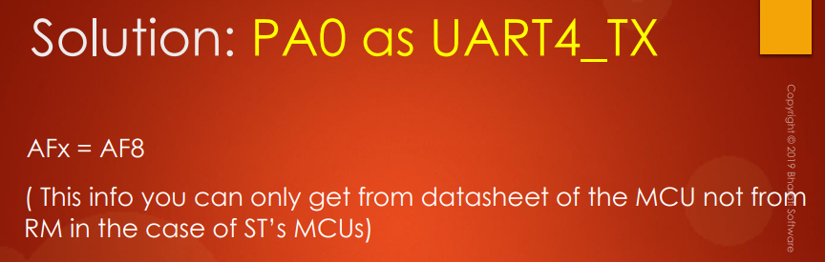

So, this info you can only get from the ***Datasheet*** of the MCU, not fromthe ***Reference Manual*** in the case of ST's MCUs.

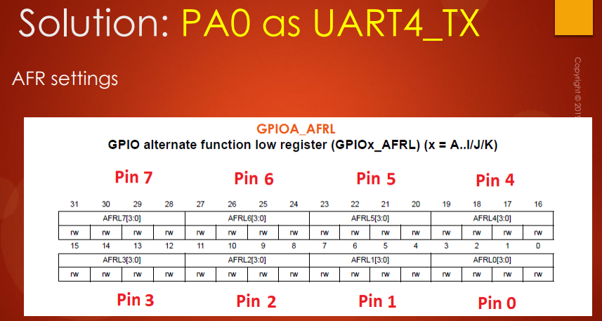

So, what are the ***AFR*** settings? Go to GPIO A alternate functionality low register. So why I have to consult Alternate functionality to low register? Because the pin is PA0: from 0 to 7 you have to refer to ***alternate functionality low register***. So, and here you have to configure this bit field. So, here you have to write the value 8 of ***AF8*** -> 8 means ***1 0 0 0***.

So, now the pin PA0 will be in alternate functionality mode 8, that means UART4_TX, according to the ***Datasheet***.

Let's move to the next solution ***PA1 as UART4_RX***.

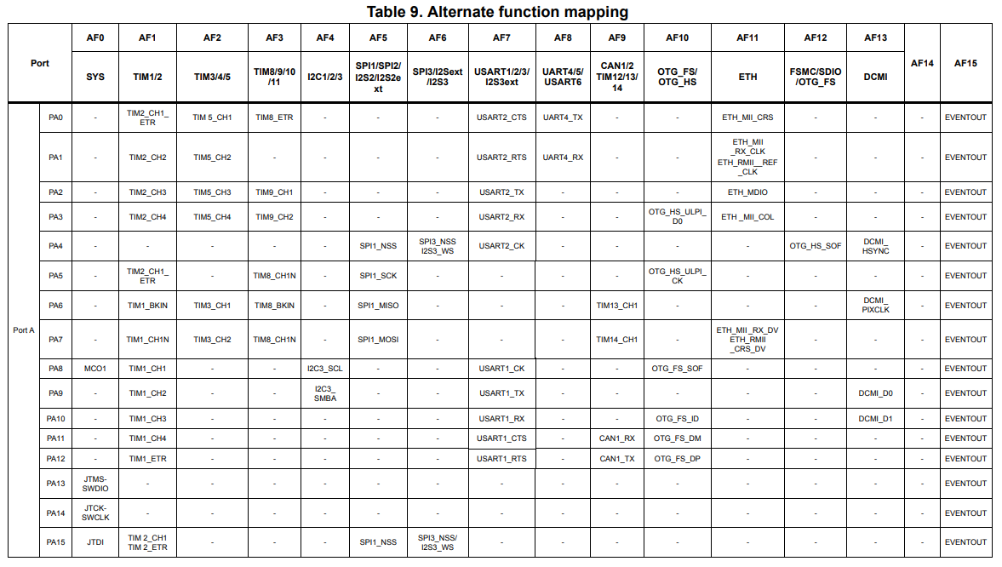

PA1 is in ***AF8*** it will behave as UART4_RX, that's why AFX is 8 and you have to configure the value 8 in ***alternate function low register*** in the bit position ***AFRL1***.

So, that’s why here you have to write 8:

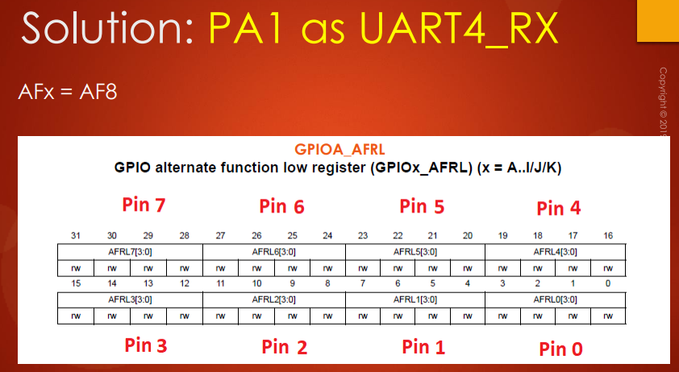

Let’s move to the other point of the exercise: ***PA10 as Channel 3 of timer 1***.

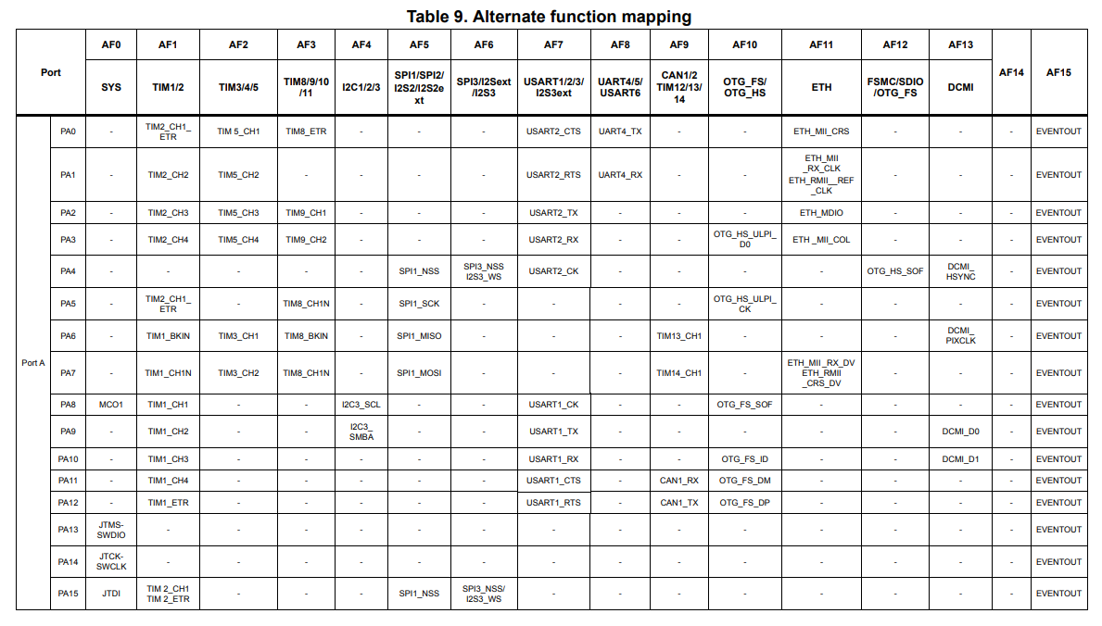

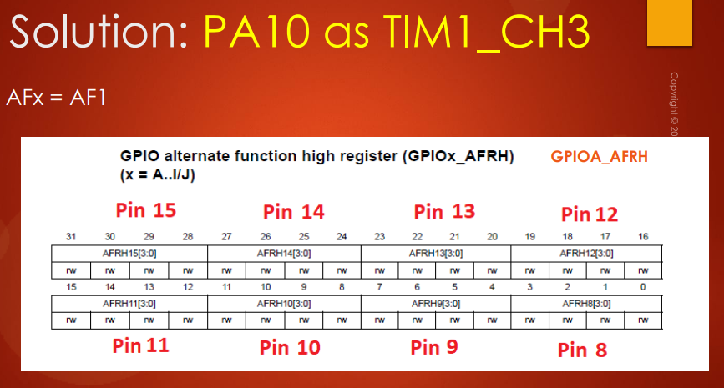

The pin number is 10. So, that's what you have to refer ***alternate function high register*** and GPIO port A. So, that's why the exact register will be GPIO A alternate function high register.

So you have to configure 1 (***AF1***) to the bit positions ***AFRH10***.

When the PA10 is kept in AF1 it will behave as timer 1 channel 3. So, that's why you have to store the value 0001 here.

So, that's how you should do alternate functionality settings for a particular GPIO pin.

I hope it is very easy to understand and let me know if you have any questions.

Just look at the ***Alternate function mapping*** table in ***Datasheet*** and you'll understand the technique used in order to assign the alternate functionalities for a GPIO pin and in the next lecture I will talk about the ***peripheral clock*** of the *GPIO port*. I'll see in the next lecture.

# Sezione 18: GPIO peripheral clock control

## 71. Enabling and disabling GPIO peripheral clock

Hey welcome back to the lecture. So, I'll quickly talk about ***enabling*** and ***disabling*** of ***GPIO port Peripheral clocks***. So, I have already explained this in the earlier part of the course, so I don't want to waste much time.

So, you already know that ***RCC*** is the engine which controls the clock for all the domain of the microcontroller, like AHB domain, APB domain, processor domain, memory domain etc.

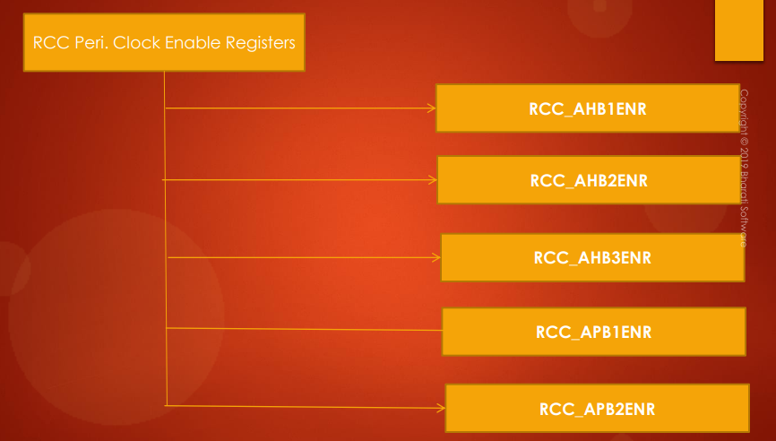

So, according to the block diagram in the ***Datasheet*** we know that various GPIO ports are actually connected or hanging on the AHB1 bus. That's why in the RCC register set so you have to go and consult the ***RCC AHB1ENR*** and there you will find the enabling and disabling bits to control the clock for various GPIO ports.

So, in the RCC registers, you have to go to the ***AHB1ENR***, there you will find bit positions to control clock for various GPIO ports from GPIO A to GPIO I

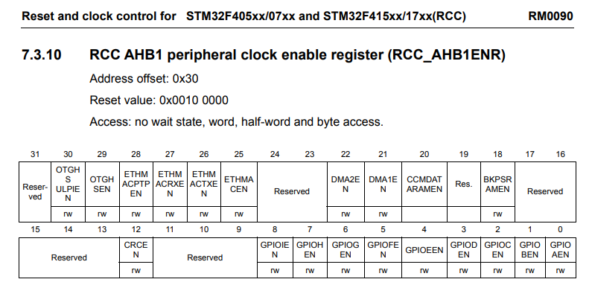

So, if you make the corresponding bit ***GPIOxEN*** as 1, the clock will be enabled. So, if you make any bit as 0, then the clock will be disabled.

So, that's about enabling and disabling peripheral clock for GPIO port. And I will see you in the next lecture.

# Sezione 19: GPIO driver development overview and project creation

## 72. GPIO driver development overview

From this lecture onwards let's get started with **peripheral driver development** and coding to develop our own driver. So, we have the knowledge of various modes of the GPIO peripheral and now we know that register details and lots of other details. So, let's begin.

First let's discuss the **high-level project architecture** that looks something like this:

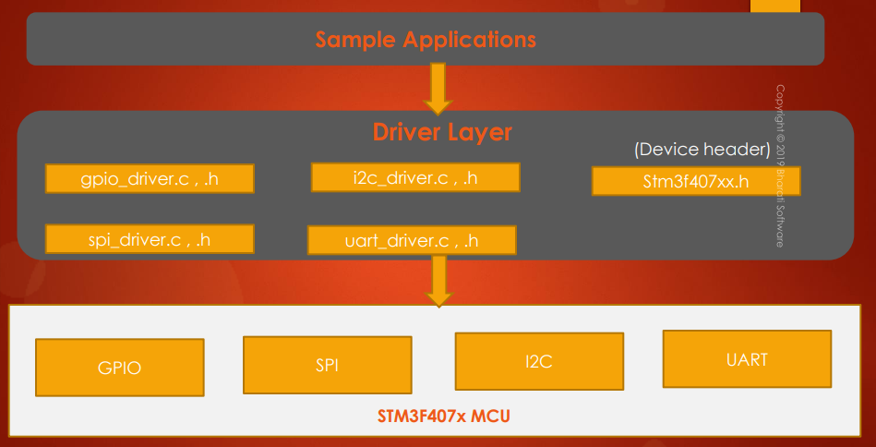

So, we'll be developing the ***driver layer***.

***Driver layer*** is the collection of various ***.c*** and ***.h*** files. We will be developing driver files for GPIO peripherals, SPI, I2C, UART. So, we will be working upon these 4 peripherals.

For each peripheral there will be its own driver *.c* file and driver *.h* file and we will code everything from scratch. When you code from scratch you will learn lots of internal details of the peripheral: how to code the registers and how to place the values, how to debug from the IDE, and lots of other details.

You can practically see and which will indeed help you to troubleshoot the issues you face when dealing with your project and also we have to write one ***device header file*** or strictly speaking this is specific to MCU, so it is called as ***MCU specific header file***.

So, in this case I am going to write ***stm32f407xx.h***. So, if your microcontroller is different, then you can give the name according to your microcontroller. Suppose if you are using STM32F446RE microcontroller, then you can just name it as like you know *stm32f446xx.h*.

So, let's create one file and we will place all the device specific details in that file, and we call that as ***device specific header file***.

And after that we can write the ***sample applications*** for GPIOs, I2C peripheral, SPI, UART in order to test how the driver is behaving and in order to validate our ***driver APIs***.

So, basically the ***driver layer*** actually exposes various ***APIs*** to the ***application layer*** (*sample application*).

The *sample application* will use the *APIs* provided by your *Driver file* in order to control the peripherals which are there in the microcontroller. Great! Now let's move forward.

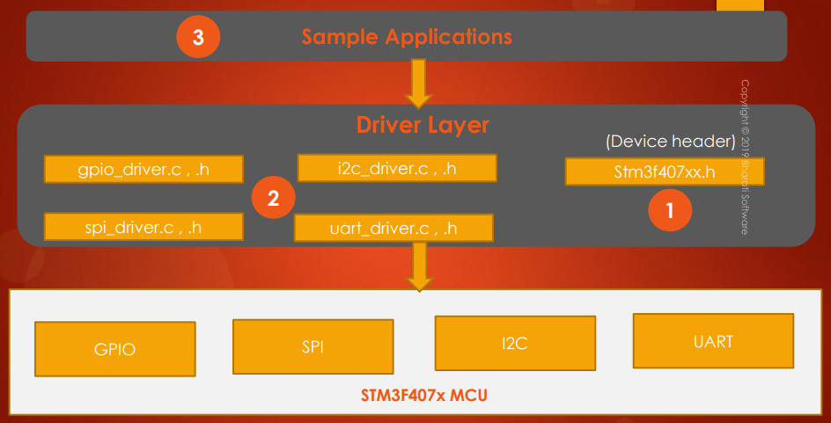

So, now the very first task of ours will be creating the ***device specific header file***. So, first, will create this file and we'll place all the microcontroller specific details into this file.

The second task of ours will be creating the respective *header file* as well as the *source file* for each peripheral. So, first let's begin with GPIO. Then we can move to SPI and then I2C and then UART.

Our third task will be creating ***sample applications*** in order to test our ***driver***.

First, we will develop ***GPIO driver*** and then we will write some ***sample applications***. We will test that, and if everything is working fine, then we'll move to SPI. We will develop the driver that and then will write some sample applications for SPI and we'll test that, and like that we will finish all the work. That means our first task is creating ***MCU specific header file***.

So, in the next lecture I will explain to you what exactly is ***device specific header file*** and what it contains. I'll see you in the next lecture.

## 73. MCU specific header file and its contents

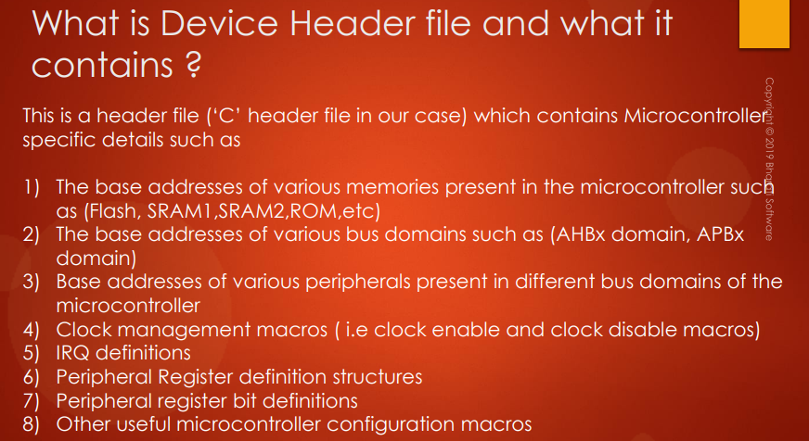

Welcome back to the lecture. So, now let us understand what exactly ***Device specific header file*** is and what it contains. This header file is a *C header file* in our case because we are using C programming, right?

Now it contains the microcontroller specific details such as the base addresses of various **memories** present in a microcontroller such as Flash, SRAM memories like SRAM1, SRAM2, ROM etc. It also contains the base addresses of various **bus domains** such as APB domain, AHB domain like that.

So, because all those base addresses are required in order to configure the peripheral or in order to program the peripheral.

After that, the base addresses of various **peripherals** present in a different **bus domain** such as APB1 APB2, AHB etc. Clock management macros like clock enable macros and clock disable macros in order to deal with the peripheral clock management of various peripherals and after that this device specific header file also contain the IRQ definitions, which are very helpful when you are doing *interrupt* related programming. So, all the IRQ definitions, priority definitions we can give in this file.

After that peripheral register definition structures: so, we have to create a C structure for every peripheral describing its **register sets**. I will guide you step by step as we make progress. Don't worry about that. So, basically what I want to say is this header file also contains the peripheral register definition structures and also if required we will also keep peripheral register bit definition. So we can explain through C macros each and every bit position of a register. Great!

And other useful microcontroller configuration macros which we can decide as we make progress to developing our driver. Great! So, let's move forward.

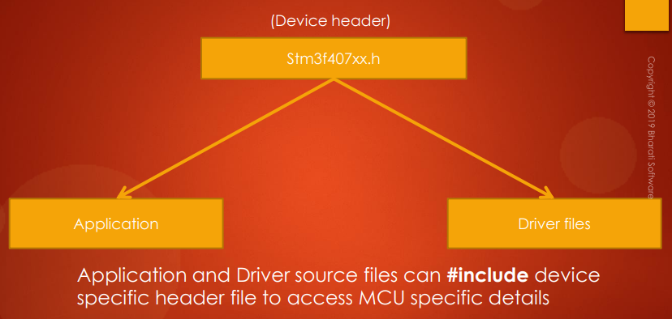

This ***device specific header file*** is actually used by both application layer and by the driver files. So, the application and driver source files can *#include* device specific header files to access MCU specific details. Great! Now let's move forward.

In the next lecture let's create ***MCU Device specific header file*** step by step and I'll see you in the next lecture.

## 74. New project creation and creating MCU specific header file

In this lecture, let's learn how to create a new project for our **driver** development task. So, now let's create new STM32 project. So, let me use my board. So, here give the project name: **stm32f4xx_drivers**. If you are using F1 based on microcontroller, then you can give f1xx, or f2xx, or lx whatever, that depends on your microcontroller. So, I'm just using f4xx_drivers. Okay? And after that use empty here. This option must be selected, because we are not going to use STM32Cube, since we are writing our own driver.

So, this must be executable, and after that just click on finish. So, you can see that, there are 2 folders here:

* ***Inc***, where you can keep your application header files.
* ***Src***, where you can keep your application source files.

So, this is an ***application layer***. So, now let's create a ***driver layer***. For that, I'm going to create a new folder. So, select this project, right click, new -> folder. So, let's give the folder name as ***drivers***, click finish. Now, inside this ***drivers*** let's create 2 more folders:

* ***Inc***
* ***Src***

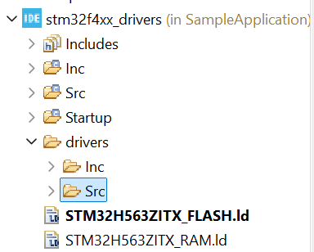

So, the folder ***“drivers/Inc”*** is used to keep ***driver header file*** and the folder ***“drivers/Src”*** will be used to keep ***driver source files***. And after that, you have to do one more important thing. So, right click on this ***drivers*** folder, go to properties, and go to C and C++ build. And here, you have to uncheck this ***Exclude resource from build***. So, just uncheck that, apply, and apply and close. And you can see that now it is included in the project.

*Quindi, di default, quando aggiungo una nuova* ***cartella*** *in un progetto, tale cartella viene esclusa dalla build.*

So, after that, now let's first create our ***device specific header file*** or ***microcontroller specific header file***. So, that header file I'm going to create under ***drivers/Inc.***

So, select that *Inc* folder, right click, new, header file. OK. Now let's give the name for our header file. So, I'm going to name it ***stm32f407xx.h***. So, if you are using let's say stm32f446re microcontroller, then you can do stm32 f446xx.h something like that. So, I'm going to name it like this. And after that, select *default C header file* template here, and click on finish. So, that creates a header file for you.

So, here we are going to keep all the *microcontroller specific details* what we discussed like base addresses of various memories of the microcontroller, base addresses of different bus domains, base addresses of different peripheral registers, clock enable/disable macros, and various other things we are going to include in this header file as C macros. So, basically this header file describes the microcontroller. So, complete up to here and I'll see you in the next lecture.

## 75. Include path settings

So, now we created this header file, right? So, now let's try to include that header file in ***main.c***. So, let's try that. So, we can include by using include directive. So, **#include "stm32f407xx.h"**.

So, when you try to compile this project you will get one famous error, ***No such file or directory***.

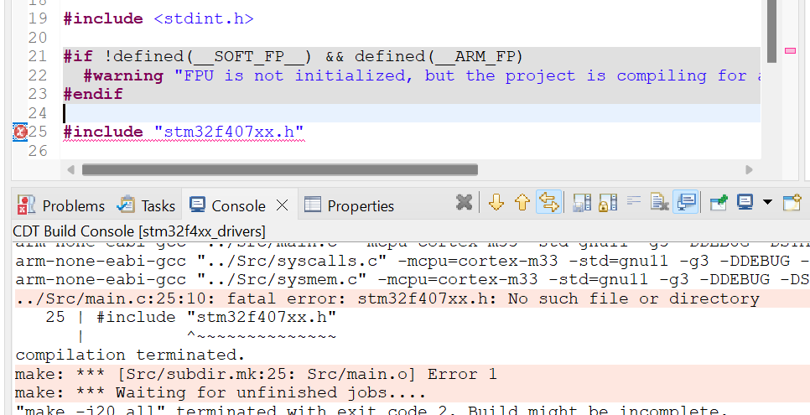

So, this error usually comes when your build setting is not properly configured. So, what happened here was, we created a new folder called ***drivers*** and we kept the header file in this folder, and that folder is actually unknown to the eclipse build system. So, you have to tell the eclipse build system that this header file is present over here. So, that we do by mentioning the path of that file in the eclipse build system. So, now what you have to do now is, you have to select the project, right click and go to *Properties*. And here go to *C and C++ build*, expand it, go to *Settings*. And after that, go to *MCU GCC compiler*. And here go to *Include paths*: here you have to add new include path. For that, click this ADD and go to workspace, ok? and select your project, and here we have to add this folder: ***drivers/Inc,*** because, that's a place where the header file is stored, isn't it? So, select that, click OK, and then OK. So, new path is added to the include path, and apply, apply and close.

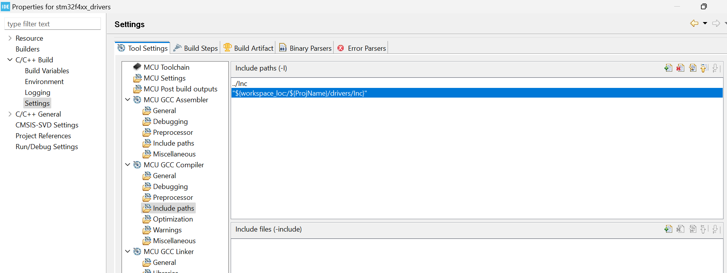

And now try to build the project. So, now you can see that, the build system is able to locate this header file. Now let's remove this header file from here. So, with that note I would like to end this lecture and I'll see you in the next lecture.

# Sezione 20: Updating MCU specific header file with bus domain and peripheral details

## 77. Writing base address C macros for MCU’s embedded memories: Part 1

Hey, welcome back to the lecture. So, now the very first thing what we're going to do is define the **base addresses** of **Flash** and **SRAM** memories. So, that means the embedded memories of the microcontroller. So, let's define the base addresses of those memories. So, now we can use C macros.

So, let me write #define FLASH_BASEADDR and let me also create #define SRAM1_BASEADDR and SRAM2 base address is not actually required for our application, because we will not be using it. So, in future, if we need it then we can add it. So, otherwise need not to add. And the main RAM is actually the SRAM1. So, that's why the SRAM is actually SRAM1 base address. So, the SRAM1 is called as main SRAM, that we simply call as SRAM.

So, now, what is the base address of Flash? You already know this, 0x0800 0000 and what is the base address of SRAM1, that is our main RAM in this microcontroller? So, RAM starts from 0x2000 0000, right? So, that's about the base addresses of flash and SRAM memory.

Remember that, by **default**, these numbers are considered as ***signed numbers***, right? So, compiler will by default treat every number as signed integer. But addresses can't be signed, right?? So, ***addresses*** always ***unsigned values***. Right? So, that's why to inform the compiler that these values are unsigned, you can either typecast this to ***(uint32_t)***, alright?? or what you can do is, instead of doing this, you can simply write ***'U'*** at the end of the value, so ***'U'*** means ***unsigned integer***.

So, this is to denote unsigned integers. So, we are actually by mentioning ***'U'***, we are indicating the compiler that this value is not signed, but ***unsigned***. You can just mention it as 'U'.

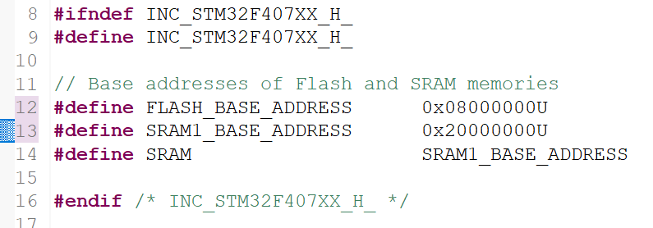

And I will also give you a small assignment or exercise to add the base address of SRAM2 as well as the base address of system memory, that is ROM. So, you can add these infos also. So, this information you can get from the ***Reference Manual*** itself.

You can go to the *Memory* and *Memory organization* or you can go to the *Embedded flash memory interface* and here you will get that info, that is, the ***flash memory*** starts from 0x0800 0000 and this is actually the flash memory, ***main memory*** means ***flash memory*** and system memory actually starts from this base.

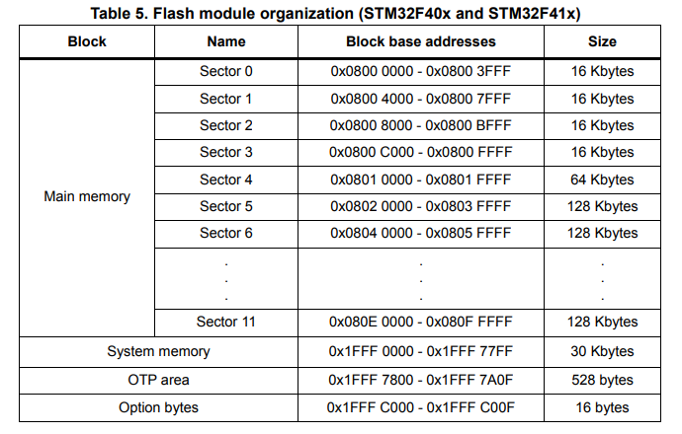

* ***Main memory = Flash memory***
* ***System memory = ROM***

This is the ROM area, remember that, it is of 30KB and OTP area you can also mention the base address of OTP area and other details. And you can get the SRAM details in memory and bus architecture, so you can just search for SRAM2.

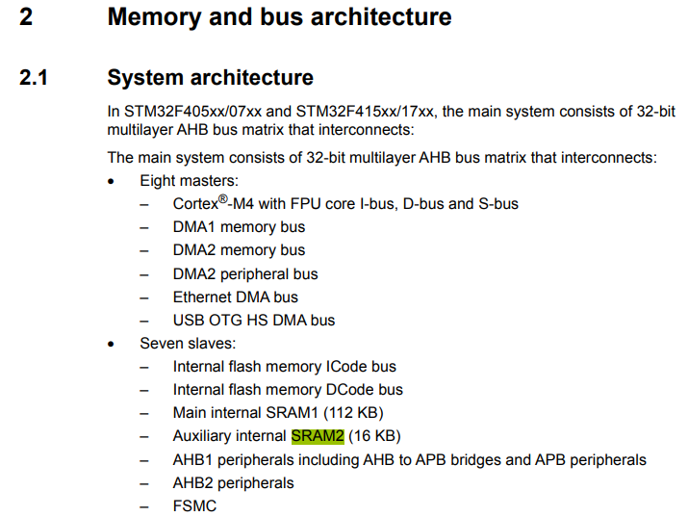

So, this is called as ***Auxiliary internal SRAM2*** which is of 16 KB which follows after SRAM1 whose size is 112 KB. So, you can calculate the SRAM2 base address and you can update in this header file if you ever need it. Great!! So, I hope you'll do that and I will see you in the next lecture.

## 78. Writing base address C macros for MCU’s embedded memories: Part 2

Let's complete this. So, SRAM2 base address. So, how do you calculate this? Actually we have SRAM1 of 112 KB, right? So, after 112 KB from this address, the SRAM2 appears, right? So, that's why we can calculate the base address of SRAM2 as something like this:

***SRAM2_BASE_ADDRESS = SRAM1_BASE_ADDRESS + SRAM1_SIZE***

So, we have 112 KB of SRAM1, these details you can get from *Memory and bus architecture* section. So, right here. So, main internal SRAM1 is 112 KB. So, 112 KB means 112 x 1024 bytes, right? And if I convert that into *hex*, so this is the value 0x1 C00, right?? So, I can say that a base address of SRAM2 is 1C00, right?? Correct?? And from here onwards SRAM2 starts and the base address of ROM is, this you can get from the ***Reference Manual*** again, you have to go to the *Embedded flash memory interface* and there you will get this table and here it is the ***System memory***, this is the ***ROM*** actually, so, this you can just copy.



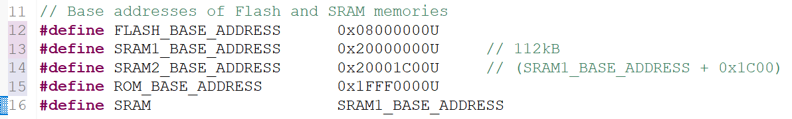

So, also remember that whenever you create C macros, it's always good to explain that macro. So, that's why let's create a small explanation area here. So, you can just create a comment section here. OK? And explain this macro briefly here. So, I'm not going to do that. So, I hope you will do that when you are documenting the code. Because documentation is very very important, remember. So, don't just leave something like this. Of course, this line can intuitively you can guess that yes, it's flash base address, but it's good if you document each macro. So, documentation is really important.

After that what we can do is, we can go one step ahead and we can create the macros for various ***bus domain*** such as ***AHBx*** and ***APBx***.

## 79. Defining base addresses of different bus domains

Hey, welcome back to the lecture. So, in this lecture let's define the base addresses of various ***bus domains*** present in our microcontroller such as ***AHB*** and ***APB***.

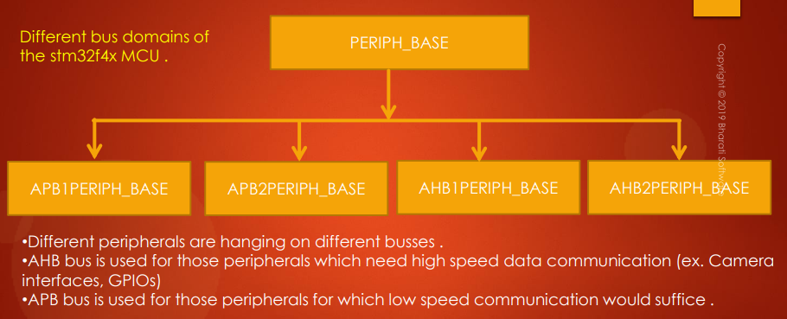

So, these are the different ***bus domains*** of the STM32F4x microcontroller and about the bus domains and about the base addresses we actually discussed in the earlier part of the course when we were discussing about the ***MCU bus interfaces***.

So, the ***peripheral base*** is divided into 4 sections:

* ***APB1 peripheral base***
* ***APB2 peripheral base***
* ***AHB1 peripheral base***
* ***AHB2 peripheral base***

and we have to mention the addresses of those peripheral base.

*Different peripherals* are hanging on *different buses*, right?

* ***AHB bus*** is used for those peripherals which need ***high-speed data communication***, example camera interfaces, GPIOs, etc…
* ***APB bus*** is used for those peripherals for which ***low-speed communication*** would suffice.

So, let's consider the memory map of the microcontroller. It starts from 0x0000 0000 to 0xFFFF FFFF:

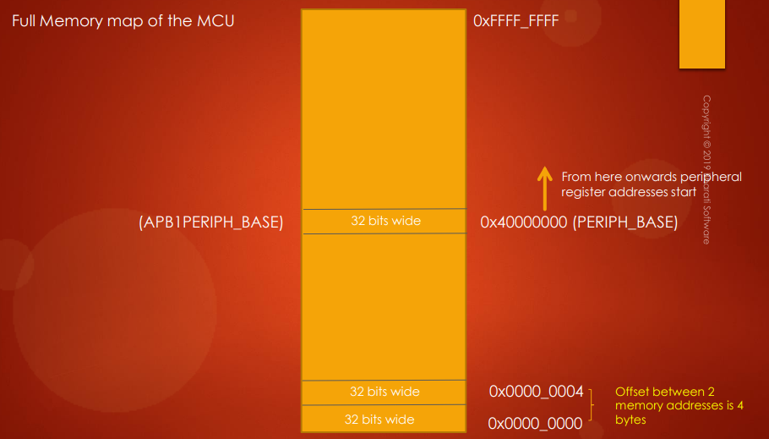

And the ***peripheral base*** starts from this address: ***0x4000 0000***. So, from here onwards, peripheral register addresses start. All right. Now let's not forward. Pause for a moment and find out 0x4000 0000 is the address of which register of which peripheral?

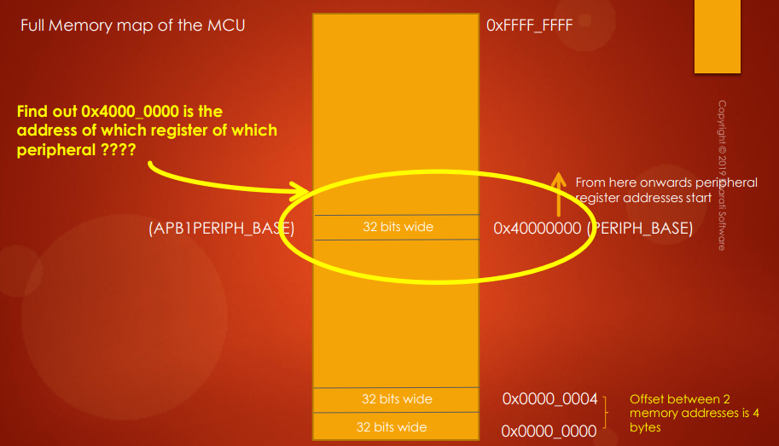

So, can you identify this by using the ***Reference Manual*** of the microcontroller. So, you have to tell the register name. So, we can find out the answer by going through the ***Reference Manual***.

In the ***Reference Manual***, I would go to ***Memory and bus architecture*** and here go to the ***Memory map*** and here you can get one table and this table you have to browse.

So, let's search for 0x4000 which is right here and let's search for 0000 and it is right here:

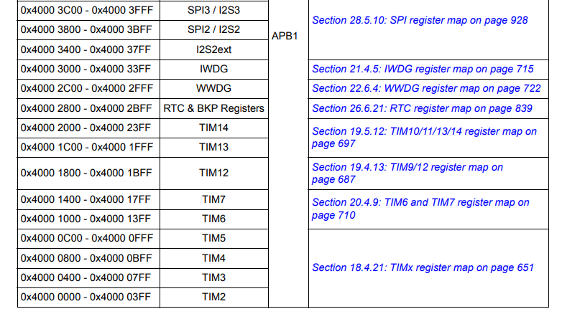

So, we know that, at 0x4000 0000, the first peripheral what we get is ***TIMER2***. So, ***TIM2*** is the first peripheral which appears on the ***peripheral base***.

And after that, you have to go to the TIM2 peripheral in order to find out what ***register*** it is. So, let's go to the TIM2 peripheral.

So, which is here, *18. General-purpose timers (TIM2 to TIM5)*.

All right. After that, go to *Registers*. So, just expand this, and after that browse here and go to *Register map* right here and here again can see that at offset 0 you get ***TIM2's control register 1*** (***TIM2_CR1***).

So, the **offset** is basically from the **base address** of that **peripheral**. So, we came to know that 0x4000 0000 is the base address of TIM2 peripheral and from that address, by adding these offsets, you can get the register address at 00.

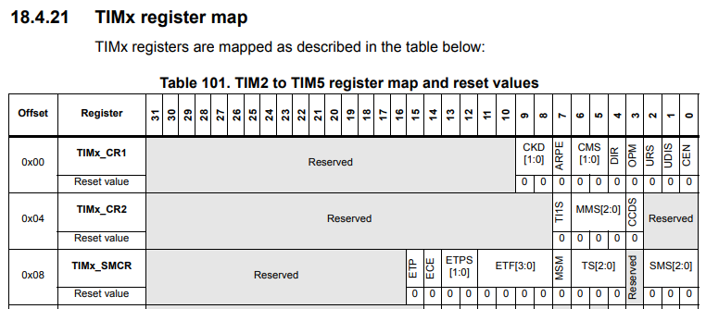

You will find ***TIM2***’s ***CR1*** register that is control register 1 and at 04, you will get TIM2's control register 2 like that. All right.

So, now the answer for this question is: at this location we actually find TIM2's CR1 register. Great! So, this may not be true in another microcontroller, you have to actually check the ***Reference Manual*** in order to understand what exactly the peripheral comes over there. Great! Now let's move forward.

So now let's quickly recap our different peripheral domain and the base addresses:

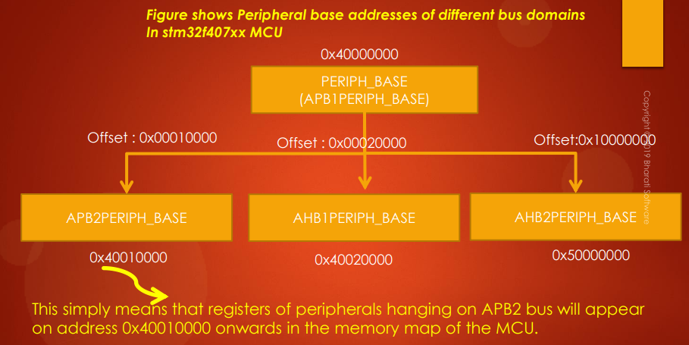

So, this figure shows ***peripheral base address*** of different ***bus domains*** present in this microcontroller. So, the peripheral base starts from here and that also happens to be the ***peripheral base*** of ***APB1 peripheral***. And from this address onwards you will find the registers of the peripherals which are hanging on APB2 bus start. So, 0x4001 0000 happens to be the base address of the APB2 peripheral base and 0x4002 0000 is the base address of the AHB1 peripheral. That means from this address onwards, the registers of the peripherals which are hanging on AHB1 bus will start.

And from the 0x50000000 address onwards, the registers of the peripherals of the AHB2 bus will start. So, it's like that. So, you have to document all these base addresses in your ***device specific header file***.

All right!! Now let's go back to our ***MCU specific header file***, and here let's *#define* all those values.

So, first of all let's define the peripheral base. So, what is the peripheral base?? So, this is a peripheral base, right?? And what will be the APB1 peripheral base?? So, APB1 peripheral base is nothing but the peripheral base, right?? So, that's why I have used this macro. And after that, the APB2 to peripheral base and APB2, AHB1 and AHB2 peripheral base addresses will be these things, right?? So, let's include them.

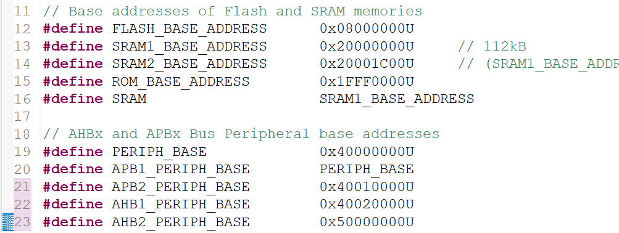

Alright!! So, I just included all these values over here. So, that completes defining ***base addresses*** of different ***bus domains*** of the microcontroller. And I will see you in the next lecture.

## 80. Defining base addresses of AHB1 Peripherals

Hey, welcome back to the lecture. So, in the previous lecture, you finished defining the base addresses of various bus domains. Let's go one step further and let's define **base addresses** of ***AHB1 peripherals***, ***APB1***, and ***APB2*** peripherals. So, now we will define the base addresses of all the required peripherals which are hanging on different bus domains.

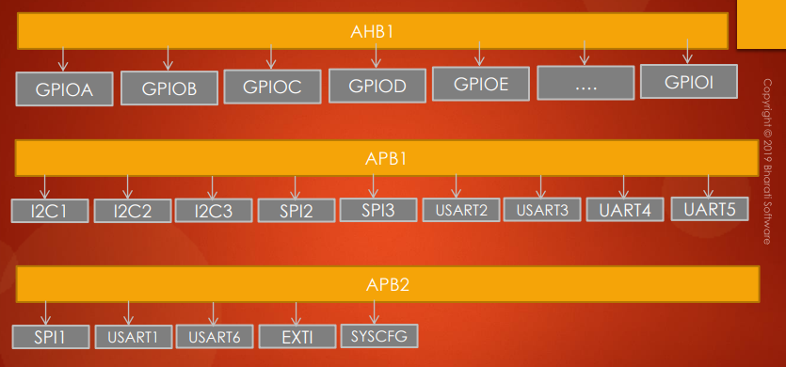

For example, in our case, we are using GPIOs, right?? We are developing drivers for GPIOs, right?? So, that driver should be applicable to all the GPIO ports which are present in the microcontroller. So, from GPIOA to GPIOI. And also we will be developing drivers for I2C peripherals, right?? So, there are 3 I2C peripherals are there in this microcontroller: I2C1, I2C2 and I2C3 they are actually hanging on APB1 bus. And also we have to develop driver for SPI peripheral, right? SPI. So, there are 3 SPI peripherals in which SPI2 and SPI3 is actually hanging on APB1 bus and SPI1 is hanging on APB2 bus. And also we have to develop driver for UART peripheral. So, there are around 6 USART peripherals and some of them are hanging on APB1 bus and some of them are hanging on APB2 bus. And also we'll be dealing with ***interrupts***, so, that's why we have to use this peripheral that is ***EXTI*** which stands for ***External Interrupt Controller***.

And also there is one more peripheral called ***System configuration peripheral*** and that also we will be using in this course.

So, now what we'll do is, in our ***MCU specific header file***, let's define the base address to each peripheral what we're going to use in this course. All right. So, now first let's define the base addresses of those peripherals which are hanging on AHB1 bus. The first peripheral I'm going to pick up is GPIOA. So, #define GPIOA_BASEADDR. How to calculate the GPIOA base address?? We know that it is hanging on AHB1 bus, right?? So, we have to take this as a base and you have to add the offset, right?? So, what is the offset?? So, offset you can get from the *Reference Manual*. So, if we go to the *Memory map* and let's search for GPIOA.

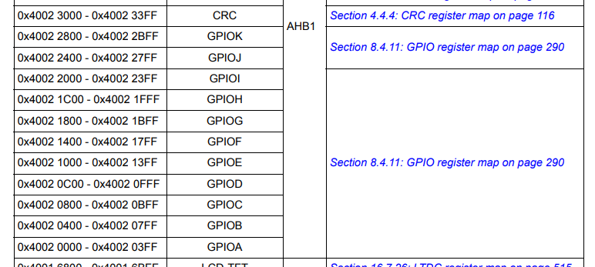

Right?? So, the offset is 0x0000, because GPIOA is the first peripheral which appears on the AHB1 bus. So, offset is 0x0000. All right. And after that GPIOB, so, GPIOB is right here and offset is 0x0400. Let's change this 0x0400. And like that complete for all the supported GPIO ports in your microcontroller and I'll see you in the next lecture.

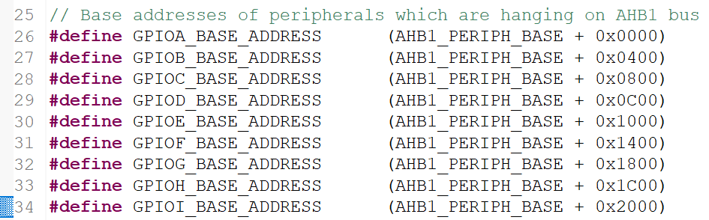

## 81. Defining base addresses of APB1 and APB2 peripherals

Hey, welcome back. So, I just completed these macros from GPIOA base address to GPIOI base address. So, I hope you have completed this. And now let's move on to defining base addresses of peripherals. Now, base addresses of peripherals which are hanging on APB1 bus. And what are the peripherals which are hanging on APB1 bus??

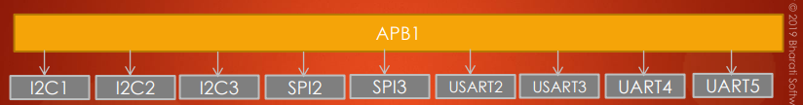

So, currently we are interested only these peripherals. So, let's define the base addresses for them. So, let me first start from I2C. Let's do it in alphabetical order. I2C1 base address which is nothing but the base address of the APB1, right?? from here, plus you have to add the *offset*. So, again let's get the offset right here and this is 0x5400 and let's add that 0x5400.

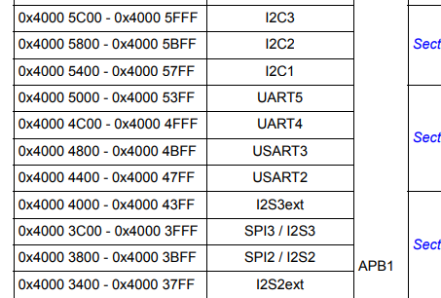

Complete for all other peripherals which are hanging on APB1 bus.

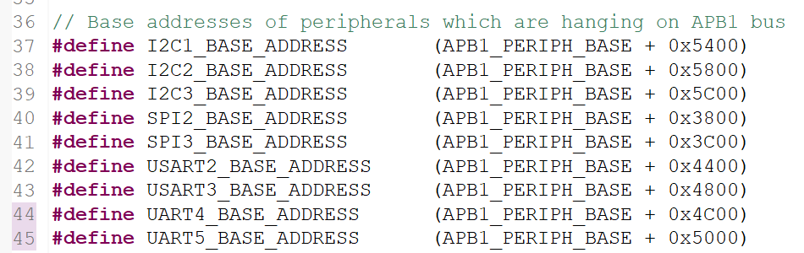

And as far as ***APB2*** is concerned, let's start from ***EXTI***. So, let me go here and let's #define EXTI_ BASEADDR. So, which is from APB2, right?

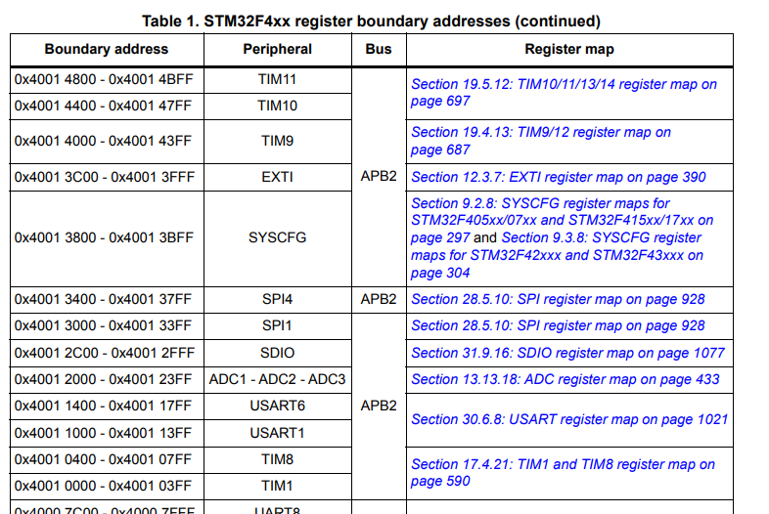

Base address plus so, let's search from *Memory map* and here it is, 0x3C00. Let's add 0x3C00. Great!! So, I have done for only one peripheral, so, complete for other peripherals. Alright! So, I have completed for EXTI, so, you have to do for all these peripherals.

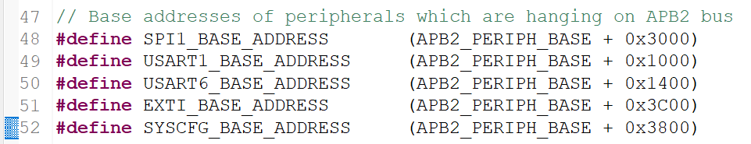

So, I hope you will do that and I'll see you in the next lecture.

## 82. Defining base addresses conclusion

Hey, welcome back to the course and did you manage to do that? So, it is very simple. Right? So, here it is so these are the ***base addresses*** of ***APB1 peripherals***.



And I actually #defined in alphabetical order and so remember that, when you name the ***UART*** peripheral so you should pay attention to the name. So, here you can see that there is a USART1 peripheral, USART2, USART3. And remember that these 4 and 5 are not called as USART, they are called as UART.

The difference between ***USART*** and ***UART*** is that UART peripheral doesn't supports ***synchronous communication***. So, UART peripheral has no capability to produce the output clock or serial clock. So, more on that will see when we discuss UART, and this peripheral also cannot work in ***synchronous mode***.

But ***USART*** peripheral can work both in ***synchronous*** as well as ***asynchronous mode***, so that's why it's called as USART. So, here you can see that I have used USART1 base, USART2 base, USART3 base, and UART4 base and UART5 base. All right. So, just note these points that's it.

So, we successfully *#defined* all the base addresses of the required ***peripherals***. Isn't it? So, this will be helpful when we code for the driver. So, if we want to touch a let's say the I2C peripheral then we can straightaway make use of this macro. So, it will be very helpful when we develop code.

You might have observed that here for all the ***C macros*** we have actually used the **capital letters**, right? so everywhere we used the capital letters. Some students they usually ask the question why not lowercase letters. And remember that, that is actually the coding style what we use in embedded system programming, that you know for C macros we actually use the capital letters. So, you can even use a lowercase letter, no problem. So, you can do that but that is not good coding style, so that's why I would suggest you to write macros in capital letters, and also whenever we are coding the *source file* that is *.c* file, so whenever we find an element which has all capital letters then we can immediately understand that this is actually a C macro.

So, some people what they do is they even give ***prefix*** to this macro, so something like this. You might have seen something like ***HAL_***. So, why they do like this is, so whenever they are coding some bigger project and when they find the prefix ***HAL_***, then they will immediately come to know that, so this macro actually belongs to the ***HAL layer header file***. So, in order to quickly identify the macro and where it lies, you can even use the suffix. So, here in this project we can even use the suffix ***DRV*** ***driver***. When we use that suffix we can immediately identify that macro that it belongs to the ***driver layer***.

Because, in a bigger project there are multiple layers like the low level layer, the driver layer, the middleware layer etc…

When you use too many macros in a project, there may be a chance that the middleware also uses the same macro name. So, then the compiler will issue an error that the macro is already defined. To escape from that kind of problem usually we use a suffixes like ***HAL_*** or ***LL_*** etc…

So, you can even use the suffix no problem. But it's OK, in this project let's not use any suffix. Great!

So, now let's move forward and let's see what our next task is.

Our next task is to understand the addresses of the peripheral registers. So, how to derive the address of individual register of a peripheral? So we actually coded the base address of the peripheral. Right? So now, from there we have to move forward and we have to calculate address of each register. I'll see you in the next lecture.

## 83. Address of peripheral registers

Let's see how to calculate the **address** of the **peripheral registers**. So, let's take an example.

Let's say, we have to calculate the address of all the registers which are there in the *GPIOA peripheral*.

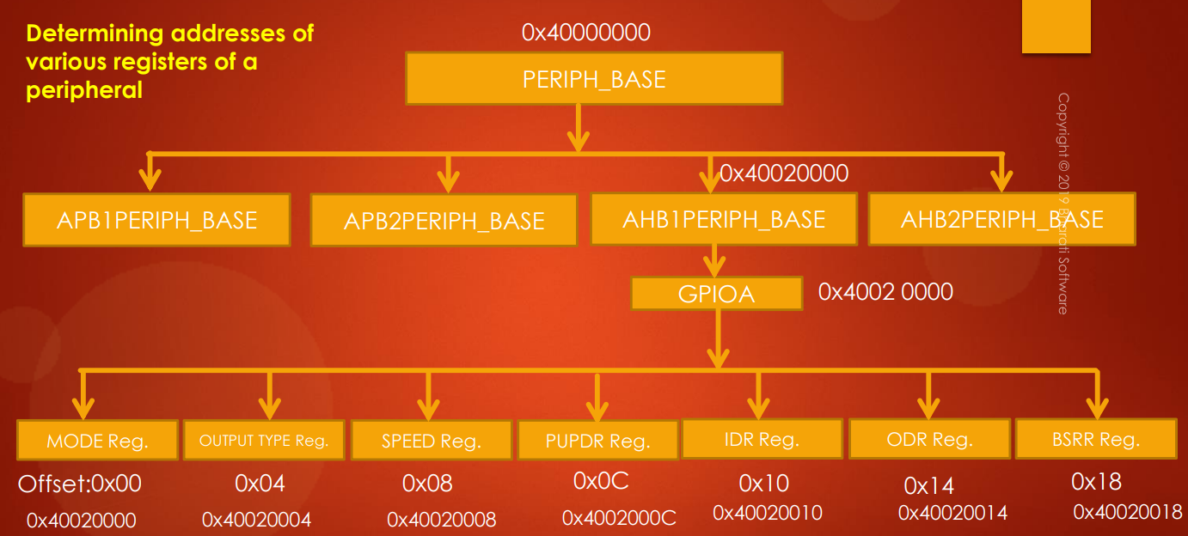

So, we know the *GPIOA peripheral base address* is *0x40020000*. Right? So, from there you have to add the **offset** given in the register description. Let's go to the register description of GPIO peripheral. So, let's go to the **GPIO section** in the ***Reference Manual***. Here, if you go to the registers. First register is ***GPIO Port mode register***.

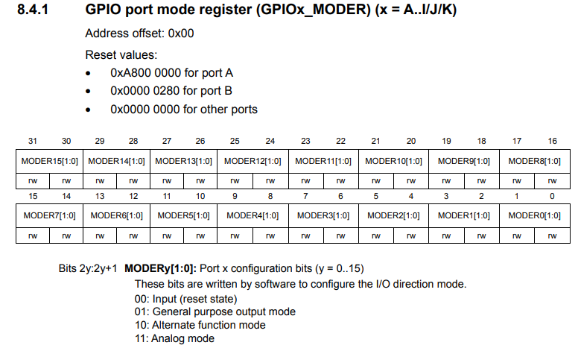

And there you will see **Address offset**, and you have to add it to the **base address** of that **peripheral**. That's it. So, that will give you the address of GPIO port mode register. That's why, they will only mention 0x00 here. So, which means that offset 0x00 from the base address of the GPIO port which you are using. So, that's why 0x40020000 will be the address of the ***mode register***, that is GPIOA mode register and 0x40020004 will be the address of a ***GPIOA output type register*** like that and so on.

So, each **register** is of **32 bits** (**4 bytes**) remember. So, hence you can see the offset of 4 bytes. So, that's why we can see that each register is 4 bytes apart in the memory map. Right? Great!! So, that's how you calculate the address of each register of a peripheral and now let's move forward.

There is a small exercise for you find out the base addresses of below registers of SPI1 peripheral.

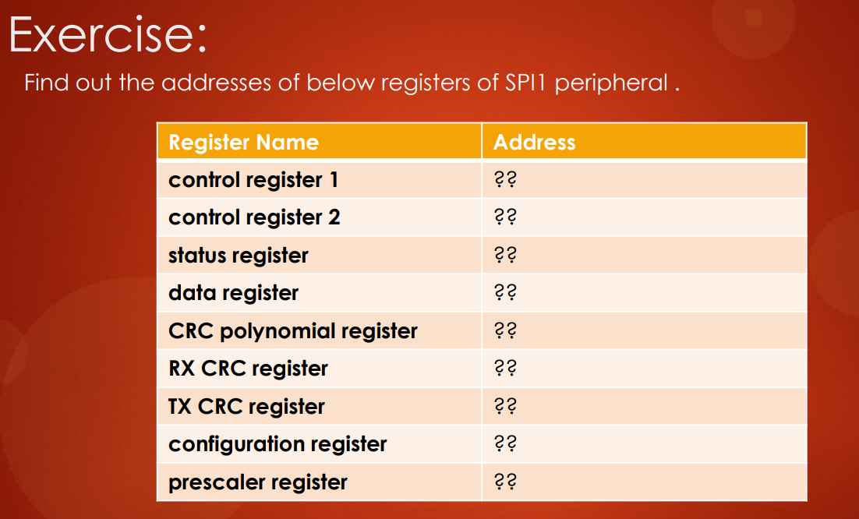

And I will see you in the next lecture. So, in the next lecture let's discuss about structuring peripheral register details.

## 84. Structuring Peripheral register details

Hey, welcome back to the lecture. So, in this lecture let's understand **structuring peripheral register details**, that means, there is a need to create *C structure* for each peripheral which contains all the register details. And let's understand why that is required.

If we go back to this diagram, let's say I want to configure the *GPIOA peripheral*.



Let's say I want to configure it's *mode*, it's *output type*, and I want to configure it's *speed*, a *pull up configuration*, etc.. Then, I have to store the appropriate value into these registers. Isn't it? So, for that in the program I have to use its dedicated **register address**. Isn't it? So, I have to dereference this address and I have to keep that value

So, that means from the program I have to access these addresses. Right? One way of dealing with this is you create macros for each register address in your **MCU specific header file**. That would be very tedious process. Why? Because, we have lots of peripherals and each peripheral has lots of registers creating register address macros for each register of the peripheral will be very tedious process.

There is one very efficient method and that method is creating a **C structure** for a **peripheral**. All right. So, let's take an example.

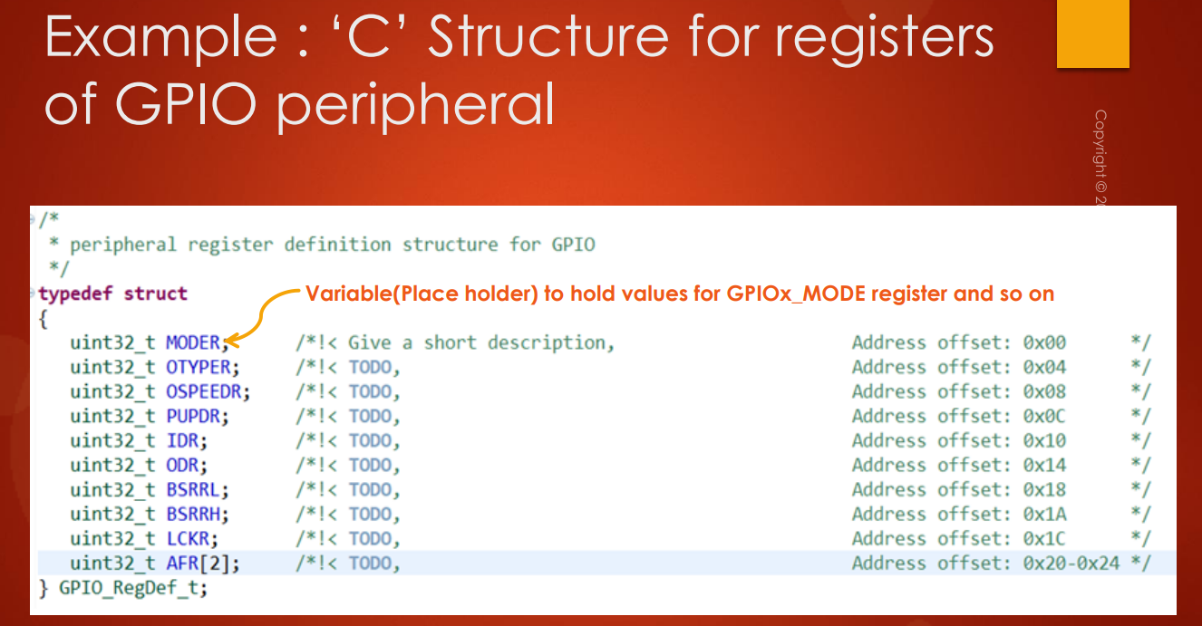

So, what you are seeing here is a C structure for **registers** of **GPIO peripheral**.

So, you will create a C structure for each **peripheral** and the member elements of that structure will be its **registers**. That means, for example, in the case of the peripheral GPIO so this is a generic structure for all the GPIO ports.

The first member element here is a variable. Right? A variable of data type ***unsigned int 32*** and this is a place holder or a variable to hold values for ***GPIOx mode register*** and so on.

So, remember that the data type of ***unsigned 32*** is used that's because, the **register** is of **32 bits** wide. All right. So, that's why it will be a very efficient method to a structure each peripheral. The similar structure we have to create for I2C also, for SPI also, for UART also, by taking the respective peripheral registers as member elements.

Quindi, creo una struttura in C in cui ogni variabile si riferisce ad un certo **registro** delle **periferiche GPIO**. Ogni **registro** occupa **4 byte**, di conseguenza mi basterà usare tutte variabili *uint32_t* in modo tale da riferirmi con ogni variabile ad un **registro** differente.

Ogni variabile, infatti, punterà ai 4 byte successivi, i quali corrispondono proprio al registro successivo. Quindi, mi basterà dichiarare un **puntatore** ad una struttura di tipo ***GPIO_RegDef_t*** ed inizializzarlo al ***base address*** della ***periferica GPIOA.***

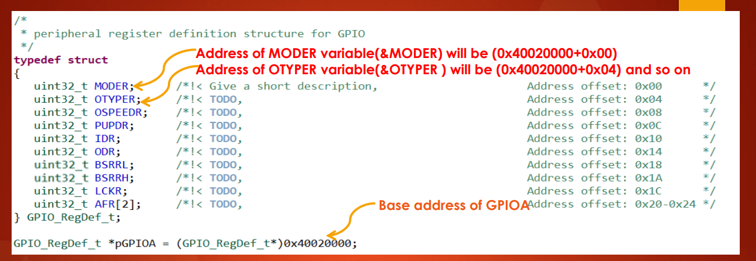

After creating this structure what have to do is, we have to create a *pointer* variable for that structure type. So, this structure type that is ***GPIO_RegDef_t***, where ***RegDef*** means ***Register Definition***.

So, we have to create a *pointer* to that register type and then we have to initialize that pointer to the **base address** of the **GPIO peripheral** in which you are interested. For example, I am interested in using or configuring the *GPIOA registers*. So, I initialize this pointer variable with the **base address** of the **GPIOA peripheral**. So, once you initialize that, then we can easily access all these member elements by just dereferencing that variable.

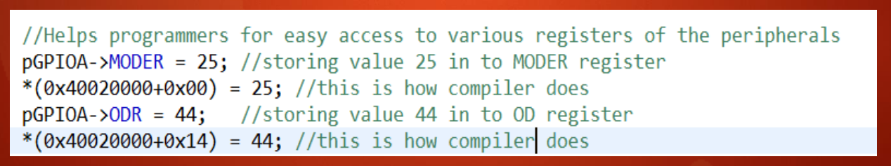

Suppose let's say I want to store the value 25 into the **MODER** **register** of the GPIOA peripheral. So, then what I would do in the program is I would simply reference that pointer and I select the **MODER register,** and I would store 25. So, this code is converted by the compiler like this. So, the base address which is 0x40020000 plus it adds 0x00. Because, the **MODER register** is at **offset** **0x00** from this address. Right?

So, the address of MODER variable will be 0x40020000, according to the C structure background. So, that means the compiler actually stores the value 25 into the MODER register.

So, suppose if I want to access the **ODR register** I can just dereference like this and I would store the value whatever I want into ODR and the compiler does something like this **0x14**, because, the **ODR** actually appears at the **offset 0x14**.

So, remember the data type used is *uint32_t*. So, MODER is at the offset 0, so that's why OTYPER will be at the offset 0x04 from this address (0x40020000). So, like that.

So, this is a very efficient method in order to touch all the **registers** of a given **peripheral**. All right. So, we have to create the C structure for each peripheral, and in the program whenever you want to access the registers you just create the pointer variable and initialize with the **peripheral base address**.

Let's move forward. So, now here instead of writing like this what I can do is, I can replace this code and I can simply write **GPIOA**, where the GPIOA is the *#define* below.

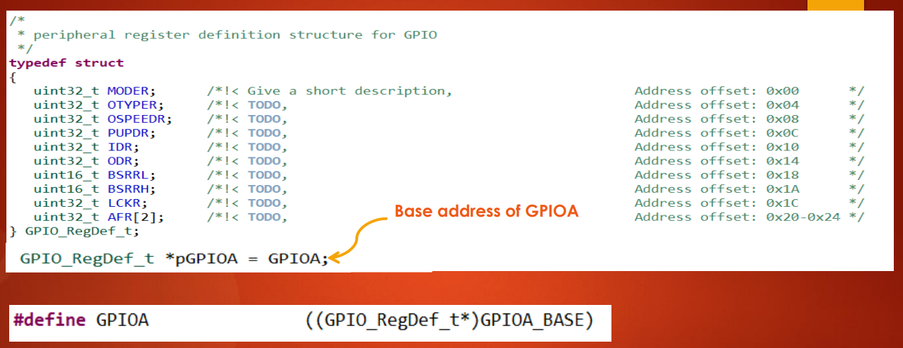

I can simply use the ***GPIOA base address*** what we defined in the ***MCU specific header file***.

So, all these things you will understand as we make a progress, don't worry about that. And now let's go to our ***MCU specific header file*** and now let's start writing the ***peripheral register definition structures***. There is a note remember that **registers** of a **peripheral** are specific to MCU.

For example, the number of registers of SPI peripheral of STM32F4x family of MCUs may be different, that is more or less, compared to number of registers of SPI peripheral of STM32Lx or STM32F0x family of MCUs. So, you have to check your device ***Reference Manual***.

The number of register may vary when the MCU family changes. So, don't worry about all those things you will understand when I take you through the ***Reference Manual***. The important section you have to refer in the ***Reference Manual*** when you create a peripheral structure is this ***Register map***.

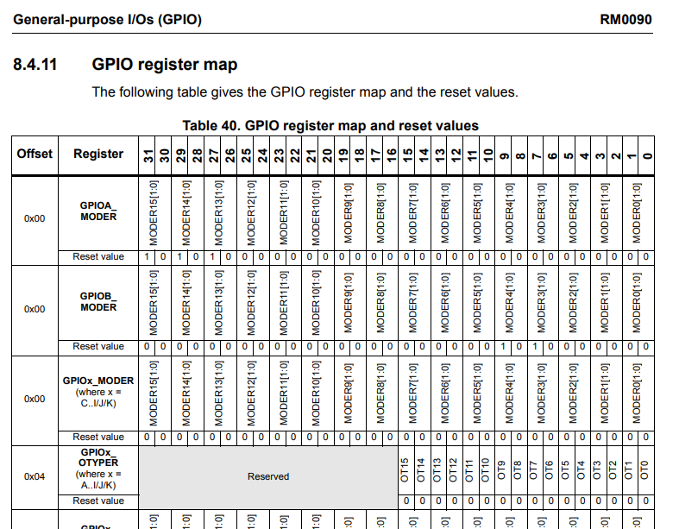

For example, first let's create a peripheral structure for the GPIO. So, what you have to do is, you have to go to the *GPIO section,* open the *GPIO register* don't look at these individual registers, you directly go to the ***Register map***.

The ***Register map*** actually gives you an idea of how to create the peripheral structure. Very very simple. Each *name* what you see here is actually a *member element*. That's it. So, just start coding.

So, let me just write typedef struct and let me give a typedef name for my structure, so let me call it as ***GPIO register definition structure***. So, I would called ***GPIO_RegDef_t***.

Remember that the data type you have to use is ***unsigned int 32*** for the member elements. First one is MODER register. So, just copy this name. So, need not to copy this GPIOA because this is a generic structure. So, let's copy MODER. All right. And then, just go next and let me create some more entries and after that move forward.

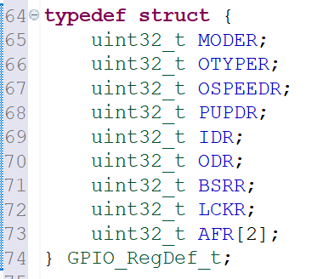

So, I just finished this **register definition structure** for a **GPIO peripheral**. So, you should pay attention to these numbers, these **address offset**.

So, 0x00 offset must go to the 0th offset, that is a MODER register.

0x04 offset is a output type and it should go to the 0x04 offset in your structure. If mismatch happens here then, you will end up programming wrong registers remember. And so we actually have 2 alternate function registers. Right? And *AF register low* and *AF register high*. So, instead of creating 2 separate variable I have just created an array here ***AFR[2]:***

* ***AFR[0]*** means alternate function register low ***AFRL*** register
* ***AFR[1]*** means alternate function register high ***AFRH***.

So, you can create an array of 2 elements ***AFR[2]*** or you can also write 2 variables ***AFRL*** & ***AFRH***, no problem.

So, we just created the **peripheral register definition structure** for **GPIO peripheral**, and don't forget to give a short description describing that member element.

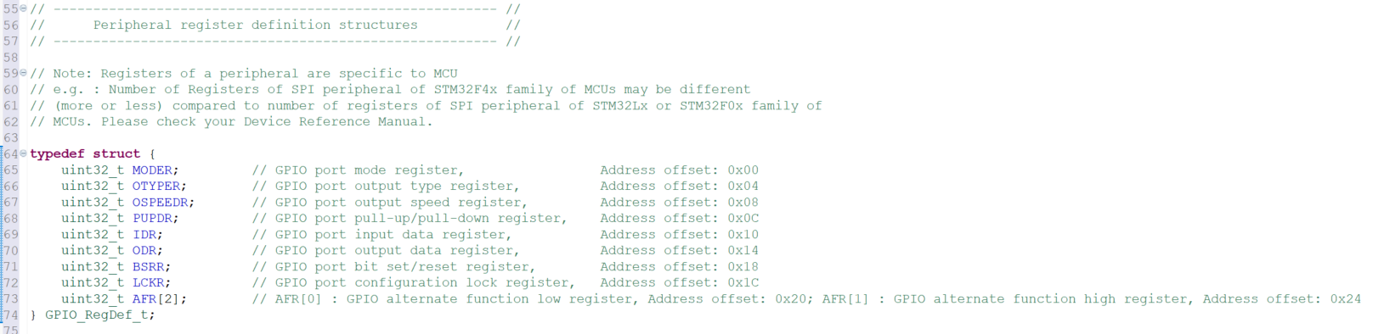

So, that is actually a good practice. That is to document the member element. You have to go to the register details, and you go to the respective register, and just copy this name that is sufficient. So, just copy that name and paste here. So, you can use this comment section in order to give some details regarding that member element. All right. And one more important change what you have to do here in this structure is, you have to use the ***volatile*** qualifier for these member elements, because, these member elements are actually used to refer to the **registers** of the **peripheral**. Right? Some registers may be highly *volatile* in nature.

For example, consider the **input data register** of the **GPIO port**: this is highly volatile in nature. Right? Why? Because, this register will get updated for each AHB clock cycle. Right? So, that's why it is very wise to use the ***volatile*** keyword for all the member element of a *peripheral structure*.

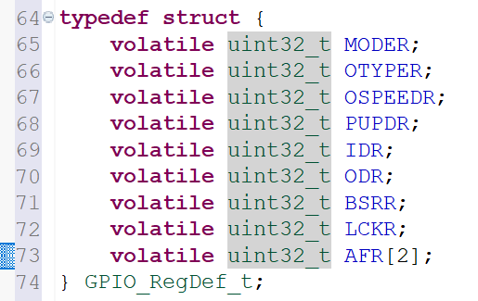

So, that's why I would suggest you to use the ***volatile*** keyword here. So, instead of writing volatile everywhere. So, what you can do is, you can simply write a shorthand notation for volatile.

***#define __vo volatile***

So, now let's use this ***__vo*** for every member element of the peripheral structure. And that's about using the ***volatile*** qualifier and it is really required. So, some of the member elements may not need this, but that's OK you can use for all the member elements of the peripheral structure, and after that, we have used this *shorthand notation* for **data type**: like ***uint32_t***, a ***uint16_t*** etc.. So, these *shorthand notations* are actually defined in ***standard library*** file that is ***<stdint.h>***.

So, that's why we have to *include* the *standard header file* ***<stdint.h>***, otherwise, compiler will through lots of errors as saying it cannot able to recognize this shorthand notation for the data type. So, don't forget to include this standard header file ***stdint.h***.

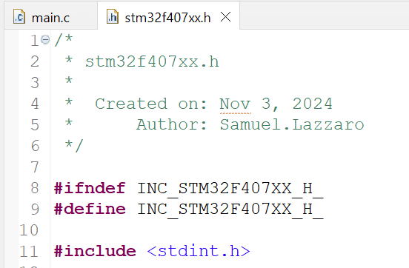

And after that, you have used many brackets here. So, be careful with that because, if you miss any brackets in between then compiler will through lots of errors and it is really hard to debug. So, most of the time it happens. So, that's why you had to cross verify whether the bracket is missing or not.

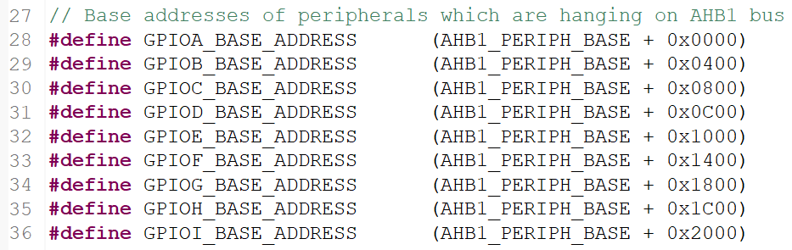

So, that's all about the Federal Register definition structure. So, as we make a progress we will create a new structure for new characters.

In the next lecture, let's create macros to enable and disable the peripheral clock. And I'll see you in the next lecture.

## 85. Peripheral definition macros

All right. So, now we have created this **peripheral register definition structure**. How to use that in our program? So, we have to create a *pointer variable* and then initialize that pointer variable to this value.

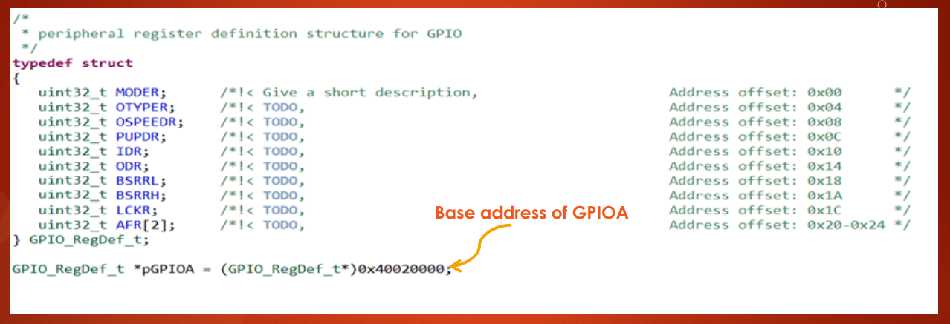

***GPIOA_BASE_ADDRESS***

So, that is the **base address** of the **GPIO port** in which we are interested. As I said, instead of writing these thing we can replace this number by **GPIO base address**. I can replace this value by ***GPIO_BASE_ADDRESS*** macro we have created. So, that's why instead of doing that. Right? So, that's why what we can do is, let's create another macro.

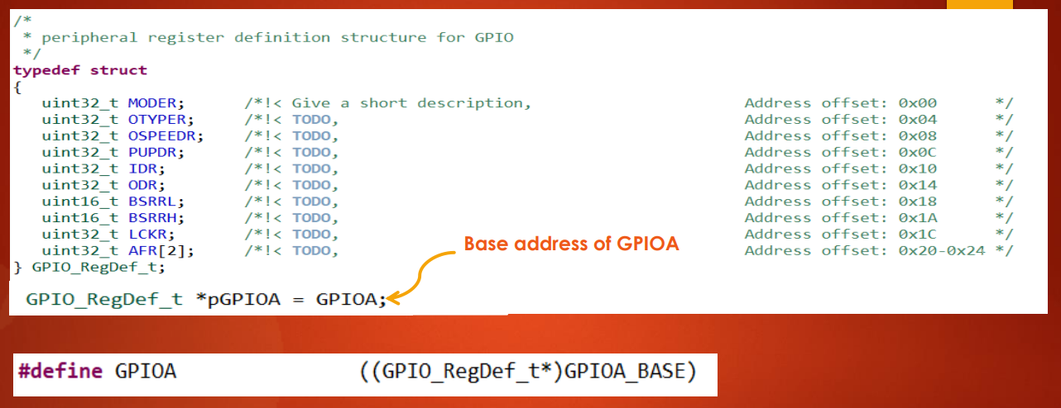

So, let's say GPIOA where GPIOA is equal to or *#define* to this value. So, that is the type casted a value of the **GPIOA_BASE_ADDRESS**. So, then we can directly use this macro wherever we need that. So, it is just creating one more macro called ***GPIOA*** which is actually equated to the type casted value of the **GPIOA_BASE_ADDRESS**, type casted to the pointer of the **GPIO register definition structure**. So, great. Now, let's do this. So, let's create these macros.

So, now let's go to the **MCU specific header file** and let's create that over here peripheral definition. So, we call it as ***Peripheral definitions***. This is actually the peripheral base address type casted to the *GPIO_RegDef_t* structure type. So, first let's create for GPIOA, so #define GPIOA. So, what we can do is, we can take the base address of the GPIOA and after that we have to type caste this address to this structure pointer type. All right. That's it. Similar thing you have to do for all the GPIO peripherals. So, let's do that. All right. So, these are nothing but just type casted value of this base address, that's it. Type casted to this structure pointer type. All right.

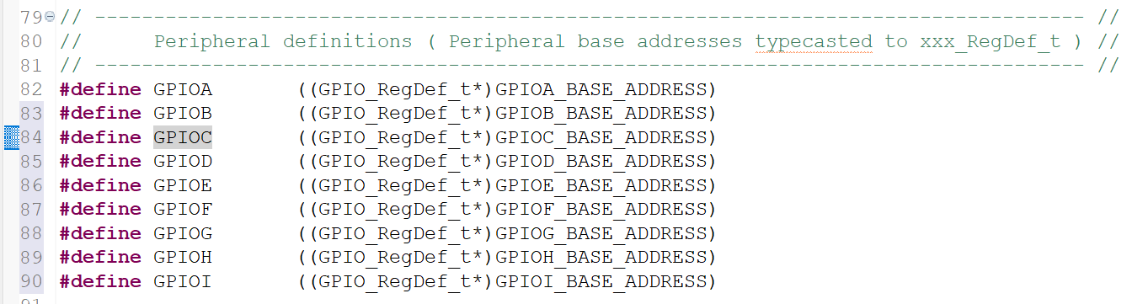

So, I have just done for **GPIO peripherals**. Later as we make a progress in this course will also do for other peripherals. And with that note I would like to end this lecture, and I hope you will complete up to here and I will see you in the next lecture.

So, in the next lecture let's create some macros in order to control the **peripheral clock**. That is to enable the peripheral clock and to disable the peripheral clock. So, we have to create some macros for that.

You already know that the **clock control** happens from the **RCC peripheral**. Right? So, that's why what we have to do now is, I will give you a small exercise. So, now we actually have to deal with RCC registers. Right? So, let's go to the **RCC register**. RCC also has many registers you can check the **register map**.

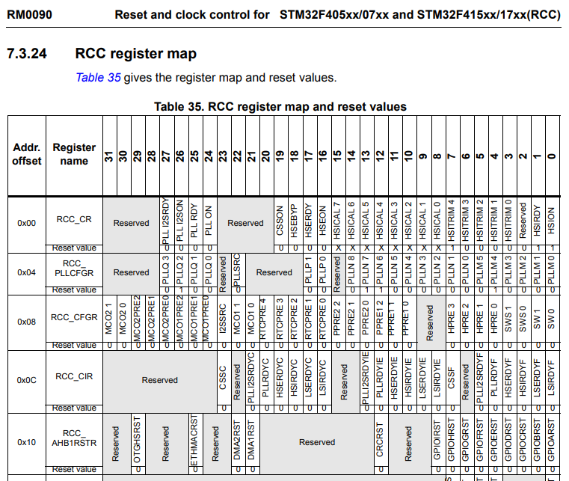

But, we don't have the **peripheral register definition structure** for this **RCC peripheral**. Right? So, that's why I would suggest you to create one more structure that is **peripheral register definition structure** for **RCC** by including all it's register as member element. So, similar thing you have to do what you just did for creating this structure. So, let me just create one more structure here, typedef struct. So, this will be for **RCC**. So, just give ***RCC_RegDef_t***.

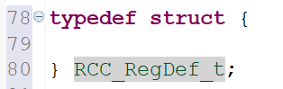

Then populate this structure with the register details of the RCC peripheral and I will see you in the next lecture. So, I hope you will do that and the next lecture I will complete this. I will see you in the next lecture.

# Sezione 22: Writing Clock enable and disable macros

## 86. Writing peripheral clock enable and disable C macros

Hey, welcome back. I hope you have created the peripheral structure for RCC peripheral. So, here it is. It's actually quite long. Here you can see that, so but I will give you some details regarding that.

So, in the register map you have to follow these offset: 0x00 has to be the first member element that happens to be the **CR**. So, like that I have coded this **PLLCFGR** should be at the offset 0x04. So, when you include all these things. So, here it is.

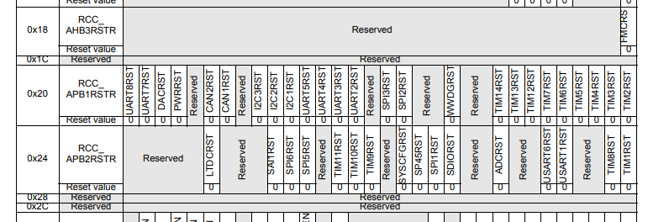

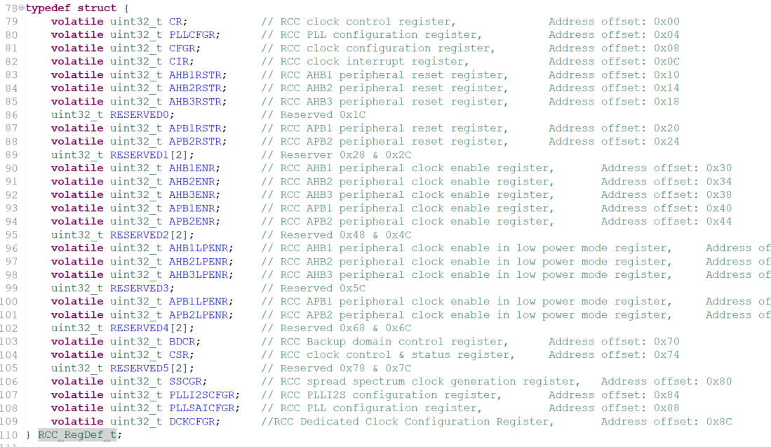

So, after 0x18 the register 0x1C is actually **reserved**. So, that's why you should give a space for that register also. That is a **reserved register**. So, that's why I have written **RESERVED0**.

So, the offset 0x1C is reserved. And after that, again you will find 2 more reserved registers at 0x48 and 0x4C. So, you should not eliminate that in the structure you should keep that. So, whenever you find 2, so you can make an array no problem (as **RESERVED1[2]**). Otherwise, you can mention it as **RESERVED1**, RESERVED2 etc... All right.

So, we will not use most of the register in this RCC peripheral, but a couple of them we definitely use. Great!! And after that what you have to do is, you have to give a peripheral definition for RCC also. So, let's **#define RCC** and create this value. And here you have to mention **RCC_BASE_ADDRESS**.

So, do you have RCC base address? Check. I don't think we have created that, so **RCC_BASE_ADDRESS**. So, no we didn't create that. So, where exactly the RCC is hanging? So, you have to check that. **RCC** actually comes under we can check that, it is actually connected to **AHB1 bus**.

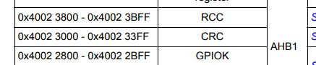

Let's create the base address **RCC_BASE_ADDRESS**. Right? It is at the offset **0x3800** from AHB1 bus base address.

**#define** RCC ((RCC_RegDef_t*))RCC_BASE_ADDRESS)

So, after that in our MCU specific header file will also create some peripheral clock **enable** and **disable** macros. Because, these macros will be very helpful while we try to enable the clock for our peripheral or disable the clock for our peripheral. So, we can straightaway use these macro what we are going to create now. Great! So, let me start with **GPIO**. So, first let's create clock enable macros for GPIOx peripherals. Let me create the macro **#define GPIOA_PERI_CLOCK_ENABLE()**.

So, this is a macro I want to create. And similarly, we will create for GPIO B C D etc...

So, that you can always do. I will show you how to create for one peripheral. In order to enable the clock we have to touch the RCC peripheral. Right? So, that is why we can use this peripheral definition **RCC**. And we can dereference that, because anyway in this address is type casted to this register definition structure. Right? So, we can dereference that because this is actually initialize to the RCC based address type casted to this register type. So, that's why I can deference this RCC and we have to select register **AHB1ENR**. Isn't it? So, let's select **RCC->AHB1ENR**.

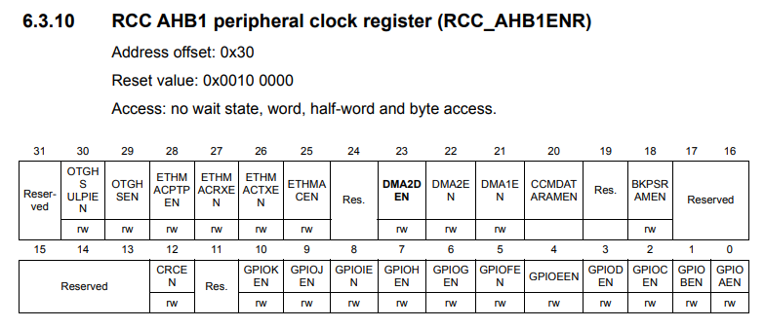

All right. So, to enable GPIOA clock we have to turn on the bit 0. Right? So, that's why we can do the bitwise OR with 1 shifted by 0. So, let's keep all these thing in brackets.

All right. So, very simple. Isn't it? So, in the RCC registers if we go to AHB1ENR, so the 0th bit position is to control the clock for GPIOA. Right? So, that's why I used the bit position as 0 and I am making this bit as 1.

**#define** GPIOA_PERI_CLOCK_ENABLE() ( RCC->AHB1ENR |= (1 << 0) )

All right. And here you can see that this is not a good macro name, because there are too many characters and always remember that you have to convey the details of that macro by using less characters, always an aim to minimize the characters involved in a macro.

For example, here, instead of **ENABLE** I can just write **EN**. Because, in embedded world or in embedded programming it is understood that:

* **EN** means **enable**
* **DI** means **disable**

So, I can just use the **EN** here.

And also **PERI_CLOCK**, so this is a long word. Right? So, I can just replace that by **PCLK**. So, **PCLK** means **peripheral clock**.

Also some people instead of using **GPIOA**, they will just write **PA** (Port A). So, that is also good but I don't want to use that. So, let me write **GPIOA**. So, you can see that it is a short name but it also conveys the same message: **GPIOA peripheral clock enable**.

**#define** GPIOA_PCLK_EN() ( RCC->AHB1ENR |= (1 << 0) )

All right. Great! Now, how to do this for GPIOB? So, let's create one more macro GPIOB and here it should be 1. The bit position is 1.

**#define** GPIOB_PCLK_EN() ( RCC->AHB1ENR |= (1 << 1) )

Right? So, similarly complete for other GPIO peripherals. So, I will leave that as an assignment. And after that, let's write clock enable macros for **I2C peripheral**. So, now there are three I2C peripheral and **APB1ENR** and let's go to APB1ENR.

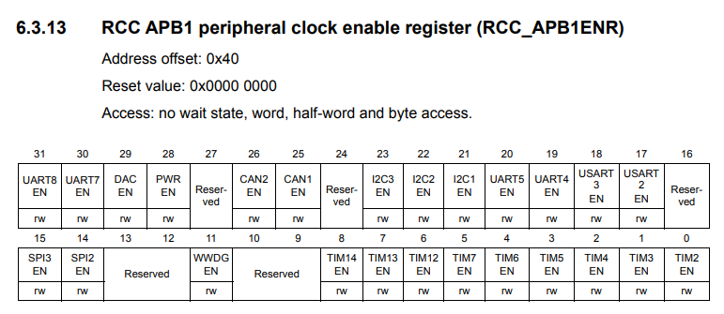

And here it is APB1ENR and the bit position is actually 21. So, we have to make this 21. So, the meaning of this is I am making bit 21 as 1 in this register.

**#define** I2C1_PCLK_EN() ( RCC->APB1ENR |= (1 << 21) )

Complete for other peripherals.

So, now let's me move onto **SPI** and let's create a similar macro. So, here I will write SPI1. So, SPI1 is not there on APB1. Right? So, you have to go to **APB2**, it is right here.

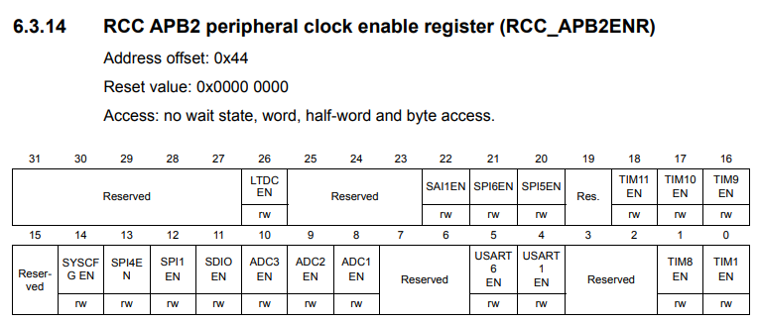

SPI1 so bit 12. So, APB2 and bit 12. All right.

**#define** SPI1_PCLK_EN() ( RCC->APB2ENR |= (1 << 12) )

And after that, complete for **USART** and also complete for **SYS configuration peripheral**, and also create **clock disable macro**.

So, I will show you for one peripheral, so let me just copy this and go right here. Clock disable macros for GPIOx peripheral. So, I will make it as **DI** disable and I have to reset that bit.

In embedded programming we use:

* **|=** (**bitwise OR**) ->to set a bit
* **&=** (**bitwise AND**) -> to reset a bit

So, we have to reset here. Right? So, AND is equal to so negation of 1 shifted by 0. So, this is a way to clear a bit. So, basically this is cleared now using **&= ~(1 …)**.

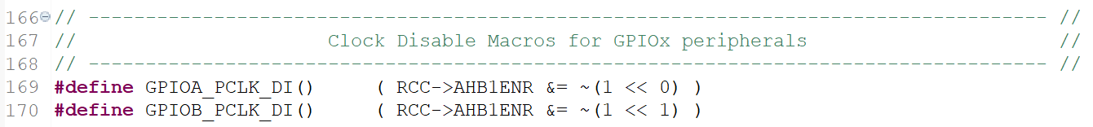

So, the first bit position is cleared. So, keep changing this according to your bit position.

So, complete for all these peripherals and that will be your task for this lecture and I will see you in the next lecture.

## 87. Project include settings and build

Hey, welcome back to the lecture. So, we have partially completed our device specific header file. So, currently our device specific header file contains the required base addresses for various memories, various bus domains, for various peripherals, and also the required peripheral register definition structures, and also clock enable and disable macro.

So, still we have to add **IRQ numbers** and other details we will do that as we make a progress.

After this let's create the **driver source file** and **driver header file**.

But, before that let's see whether this project build successfully or not. Before building this project so, what I would suggest you to do is, go to your source here and create a source file a dummy source file. Now, let's create a source file let's say main.c. So, this is just to build the project. And here in the main.c include your device specific header file what you have created, that is STM32F407xx.h. And after that just write one dummy function int main. The eclipse build system will not able to recognize a this header file actually. Because, you have to tell the path of that header file to the build system.For that what you have to do is, you have to right click on the project. This is very very important step so you have to do this, otherwise you will end up seeing the error no such file or directory.

Io avevo già incluso correttamente la directory dell’header file.

So, go to *Properties*, and after that go *C / C++ build*, just expand that. Go to *Settings* and go to *Include*. So, I have one entry here I will just remove that. So, you will see full blank over here.

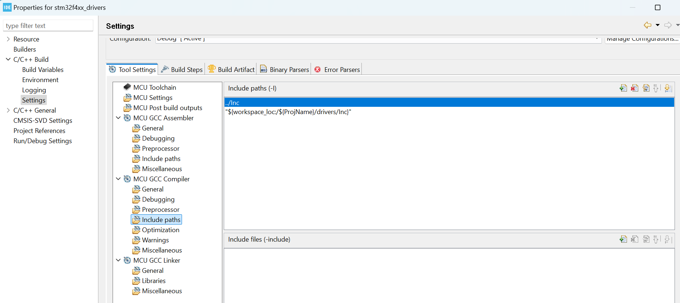

So, just click on includes. Remember that, under *GCC compiler*. All right. And click on this *+ icon* here, and then click on this workspace, and point to the location where that device specific header file is stored.

That is under drivers under inc. Right? So, select this click OK, click OK, and after that apply, yes and OK, and now let's rebuild the project. Let's clean the project and let's rebuild the project. And here it is the project compile successfully. So, that means So, whatever we have written here doesn't contain any error. So, if I just place any character over here the build failed. So, that means the compiler is really including our header file. That's great. And in the next lecture, let's create the driver source file and header file. I'll see you in the next lecture.

# Sezione 23: GPIO driver API requirements and handle structure

## 88. Creating GPIO driver header and source file

Hey welcome back to the lecture.

Let's create driver .c and driver .h file.

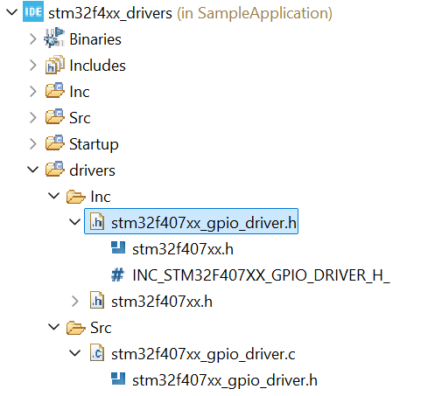

The **driver source file** ***stm32f407xx_gpio_driver.c*** always should contain the **driver header file** ***stm32f407xx_gpio_driver.h***. So, that's why the first thing what we have to do is include the respective header file that is ***stm32f407xx_gpio_driver.h***.

The **driver header file** ***strm32f407xx_gpio_driver.h*** should contain the **MCU specific header file** ***stm32f407xx.h.***

Now we have 2 header files:

* MCU specific header file ***stm32f407xx.h***
* Driver specific header file ***stm32f407xx_gpio_driver.h***

MCU specific header file where contains MCU specific data, while driver specific header file contains driver specific data. So, we'll see what are those drivers specific data in the next lecture.

## 89. Defining GPIO handle and configuration structure

Hey welcome back to the lecture, now in this lecture lets discuss about the **driver specific data** that is the **GPIO handle and configuration structure** which will be using to work with the **GPIO peripheral**.

The driver that we are developing is the driver APIs that we are about to write in this course. So, ultimately who is going to use that? This is going to be used by the user application. So, the user application may want to initialize or use a different GPIO ports or the user application may change the PIN number. It can change the GPIO modes, speed, output type etc.

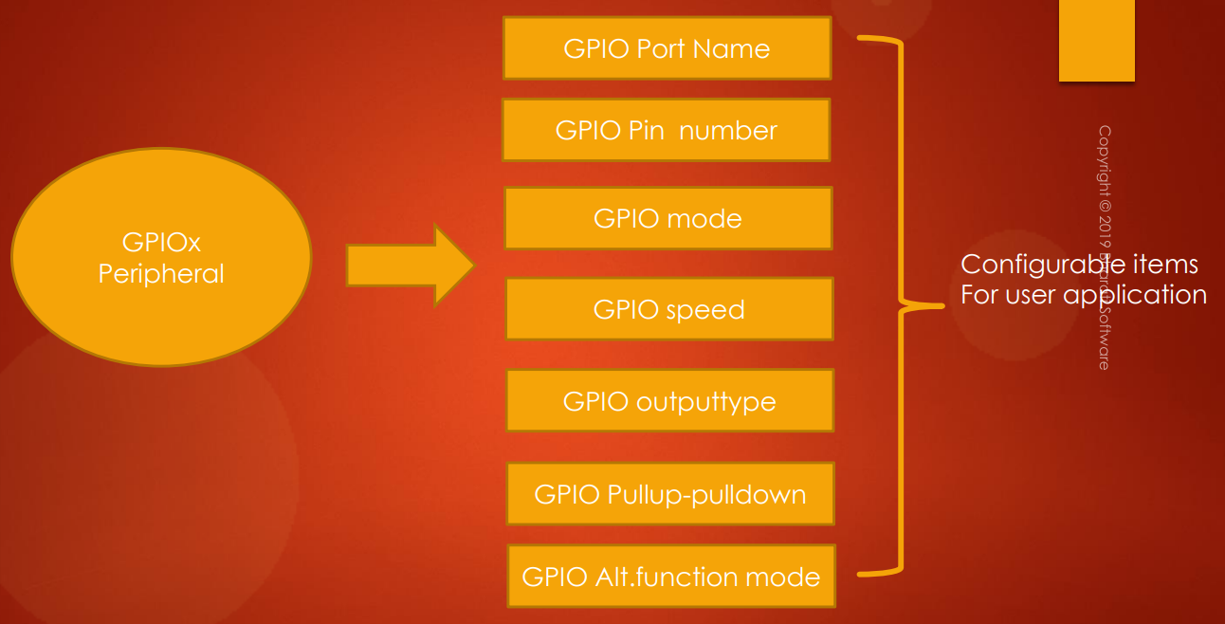

And the user application takes the help of driver APIs which we are going to develop in this course.

So, that's why the **driver layer** should give a **configuration structure** to the **user application**. So the user application will initialize or fill that structure and then it will pass that structure to the driver APIs. And the driver APIs will decode the structure and it will take appropriate action like initializing the peripheral registers.

So, now there is a need to create a **configuration structure**. So, let's create 2 structures:

* **GPIO handle structure**
* **GPIO configuration structure**

So, now let's get into the GPIO driver header file and let's create the **handle structure** for a GPIO pin.

So, let's use a typedef structure and I would call it GPIOx or GPIO for that matter. So, you can just use GPIO handle structure ***GPIO_Handle_t***. Now the first member element here should be a pointer to hold the base address of the GPIO peripheral. So, that's why we can create a pointer variable to the register definition structure what we have created. So, let's create a pointer variable and we'll call it as GPIOBaseAddr. So, this actually holds the base address of the GPIO peripheral so you can just initialize it to GPIO A or B or C or whatever. These peripheral definitions are defined here right ? in the MCU specific header file. Right ? So, that actually gives the base address. And it is already typecasted it to this pointer type. Right ? Great ! So, that's why this will be our first member element. Let me give a small description about this member element. So, this holds the base address of the GPIO port to which the pin belongs. All right. So, before working with any peripheral we needed base address. Right ? So, this pointer will hold that base address. All right. Now instead of using this long name. What I would like to use is I would like to just use GPIO x here.

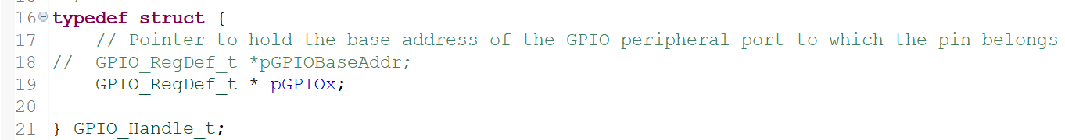

So, that is actually more sensible name. Okay so ***pGPIOx*** means ***x*** you can replace by any value which is there in this peripheral definition and also observe that I have used a lower case ***p*** here. So, this is to indicate that this variable is actually a pointer type so you can use this naming convention so, you can also write like this. No problem but whenever it is a pointer variable so you just use lowercase ***p*** here.

The second member element is let's create a configuration structure so GPIO_PinConfig_t because a pin can have many configuration items right and will create a variable called GPIO_PinConfig.

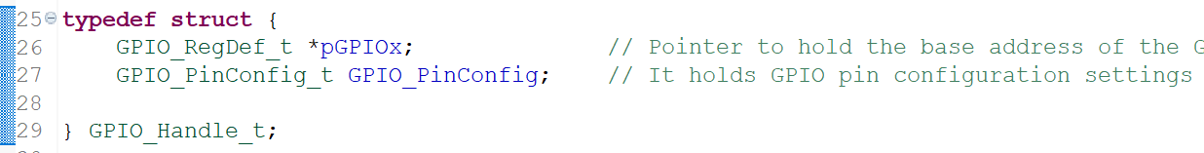

Now this structure GPIO_PinConfig_t is not yet created. Let's create that. So, basically this variable holds GPIO pin configuration settings. Alright so now let's create this structure right here.

What are the configurable items? So, these are the configurable items:



So, let's create a member element to hold each configurable item. Let's go back and let's create here.

So, I have used unsigned int 8 in order to hold the PIN number because PIN numbers can range from 0 to 15. So, that's why one byte is sufficient here. So, this variable is to hold the pin mode. This is to hold the speed etc.

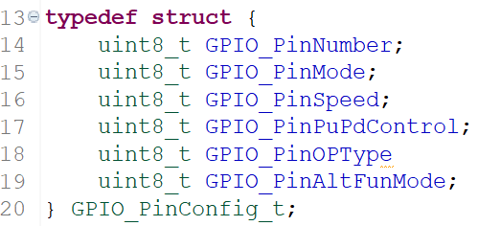

So, the names are self-explanatory here.

So, that completes the creation of configuration structure for a GPIO pin. And this is actually the structure which contains the GPIO base address and the configuration settings for the pin. All right. So, complete up to here and I will see you in the next lecture.

## 90. Driver API requirements and adding API prototypes

So, in this lecture let us understand what the driver APIs are.

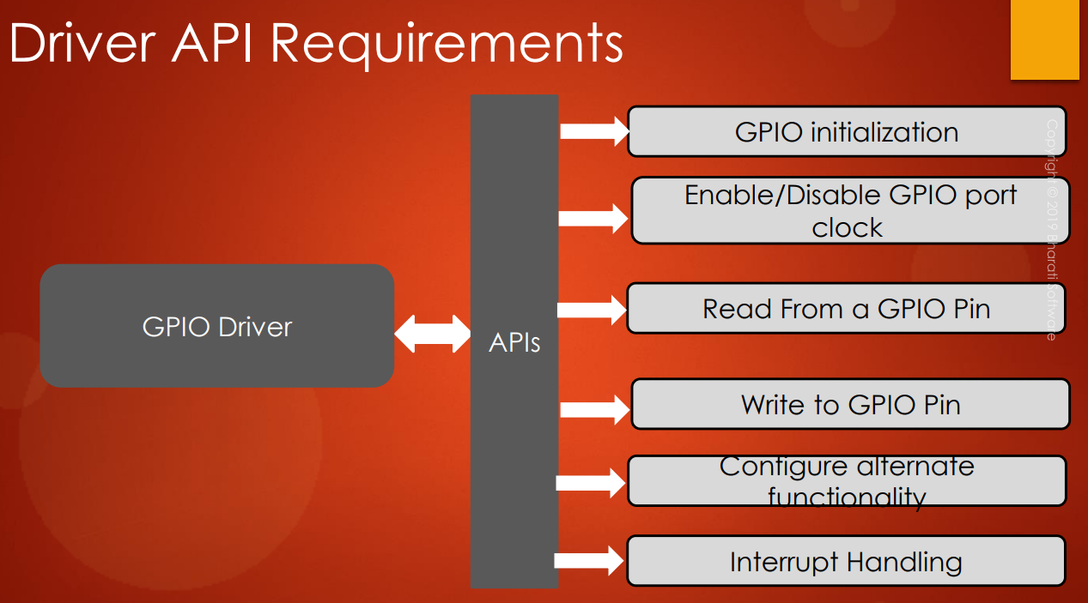

We are going to support in this GPIO driver development project. So, let's discuss what are the required APIs. So, a GPIO driver should be able to give all this APIs to the user application:

* API to initialize the GPIO port peripheral
* API to enable/disable GPIO port peripheral clock
* API to read from GPIO pin or from GPIO port
* API to write to GPIO pin or to GPIO port
* API to configure the alternate functionality
* API to give interrupt handling capability

So all these APIs should be supported by the **GPIO driver** and we will see how to do that. Don't worry about that. So step by step we will develop and we will support all these functionalities in our driver.

Now let’s create the **API prototypes**. The prototypes have to be created first in the **driver header file** and then we will implement them in the **driver source file**.

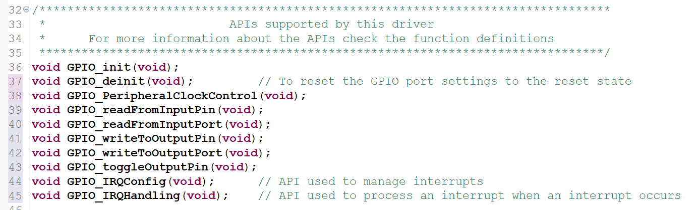

## 91. Driver API input parameters and return types

Hey welcome back to the lecture. So, in the previous lecture we actually finished writing the prototypes of the APIs. And now let's decide the input parameters as well as the return values.

First of all **GPIO peripheral clock control**:

**void** **GPIO_PeripheralClockControl**(**void**);

So, by using this function you are going to enable or disable, the peripheral clock for a given GPIO base address. So, that's why the first parameter will be the pointer to the base address. Right ? So, that's why we will use our ***GPIO_regDef_t*** and this will be *pGPIOx.

Then in the second parameter you have to tell whether it is enabled or disabled. So, I would use uint8_t data type. So, let me create a variable En or Di enable or disable. So, now let's create two macros enable or disable, so that will create in our **MCU specific header file**. So, in the MCU specific header file let me create two macros. Maybe after this. Some generic macros. So #defined enabled means always 1 and #define disable means 0. Some miscellaneous macros which you can use in our work.

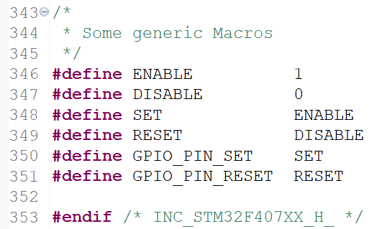

Now let's get back to our GPIO driver.h So, this would take either enable or disable. If it is enable you have to enable clock, if it is disable you have to disable the clock.

**void** **GPIO_PeripheralClockControl**(GPIO_RegDef_t *pGPIOx, uint8_t enable);

and for the ***GPIO_init()*** you have to take a pointer to the handle structure. So, we have to take pointer to the handle structure. and that's it. Though it doesn't take anything extra. Only one parameter is enough. That is pointer to the GPIO handle. So the user application should create a variable of this type initialize that and send the pointer of that variable to the ***GPIO_init()*** function to initialize the GPIO port and pin. And this function doesn't return anything so let's keep void.

**void** **GPIO_init**(GPIO_Handle_t *pGPIOHandle);

Alright so now let's move on to the next API. That is ***GPIO_deInit()***. So the ***GPIO_deInit()*** is used to deinitialize the registers of the given GPIO peripheral. So de-initializing register means sending that register back to its **reset state** or **reset value**. So, to do this that is one important register is available in RCC section or in RCC Peripheral. So, you need not to go through each and every register and you need not to manually send that to register value back to reset value so that not required in one shot. We can do that. So, for that you have to go and consult the **peripheral reset register** present in the **RCC** section. For example there is a reset register for AHB1 peripherals.

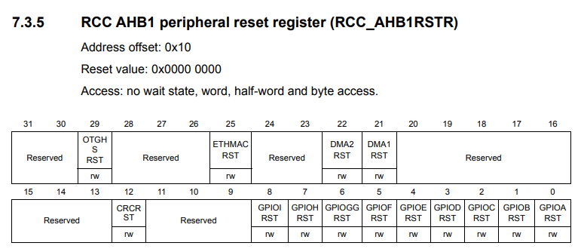

For example, let's say I want to reset all the registers of GPIO A peripheral in one shot. Then what I would do is I will simply come to this register and I will make the bit 0 as 1. So, if I make this bit position as 1 then all the registers of a GPIO A peripheral will be reset.

So, that's why what parameter the API should take? It should just take the base address of the peripheral. So, that's why I can just use this.

**void** **GPIO_deinit**(GPIO_RegDef_t *pGPIOx);

Now let's move on and now let's define the parameters and return values for GPIO read from input pin. So, this name itself suggests that you need a PIN number and the base address of the GPIO peripheral, and the return value must be either 0 or 1. So, what would be the pin state? It would be either 0 or 1.

So, I can just use boolean or I can just use uint8_t here, as a return type.

uint8_t **GPIO_readFromInputPin**(GPIO_RegDef_t *pGPIOx, uint8_t pinNumber);

And read from input port. So, how long is the **port**? So port is of **16 pins**, so, that means I have to use **uint16_t** as return value and what I would just need is the base address of the GPIO port. So, this will return the content of **input data register** so that we'll see when we implement this.

uint16_t **GPIO_readFromInputPort**(GPIO_RegDef_t *pGPIOx);

Let’s see API to write to output pin. So, again I would need these two parameters here and return value will be nothing it will be void because it is write. And here I would need one more argument or parameter that is value. So ***uin8t_t value*** because it can be either 0 or 1: **set** or **reset**. So this value can take pin set or pin reset.

**void** **GPIO_writeToOutputPin**(GPIO_RegDef_t *pGPIOx, uint8_t pinNumber, uint8_t value);

So, that's why let's define those macros here:

**#define** ENABLE 1

**#define** DISABLE 0

**#define** SET ENABLE

**#define** RESET DISABLE

**#define** GPIO_PIN_SET SET

**#define** GPIO_PIN_RESET RESET

So, all these things I'm doing in **MCU specific header file** because this header file will be used by many drivers. So, if they want to access these macros then it will be available for them also. So, don't make these macro specific to the GPIO header. So, that's why I'm not writing these headers in the driver specific header file, because later that I2C driver may use these macros. So, that's why I would need that later. So, that's why I am writing in MCU specific header file.

And after that let's move on to the next one. So, again for the GPIO_writeToOutputPort I don't need pin, I just need value. The value should be uint16_t because there are 16 pins in a port.

**void** **GPIO_writeToOutputPort**(GPIO_RegDef_t *pGPIOx, uint16_t value);

And after that toggle output pin. Now again for toggling you need just a base address and the pin number that's it.

**void** **GPIO_toggleOutputPin**(GPIO_RegDef_t *pGPIOx, uint8_t pinNumber);

So, those are read and write APIs.

Let's move on to the IRQ configuration APIs. So, IRQ config in order to config the interrupt what you need, you need the IRQ number isn't it? So, uint8_t IRQNumber and after that you need IRQPriority. And also you have to mention here whether you want to enable that. IRQ or Disable that IRQ. So, I would give another parameter here that is enable or disable. So this would take enable or disable macro. Here you should mention the priority of that IRQ. Here you have to mention that IRQ number. So that is about the ***GPIO_IRQConfig()***. You can also take one more parameter here that is IRQ grouping. So, that actually I don't consider for this project. But you can do that. So, let's keep it simple. Let's just take ***IRQPriority*** and ***IRQNumber***. And this is the command whether IRQ needs to be enabled or disabled. and here the IRQ handler and this also returns nothing so void.

**void** **GPIO_IRQConfig**(uint8_t IRQNumber, uint8_t IRQPriority, uint8_t enable);

And after that IRQ handling. So, here the interrupt for that GPIO pin number will be managed. So, that's why we just have to take pin number.

**void** **GPIO_IRQHandling**(uint8_t pinNumber);

All right. So, because the **IRQ handling** functions should know from which pin interrupt is triggered.

So, these are our APIs. And we have fixed the input parameters as well as the return types. And if any changes are required here we will do that later. Changes may be required. We don't know. But once we start coding then only we'll come to know if there is any changes required or not.

## 92. Driver empty API implementation and documentation

In the previous lecture, we just finished prototyping our APIs. Now, let's start implementing these APIs.

Now, for that let's copy all these function prototypes and let's go to the driver.c file and let's paste here. And after that, now give the function definition. Now we have to code all these functions or APIs.

Now, for each function, there should be a documentation or a comment section where you should document the purpose of that API, and you should also explain the various parameters you used for that function, also, you should explain what exactly a return type or return value is.

Now, for that let's create the documentation section here. So, this will be my documentation section.

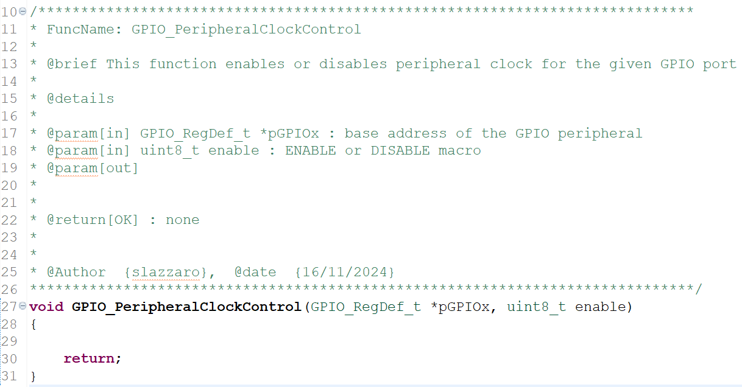

So, in this documentation section, there will be a function name and you should briefly describe what that function does and you should explain all the parameters. For example, this is the first parameter, this is the second parameter description and this is the third parameter description. And then, if there is any special note for using this API, then you should mention that. Sometimes, there will be a special note in order to use an API. And also you should mention the return type. So, return type here will be **none**. You can just write none and special note I think we don't have any special note. If there is any special note, then we'll write it. So, currently I will keep none and here you just mention function name. The function name is ***GPIO_peripheralClockControl*** and also give brief description about this function what it does. So, brief description would be this function enables or disables peripheral clock for the given GPIO port. So, what is the first parameter? The first parameter would be base address of the GPIO peripheral, and the second one will be macros which is there in **MCU specific header file**. You should mention enable or disable visible macros. So, that's it. And return is none and note is none.

So, that's about the documentation. So, complete up to here and also add the comment section or documentation section for other APIs.

Nel mio caso non ho messo ***note*** come parametro della descrizione della funzione.

# Sezione 24: GPIO driver API Implementation: Clock control

## 93. Implementation of GPIO peripheral clock control API

Hey, welcome back to the lecture. So, let's get started with our API implementation. So, first let's implement this API. So, here we have to enable or disable the clock for different GPIO ports based on this parameter that is enable or disable. So, what I would do is, first let's check what is the value of this parameter.

So, if it is equal to enable then we have to enable the clock for given GPIO port address which is here. So, that's why, else we have to disable.

/*****************************************************************************

* FuncName: GPIO_PeripheralClockControl

*

* @brief This function enables or disables peripheral clock for the given GPIO port

*

* @details

*

* @param[in] GPIO_RegDef_t *pGPIOx : base address of the GPIO peripheral

* @param[in] uint8_t enable : ENABLE or DISABLE macro

* @param[out]

*

*

* @return[OK] : none

*

*

* @Author {slazzaro}, @date {16/11/2024}

******************************************************************************/

**void** **GPIO_PeripheralClockControl**(GPIO_RegDef_t *pGPIOx, uint8_t enable)

{

**if**(enable == ENABLE)

{

**if**(pGPIOx == GPIOA)

{

GPIOA_PCLK_EN();

}

**else** **if**(pGPIOx == GPIOB)

{

GPIOB_PCLK_EN();

}

**else** **if**(pGPIOx == GPIOC)

{

GPIOC_PCLK_EN();

}

**else** **if**(pGPIOx == GPIOD)

{

GPIOD_PCLK_EN();

}

**else** **if**(pGPIOx == GPIOE)

{

GPIOE_PCLK_EN();

}

**else** **if**(pGPIOx == GPIOF)

{

GPIOF_PCLK_EN();

}

**else** **if**(pGPIOx == GPIOG)

{

GPIOG_PCLK_EN();

}

**else** **if**(pGPIOx == GPIOH)

{

GPIOH_PCLK_EN();

}

**else** **if**(pGPIOx == GPIOI)

{

GPIOI_PCLK_EN();

}

**else** **if**(pGPIOx == GPIOJ)

{

GPIOJ_PCLK_EN();

}

**else** **if**(pGPIOx == GPIOK)

{

GPIOK_PCLK_EN();

}

}

**else**

{

**if**(pGPIOx == GPIOA)

{

GPIOA_PCLK_DI();

}

**else** **if**(pGPIOx == GPIOB)

{

GPIOB_PCLK_DI();

}

**else** **if**(pGPIOx == GPIOC)

{

GPIOC_PCLK_DI();

}

**else** **if**(pGPIOx == GPIOD)

{

GPIOD_PCLK_DI();

}

**else** **if**(pGPIOx == GPIOE)

{

GPIOE_PCLK_DI();

}

**else** **if**(pGPIOx == GPIOF)

{

GPIOF_PCLK_DI();

}

**else** **if**(pGPIOx == GPIOG)

{

GPIOG_PCLK_DI();

}

**else** **if**(pGPIOx == GPIOH)

{

GPIOH_PCLK_DI();

}

**else** **if**(pGPIOx == GPIOI)

{

GPIOI_PCLK_DI();

}

**else** **if**(pGPIOx == GPIOJ)

{

GPIOJ_PCLK_DI();

}

**else** **if**(pGPIOx == GPIOK)

{

GPIOK_PCLK_DI();

}

}

**return**;

}

# Sezione 25: GPIO driver API Implementation: GPIO init and de-init

## 94. Writing user configurable macros

Now let's do the ***GPIO_init()***.

In ***GPIO_init()***, we have to initialize the given GPIO port and the given GPIO pin, isn't it?? So, we have to configure its mode, its speed, its output type, pull-up pull-down resistor configuration, alternate functionality and various other things. First, what will do is, first will configure the mode of a GPIO pin. After that, we will configure the speed, after that will configure the pull-up pull-down settings and after that, we will configure the output type and after that, we will configure the alternate functionality if required. So, now let's see what the possible modes of GPIO pin are. So, we can get this information from the ***Reference Manual***, right? So, in the ***Reference Manual*** in the port mode registers, so these are the possible modes.

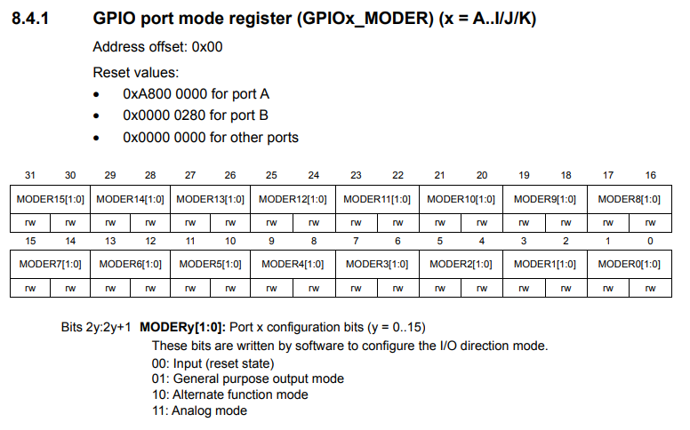

So, now let's create C macros for all these modes and let's assign these values 0, 1, 2, 3. Now, let's create macros for these modes.

For that, let's go to the "***gpio_driver.h***", because this is peripheral specific, so, that's why need not to write the possible ***mode*** information in the **MCU specific header file**. This is **driver specific**, so, that's why we can write that in gpio_driver.h.

So let's #define the possible modes of a pin.

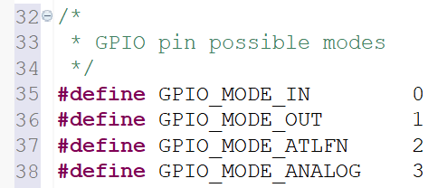

Apart from that, we also have **interrupt modes**, because when the pin is in **input mode**, we can also configure the GPIO pin to deliver an interrupt to the processor when the falling edge or rising edge is detected on that pin. So, we can also consider that as modes. So, that's why, we can create more modes here. So, I'll write that.

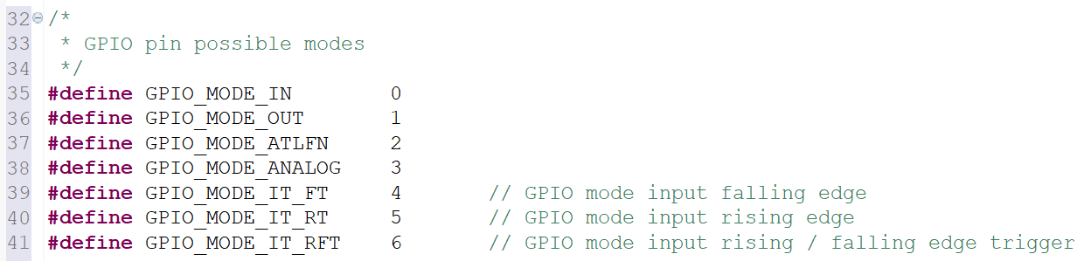

These are the possible modes.

Now let's move ahead and let's go to the next register that is **GPIO port output type register** and what are the possible output types?

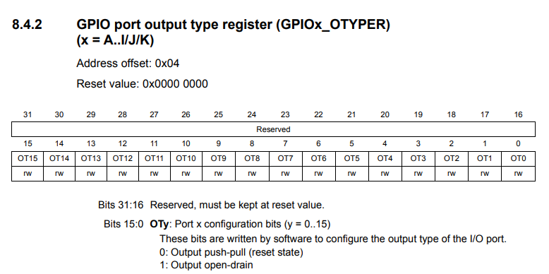

* Output push-pull
* Output open drain

Now, let's convert this information into C macro.

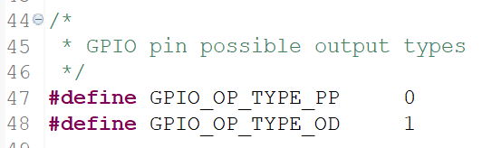

So, GPIO output type push-pull. Let's write PP for push-pull, type open drain. OD. So, let's say this is 0 and let's say this is 1.

Let's move to next register, that is the speed register.

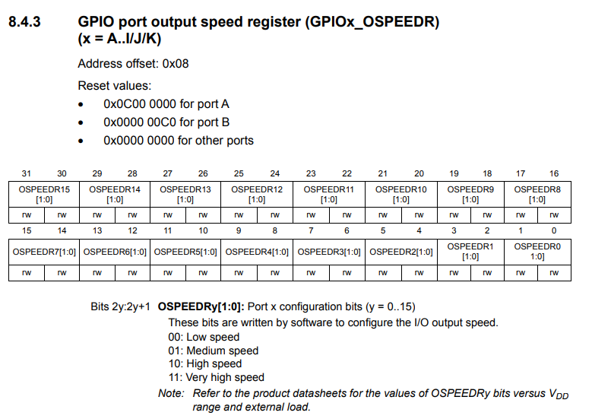

So, now let's document all these speed modes, let's again create another section here. GPIO pin possible output speeds:

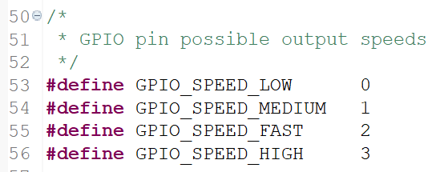

Let's move to the next register: **GPIO Pull-up/pull-down configuration**.

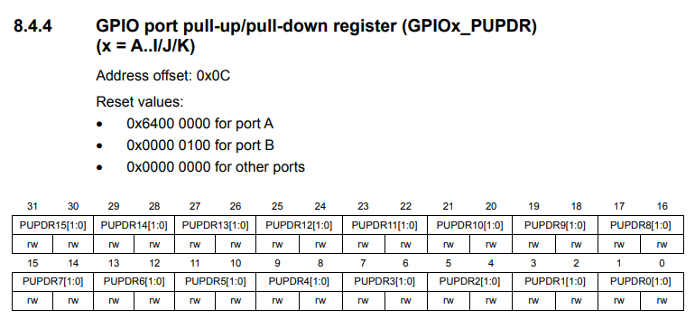

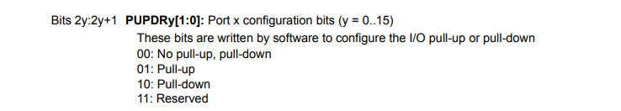

So, here there are 3 different combinations. Let's create C macros for this configuration also.

So, here it is, GPIO pin pull-up and pull-down configuration macros.

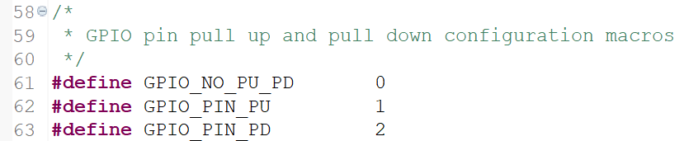

So, these are some of the macros we need, because the user application can use this macro whenever user application wants to do the settings.

So, one among these values will be used in order to initialize variable **GPIO_PinMode**, so that's why you have to tell in the documentation what are the possible values for this pin mode in order to initialize this variable. The user has to know that. So, that's why we can create a small documentation here. So, possible values from so, you have to give the reference.

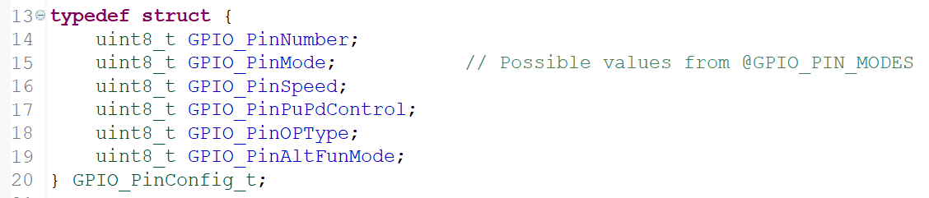

This is a documentation, possible values from this reference. So, whenever user wants to initialize variable **GPIO_PinMode**, he actually sees this reference and then he searches that reference. And that will take him to this section in order to initialize this variable.

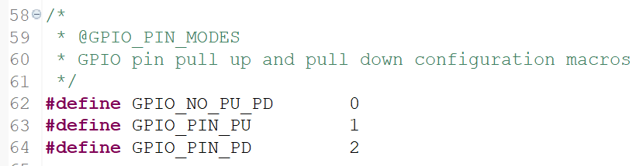

That's why, we actually created these macros.

So, like that, so you can do for the rest. And so now what other possible values for pin number?? So, for that also we have to create couple of macros, right?? So, pin numbers can range from pin 0 to pin 15, right?? So, let's create macros in order to initialize the variable pin number, GPIO_PIN_NO_0. So, let's initialize this to 0. Let's hash define this to 0. Alright! Now, let's create up to 15.

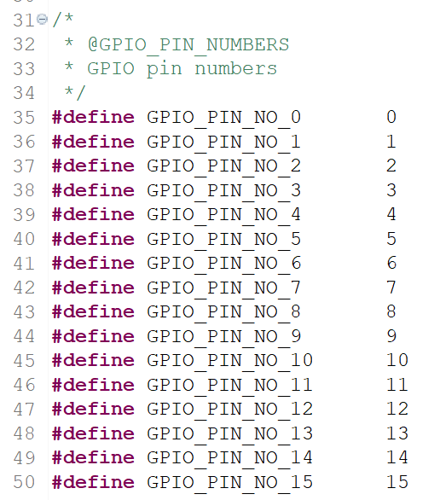

So, I have created possible pin numbers macros. Great!! So, finish up to here and I will see you in the next lecture and also don't forget to compile the code and see whether everything builds properly or not.

## 95. Implementation of GPIO init API

Hey, welcome back to the lecture. So, now let's first do mode configuration of a GPIO pin. Now, if you look at all the possible modes, these are no-interrupt modes.

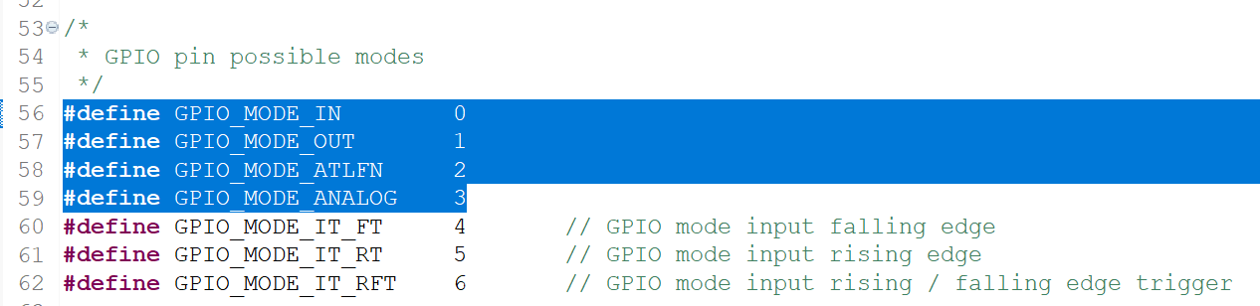

Input, output alternate function and analog: those are non-interrupt modes.

The last ones are interrupt modes. So, let's not code for interrupt modes for a time being, because that needs some other blocks of the microcontroller such as EXTI and all. So, that will discuss later. So, now let's not discuss about the interrupt modes.

Let's only work upon configuring these non-interrupt modes. How to find out given mode is non-interrupt mode or interrupt mode? So, if the value is less than or equal to 3, then it is non-interrupt mode. If the value is greater than 3, then it is interrupt mode. So, that's why what we can do here in our function, if the mode which is given by the user is lesser than or equal to GPIO mode analog, then it's a non-interrupt mode. So, else it's an interrupt mode. So, this part will code later.

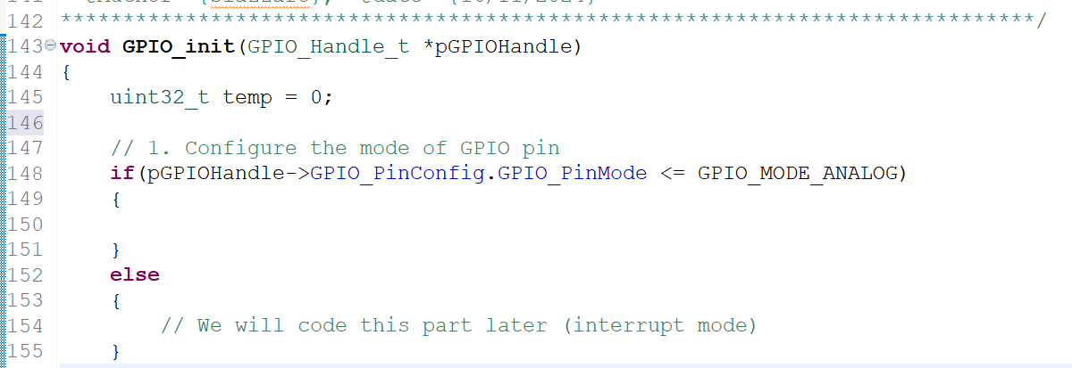

So, this is actually the interrupt mode. Let's take one temporary variable 'temp' and let's initialize this to 0. All right. So, after that, we have to place the mode setting into appropriate pin position, right? So, for example, in the port mode register, this section is for pin 0, this section is for pin 1. So, each pin takes 2 bit fields.

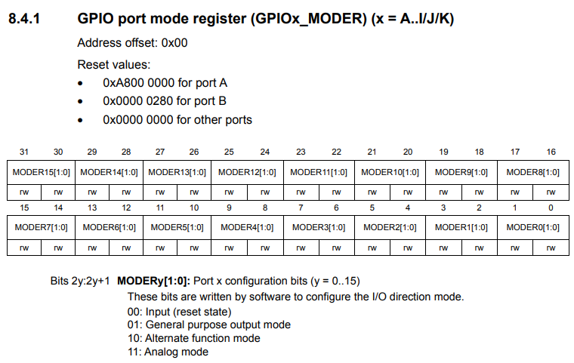

So, that's why we have to shift the value appropriately in this register according to the pin number. So, let's do that. So, what I can do is, here temp is equal to pin mode left shifted by 2 into the PIN number. Right?? So, the first parameter is actually pin number, right?? So, PIN number.

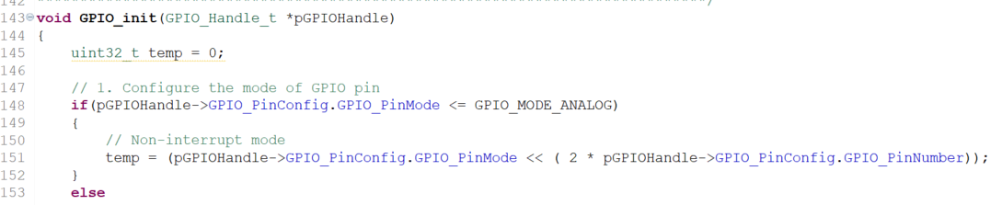

So, very simple to understand this code. So, don't get confused. Remember that, each pin takes 2 bit fields. So, that's why multiplied by 2. Multiplied by what? 2 with the pin number. So, if it is pin 0, then 2 * 0 = 0. So, the value will be placed here. If the PIN number is 1, then 2*1=2. So, pin mode value which is given by the user is left shifted by 2. So, the value will be placed here, like that. That's the reason we are multiplying this with 2. And after that, let's store the value of this variable into the actual register.

So, how to get the actual register?? Very simple. So, you just decode this and go to the base address. This is the base address of the peripheral, right? Select that, take the MODER register and store that value temp, that's it. And then you can again re-initialize the temp to 0. And this is actually how you configure the mode for a GPIO pin.

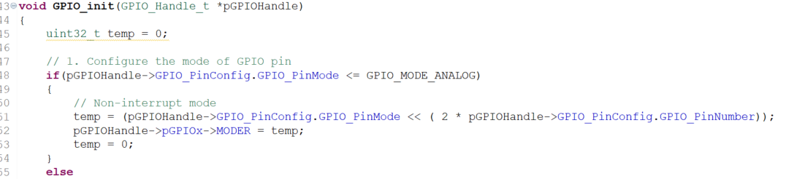

Let's configure the speed. Again, let's take temp here. So, temp is equal to, so instead of doing temp is equal to 0 here, so, you can do it here. That would be better. Now, temp is equal to again here you have taken pin mode, now you have to take speed. Right?? GPIO speed, GPIO pin speed value left shifted by by how much amount you have to left shift?? So, you have to calculate by using the speed register.

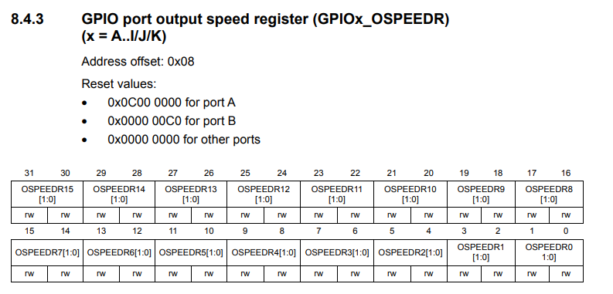

Here you can see that 2 bits are dedicated to each single pin. Again you have to multiply by 2 actually. 2x again same thing, by the pin number you have to multiply. After that, just use this handle variable to get the base address and access the speed register, OSSPEEDR, here it is, is equal to temp. All right. So, after that make temp=0, once again.

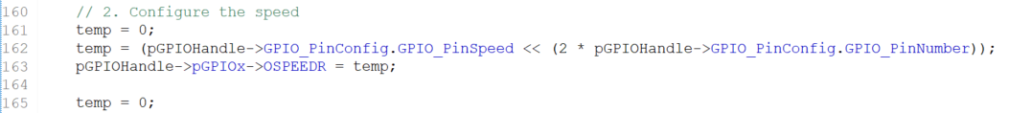

And now let's configure the **pull-up and pull-down configuration settings**. Now, let's go back to the reference manual and here each pin takes again 2 bits.

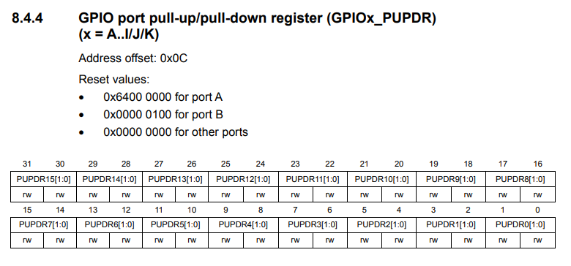

Again the same code you have to repeat. I'm going to repeat the same code here as well. But I would change this to pin PuPd control and this will be same and this register will be PUPDR.



And here now let's do the **output type**.

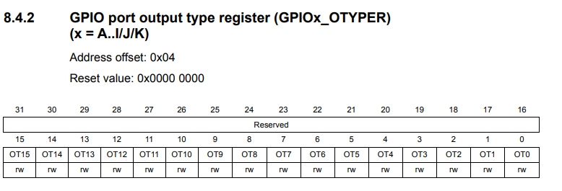

To do the output type, each pin takes single bit, right? So, that's why multiplying by 2 is not required. Great!! Now, let's use the same code and let's do temp=0 here. Alright. And here this is not required. So, let's remove this and here this is pin output type. And here this will be OTYPER. Great!! So, this actually will be either 0 or 1.



Now, let's do the alternate functionality register configuration. So, that means if the mode is alternate functionality mode, then only you can configure the alternate functionality register. So, if the mode is equal to GPIO_MODE_ALTFN, then only configure the alternate function registers.

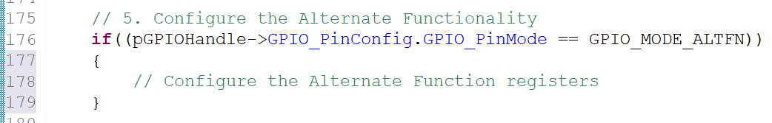

So, we'll do that in the next lecture, no problem.

## 96. Implementation of GPIO init API contd.

Hey, welcome back to the lecture. So, there is a quick update here. We actually did one fatal mistake. We did mistake several times in all these initialization. So, I will tell you what we did wrong. So, first of all, remember that we should modify only those bits in the register in which we are allowed. We should not unnecessarily touch other bits of the registers.

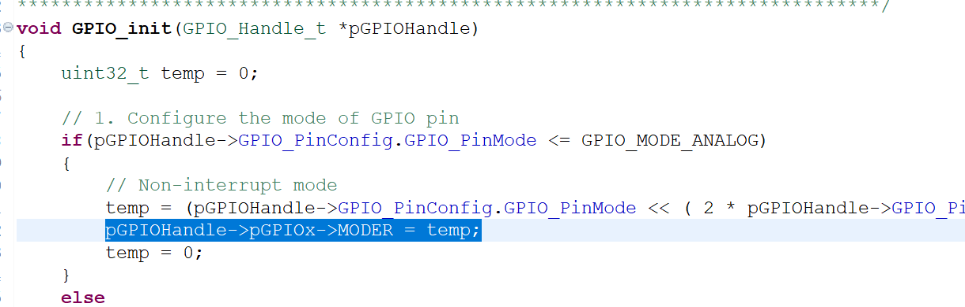

So, because that will cause problem to other functionalities of the project. So, here what we are doing is, we are actually equating this temp that means we are actually re-initializing the MODER register. with the value of temp. So, temp is actually initially 0, and then some bits are changed here. And after that, we are actually initializing that to MODER. That is actually wrong because that will affect other bit positions of the MODER register, that we should not do. We should only touch those pin positions in which we are interested. So, we are interested in this pin number, that's why we should touch only those bit positions.

Sostanzialmente, usando ***= temp*** si cambierebbero tutti i valori degli altri bit del ***MODER***, invece noi vogliamo solamente inserire un nuovo valore in dei bit ben precisi. Per questo motivo bisogna utilizzare ***|= temp***, in modo tale da non modificare il valore degli altri bit che sono già ad 1.

So, that's why this mistake can be solved by doing bit-wise OR here, instead of equating it. So, you have to use bit-wise OR everywhere.

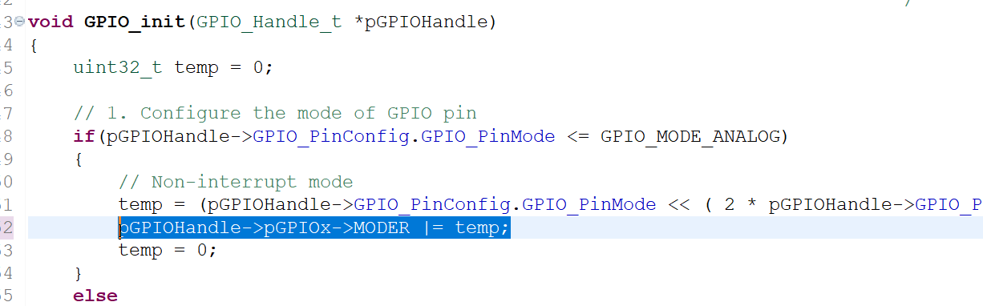

So, that's a mistake. So, I would suggest you to correct it. So, in your embedded programming, when you are changing the content of physical register, be very very careful. Most of the time you should not use an assignment operator. You should always be using the ***bitwise OR***. So, you should pay attention to those lines in which the physical register is involved. So, this would be fine.

When I initialized ***temp*** variable I need not to use bitwise OR because it is my temporary variable, so I can do whatever I want. But ***MODER*** is actually the physical register, then you should not affect the other bits of this register. So, that's the update. Please correct everything and I will see you in the next lecture.

## 97. Configuring Alternate function registers

Hey, welcome back to the lecture. So, in the previous lecture, we actually did all this configuration and in this lecture let's understand how we can do the alternate functionality register settings.

Remember that in our *GPIO_PinConfig_t* structure, this alternate function mode setting ***GPIO_PinAltFunMode*** is only applicable when the mode ***GPIO_PinMode*** is set to **alternate function mode**. Otherwise, this field has no meaning.

If the mode is **alternate function mode**, then only we have to configure the alternate function registers with a value mentioned in the variable ***GPIO_PinAltFunMode***.

Now let's understand how to configure the alternate function registers. So, we have 2 alternate function registers:

* **alternate function low register:** and by using that you can configure the alternate functionality for 7 pins from 0 to 7.
* **alternate function high register:** to configure the alternate functionality mode for pin 8 to pin 15

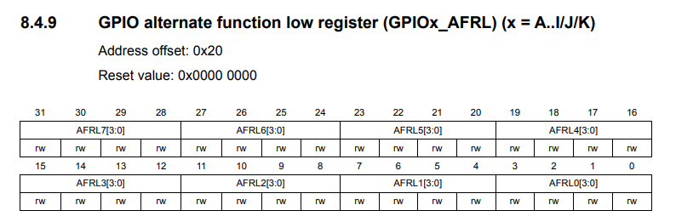

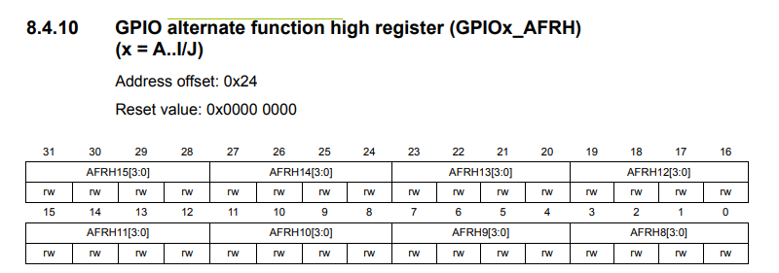

So, we have to first decide which register you have to configure based on the pin number.

In our C program, the low register is called as ***AFR[0]*** and it is ***AFR[1]***. So, I hope you remember this because we actually have used an array for the AFR registers. Here it is, in a ***GPIO_RegDef_t***, we have used an array. Therefore:

* ***AFR[0]***: means ***low registers***
* ***AFR[1]***: means ***high registers***

So, first what you have to do is, so let's say the user sends the pin number as let's say 9. First, you have to divide the number 9 by 8 and then you have to take the result. So, 9 / 8 = 1 as integer division. So, save that number into a variable called temp_1. So, this will decide which register you have to use. Either you have to use AFR[1] or AFr[0]. So, in this case, we have to use register AFR[1].

Then you have to calculate to which **bit position** you have to program the value that is alternate functionality mode value. Pin 9 means I have to store the value from the position 4, because the pin 9 starts from bit 4. So, that you have to decide by taking the mode. Let's create another variable *temp_2* and here let's do *temp_2 = 9 % 8 = 1*. And after that by using AFR[temp1] = the value left shifted by 4 into temp 2. So, that means the value will be left-shifted by 4.

***AFR[temp_1] = value << (4 * temp_2)***

So the alternate functionality mode **value** will be left shifted by 4, you will configure the value in this section. Remember that, in this register, 4 bits are dedicated for each pin. So, that's why you have to multiply by 4 here.

So, let's try for another pin number. So, let's say pin 6:

***temp_1 = 6 / 8 = 0;***

***temp_2 = 6 % 8 = 6;***

***AFR[temp_1] = value << (4 * temp_2);***

***AFR[0] = value << (4 * 6);***

So, you will be configuring the value that is alternate functionality value from 4*6 = 24. So, the value will be stored in this location that happens to be the bit position for pin 6. Alright. So, very very simple.

Let's do all these things in code and let's go to the driver.

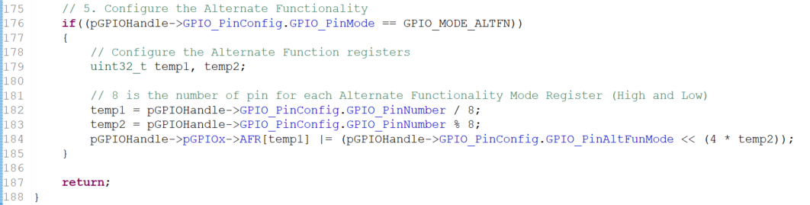

So, now we have partially finished all these settings and I would like to introduce one more thing here. See, here we are actually setting the required bit fields, but we don't know whether those bit fields are cleared initially or not. So, before setting any bit fields, make sure that it is cleared already, otherwise your bitwise OR operation may not be successful. So, you won't be able to achieve your goal. So, that's why we should make sure that the required bit fields are cleared in the first place, before setting them.

So, for example here, before setting this register, let's clear the required bit fields. For that, let's copy this MODER register. So, in order to clear, what we should use, we should use bitwise AND, and is equal to negation of so, here we have to clear 2 bit fields, because 2 bits are dedicated for each pin.

So, how to cover 2 bits? By using the binary 11. For example, let's say mode register and so, how to clear these 2 bit fields? So, I have to write 00 here, right? So, that means I have to negate the value 3: 3 means binary 1 1. So, that's what we have to do, 0x3 left shifted by pin number.

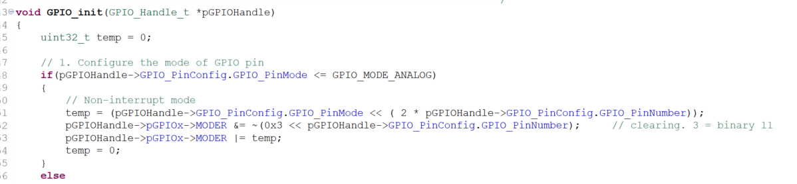

So, this is actually **clearing** and this is actually **setting**. So, let's do the same thing for the others.



For the **output type** it is 0x1, right? So, only one bit field.

For the **alternate functionality mode** there are 4 bits for each pin, so we need to use the binary 1111 that is equal to 0xF in hex:

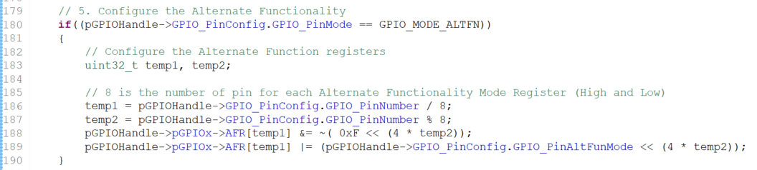

So, we have just finished the coding of **GPIO_init()** API. Still, one task is spending that is coding for the interrupt modes and that we can take up later. And now let's go to our project and let's try to compile the whole project and let's see how many errors are there.

**void** **GPIO_init**(GPIO_Handle_t *pGPIOHandle)

{

uint32_t temp = 0;

// 1. Configure the mode of GPIO pin

**if**(pGPIOHandle->GPIO_PinConfig.GPIO_PinMode <= GPIO_MODE_ANALOG)

{

// Non-interrupt mode

temp = (pGPIOHandle->GPIO_PinConfig.GPIO_PinMode << ( 2 * pGPIOHandle->GPIO_PinConfig.GPIO_PinNumber));

pGPIOHandle->pGPIOx->MODER &= ~(0x3 << pGPIOHandle->GPIO_PinConfig.GPIO_PinNumber); // clearing. 3 = binary 11

pGPIOHandle->pGPIOx->MODER |= temp;

temp = 0;

}

**else**

{

// We will code this part later (interrupt mode)

}

// 2. Configure the speed

temp = 0;

temp = (pGPIOHandle->GPIO_PinConfig.GPIO_PinSpeed << (2 * pGPIOHandle->GPIO_PinConfig.GPIO_PinNumber));

pGPIOHandle->pGPIOx->OSPEEDR &= ~(0x3 << pGPIOHandle->GPIO_PinConfig.GPIO_PinNumber); // clearing. 3 = binary 11

pGPIOHandle->pGPIOx->OSPEEDR |= temp;

// 3. Configure the pull-up / pull-down settings

temp = 0;

temp = (pGPIOHandle->GPIO_PinConfig.GPIO_PinPuPdControl << (2 * pGPIOHandle->GPIO_PinConfig.GPIO_PinNumber));

pGPIOHandle->pGPIOx->PUPDR &= ~(0x3 << pGPIOHandle->GPIO_PinConfig.GPIO_PinNumber); // clearing. 3 = binary 11

pGPIOHandle->pGPIOx->PUPDR |= temp;

// 4. Configure the Output Type

temp = 0;

temp = (pGPIOHandle->GPIO_PinConfig.GPIO_PinOPType << pGPIOHandle->GPIO_PinConfig.GPIO_PinNumber);

pGPIOHandle->pGPIOx->OTYPER &= ~(0x1 << pGPIOHandle->GPIO_PinConfig.GPIO_PinNumber); // clearing. 1 = binary 1

pGPIOHandle->pGPIOx->OTYPER |= temp;

// 5. Configure the Alternate Functionality

**if**((pGPIOHandle->GPIO_PinConfig.GPIO_PinMode == GPIO_MODE_ALTFN))

{

// Configure the Alternate Function registers

uint32_t temp1, temp2;

// 8 is the number of pin for each Alternate Functionality Mode Register (High and Low)

temp1 = pGPIOHandle->GPIO_PinConfig.GPIO_PinNumber / 8;

temp2 = pGPIOHandle->GPIO_PinConfig.GPIO_PinNumber % 8;

pGPIOHandle->pGPIOx->AFR[temp1] &= ~( 0xF << (4 * temp2));

pGPIOHandle->pGPIOx->AFR[temp1] |= (pGPIOHandle->GPIO_PinConfig.GPIO_PinAltFunMode << (4 * temp2));

}

**return**;

}

In the next lecture I'm going to explain the next API that is GPIO_DeInit().

## 98. GPIO de-init API implementation

Hey, welcome back to the lecture. So, in this lecture let's code for **GPIO_DeInit** API.

**void** **GPIO_deinit**(GPIO_RegDef_t *pGPIOx);

This function actually takes only one argument and that is the base address of the GPIO port. And we have to reset all the registers of the GPIO port which is supplied here, as I said earlier in order to reset the peripheral.

So, that means reset all the registers of a peripheral you have to refer to the respective **RCC register** in the RCC block. For example, for GPIOs we have to refer to the **AHB1RSTR** register.

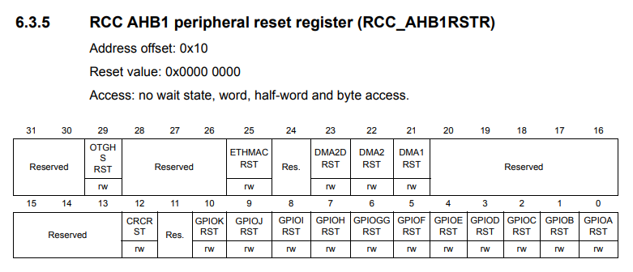

For example, if I want to reset all the registers of GPIOA, then I would make bit 0 as 1 and after that you have to again make it as 0. You cannot keep holding the value 1 over this bit field, otherwise the registers will be in reset state always. Right? We have to first to make this 1 and then we have to make it 0 again. So, that's what we call reset. Now, let's do that.

So, let's go to the GPIO driver here. We can use the same code what we did in peripheral clock control. So, I can just copy these codes and I will paste here. And now let's change the macro name let's say this is GPIOA_PCLK, not PCLK let me call as a register reset REG_RESET so change the macro name.

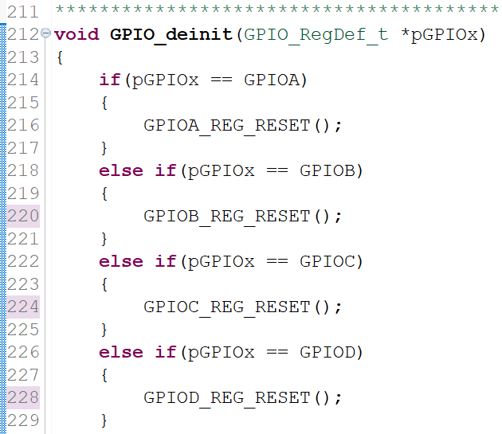

So, now it is completed. So, very very simple function and now we have to create these macros. So, we will create these macros in **MCU specific header file**. So, in the MCU specific header file we have actually the clock enable macros here, and after that we have clock disable macros here, and after that we will create one more section that is **macros** to **reset GPIOx peripherals** and there we will do this. GPIOA register reset. So, what have to do? You have to touch this register and these bit fields and you have to set that corresponding bit position first and then you to reset remember. Great! Now, let's do that. So, now let me copy this code, because the code is similar we are to do here. All right. So, we have to touch **AHB1RSTR**. Right? So, let's change the name and so let's make it as 0, and then we have to reset. Right? set and reset. So, & is equal to negation of this one. So, how to include 2 statements in one single macro. So, the trick is here to use do while loop. So, what we can do is, do you can use see do while loop. do and give the brackets here and open the body. So, this is a first statement. Right? So, you have to give a semicolon here, because the first statement ends here and after that this is the second statement. Right? And again you have to give one more semicolon here. So, this is a first statement, this is the second statement. And after that, close the body and while 0. So, now don't give a semicolon “;” after *while(0)*, because when we call this function from the program we actually give a semicolon “;” after the macro.

**#define** GPIOA_REG_RESET() **do**{( RCC->AHB1RSTR |= (1 << 0) ); ( RCC->AHB1RSTR &= ~(1 << 0) );}**while**(0)

So, this is a way in C programming we actually use 2 or more statements in a C macro by using **do while loop**. This called as **do while condition 0 loop**. So, condition is 0, so this will be executed only one time.

And repeat this for other GPIO ports and I will see you in the next lecture.

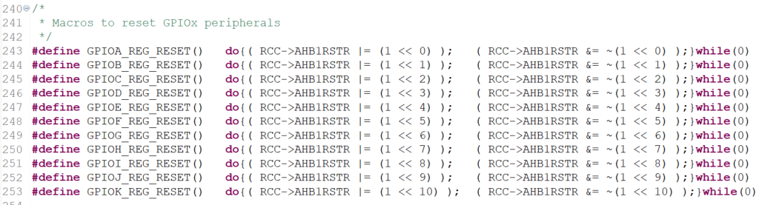

I'll see you in the next lecture.

# Sezione 26: GPIO driver API Implementation: GPIO data read and write

## 99. Implementation of GPIO input port read and input pin read APIs

Hey, welcome back to the lecture. So, now let's do the next API that is **GPIO read from input pin**.

uint8_t **GPIO_readFromInputPin**(GPIO_RegDef_t *pGPIOx, uint8_t pinNumber);

Very very simple. So, we will be having the PIN number and we actually have to read the corresponding bit position in the input data register, that is **IDR**. Let's create a small variable uint8 value. All right. So, value is equal to the IDR, that is input data register. And here actually we want the bit field which is corresponding to this pin number. Isn't it? How to get that?

So, for example let's say this is a input data register and we want the value of the bit position 8 let's say.

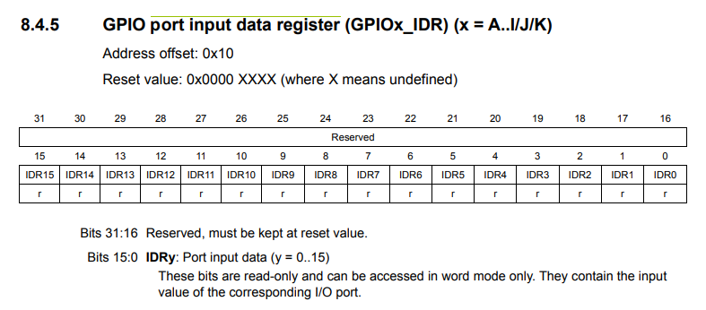

So, what I would do is, I would just simply shift this bit position 8 times. So, what happens when I shift this bit position 8 times to the right? That bit position will come into the 0th position. Right? Then we can mask all these bits and just return this value. That's it. So, if it is a bit 4, then just shift by 4. So, here I would just shift this register, that is right shift this register by the amount which is mentioned in pin number. And then mask with that is bitwise AND with how much 0x00000001. So, now you can typecast this to uint8 here and after that just return value, that's it.

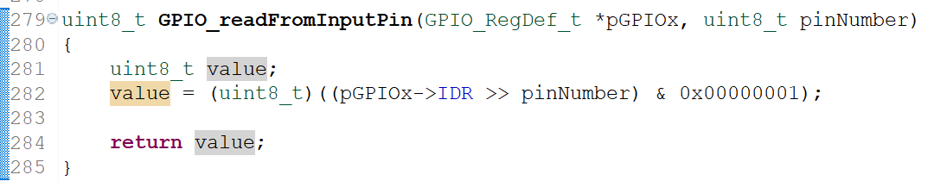

So, I hope this makes sense. So, let me explain one more time. So, the IDR value I'm shifting by the amount which is mentioned in the PIN number in order to extract or get that bit position to the LSB position of the IDR register, and I care only the least significant bit. So, that's why I mask all other bit positions with 0. I make every bit position except the least significant bit as 0. So, that's why I have used &, and with 0 means 0. So, I'm only interested in the least significant bit. That's it. And after that, I am actually typecasting to uint8 because the value is of data type uint8 and then I'm returning the value. That's it. So, the return value will be actually 0 or 1. Right? That's it. And that is about read from input pin.

Let’s write code for **read from input port**. We can use the same code, but here we have to change something. So, we have to make this as **uint16_t**. And here, we need not to shift anything because we need entire port. So, what we can do is, just return the entire port IDR and just return value, that's it.

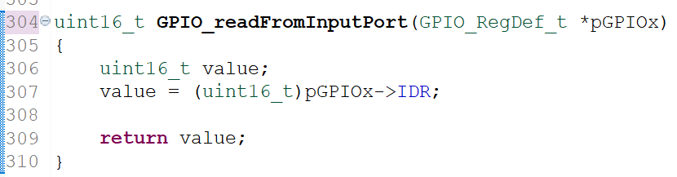

So, this function is very very simple. Right? So, read from input port. So, that's it. All right. So, just go through these 2 functions and I will see you in the next lecture.

## 100. Implementation of GPIO output port write and output pin write APIs

Hey, welcome back to the lecture. In this lecture, let's code this API: **GPIO_WriteToOutputPin**.

So, we have to write this value to this pin. This value can be either 0 or it can be 1. That's it. And this is a base address of the GPIO port. Right? Great! So, the code is very simple. If value is equal to GPIO_PIN_SET, then you have to write 1, else you can write 0.

So, here write 1 to the output data register at the bit field corresponding to the pin number. All right. Now, let's code. So, very simple. Let's take this base address and we have to now refer to the ODR (Output Data Register). So, bitwise OR is equal to 1 shifted by PinNumber bit. And here you have to clear that.

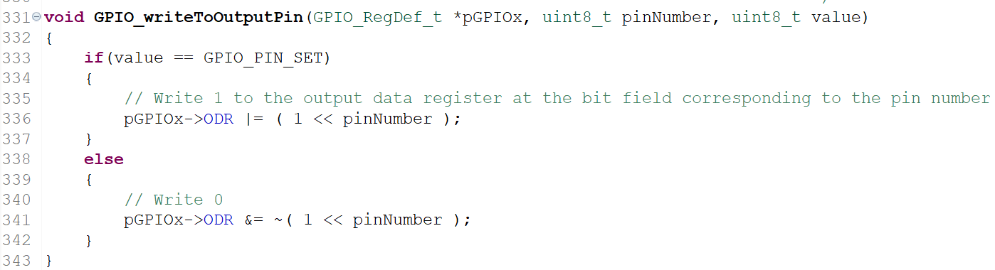

So, here what you are doing is you are actually clearing the bit position corresponding to the pin number in the ODR register.

Now, let's move forward and let's see how to implement **GPIO_writeToOutputPort**. So, you just have to copy the value of this variable into the ODR register, because, you are actually writing into the whole port write of the given GPIO peripheral. So, that's why you have to just copy the value into the ODR register.

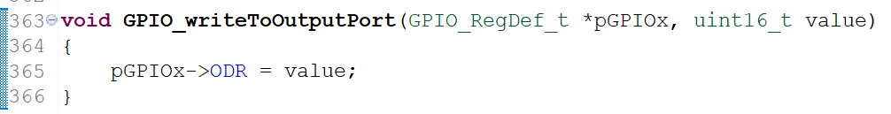

All right. So, that concludes a **GPIO_WriteToOutputPort** and **GPIO_writeToOutputPin**. And in that note, I would like to end this lecture and I'll see you in the next lecture.

## 101. Implementation of GPIO pin toggle API

**GPIO_ToggleOutputPin** can be easily done in one line of code that is this one. We can use **bitwise XOR** operation in order to toggle the required pin number. So, by using shorthand notation I can also write something like this. **XOR** is equal to. So, this will toggle the required bit field whenever this function is called.

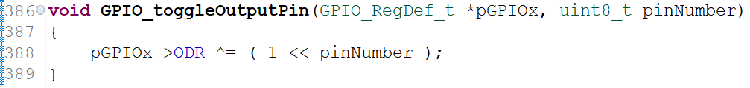

If you want to know more about **XOR** operation, please consult the truth table of XOR operation.

So, after that let's move on to our next APIs, now we have 2 APIs left and these are actually interrupt based APIs. So, let's touch the interrupt part later. So, before that let's test all our APIs developed. To see whether they are working properly or not so we can use some LEDs, we can use some buttons to interface to our board, and we will work upon our APIs. Great!! So, I will see you in the next lecture with some applications.

# Sezione 27: Exercise

## 102. Exercise: LED toggling with Push Pull configuration

Hey, welcome back to the lecture. So, in this lecture let's do one exercise. Write a program to toggle the on board LED with some delay. Now, let's do this in 2 cases:

* case 1: use push pull configuration for the output pin
* case 2: use open drain configuration for the output pin

First, let's attempt case 1, and remember that, you can use your **on board LED,** your board must be having the on board LED. If you want to know the connection of on board LEDs, then you have to refer to the schematic of your board. So, your board manufacturer must have given the schematic of the board and you have to open that and there it is mentioned how exactly the LEDs are connected.

Let me take you to the schematic of the **discovery board**. So, this is actually you can find in the **user manual** of the discovery kit. So, you can go to the page number 28 and here you'll get the schematic.

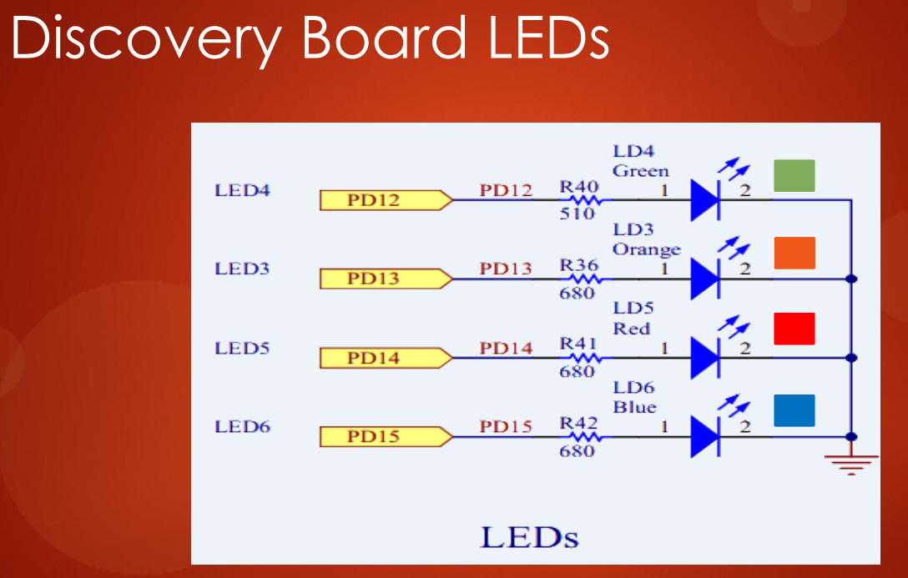

Io non ho trovato questo schematico nello **User Manual.**

And just browse through this schematic so you will get the connection of LEDs. So, here it is. So, this is a connection of LEDs. This board has got 4 LEDs and the part number of the LEDs are LD4, LD3, LD5, and LD6. So, basically LD4 is the first LED. And you can also see that the resistor the CDs resistor is already there. So, you need not to connect any series this is actually the current limiting resistors. And after that, the LED1 that is LD4 is actually connected to PD12. And next LEDs connected to PD13, PD14, and PD15 that is GPIO port D pin number 12, 13, 14, 15. All right. So, these are actually user LEDs.

If you're using **STM32F446RE nucleo board**, then you have to refer to a schematic of that board. For example, this is a schematic of my nucleo board and if you are using this board then you can just search for LED, so you don't get it. No problem. So, let's search here. Not here, not in the page 3. Let's go to page 4. In the page 4, you can see here the LED this is LED there is only one LED one user LED in the nucleo board, and that is actually connected to the pin PA5. So, in the program if you are using this board that is nucleo board, then you have to use PA5.

In this exercise we will use the **discovery board**, so let's just use one entity that is PD12. So, I am going to use PD12 in the case of discovery board. All right. Now, let's toggle this LED by using our driver APIs. All right. Now, let's go to the project, and let's create a new *main.c* file that we will call ***001_led_toggle.c***:

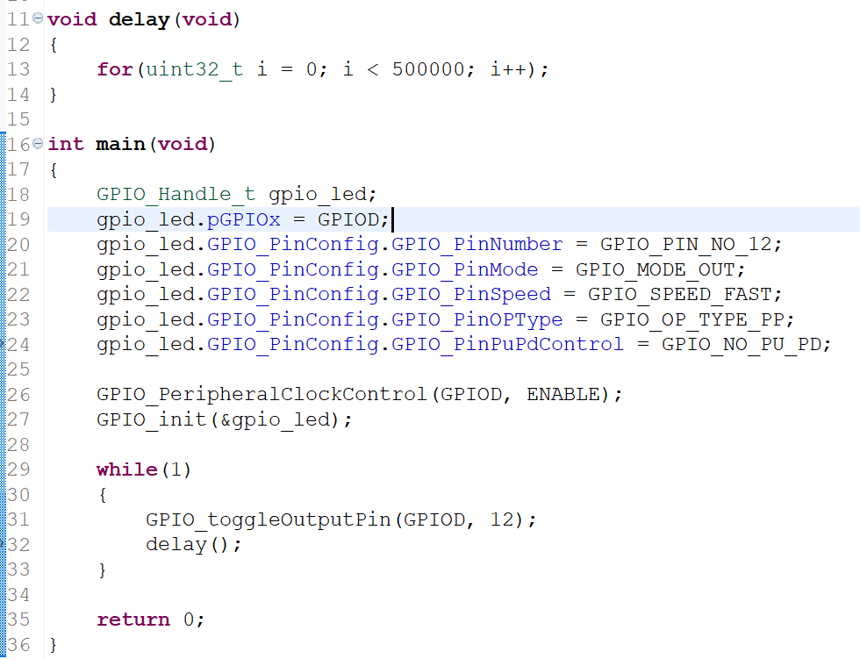

Let's first create a variable for our GPIO handle. So, have to use the GPIO handle structure. Right? Now, let's create a variable. So, let's say GpioLed. Now we have to initialize this. Now, let's initialize this structure variable. First, select the port actually this is GPIOD. After that, let's do the pin configuration.

So, the first thing let's select the PIN number. So, what is a PIN number? GPIO PIN number 12. After that, let's select alternate function mode we need not to select PinMode. PinMode is output. And after that speed, actually speed doesn't matter. So, you can keep whatever you want. Let's keep speed fast no problem. And after that output type. Output type let's use the case 1 output type and let's select the push pull. GPIO output type push pull. And after that, GPIO config push pull pin pull up or pull down control. Actually you need not to enable any pull up resistors, because the pin output type is already push pull. So, that's why NO_PU_PD. That's it. And now, let's call our API GPIO_Init() and you have to send the address of this one. That's it.

Remember that, before configuring the registers of the GPIO peripheral you have to **enable** the **peripheral clock**. Right? Because, this function is going to do lots of peripheral initialization. Right? So, that's why let's use our clock control API that is GPIO peripheral clock control and let's enable the clock for GPIOD. That's the port we are using. All right. And after that let's toggle.

Let's go into the infinite loop and let's toggle, we have a toggle API. ToggleOutputPin. So, GPIOD and pin number 12. And let's give small **delay** so that we can notice the toggle, so delay. So, let's implement a small delay function here. So, actually let's implement **software delay** by using for loop. uint32_t i = 0; i is less than let's say let's give some number 500000. 500K and i++. Because, this will add significant delay. All right. That's it. So, this should toggle your LED if all our APIs implementation is correct. All right. So, now let's compile this code, build the project, so no errors. That's great. And let's all right. So, the LED is indeed toggling.

Per utilizzare questo codice con la mia ***NUCLEO-H563ZI*** dovrei modificare non sono la GPIO port ed il pin number da utilizzare per uno dei 3 ***user LEDs***, ma dovrei modificare anche tutto l’**MCU specific header file** in quanto cambiano tutti i ***base address***delle varie periferiche.

So, let's trace the LED by using the logic analyzer.

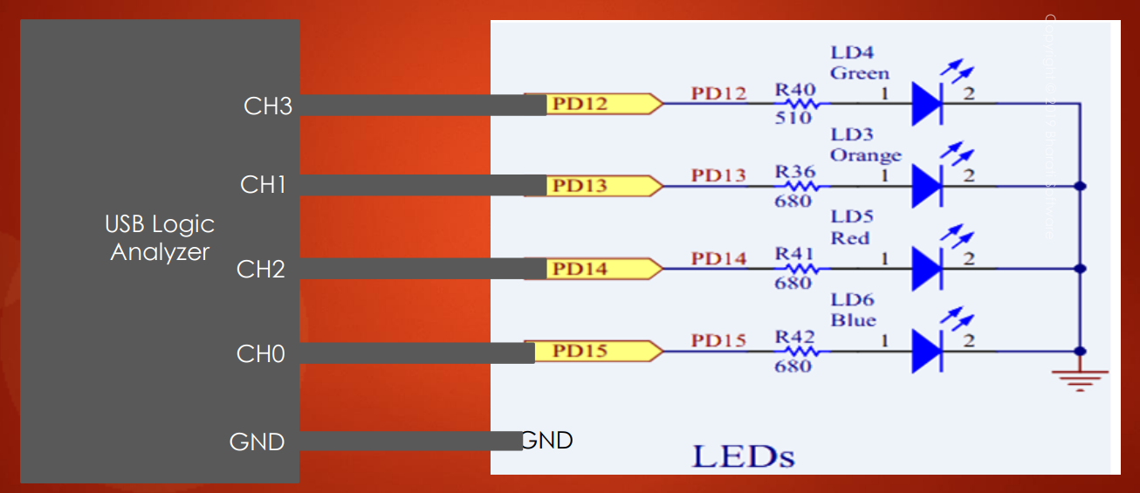

So, if you want to use logic analyzer in order to trace the activity on the LED, so you can use any channel of your USB logic analyzer. Now, what you do is. So, here we are using only one pin. Right? That is PD12. So, just select one channel on your USB logic analyzer. For example, let's say channel 3, or channel 1, or channel 0. So, connect one jumper wire from channel 3 to PD12 and connect ground to the ground of the board. So, PD12 you can get in the board header. So, if I go to the schematic. So, these are the board headers. Right? This is your board. Right? So, PD12 you can get write here. So, just connect one of the channel of the logic analyzer to PD12 and connect the ground point of the logic analyzer to ground.

And after that, you can just open the software and let's trace. So, before tracing so you can keep this around 12 MS and here let's keep 8 and let's capture. All right. So, let's stop and here we can see that my LED is indeed toggling and the delay is around 400 milliseconds. Great! Let's decrease the delay and let's see that effect. So, let me divide by 2. All right. Now, let's again built and let's me capture and here it is. So, delay is little fast that is 216 milliseconds. All right. I hope you can reproduce this at your desk and if you are not using discovery board, then you can change the port here and the Pin number here. Rest all will be same. That's it. And here also you have to change that is the peripheral clock control. So, you have to mention the GPIO port for which the LEDs connected. All right. So, this is very very simple application but this code entirely uses the APIs developed by us. Isn't it? So, I'll see you in the next lecture. So, in the next lecture let's use the open drain configuration. I'll see you in the next lecture.

## 103. Exercise: LED toggling with Open Drain configuration

Hey, welcome back to the lecture. So, now let's attempt the case 2 that is output pin with **open drain configuration**. So, what we can do is, we can keep the pin output type as output type. So, now let me make the output type as GPIO_OP_TYPE_OD.

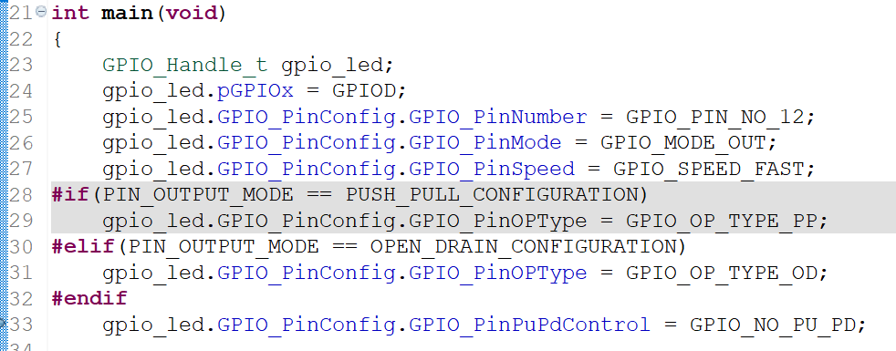

Now, let's see we can able to toggle the LED or not. All right. So, according to theory the LED should not toggle now because the LED is actually connected here.

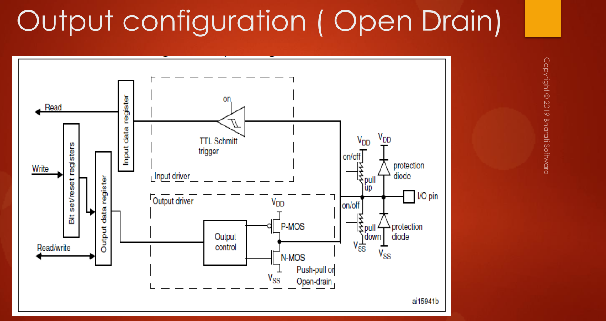



1

0



PD12



So, this is resistor which is given in series in the board this is actually 510 ohm and this is PD12. And now the configuration is actually **open drain** and the pull-up resistor is not activated. So, the LED can be pulled down. Right? When you write 0, the LED can be pulled to ground but it can't be pulled to VDD. Right? So, that's the reason the LED cannot toggle in this case.

How to solve this issue? Activate the **pull up resistor**. Now, let's activate this pull up resistor but what happens. This pull up resistor value is 40K remember, 40 Kilohms. So, a very very tiny current actually flows across the LED, very small. So, that's why you should see LED blinking or toggling with very very less intensity or sometimes you may not able to see that LED toggling. But current indeed flows across the LED but that will be very very small and will see whether we are able to capture that effect or not.

So, I am going to activate the pull up resistor that is internal pull up resistor.

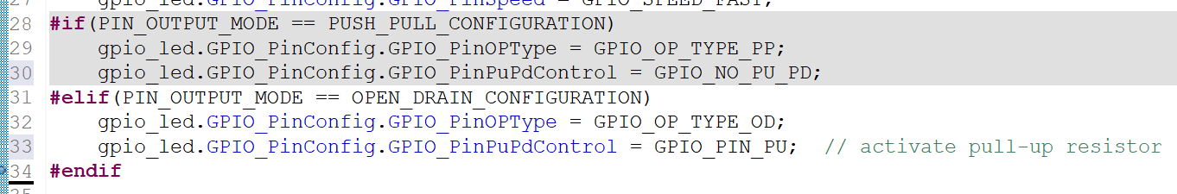

And yes, the LED is actually toggling but the intensity is very very small. It is almost unnoticeable. So, that is actually expected.

How to make LED toggle with normal intensity?

The idea here is that don't use the internal pull up resistor. So, let's get rid of the internal pull up resistor. So, we can keep this in OD no problem, that is open drain. So, don't use this because that is very big value so don't use this. So, basically what you to do is. So, this is our LED. Right? So, you give one external resistor, so connect one external resistor you can use very small value, so let's say 320 or whatever.





+VCC (5V)

510 ohm

320 ohm



PD12



So, this is 510 and connect this to +VCC that you can connect it to 5V. All right.

So, this would be fine, instead of using 40 kilohm pull up you use very small resistance pull up. So, this would actually make your LED toggle at normal intensity. So, now what you have to do is, you have to take one jumper wire and connect the PD12 to VCC via one resistor. External resistor of value 320 ohm or 470 ohm or whatever. You can use 470 ohm, which is actually standard value. That's it.

So, in the schematic what happens is PD12 is here. So, take one jumper wire and connect this PD12 to the VCC5. So, which is right here in the P2 header. So, 5V you can get here. So, connect here through a resistor of 320 or 470 ohm. So, that is actually like giving an external pull up to the PD12 pin. All right. And let's test this code.



So, let me make it as no pull up/pull down (***GPIO_NO_PU_PD***) and let me compile the code. So, now let me just download the code and yes, indeed the LED is toggling with the normal intensity. All right. So, there are some settings you have to do when you use **open drain**.

So, I would suggest **not to use open drain** unless you have specific reason in your application design. So, for all your application you can safely use **push pull** **configuration**. No problem. But, if we have any special considerations then only you can go for open drain.

So, that's about the push pull and open drain push pull configuration testing on the LED.

So, now let's do another exercise in the next lecture. Write a program to toggle the on board LED whenever the on board button is pressed. Now, we are going to use 2 pins here: one for the LED and one for the button. So, one pin will be in output mode and another pin will be in input mode. And whenever the button is pressed, the LED should toggle and I will see you in the next lecture.

## 104. Exercise: Handling on board LED and button

Hey, welcome back to the lecture. And now let's do another exercise, write a program to toggle the on board LED. We can select the on board LED as PD12 again PD12 and whenever the on board button is pressed. For this we have to first check where exactly the button is connected in our schematic. Right? So, that's why let's go to the schematic of the **discovery board**.

In the schematic so just go to the LED section in the page number 31.

***CAD Resources -> Schematic Pack:*** mb997-f407vgt6-c01_schematic.pdf

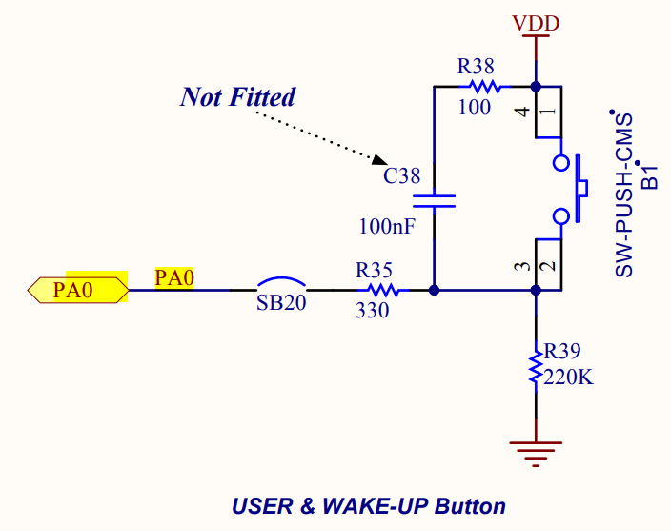



So, here you can find the **user button** here it is. So, this is a button and this button is connected to the pin number 0 of port A (***PA0***). And what happens here is that, so when you press the button what happens, this will get shorted. So, that's why the PA0 is actually pulled to high. Remember that. So, it will not be grounded. Why? Because, this resistance is very high. So, that's why when you close the switch actually the VDD doesn't go to ground but, so the PA0 is actually pull to VDD. So, actually the current flows in this direction (**rosso**).

Quindi, quando premo il pulsante la VDD non va al GND in quanto la resistenza R39 è molto elevata, di conseguenza la VDD va verso PA0.

When you release the button, there is a disconnection and so that's why the pin will be pull to ground (**verde**).

* when you press the button remember PA0 will be high
* when you release the button PA0 is low

So, this is actually board specific and if you go to the **nucleo board**, so this is actually different. So, I would like to mention that change. For example, in the case of nucleo board so button is actually right here, which is connected to PC13 actually. So, you can see that it is connected to PC13. And when you press the button the PC13 is actually pulled to ground. When you press the button the PC13 is pull to ground and when you release the button PC13 will be pull to VDD.

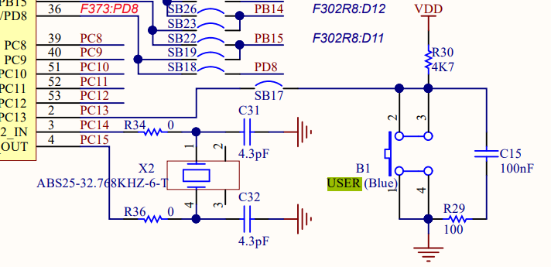

So, that's the difference between on board connection button in **discovery board** and **nucleo board STM32F446RE**. All right. So, I hope you will remember that difference here and with that note let's code this application.

Let's create new source file **002_led_button.c**. And after that, so we need not to use this source file now. So, that's why exclude this source file from the build. So, right click on that, go to properties and click on exclude from build. So, go to settings exclude from built, apply. All right. We can copy some of the code from here we can copy this delay, let's copy that and we can copy main as well, we can copy everything no problem. All right. And now, let's create another variable here. GPIO let's say Btn (button). All right. And this is LED configuration, that is correct. And after that let's copy all these thing once again and let's change this to GPIO button. All right. All right. So, GPIO is connected at PA0. Right? So, this is A, this is 0. And the mode is input, because it's a button and this can be fast no problem. Now, here so this doesn't matter now. Because, this is applicable only when the mode is output. Right? So, that's why you can delete this line and here pin push pull and pull up/pull down control. So, you can keep as no pull up or pull down. Why? I will tell you. So, because if you look at this schematic of button.



So, this is a pin right PA0. And you can see that there exists already a pull down resistor (**R39**). Right? So, this is a pull down resistor. Right? So, external pull down resister is already available in the schematic itself. So, that's why it doesn't make sense to activate the internal pull up or pull down. So, the schematic itself has given a resistor. Right? So, that's why we need not to do anything.

But in the case of **nucleo board STM32F446RE** you can see that pull down is not available, but pull up is available. So, they have given pull up resistor. All right. So, here there is an external pull up, but in that case external pull down is available.

Come back to the **discovery board**.

Now, let's do some settings here. So, this is GPIOA. All right. That's good. And now when the button is pressed you have to toggle the LED. Right? So, let's remove this delay. So, now we have to read the status of the button. For that, we have an API ***GPIO_ReadFromInputPin()***. So, you have to use input pin. So, what is a port? GPIOA. What is a pin? GPIO_PIN_NO_0. All right. If the button is pressed, then pin will be high. So, this function will return high if the pin is pressed. So, in that case only we will toggle the LED. That's it. All right. Or I can write something like this a this is equal to button pressed. And button pressed I can hash define here, button pressed is high in our case. I can make high as enable or 1. I think it looks good. Right? So, in the case of nucleo button pressed is equal to low you have to remember that. Fine. So, now you have to take care of **button debouncing**. Because, when you hit the button so this loop may execute multiple times and you may not able to see the toggling of the GPIO or LED properly. I mean, because this loop can execute multiple times. Right? Because of that pin debouncing. So, what we can do is, we can introduce a **small delay**, we can reduce this delay by let's say half. All right. So, this delay is given because once the code finds that the button is pressed, it will wait until the debouncing of button gets over. Otherwise, this loop will execute multiple times and it can execute this function multiple times. So, that's why to avoid that, So, I'm just giving this delay in order to wait until the debouncing gets over. Fair enough. So, should work and let's compile. So, now let's tap the user button. Yes, it is indeed working. Great!

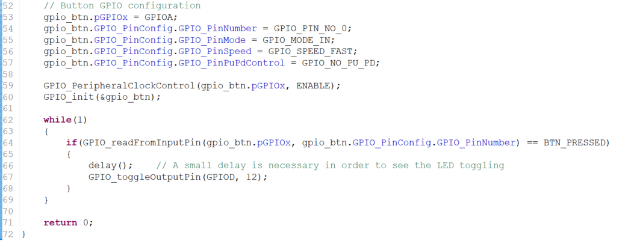

So, you can see that toggling of LED is very clean. Isn't it? But if you remove this delay, then the toggling of LED will not be very clean. You can see some distortion in the output.

Now, let's try this one. So, you can try that, your output will not be proper if you remove that delay.

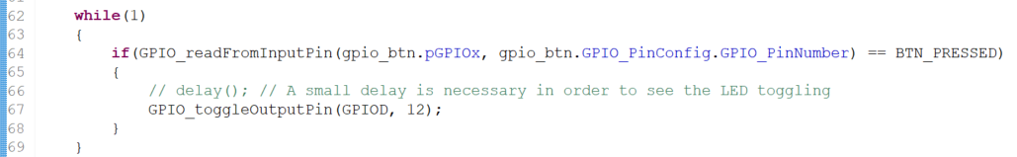

So, that's because of **button de-bouncing** the loop will execute multiple times. Because, the read from input pin will be true multiple times. All right. So, with that note I would like to end this video, and if you have any questions let me know and it is very very simple.

And if you are using **nucleo board**, then you should make sure that button pressed is equal to **low**.

In the next lecture, let's do another exercise: write a program to connect an external button to the pin number PB12 and external LED to PA14. Toggle the LED whenever the external button is pressed. So, you need not to use external LED you can make use of an internal LED, no problem. So, you need not to connect an external LED. So, but if you have external LED, than you can use it and with CDs resistance of let's say 470 ohm. So, external LED should come with one series resistance you can use 470 ohm, and then you connect one LED, and the pin will be PA14.

And after that the button you should connect to PB12. And I will tell you how to connect an external button in the next lecture. So, for this exercise you need one external button. Because, we can learn how to connect external button properly to the pin of the microcontroller. But, I don't think you need external LED, so you can make use of internal LED, no problem. So, if you don't have buttons and LEDs, then no problem. You can watch the video and later you can do when you have those components. So, to do this exercise you need one external LED, one external button, and also you need one resistor of 470 ohm. And I'll see in the next lecture.

## 105. Exercise: connecting external button and circuit explanation

Hey, welcome back to the lecture. So, in this lecture let's learn how we can connect the push button to our STM32 microcontroller and we can see, how to test that using our APIs. So, a push button is required for this exercise and let me briefly explain how exactly a push button looks.

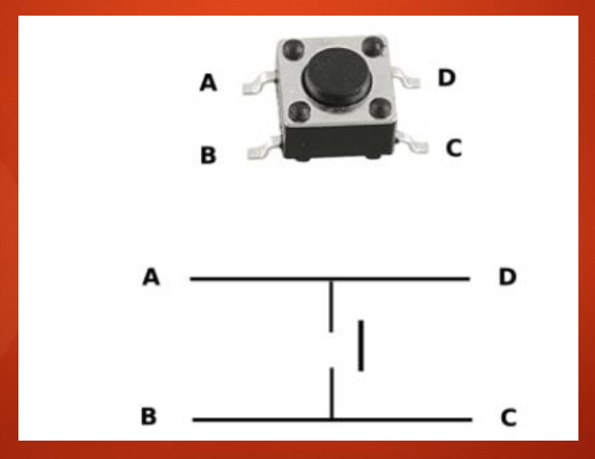

Near ends



Far ends



In the push button always remember that, when you hold the push button the far ends A-D & B-C are actually connected. So, it's like one thread going from inside and coming out. All right. So, sometimes what happens is when you hold the push a button so you will get confused, which ends are connected and which ends are disconnected. So, you have to identify the far ends:

* A-D, B-C: **far ends ->** each far ends are connected
* A-B, C-D: **near ends ->** each near ends are disconnected

So, these are connected and the near ends are disconnected. So, that's what a shown in this diagram. So, when you push that button what happens is these ends and these ends will get connected. All right. So, now what we are going to do is, we are going to connect this push button to the pin number PB12. And we are also going to connect one external LED to pin PA14.

And now let's see the push button connection, let's see how we can connect the push button. So, you can go and simulate in this Web site:

<https://www.tinkercad.com>

So, this is actually tinkercad.com and here you will get the list of all the components, and this site is to simulate the electronics circuits, and 3D modeling simulation etc.. So, you cannot simulate the code for a STM and all. But you can simulate the code for Arduino boards. All right. So, now here get the push button and place it on your bread board somewhere in the middle.

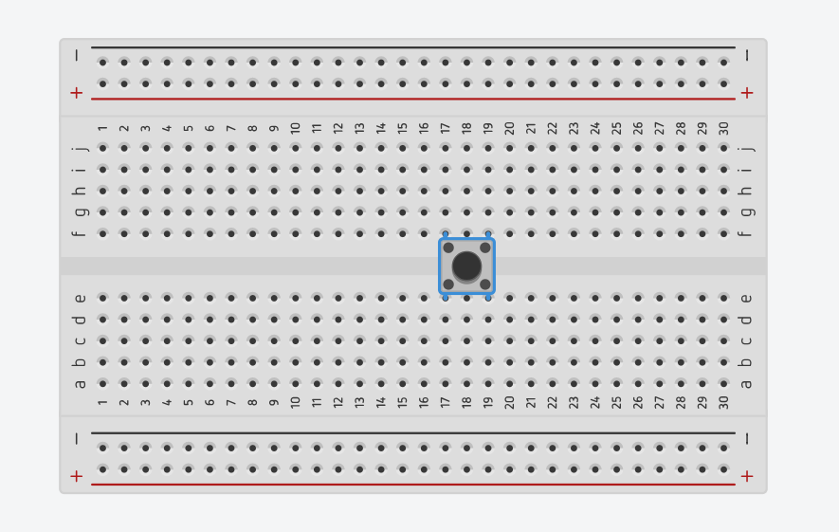

Near ends

Far ends



So, here you can see that these ends are actually far ends. Right? So, those are connected actually. These ends are disconnected. So, these are near ends. So, t1 is actually not connected to t2. So, when you press the button so these two end will get connected. All right. So, now what we can do is, we can just connect one end let's say t2 to ground. So, let's consider this as ground point. All right. So, let's change its color to black. And let's connect this end to our STM32 microcontroller pin, maybe PB12. So, connect this to PB12 of your board.

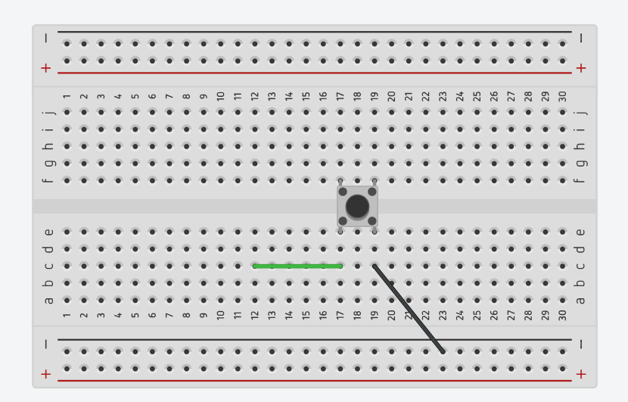

PB12

Remember that. So, you have to connect this to board. And now what happens here. So, just analyze this circuit. So, when I press the button so what happens is, there will be a short. So, this will be grounded. So, when I press the button it will be grounded. But if I don't press the button you can see that this pin (c17 of the breadboard) is actually floating. So, that is not good. Right? So, that is actually not good. So, for that what you do is, take a resistor and connect between let's say this pin and VCC. We are actually connecting a resistor between the terminal t1 and VCC. Remember this is VCC and this is ground. And you have to connect the ground point of your board to this ground point and you have to connect VCC that is +5V from your board to this line. So, remember that. So, I am not showing that, so we have to do that. All right. So, now let's set the value for this resistor. So, you have to use very high resistance here 22K let's say. So, I have used 22K. So, now what happens. So, now when you don't press the button this pin will be pull to high. Right? So, this resistor is actually called **pull up resistor**, so the **external pull up resistor**. And which is very very important because it avoids the **floating state** of the pin, when the pin is not pressed. When you press the button the circuit actually look something like this.

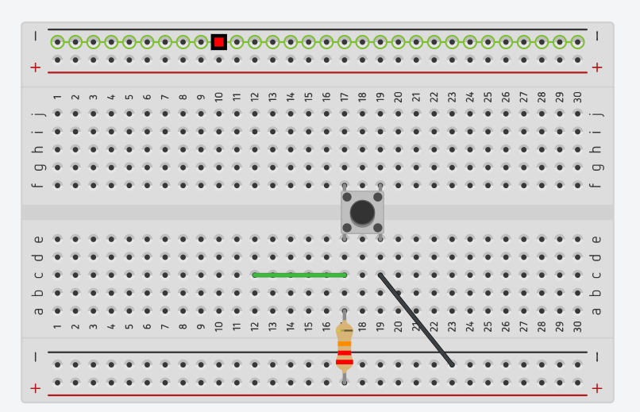

GND board

+5V VIN board



22 kOhm

+VCC

0V

pin

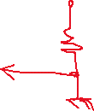

This is going to pin and this is our resistance connected to the VCC, so let's show that here. So, this is let's say 22K resistance, this is +VCC, and so this is going to ground. So, pin is actually grounded here. Right? So, this point is actually grounded. So, the potential difference is actually 0V. Right? So, that's the reason the pin will be grounded when you press that button.

So, this is a right way to connect the push button. And remember that, this should go to PB12 on your board or whatever the pin you select to connect this push button on the board. And from the board you have to connect 5V to this line (+), this 5V comes from the board. Remember that point from board. And also from the board you have to connect ground here (-). This is a ground. All right. And after that, you need **not** to use this resistor because instead of this we can activate the internal pull up resistor. In fact, we also have 40 kilohms of internal pull up resistor. So, that's why you can also make use of that and if your pin doesn't support internal pull ups, then you can use this external pull ups.

Let's test this. So, LED buttons. So, this is actually done and let me create a new source file **003_led_button_ext.c**. Let me also talk about the LED connection, so you can take one LED and you can place it somewhere.

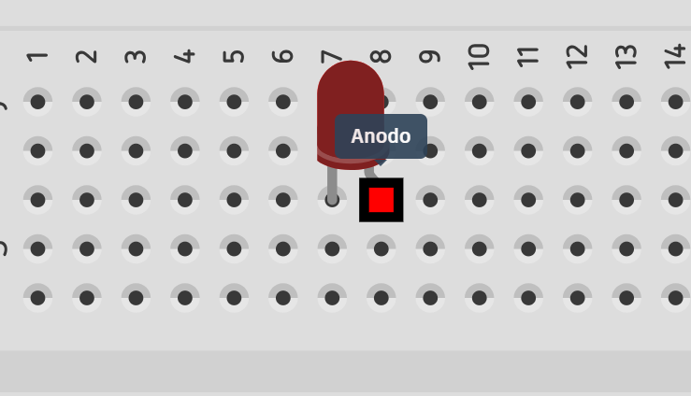

* Gamba storta o lunga: anodo -> positive (+)
* Gamba dritta o corta: catodo -> negative (-)

So, negative you can simply ground it. No problem. All right. So, just connected to ground. All right. And after that, for the Anode remember that you have to connect one resistor, that we call as **current limiting resistor**. So, you have to connect one current limiting resistor and this resistance value you can keep as let's say 470 or 500 Ohm.

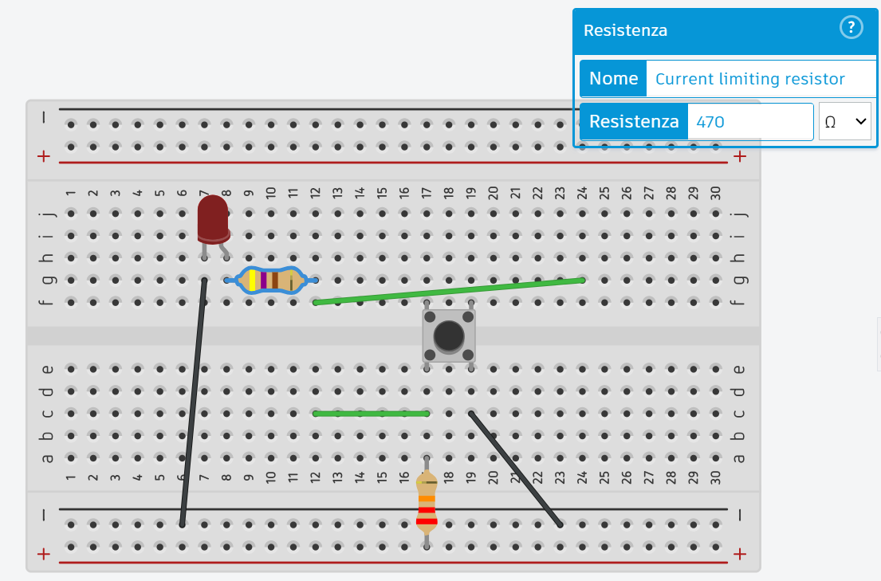

PB12

PA14

And after that, so this point and this should go to the board. In our case, this is PA14.

Let's get back to the code and here let's modify this code. So, this is our GPIO configuration and here let me use PA14 and let me use pin number 14. And I'm going to use the **push pull configuration**, so no pull-up/pull-down.

For the button I'm going to use PB12. So, let's use PB12 and after that this is IN and you have to use internal pull up resistor. I am using internal pull up because I don't want to connect that external 22K resistor.

If the button is pressed, in our case, then the pin is grounded. Right? So, that's why we have to change the **#define BTN_PRESSED**. If the button is pressed, then we read **LOW**.

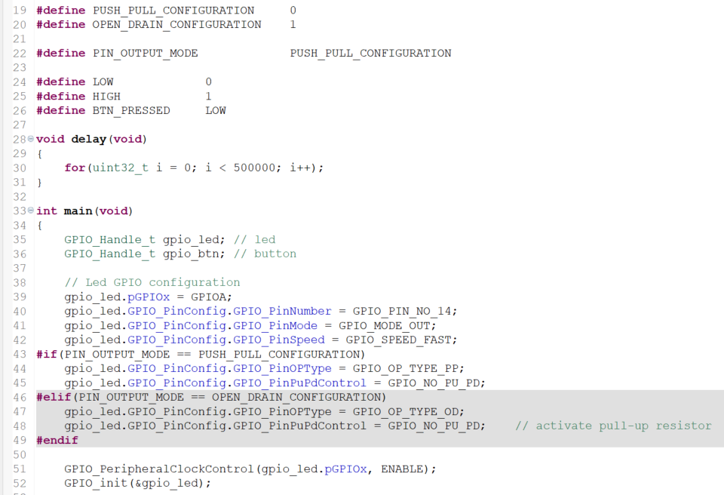

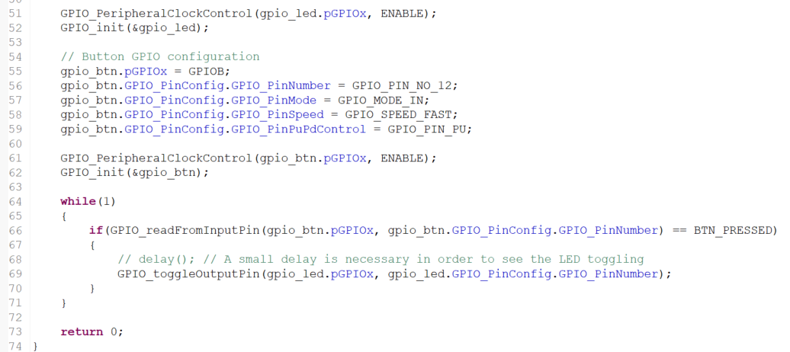

So, in the next lecture let's test this application. And I'll see you in the next lecture so try to reproduce this, you need not to use the same pins what I have used here: PB12 or so you can select whatever you want, no problem. All right. I will see you in the next lecture.

## 106. Exercise: Testing button interface

Hey, welcome back. So, now let's just build this code and let's download and test.

So, now let me press the user button to see the external LED connected at PA14. Let me press the button couple of times and the output is not coming actually, the LED is not toggling. So, we are doing something wrong. Actually, the LED or button code something must be wrong.

First of all let me check whether the GPIO PA14 is valid GPIO pin or not. For that, what I can do is, I can go to the **Datasheet** and just search for PA14.

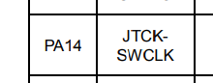

So, the PA14 is actually used as a single wire debug clock or JTCK clock. You can't use PA14 as GPIO. So, that's a problem. So, you cannot use that pin.

So, let's go to the **Reference Manual** and let's do a random search for PA14. Let's see, what we get. All right. Here it is.

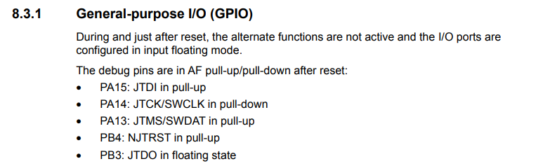

During and just after reset, the alternate functions are not active and I/O ports are configured in input floating mode. The debug pins are so these are actually debug pins. Those are actually in AF mode actually. That means, it will be automatically configured to the AF mode. So, that's why you cannot use them unless you change the alternate functionality configuration.

So, these are actually used for the debug purpose and we should not touch that. And so, let's change PA14 to PA8 in our code.



PA8 is actually the valid pin. So, strictly speaking before selecting any pin you have to check here in this table. All right. So, PA8 we can use PA8. So, remember that we cannot use **debug pins**. Don't use these pins other than these pins you can use any other pin.

Let's use PA8. So, let's go back. So, let's use PA8 for the LED. All right. So, just change this to PA8 here and here also PA8. All right. Now, let me just download the code. So, I just connected the LED to PA8, and now let me just hit the button and here it is. It is working. Right? Great!! So, we just learnt how to successfully connect the external LED and external button. That's about this exercise and now let's move on to the next exercise.

## 107. Button interrupt introduction

Hey welcome back to the lecture. Let's do one more exercise. That is connect an external button to PD5 pin and toggle the LED whenever interrupt is triggered by the button press, so interrupt should be triggered during falling edge of button press.

Now we have to discuss the **interrupt configuration** of a GPIO pin.

Because we haven't given interrupt support in our driver code, now we have to learn about the various interrupt modes, its configurations and selecting the interrupt triggering like the falling edge triggering, rising edge triggering etc.. And we have to learn about the IRQs and we have to implement APIs for IRQ configuration and also have to implement the ISR handling.

So all these things let's implement first and then we'll take up this exercise. Alright from the next lecture onwards let's improve our driver code in order to support interrupt handling. I'll see in the next lecture.

# Sezione 28: GPIO pin Interrupt configuration

## 108. GPIO pin interrupt configuration coding: Part 1

Hey welcome back to the lecture. So from this lecture onwards let's give support for **interrupt capability** in our driver source file. So in the ***GPIO_init()*** we have to complete this part that is configuring the **interrupt mode**:

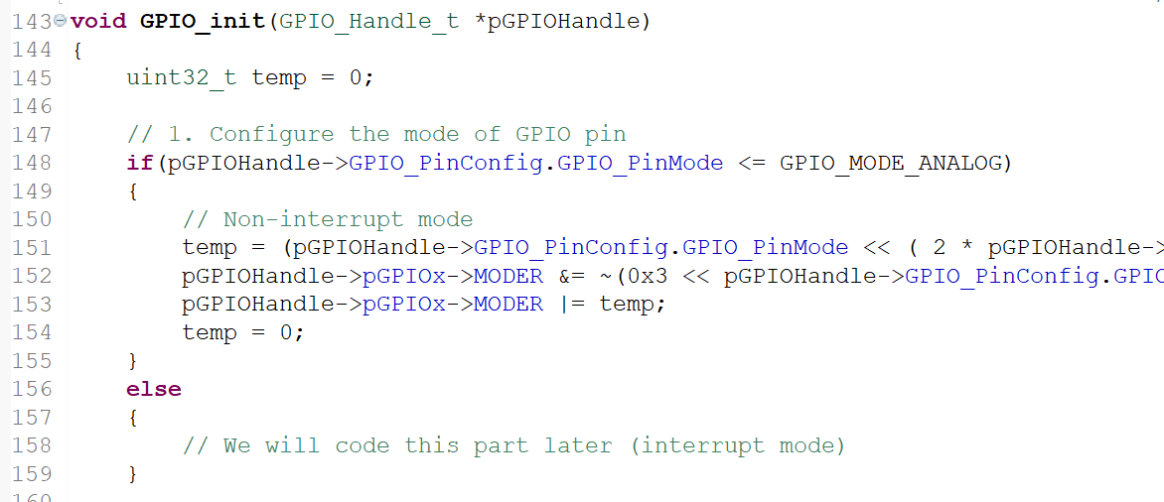

And after that we have to complete these 2 APIs:

* void GPIO_IRQConfig(uint8_t IRQNumber, uint8_t IRQPriority, uint8_t enable);
* void GPIO_IRQHandling(uint8_t pinNumber);

***GPIO_IRQConfig()*** is to do the configuration of NVIC registers of the Arm cortex Mx processor.

In this lecture let's concentrate upon this part and if we see all the modes of our GPIO pin.

So these three are actually interrupt modes:

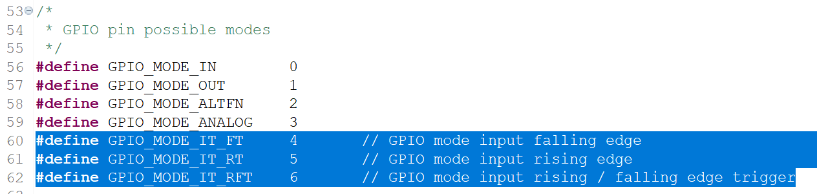

So we can configure GPIO pin in 3 **interrupt modes:**

* **falling edge detection**
* **rising edge detection**
* **falling / rising edge trigger**

So these are the 3 combination of modes in interrupt mode and in earlier part of the course we actually discussed about the interrupt design, the EXTI registers and various other things.

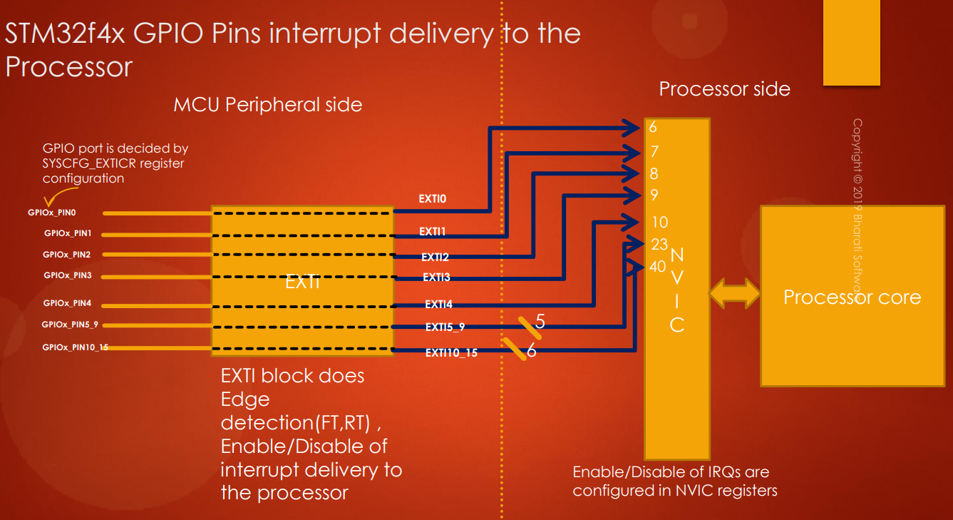

I want to give you a quick overview about the things we discussed in earlier part of the course.

So this is actually the STM32f4x GPIO pins interrupt delivery to the processor. So GPIO pin 0 delivers its interrupt on EXTI0 line. Pin 1 delivers interrupt on EXTI1 line.

Remember that all the EXTI lines from 5 to 9 are actually tied together and they are actually connected to single IRQ number that is 23. So this information you have to obtain from the **vector table**.

All the EXTI lines from EXTI10 to 15 are tied together and they are connected to a single IRQ number that is 40. There is an **EXTI block** in between, and that block does edge detection and it also gives you a registers to enable and disable interrupt delivery to the processor.

These **IRQs** are actually **disabled** by **default**. So you have to configure the **NVIC registers** in order to enable or disable the interrupt reception on those IRQ numbers. So you have to remember all these points. And here which GPIO port it is.

GPIOx_PIN0 is of which port so that is actually decided by the SYSCFG_EXTI control register. So this also we have to configure in our **GPIO_init()** API. So let's move forward.

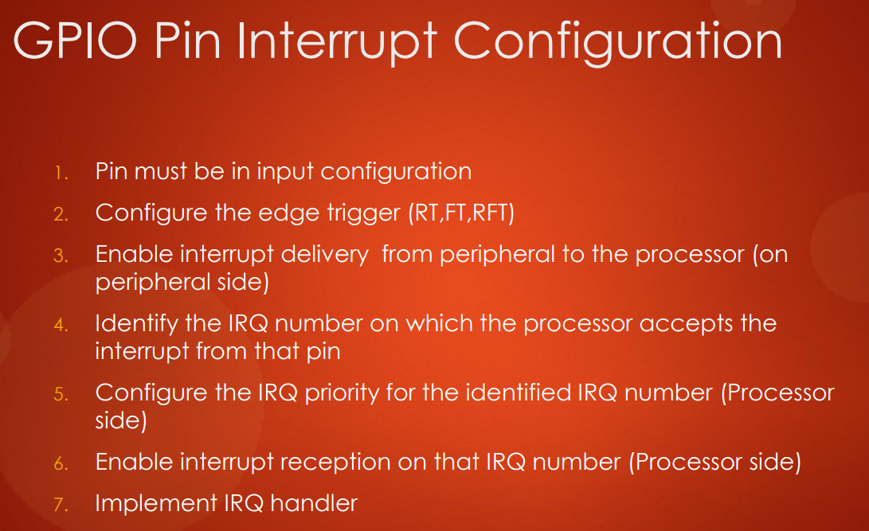

**GPIO pin interrupt configuration**:

To implement successfully the interrupt modes on a GPIO pin you have to follow these steps. Remember that these steps are very much common to any microcontroller you use.

1. First thing is make sure that the pin is in **input mode**. So the pin must be an input mode because you are receiving an interrupt.
2. After that, configure the edge detection or edge triggering like which **Edge Trigger** you want. I mean rising and falling or both rising as well as falling edge. So we do this in the **EXTI register.**
3. And after that, **enable interrupt delivery** from **peripheral** to the **processor**. You have to do this in peripheral side. So you have to do this in the EXTI register by using **interrupt mask register** of the **EXTI**.
4. And after that, identify the **IRQ number** on which the processor accepts the interrupt from that pin. So that means, for example, in this case if you want to send interrupt from pin 0 then you have to identify the IRQ number (6). We do this by using the **vector table**.
5. And after that, configure the **IRQ queue priority** for the identified IRQ number. So you have to configure this in the **NVIC register**. So **NVIC** has **priority register**.
6. After that, **enable interrupt reception** on that **IRQ pin**. Again, you have to touch the **NVIC register** in order to enable the IRQ number. Because by default all the **IRQs** are **disabled.**
7. After that, implement **IRQ handler**.

So, if you are confused don't worry. We are going to implement this step by step in our code and your doubts will get clarified. Let's get into the IDE and let's go to the ***GPIO_init()***.

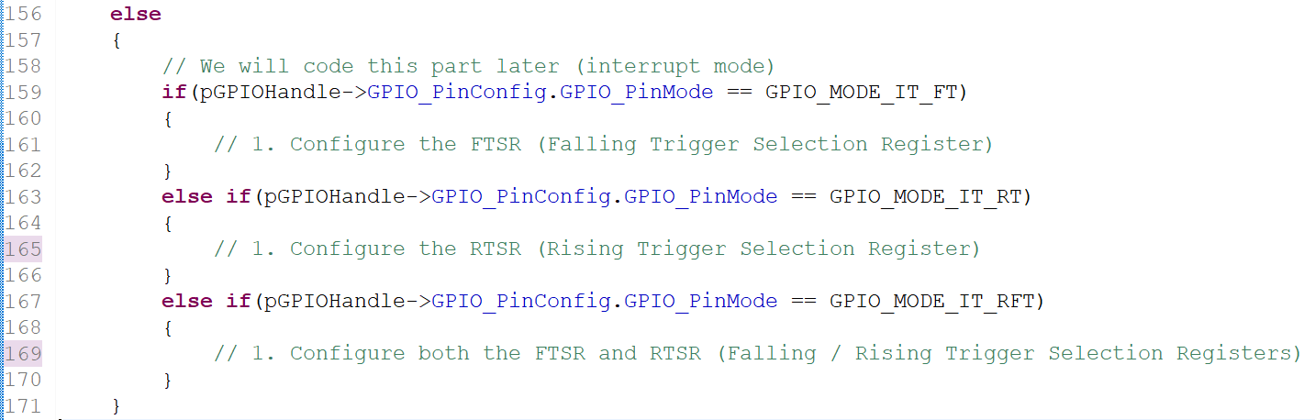

After that what you have to do is configure the GPIO port selection in **SYSCFG_EXTI** Control register. So don't worry I will explain this. After that you have to enable the EXTI interrupt delivery using **IMR**, that is **Interrupt Mask Register**. So let's code all these things in the next lecture.

## 109. GPIO pin interrupt configuration coding: Part 2

Now configure the **FTSR**. FTSR is a **register** of **EXTI**. So let's use the EXTI peripheral and let's dereference that. But we don't have a EXTI peripheral definition in the MCU specific header file. Now let’s create that.

So we didn't do actually. So let me do that here.

**#define** EXTI ((EXTI_RegDef_t*)EXTI_BASE_ADDRESS)

But EXTI peripheral structure is not yet created, so we have to create that, otherwise it will not be able to access its registers. Let's create here:

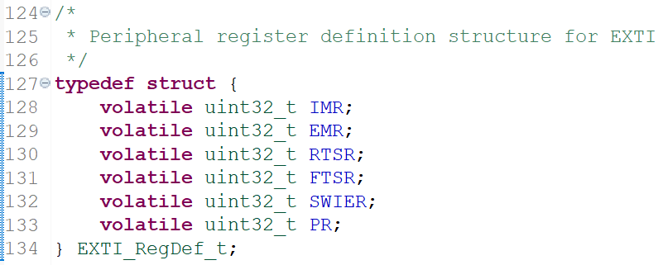

So I just created the EXTI peripheral register definition structure. And now let's go back to the code and now let's go back to the driver.c.

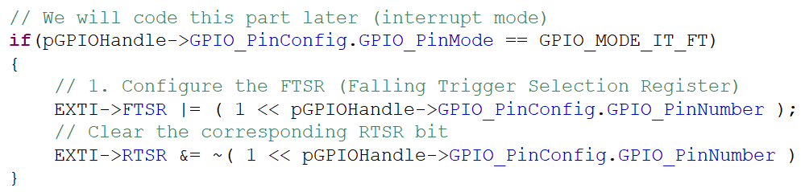

Here EXTI Dereference and select **FTSR**: now we have to set a bit in FTSR register which is corresponding to the pin number provided. Right. So that's why 1 left shifted by **pin number** that's it and make sure that the corresponding bit in the **RTSR** is **cleared**. Because we just want falling edge detection.

So maybe accidentally or maybe due to the other configuration previous configuration the RTSR the corresponding bit in RTSR are maybe set. We don't know. So that's why it's better to clear the RTSR bit.

So clear the corresponding RTSR bit. So How to do that? So just select copy and paste and is equal to negation of. So just select RTSR.

The same thing you had to copy for other interrupt modes as well. But you had to change this to RTSR And this to FTSR.

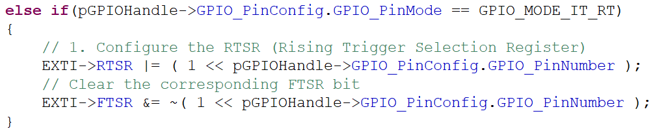

And after that you have to copy this once again here. So you had to configure these 2 lines once again and you had to paste here and here you have to set both RTSR and FTSR.

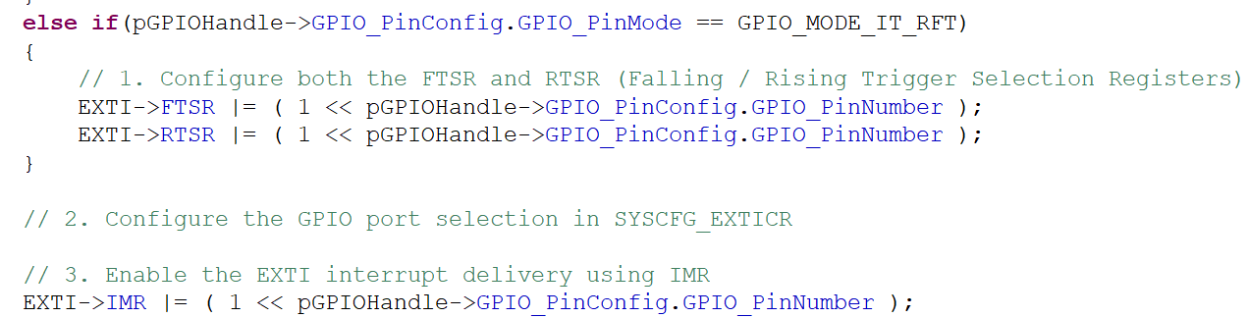

So we finished all these modes and then after that we have to configure the GPIO port selection in **SYSCFG_EXTI** control register and I will tell you that in the next lecture.

Now, **enable** the **EXTI interrupt delivery** using **IMR**. So you have to enable the interrupt delivery on that EXTI line corresponding to the pin number provided.

We will do step 2 in the next lecture, and I will see you in the next lecture.

So before ending this lecture I would like to give you a small assignment. So here we are going to configure the SYSCFG registers in the next lecture. So let's go to the **Reference Manual**.

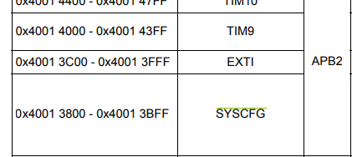

So here you can see that the **SYSCFG** registers are actually part of the **APB2** bus. So this peripheral is actually hanging on APB2 bus and you have to enable the clock for it. So create a clock enable macro in the **MCU specific header file**. So I have already created it:

**#define** SYSCFG_PCLK_EN() ( RCC->APB2ENR |= (1 << 14) )

So this clock enable macro must be present. And after that also create the **peripheral register definition structure** for SYSCFG peripheral. So currently it is not present. I'll quickly create that and I will return in the next lecture and I hope you will do that and I'll see in the next lecture.

## 110. GPIO pin interrupt configuration coding: Part 3

Hey welcome back to the lecture. So now I am in the **MCU specific header file** and here I have created **SYSCFG_RegDef_t** structure and this is how you should create it.

If you open the Reference Manual, let's go to the SYSCFG Peripheral, and if you go to the registers and go directly to the register map and here it is:

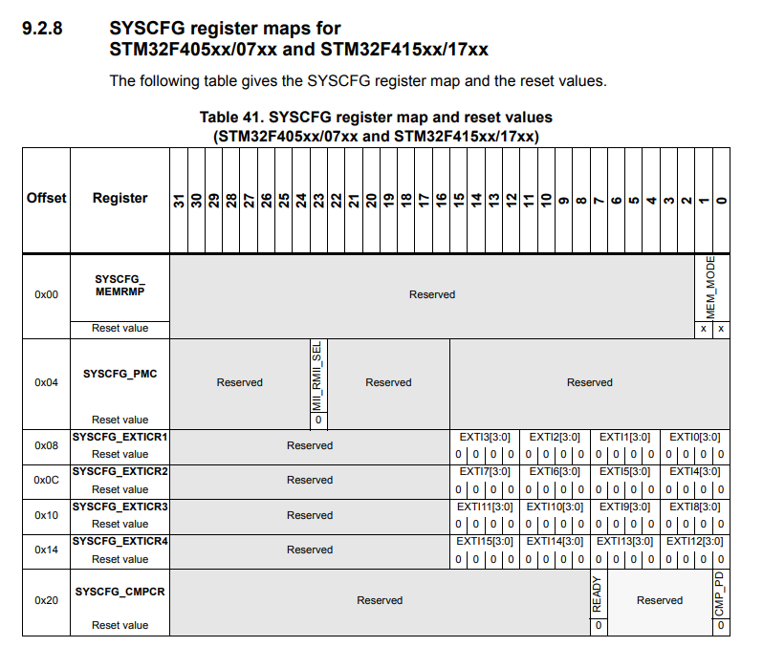

So it has 4 EXTI control register **SYSCFG_EXTICRx**. So basically you can make use of an array here, so that's why I have used ***EXTICR[4]*** an array so:

* EXTICR[0] means SYSCFG_EXTICR1
* EXTICR[1] means SYSCFG_EXTICR2
* EXTICR[2] means SYSCFG_EXTICR3
* EXTICR[3] means SYSCFG_EXTICR4

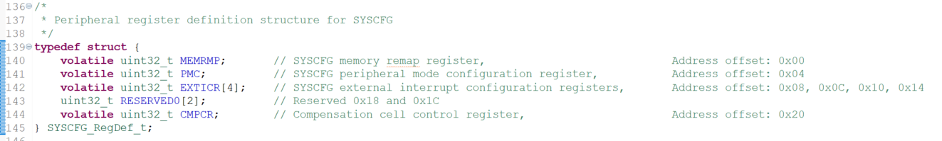

And among these registers we are only interested in **EXTI Control Registers** because we are working with EXTI lines. So that's why we are only interested in EXTI Control Registers and let’s see what those registers to.

## 111. GPIO pin interrupt configuration coding: Part 4

Hey welcome back to the lecture. So in this lecture let's talk about the **SYS config EXTI control register** configuration.



If you look at this diagram, you can see that **GPIOx_PIN0** is actually delivering the interrupt over **EXTI0** line but pin 0 of which port? So you have to decide which port, that you can configure in the SYS config EXTI control register (**SYSCFG_EXTICR**). That means pin 0 of which port should take over this EXTI0 line.

So by default the EXTI0 line is held by GPIO port A. So if you want to assign this EXTI0 line to pin 0 of some other GPIO port then you have to configure the SYS config EXTI control register (**SYSCFG_EXTICR**).

So this register decides which **GPIO port** should take over these EXTI lines.

Let's move forward. There are 4 different EXTI control registers:

* **SYSCFG_EXTICR1**
* **SYSCFG_EXTICR2**
* **SYSCFG_EXTICR3**
* **SYSCFG_EXTICR4**

Now let's look at **SYSCFG_EXTICR1**:

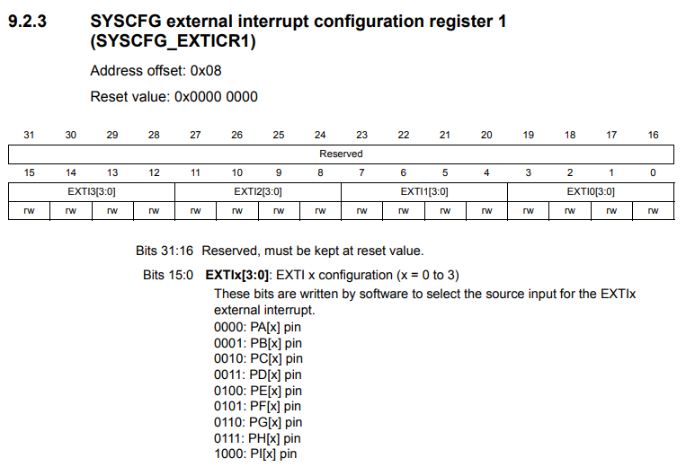

Here you can see that this register is of 32 bits. Only 0 to 15 bits are used and other bits are actually **reserved**. And this register controls 4 EXTI lines: EXTI0, EXTI1, EXTI2 and EXTI3.

Red rectangle highlights the values corresponding to different GPIO ports.

Now let's understand this with an example: let's say you have a button which is connected to **PD3**, that is GPIO port D pin number 3. And as we know, PD3 can actually deliver interrupt over EXTI line 3. But by default, the EXTI line 3 will be owned by GPIO port A. So that why you have to change that configuration now. So what you have to do is you have to go to the respective bit field of the EXTI3 line.

So in the register of **EXTI3[3:0]** you have to change the bit values. So what you have to do is here you have to use this value **0011** so that is you have to select the **port D** and if you do this the EXTI line number 3 will be owned by the port.

Now let's take another example: let's say you have a button connected to **PC13**. So PC13 delivers interrupt over EXTI line number **13**. Each register is for only 4 EXTI lines, so if you go to **SYSCFG_EXTICR2**, that is up to **EXTI7**. So you have to go to the **SYSCFG_EXTICR4**, where there is the position for **EXTI13**.

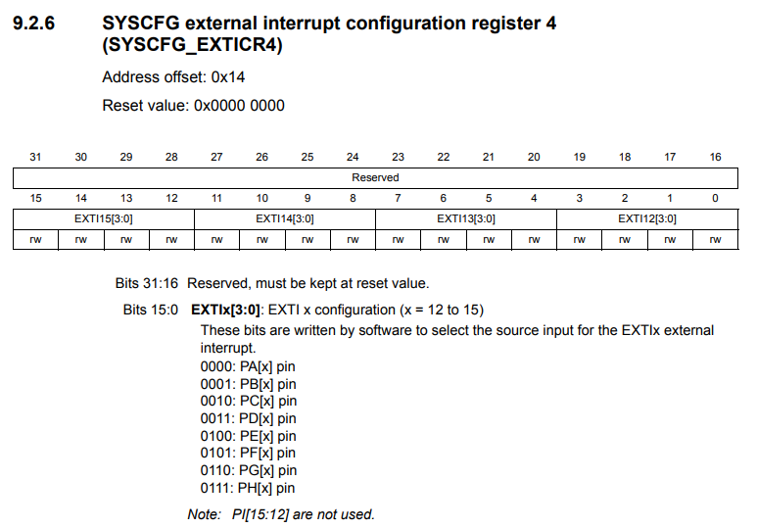

1st

0th

We want PC13, so you have to configure in the **SYSCFG_EXTICR4** register, and here you have to place the value **0010** in order to select the **port C**.

So you have to do these settings in SYS config EXTI control registers in order to control the EXTI Lines by different GPIO ports.

So now we have to take care these things in our code in the ***GPIO_init()*** code. So now how to identify the EXTI control register and how to program the value in appropriate position through our code. So let's find out how we can do that. Let's again take the example of PC13. So first what we have to do is to divide the PIN number by 4 and store the value in **temp1** integer division gives you 3. So this indicates that we have to configure the EXTICR[3], or EXTICR[temp1] in our array peripheral register.

So we have to refer to the EXTI control register 3, and after that again in another register temp2 we have to take 13%4 = 1. So we have to go to the EXTI control register 4 and after that we have to refer to the 1st section, so to **EXTI13**. So that means we have to multiply **temp2** by 4. So we will start storing the value from 4th bit onwards.

***temp1 = 13 / 4 = 3 -> EXTICR[3]***

***temp2 = 13 % 4 = 1 -> 1 * 4***

And after that we have to find out which value we have to use. So by using the base address of the peripheral we have to find out what is the code. So if the base address is GPIO A then it's code 0000. If it is B then code is 0001 like that and that code we have to store in these bit fields. I hope this is clear.

Let me take another example. So for example let's say **PA5**:

***temp1 = 5 / 4 = 1 -> EXTICR[1]***

***temp2 = 5 % 4 = 1 -> 1 * 4***

So that means we have to start storing the value from here:

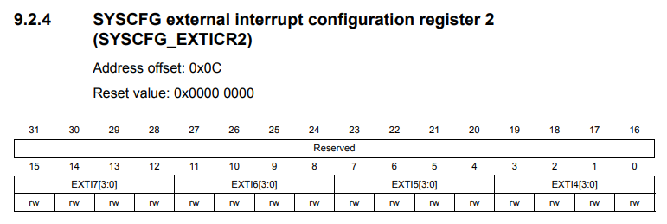



So this is a position for EXTI5, and here you have to store the port code 0000 for port A.

Now let's start coding this and here.

In the MCU Specific header file let’s add this:

**#define** SYSCFG ((SYSCFG_RegDef_t*)SYSCFG_BASE_ADDRESS)

While in the ***driver.c*** let’s add this code:

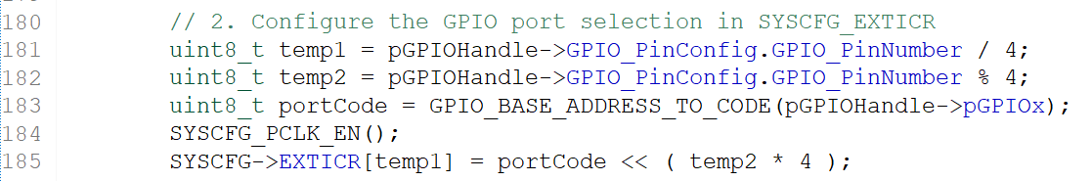

We don't know what is a port code so let's use **portCode** variable left shifted by **temp2** multiplied by 4. We can create a small macro to convert a GPIO base address to a port code, so later we can implement this macro. Remember that before configuring the SYS config register you have to enable the clock. So you have to use ***SYSCFG_PCLK_EN()***.

Now let's implement the macro **GPIO_BASE_ADDRESS_TO_CODE()**. So this macro actually takes GPIO base address as input. Actually you can implement this macro in **MCU specific header file** instead of driver header file because you know that this macro may be required in other drivers like I2C driver or SPI driver. So don't make it specific to GPIO so also make a generic. So let's keep that in MCU specific Header file so I would rather prefer that so you can even keep here.

So now let's create this macro define so it actually takes one argument let's call it as **x**. You can even create a C function to do this. No problem but I'm just using C macro so we can use **C conditional operators** here. So this is called **conditional** or **ternary operations** in C.

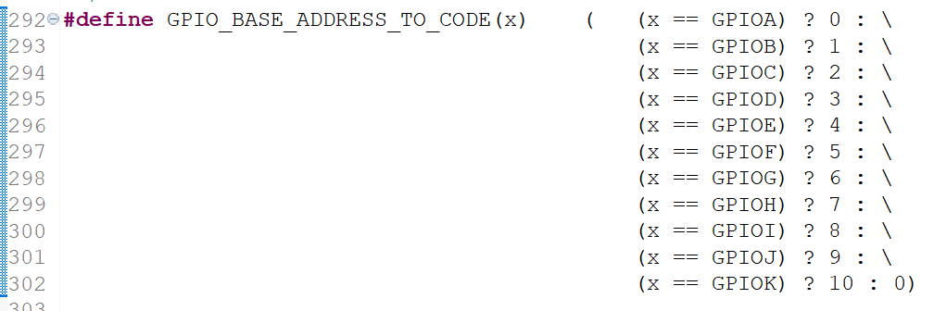

So basically if is hard to understand, don't worry you can use if and elseif ladder and you can write a small C function to return the code.

So now let's go back and these errors actually got resolved here and that's it. We are done with our ***GPIO_init()*** API and let's see whether our code compiles or not.

In the next lecture let's complete this API that is **IRQ config**.



Remember that in this diagram we actually enable the interrupt on the **MCU peripheral side** and now we have to take care of the **Processor side,** so that means we have to configure the **NVIC registers** to set the priority which is actually optional. Setting priorities actually optional.

So we have to configure NVIC registers to set the priority for these IRQ numbers or given IRQ number and also we have to enable those IRQs because, as I said, by default the **IRQ number** will be **disabled** inside the NVIC and all those things we are going to do in IRQ config function ***GPIO_IRQConfig()***.

**void** **GPIO_IRQConfig**(uint8_t IRQNumber, uint8_t IRQPriority, uint8_t enable);

Now we actually need **IRQ number** definitions. So that's why the exercise for you right after this video is go to your **MCU specific header file** and create macros to define the IRQ numbers for different EXTI lines.

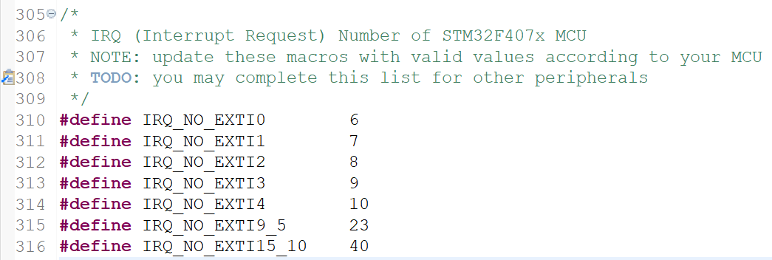

For example here I have #defined various IRQ numbers. So this is actually specific to microcontroller family. For all those microcontrollers which are based on F4 family. These macros will be same. These numbers will be same but your microcontroller families different then you how to verify these numbers by going through the **vector table** of your **Reference Manual**.

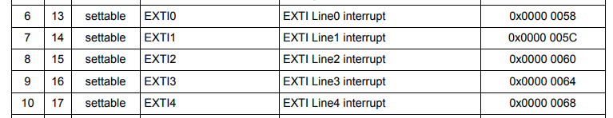





So I would suggest you to verify these numbers by checking the **vector table**.

The ***IRQ number*** of each EXTI Line is the number corresponding to the ***Position*** column of the ***vector table***. (ex. EXTI0 -> Position = 6 -> IRQ = 6).

Update this section as we encounter more and more peripherals. So I hope you will do this and I'll see you in the next lecture.

## 112. GPIO pin interrupt configuration coding: Part 5

Hey welcome back to the lecture. So in this lecture let's implement ***GPIO_IRQConfig()*** API.

**void** **GPIO_IRQConfig**(uint8_t IRQNumber, uint8_t IRQPriority, uint8_t enable);

This API takes 3 parameters:

* IRQ number
* IRQ priority
* enable or disable macro

Remember that all the configuration what you are going to do in this API is **processor** specific, so we are going to do at the **processor side**. So far we did in the **MCU peripheral side**.

So, for this reason, we have to refer to the **registers** of the **processor:** for that I'll be using the **Cortex M4 microcontrollers generic user guide**:

DUI0553.pdf

In this document you have to refer to the cortex M4 peripherals and **Nested Vector Interrupt Controller** (**NVIC**).

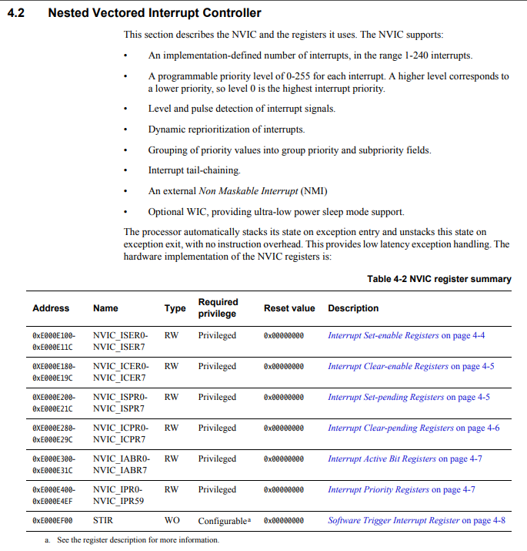

So there you'll get this nice table and these are the **registers** of the **NVIC**.

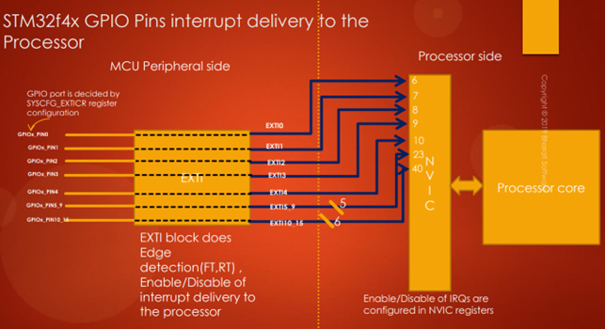

Because you can see from this diagram that all the EXTI lines or all the interrupt lines from different peripherals finally go and meet the **NVIC**. So that's why we have to look at the **NVIC registers,** that's why we have to refer to the NVIC registers.

Here You will find:

* **Interrupt Set-enable register:** this register is actually used to enable an interrupt on a particular IRQ number
* **Interrupt Clear-enable register:** this register is used to disable an interrupt on a particular IRQ number.

So we'll be looking at **ISER register** and **ICER register** and also in order to set the priority we will be looking at **Interrupt Priority Registers** (**IPR**).

Now let's get started. First of all let's discuss about the **Interrupt Set-enable registers**.

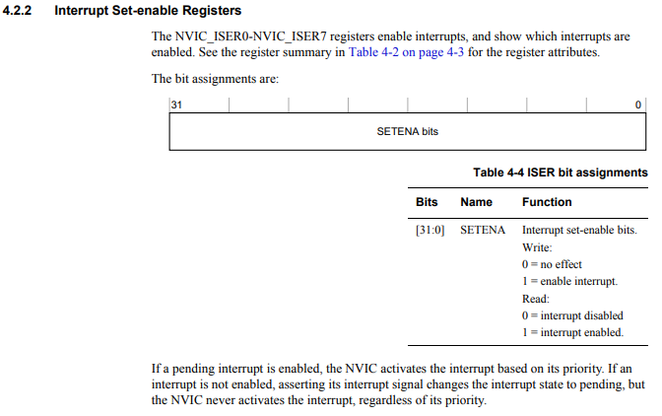

There are 8 registers and each register is of 32 bits: they are used to enable interrupts on different IRQ number.

For example: writing 0 to this register has no effect, so that means you cannot disable an interrupt from this register. You can only **enable**. So 1 means you can enable the interrupt.

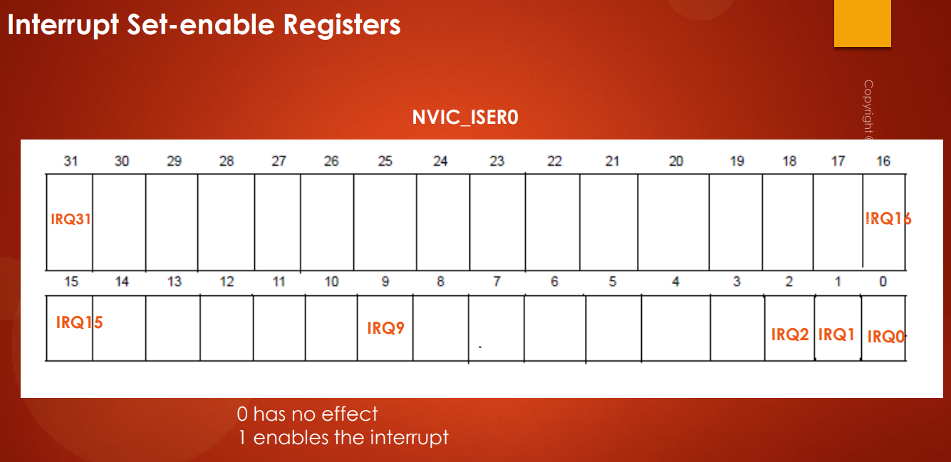

So here in this register, there are 8 registers. By using NVIC_ISER0 you can control 32 IRQ numbers, from 0 to 31. So if you make bit 0th as 1 then interrupt on IRQ0 will be enabled.

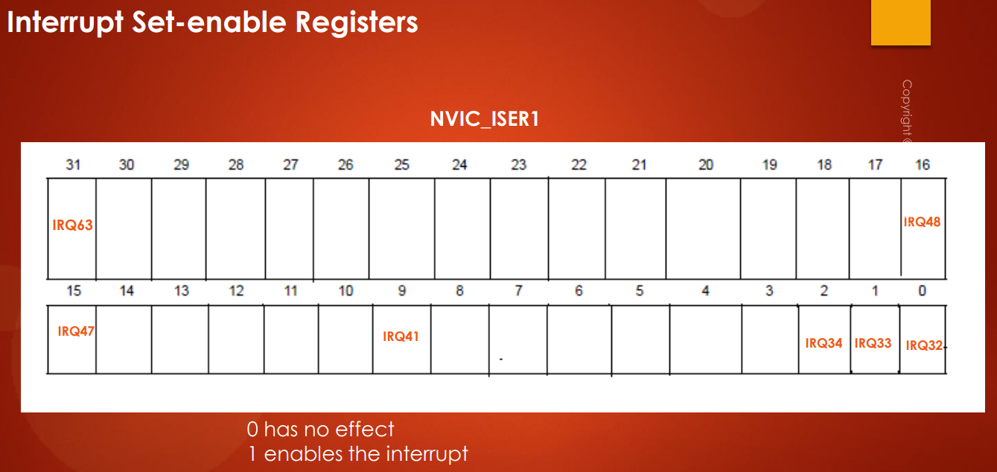

By using **NVIC_ISER1** you can configure the IRQ number from 32 to 63 and so on.

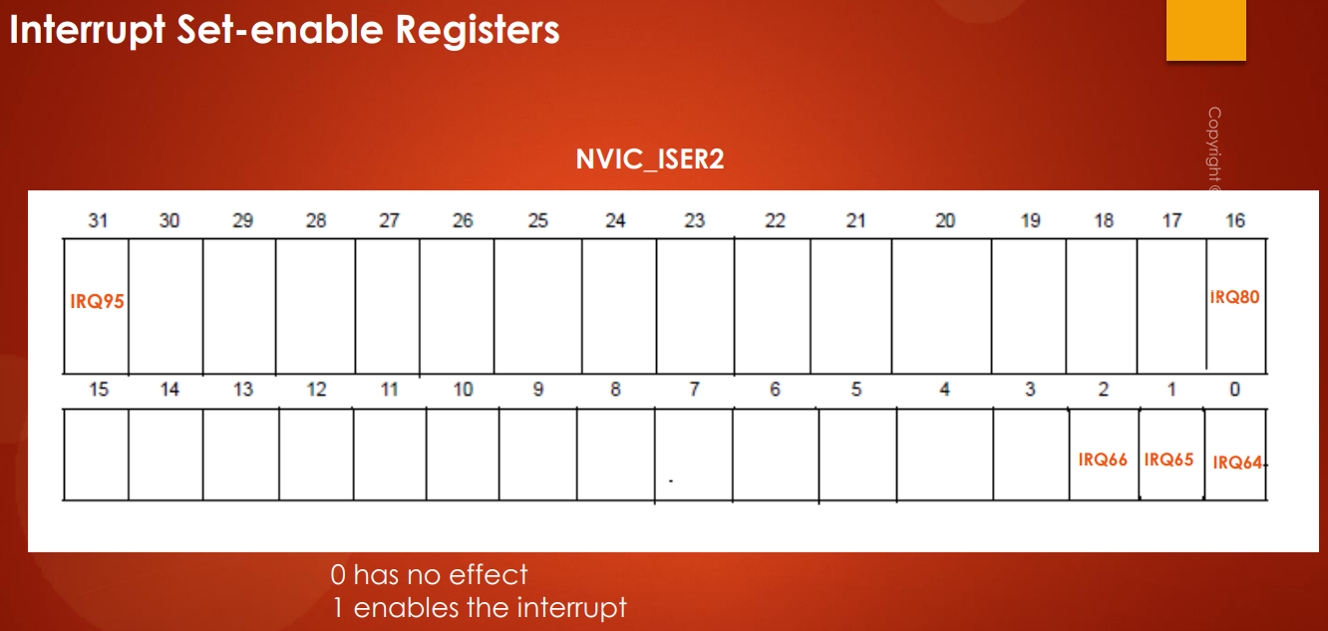

**NVIC_ISER2** is for IRQ number from 64 to 95.

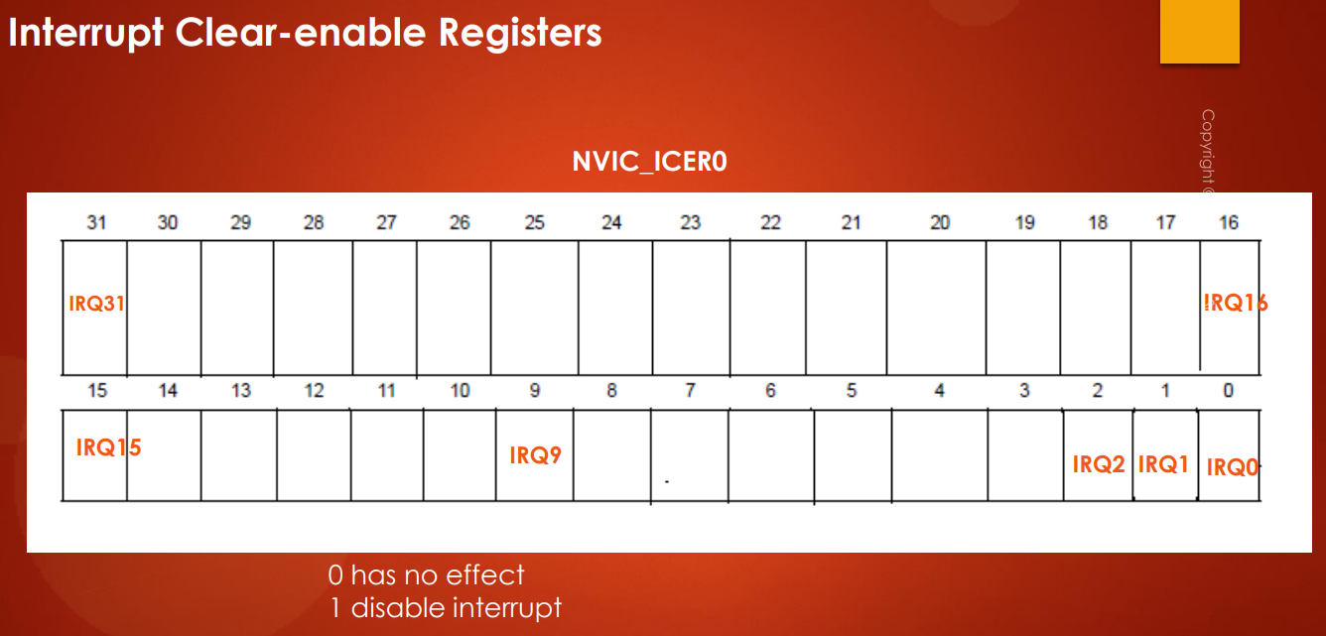

And by using **NVIC_ICERx** registers you can **clear** or **disable** that **interrupt**. So again 0 value has no effect here. So if I write 1 in IRQ0 then the interrupt on IRQ0 will be disabled.

So now about the **Interrupt Priority register** I will discuss later.

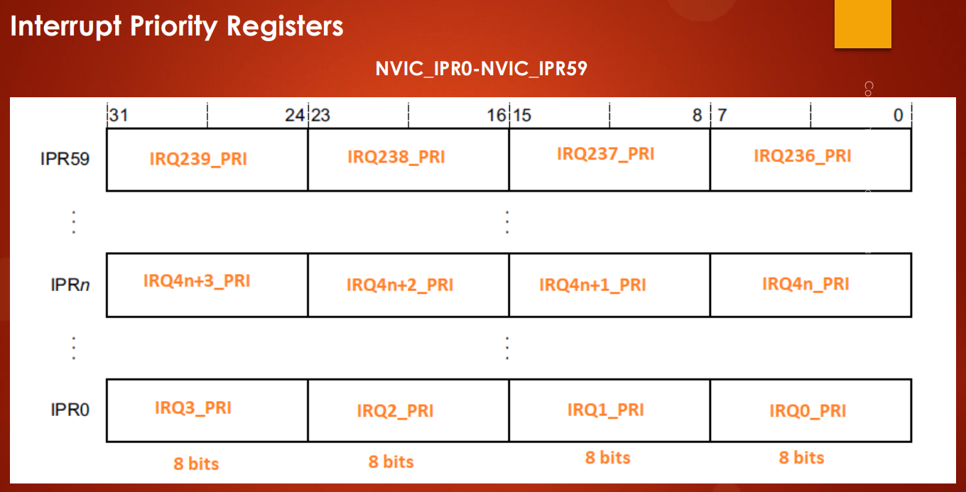

Let's go back to the code:

**void** **GPIO_IRQConfig**(uint8_t IRQNumber, uint8_t IRQPriority, uint8_t enable)

{

**if**(enable == ENABLE)

{

**if**(IRQNumber <= 31)

{

// Program NVIC_ISER0 register

}

**else** **if**(IRQNumber > 31 && IRQNumber < 63)

{

// Program NVIC_ISER1 register

}

**else** **if**(IRQNumber >= 63 && IRQNumber < 96)

{

// Program NVIC_ISER2 register

}

}

**else**

{

**if**(IRQNumber <= 31)

{

}

**else** **if**(IRQNumber > 31 && IRQNumber < 64)

{

}

**else** **if**(IRQNumber >= 64 && IRQNumber < 96)

{

}

}

}

This is sufficient because in our MCU are implemented **81** **IRQ numbers**, so we can use up to **NVIC_ISER2** is sufficient.

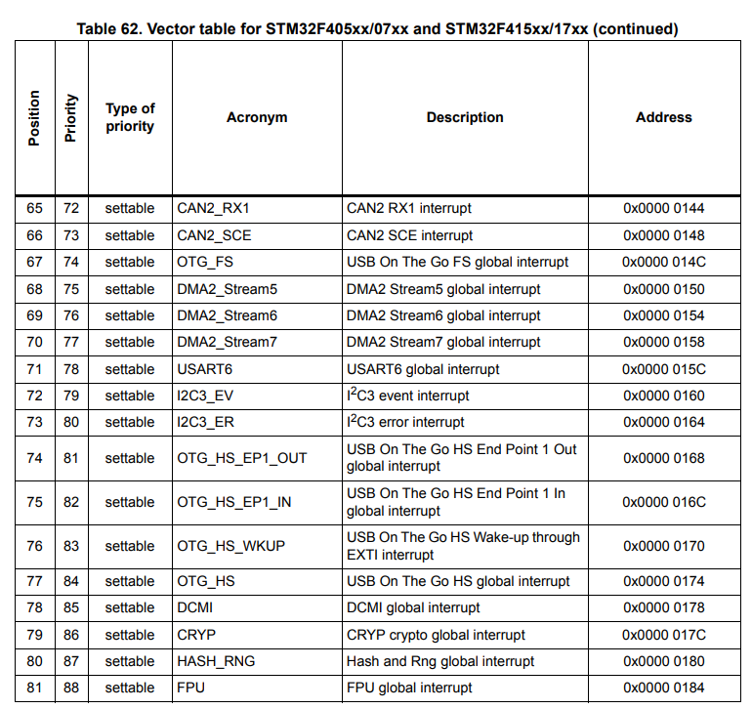

Great and here we have to program **NVIC_ISER register**. So what is the base address of ISER0 register. So we have to now find out the base addresses of all these registers. So that's why Iet’s create some macros for that. Now I am going to the **MCU specific header file** and these details I'm going to write at the top, in the MCU specific header file. Let's keep the processor specific details at the top, So I will create one section here processor specific details. ARM cortex MX processor, NVIC, ISERx register addresses. All right. Now the first register is let's write NVIC_ISER0 so what's the address ? You can get from the Arm document.

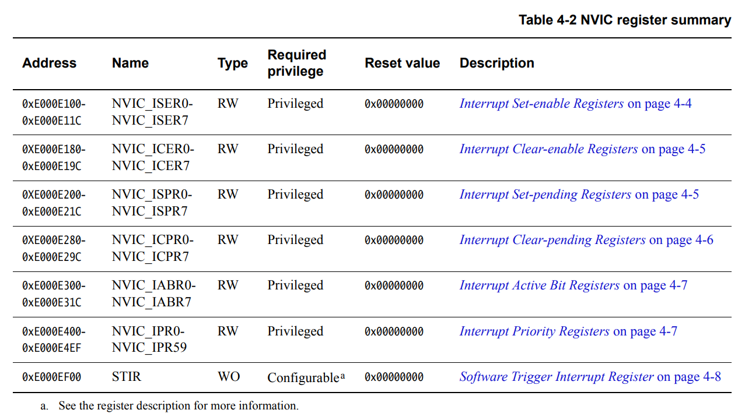

NVIC_ISER0 starts from address **0xE000E100**. So let's define that. The **address** is always **unsigned**. So let us make it an **unsigned pointer** and also make this as **volatile**. So you can make it as volatile unsigned integer pointer. Let's make also **ICER** registers.

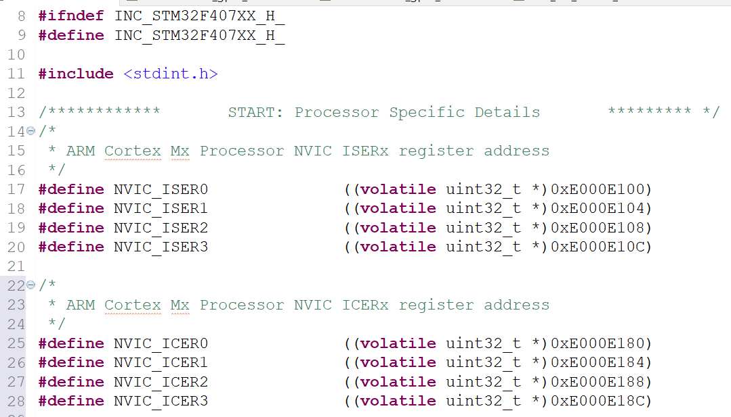

So these are the **ARM Cortex Mx processor NVIC_ISERx** and **NVIC_ICERx** register addresses.

Now let's go back to the driver source file. So here you have to program NVIC_ ISER0, so you have to dereference this address and you have to put the value.

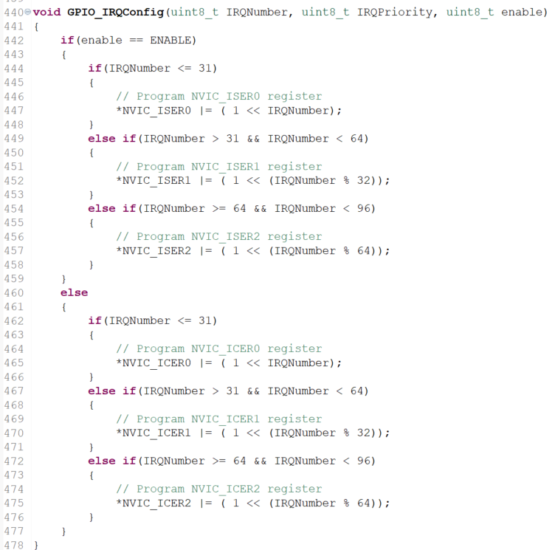

So |= to 1 left shifted by the IRQ number that's it. And now if the value is greater than 3, what happens?

For example if the value is greater than 31 then we should go and check NVIC_ISER1 register: here 32 means 0th.



So that means we have to take **X%32**.

If X = 32, so 32 % 32 = 0. So we actually touched this one, if X = 33, then 33 % 32 = 1.

For ISER3 it is used **X % 64**.

So that completes **IRQ interrupt enable** or **disable** **configurations** and in the next lecture will take care of the **priority**. Let's learn how to set the priority. I'll see in the next lecture.

## 113. GPIO pin interrupt configuration coding: Part 6

Hey welcome back to the lecture. So in a previous lecture we actually learned how to use **ISER** and **ICER** **registers** in order to **enable** or **disable** an **interrupt** on a given **IRQ Number**.

In this lecture let's learn about **Interrupt Priority Register** (**IPR**). So that means with the help of **priority** **registers** we can configure the **priority value** for a given IRQ number.

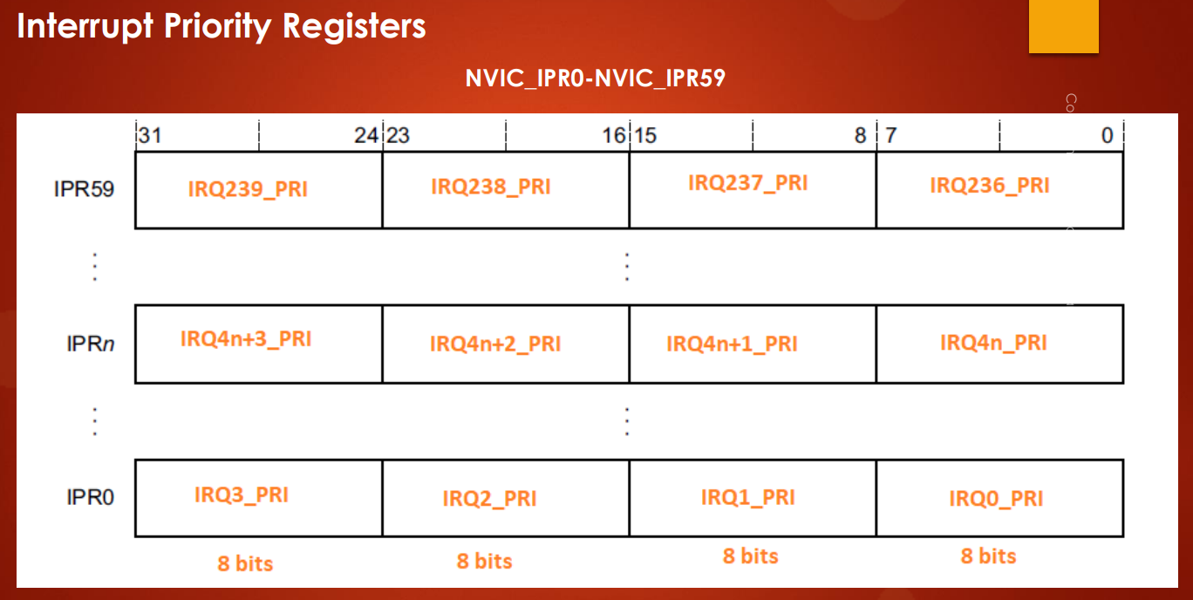

Remember that in ARM Codex Mx processor there are **60 priority registers** from **IPR0** to **IPR59** and each register is of 32 bits. And what they have done is they have divided each register into 4 sections of 8 bits each. Each section is for one **IRQ number** in order to configure the priority value so that means by using IPR0 for example, you can set priority value for 4 IRQ numbers from IRQ0 to IRQ3.

If you want to set the priority value for IRQ4 then you have to refer to IPR1 register.

So now in the program how do you find out which register you have to refer and which section you have to refer for a given IRQ number.

For example, let's say the given IRQ number is 236. First you have to find out which register you have to touch, which IPR register you have to touch. So for that you have to divide this number by 4. Why? Because each register supports 4 sections, so that's why you have to divide the IRQ number by 4.

**IRQ Number = 236**

**IPR Number = IRQ Number / 4 = 236 / 4 = 59**

So you actually get 59 here. That is **IPR** that is **Interrupt Priority Register**. So you have to touch the **IPR59** and after that which section that you have to find out.

So there are 4 sections, so again you have to take the % 4 here.

**IPR59 section = IRQ Number % 4 = 236 % 4 = 0**

So that gives you 0 in this case. So that means you have to touch the Section 0.

So suppose it is the IRQNumber = 237. Then you would still get IPR59 here and you would get Section 1, so that means you have to touch the first section. So what you have to do is you have to multiply by 8 the section number.

**IPRx Section Number * 8**

So now let's go to the GPIO driver.c and let's configure the priority.

L’API GPIO_IRQConfig() è stata divisa in 2 APIs:

* GPIO_IRQInterruptConfig(): la quale è la vecchia GPIO_IRQConfig()
* GPIO_IRQPriorityConfig()



Now what is the base address of the priority register? Let's take the ARM Cortex M4 document.

So the base address of the **priority registers** is this:

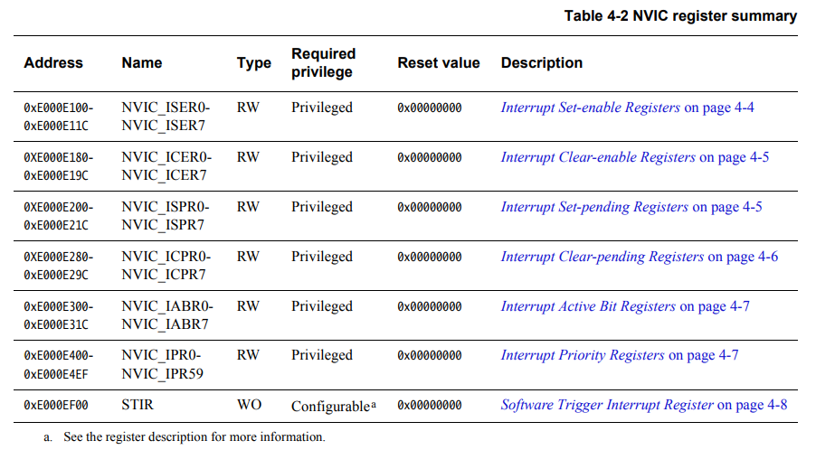

So let's go to the **MCU specific header file** and let's add the #define:

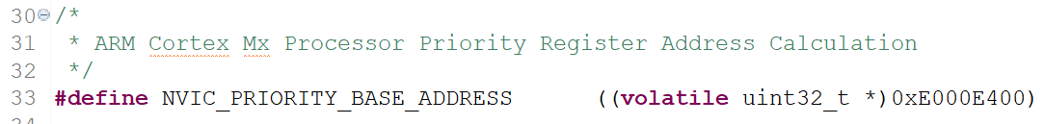

First let's find out the **IPR register**.

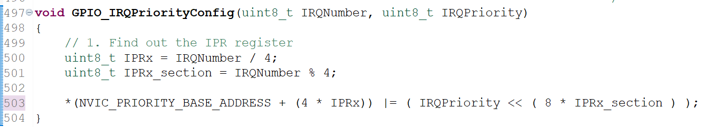

We have to program into the base address of the IPR register plus you have to add this IPRx multiplied by 4. So that actually jumps to that IPR registers address.

We have to multiply it by 4 because each IPRx is 32 bits, then 4 bytes.

***Errore:*** tale funzione deve essere modificata in questo modo, ossia bisogna togliere il ***4 \****  in quanto altrimenti si va oltre dato che NVIC_PRIORITY_BASE_ADDRESS è stata definita come ***uint32_t \****, di conseguenza ogni suo incremento è già di 4 bytes. Inoltre, il data type di ***IRQPriority*** stato modificato a ***uin32_t*** in quanto poi viene shiftato di una quantità pari a *shift_amount*, quindi si potrebbe andare oltre gli 8 bit dell’*uint8_t*:

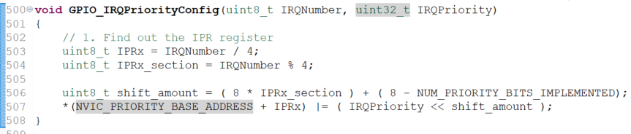

The configuration is not yet complete actually. So we have to do one more setting here. So here what happens is let's take section **IRQx_PRI,** this is the priority register for IRQ0, 8 bits.

So here in this register or in this field, only 4 bits are implemented. So if we divide this register into 4 bits, then the lower part is not implemented or not applicable.





So only upper 4 bits are implemented, so that's why if I want to set the priority as 8 then what is the binary equivalent of 8? b00001000.

So if I write this number here what happens? This actually goes into **non implemented** part, so that is wrong. We should shift again by 4. We have to take care of that because the lower part is not implemented. Lower 4 bits are not implemented in each priority field.

So for that what you have to do is while shifting.



Number of priority bits implemented is actually specific to the microcontroller. In ST's case it is actually 4. So this is very important macro. Let's define this in our MCU specific header file.

**#define** NUM_PRIORITY_BITS_IMPLEMENTED 4

So this value is actually 3 in the case of some of the TI microcontroller.

So that completes **priority configuration** in the NVIC register and in the next lecture let's go to the **IRQ handling**. I'll see in the next lecture.

## 114. GPIO pin interrupt configuration coding: Part 7

Hey, welcome back to the lecture. So, in the previous couple of videos, we discussed about the **interrupts** and we coded for the **priority**, we coded for **enabling** and **disabling** **interrupt**.

So, in this lecture, let's discuss about what happens when **interrupt triggers** and also let's understand how **ISR** will get called and after that let's implement our final API that is **GPIO_IRQHandling(),** GPIO Interrupt Handling.

Remember that **interrupt handling** depends upon the **peripheral**.



For example, in this case, the peripheral is GPIO, which is actually a simpler peripheral, because GPIOs doesn't have too much complexity. The interrupt handling really depends on the peripheral. The way you write **ISR** varies when the peripheral changes.

For example, I2C peripheral is actually much complex peripheral. So, the way you handle interrupt for I2C is very different from the way you handle interrupt for GPIO.

So, in this case, how actually the interrupt triggers? Let's say a button is connected to a GPIOA pin number 0. And let's say you have configured that button trigger as **falling edge** and you have also enabled the interrupt here. And so, when you press the button, the EXTI engine detects the transition whether it is falling edge transition or rising transition. So, there is an edge detection block inside the EXTI block. And if it is falling edge and if the interrupt delivery is enabled, then interrupt will be sent over the EXTI line 0 to the associated IRQ number (IRQ 6 in this case).

So, when NVIC receives that interrupt, what it does is, there is one more register called **PR** (**Pending Register**). So, there are 2 **pending registers**, remember:

* One is in NVIC register
* One is in EXTI register

So, EXTI also has one pending register. So, there also it will get registered actually. So, that I explained in the earlier part of the course.

And after that, if the processor is not executing any ISR, then what happens is, the **fixed vector address** which is related to the IRQ number vector address which is related to the IRQ number will be accessed. So, what is the **fixed vector address** for IRQ 6?

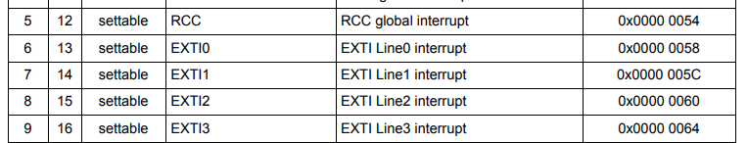

In the **vector table**, the **fixed vector address** for EXTI0 that is IRQ number 6 is **0x0000 0058**.

So, what processor does is, it actually reads a value which is stored in this address. So, that value is nothing but address of your **Interrupt Service Routine** (**ISR**) for that IRQ number.

So, that means it's your responsibility to keep the address of your Interrupt Service Routine function at this location, because the processor automatically checks this address. So, that's why it is called as **fixed vector address**.

And after that, what processor does is, it will actually clear this pending bit and it will execute the ISR.

So, when the interrupt is registered in the **Pending Register** of NVIC and if the processor is already running an ISR, let's say it is already running IRQ number 10th ISR, then what happens is, **priority** will be compared. So, if newly arrived IRQ number's priority is greater than currently executing IRQ's interrupt, then the ISR execution of 10th IRQ number in this case, will be preempted and the ISR related to 6th IRQ number will be scheduled to run. That's how it works.

Viene quindi eseguita la ISR relativa all’IRQ Number più basso, in quanto quello più basso è quello con una priority maggiore.

And also remember that even if you disable the interrupt reception on the IRQ6, the interrupt can still register, remember. So, even if you disable the interrupt, if interrupt arrives here, it will get registered in the PR. Only thing is ISR will not get executed.

So, now what are the action steps if you want to handle the interrupt properly?

1. Implement the ISR function: it is just a C function.
2. Store the address of your ISR at the vector address location corresponding to the IRQ number for which you have written the ISR.

So now let's go back to our program and let's implement the ISR. Remember that, strictly speaking, ISRs are not actually implemented in the driver code. So, **ISRs** are actually **application specific** and they should be implemented in the **user application** that is in the application area like ***main.c*** and the ISR implemented in the application layer then should call the driver supported ***GPIO_IRQHandling()*** API in order to process that interrupt.

And now if you go to the startup code of your project, file ***startup_stm32.s*** inside ***Startup*** folder, and if you just browse through the startup code, you can see that the ISRs for various IRQ numbers already being implemented.

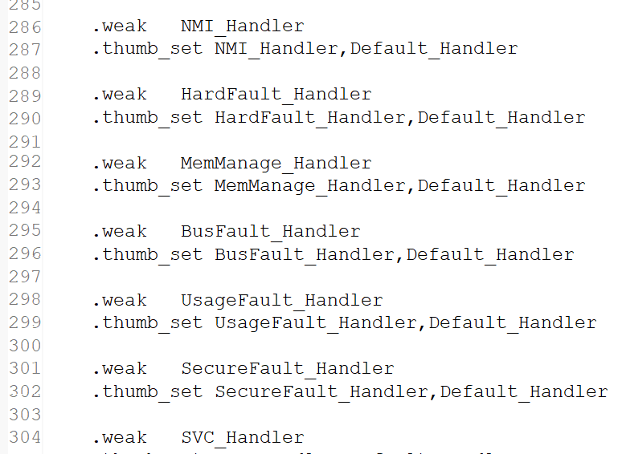

And those ISRs are attributed as ***weak*** ***ISRs*** and it is your responsibility to override those ISRs in your application.

So, for example, for EXTI0, so, here you can see that the ***EXTI0_IRQHandler()*** is already implemented which actually jumps to the ***default handler*** and the default handler is actually implemented somewhere in the beginning.

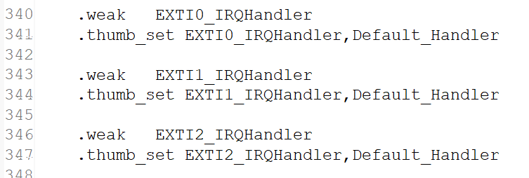

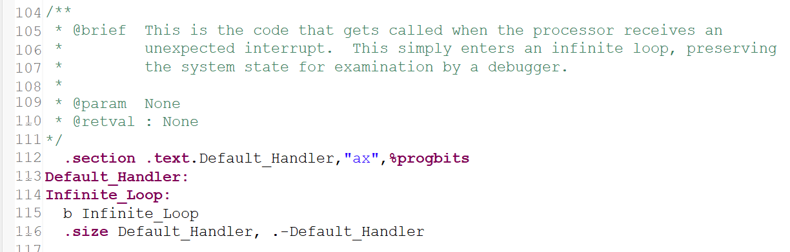

And here you can see that the ***Default_Handler*** is implemented here which is an assembly code which actually an ***Infinite_Loop***, you can see that it branches to infinite loop which is this one. So, it is in infinite loop.

So, the idea here is that the **startup code** will give you the **weak** implementation of **ISRs**. Whenever you need the real ISR implementation, you have to override that function in your application.

For example, let's say I want to implement an ISR for EXTI0 interrupt. Then I will just search for ***EXTI0_IRQHandler***, then I will just copy this name and I will go to my ***main.c*** and I will just implement this here.

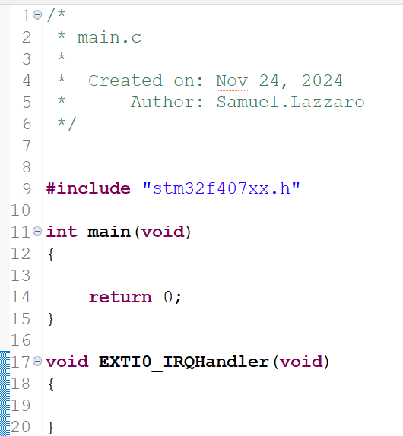

This is the **ISR implementation**.

Remember that ISR doesn't take any parameter as input and it doesn't return anything.

Inside the **IRQHandler**, you have to handle the interrupt. So, this is an ISR implementation. Now you have to handle that interrupt. So, for that, this **IRQHandling** API is given from the driver side. So, you have to call this function from 'main.c'. So, the driver API needs the pin number. So, you have to give the pin number from your application. So, whatever it may be, it depends on your application. You are expecting that intercept from which pin number. So, that pin number you have to mention and you have to call the interrupt handling API which is supported by the driver.

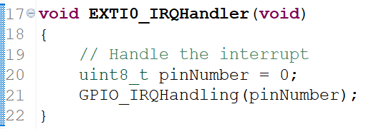

And remember that the address of this function has to be stored at the **vector address** of the corresponding IRQ number. And that is also **automatically** taken care by the **startup code**.

For example, if you browse this startup file, here you will see that **vector**.

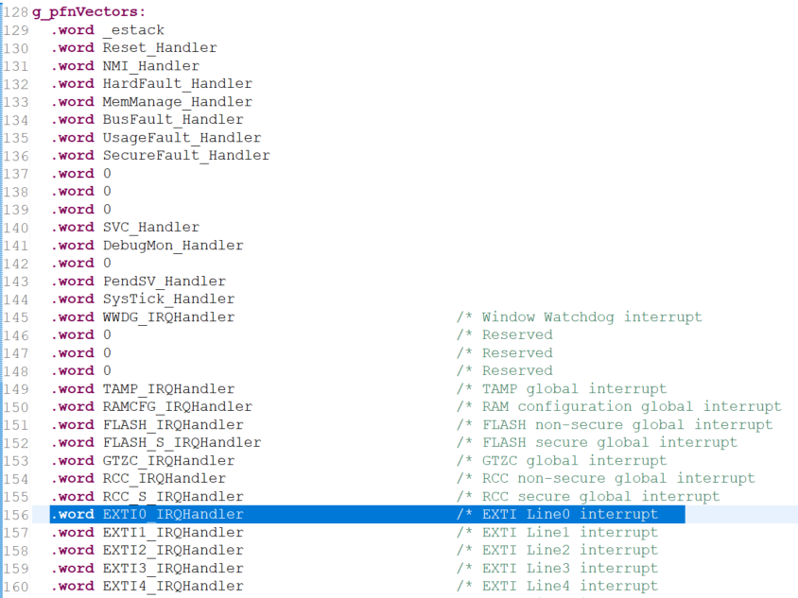

And this **vector table** which is actually an assembly code which actually places the address of that function into the right vector address location. So, that is actually taken care by the **startup code**. So, that's why if you want to work with a microcontroller, always include its **startup file** in the project, otherwise your project will not work properly.

And as per your application requirement, you have to override the ISR in which you are interested. So, when the interrupt occurs through the EXTI0 line, then control will not go to this IRQ handler, rather it comes to IRQ handler in *main.c*. Why? Because this is attributed as **weak** and that is already overridden in my ***main.c***.

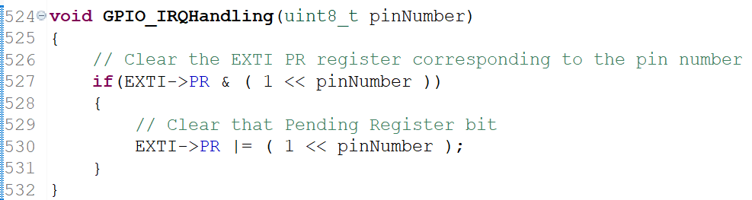

The IRQ handling in this case would be clear the EXTI PR register, corresponding to the pin number.

So, if EXTI of PR and 1 left shifted by pin number, so, if the PR bit position corresponding to this pin number is set, then the interrupt is really pended. So, that's why clear that pending register bit. Clear. So, how do you clear? You have to write 1 in order to clear in the case of PR.

So, actually, the procedure to **clear** the **Pending Register** is actually **writing 1**. So, that's what mentioned in the register details.

So, the IRQ handling in the case of GPIO is very very simple, so just 2 lines of code.

So, I think we have completed all the APIs and now let's compile once to see everything is good or not. So, let's build the project. The project is building and looks like it is error free.

So, the driver files have compiled successfully and in the next lecture let's do some interrupt related exercises and we'll see whether we really receive interrupt and process the interrupt or not. I'll see you in the next lecture.

# Sezione 29: Exercise: GPIO Interrupts

## 115. Exercise: External button interrupt implementation

Hey, let's do this exercise now.

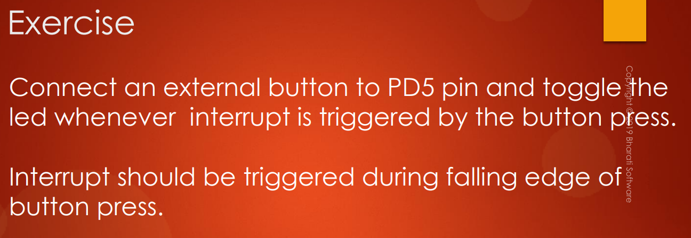

That is we have to connect an **external button** to **PD5**. So, now you already know how to connect an external button. And you can toggle the LED, you can toggle the onboard LED, no problem. So, but LED should be toggled whenever interrupt is received from the button press and the interrupt should happen only during **falling edge** of button press.

So, when we press the button what happens? When we press the button, the **pin** is actually pulled to **low**, right?? That is to **ground**. So, that means pulling to ground means what? It is actually **high** to **low** transition. So, that is nothing but **falling edge transition**.

So, let me go to the IDE and let me just copy this source file and let me paste here and let me change the name. So, the name will be "**005_button_interrupt.c**". Now let's use PD5 for the external button. While for LED we can use PD12, no problem. So, let me use PD12 in push pull configuration.

For the button we use a pull-up resistor. So, now here mode is actually not input, but it is **interrupt mode**. So, interrupt falling edge. So, you have to select interrupt falling edge. So, because we are now using this GPIO to trigger an interrupt whenever the button is pressed.

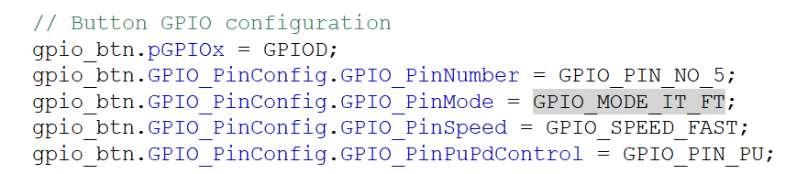

So, after this, what we have to do is, we have to do the **IRQ configurations** for this pin. We have to enable its **IRQ**. For that, we have given the API ***GPIO_IRQInterruptConfig()***. So, this you have to use. **Priority** is not required, because it's **optional**. So, **priority** is used when there are more interrupts involved. So, here there is only one interrupt involved. So, need not to configure the priority. If you do also, no problem.

So, let's use ***GPIO_IRQInterruptConfig()***: in this API, what is the first argument? **IRQNumber** and enable/disable, that's it. Very simple. So, Sorry. So, let's use IRQ EXTI, which one? PD5 will send its interrupt over EXTI5. So, I have to select this one, EXTI9_5. And after that, we have to enable that IRQ.

So, lets give **enable**. So, let's also configure the priority. Actually it is optional, that's OK. But let me also configure the priority. So, for the priority, you have to send IRQ number and priority levels. So, IRQ number is again this one. And priority is you can send any value between 0 to 15. So, I can send let's say 15. So, instead of writing 15 like this, it will be good if you can give the macros for that, like "**NVIC_IRQ_PRIORITY15**".

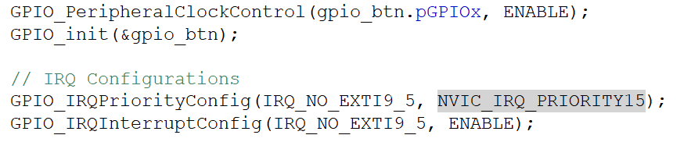

So, we can define these macros in our **MCU specific header file**. So, let's go to the MCU specific header file and here there are various macros for IRQ number. So, create another section here for IRQ priority. So, these are actually macros for all the possible priority levels: 0 to 15.

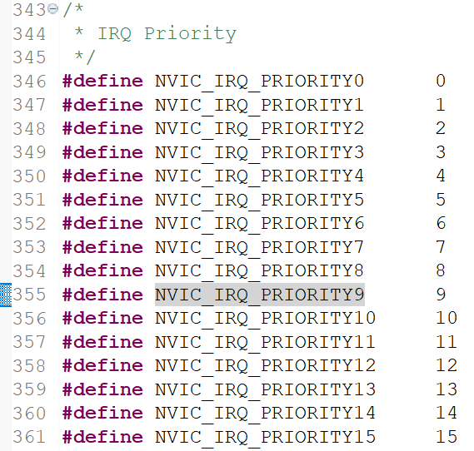

Let me go to my application. So, now I have to implement the **ISR**. So, to get the ISR name, you have to go to the **startup file**. So, go to the startup file and just go to the vector table and select the appropriate name. So, we are using EXTI9 to 5. So, I have to use ***EXTI9_5_IRQHandler()***. So, let's copy that name. Go to your application and implement. All right. So, this is the ISR and here we have to call the driver supplied ***GPIO_IRQHandling()*** API and you have to send the **pin number** here. Which pin are you using? We are using GPIO pin number 5. So, our driver will handle that IRQ handling.

So, after that, our goal is to toggle the GPIO. So, you can write that code here itself, no problem. I can call ***GPIO_toggleOutputPin()*** and I can call GPIOD pin number 12.

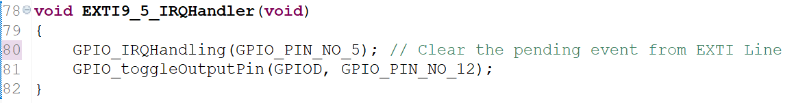

All right, so now let's compile this code and now let's download the code. And now let's hit the button and whenever we press the button, the onboard LED should toggle. And here it is, the code is not at all working. All right. So, now we have to debug, why this is not working. First of all, let's see the interrupt is triggering or not. So, what I will do is, I will just go to the debug mode. Now, in order to send the eclipse to debug mode, what you have to do is, you have to right click on the project, select Debug As and after that select this, Ac6 STM32 application. Now, the IDE will go to the debug mode. Click yes here. So, this will open the debug perspective. Now, this is a debug perspective. And if you want to go back to the C and C++ perspective, then you have to click over here. So, it will take you to the C and C++ perspective. So, you can go to the debug mode here and here you can see that the code is actually halted here in the main. I have set a couple of breakpoints here. So, now let me remove all these break points. So, let me just remove this and remove this as well. So, the debug perspective actually keeps one breakpoint automatically in the main, in the first line of the code, so the devil perspective does this automatically. So, later you can keep the breakpoints wherever you want.

In order to test this application, let's see whether we are really getting interrupt or not. So, what I would do is, I'm going to keep the **breakpoint** in the **ISR**. So, go to the ISR, And here you can see that this blue strip, right? So, here you can double click. For example, on the line 63 in this area, I'm going to double click and that breakpoint is insulted and here you can see that the breakpoint window is also showing that at line 63 a breakpoint is inserted. All right. Now let's hit run. Now the code is running. And if you stop this code execution, so you can click over here. suspend, and here you can see that the code is actually currently hanging in infinite while loop. So, that is what expected. That is correct. Right?? All right. Now, code is not running, remember, because I actually suspended the execution. So, the code is currently not executing. Now let's hit resume, again it will start executing and now let's press the button.

If our configuration is correct, then the code execution will come to this ISR and I am going to press the user button now. All right. So, here it is. I pressed the user button and the execution indeed came to the ISR. Right? So, that means the interrupt is indeed triggered. And after that, we are going to toggle the output. Right?? That is this output pin that is LED. Now let's hit this step over and let's hit this step over to see whether our LED toggles or not and here you can see that our LED is not actually working. All right. Now let's hit run once again and let's hit the button once again. And the interrupt is triggering but the LED is not turning on. So, that means the LED configuration may be wrong. So, we have to debug this. How to debug this?? So, first, let's check the GPIO registers. The first checkpoint what I check is, check whether the **peripheral clock** is really **enabled** or not. In this case, it is indeed enabled. Why??? Because the interrupt is triggering, right?? So, that means GPIOD port is really activated. So, we need not to cross-check that, because both pin 12 and pin 5 they belong to GPIOD. So, this part is working well. Right?? So, we are getting the interrupt, but the problem is actually in the LED, that is confirmed now. Right?? So, that means we have to cross verify all these settings now and now we are to check the registers of the GPIOD peripheral. Strictly speaking, we have to verify the bit positions related to pin number 12. Now, let's suspend the execution. The execution is already suspended. Alright?? And now let's go to the register section here, I/O registers. And here, you can see various peripherals of the microcontroller. We are interested in GPIO. So, let's open GPIO and let's open GPIOD. So, in order to fetch the value of GPIOD registers, what you have to do is, you have to double click on register to fetch the value. So initially, this will be in black color. So, now here you can see that it is highlighted in green color, right?? So, initially, it will be in black color. So, what you have to do is, you have to double click over that peripheral. Let me double click over here. You can see that the value is not fetched, right?? So, now let's double click once again. And here you can see that the IDE fetched the values of the registers. Great!! And while fetching the value, make sure that your state is suspended. So, when the code is running, you cannot actually fetch the register values. And sometimes eclipse may go to not responding mode. Alright?? So, now it is not responding. Wait a minute, we can solve this issue. It will come out of that not responding mode. All right. So, that's why always suspend the execution, then fetch the value of the register. All right. So, now let's check the mode whether the mode is properly configured or not. So, our bit position is actually 12, right?? So, here it is. The bit position 24-25 and it is set to 1, 1 means output, that's correct. And look at output type. All right. So, wait a minute. So, this register is corrupted.

Here you can see that we are actually configuring the output type for only one pin, right?? That is pin number 12. This one, right?? And its value is actually corrupted. So, this is set to 1, 1 means open drain. So, some other code is corrupting this register actually. So, here it is, here you can see that multiple bits are actually set to 1. Right?? So, this is actually wrong and some code is corrupting this register and to debug this again, so, what you can do is, actually, we call GPIO Init twice, right?? So, let's see what is the value of output type register after this call and let's again verify after this line, and then we'll see who is corrupting that. So, for that, let's keep the breakpoint here and let's go back to the debug mode and after that let's reset, so click here to reset, reset the board. Now the board has undergone the reset and now let's hit run. So, the first GPIO_Init is over, the code is now hanging here, isn't it?? Now, let's verify the I/O registers and let's fetch the value. Here you can see that the code is not running, it is in the suspended state. Alright?? So, now let's fetch the value of output type register. So, double click over this and once again double click. And here you can see that the bit number 12 is 0. That is zero means push-pull, that's correct. And after that, let's remove this breakpoint. To remove this breakpoint, what you can do is, you can go here and you can double click over that. So, just double click and here you can see that it is removed. And after that let's keep here, after this line. Now let's hit run.

The second GPIO_Init is over, and here you can see that all values are corrupted. So, that means this call is actually causing that problem. Reason for that is, actually here you have not initialized the output type field, right?? So, that's why it actually took the random value. Because this variable is nothing but the local variable. So, the local variable will contain garbage values, right?? So, that is the reason, the output type since it is uninitialized here, it took the random values and in the code also, we don't have any checks for detecting the random values, right?? For example, in the code where we configure the output type, here you can see that, so, you should configure this only if the mode is output mode, right?? But we are not doing that check actually.

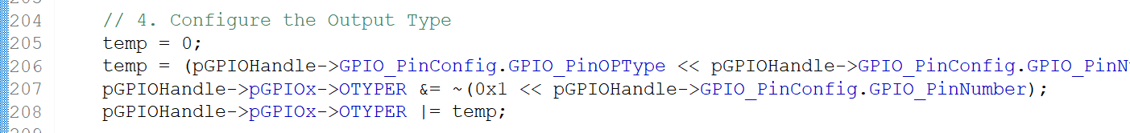

You can include that check if you want, so, that would be good.

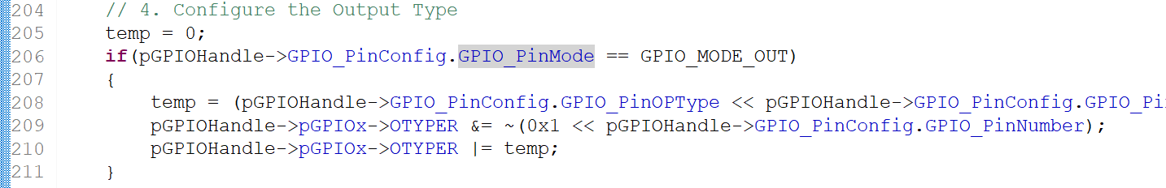

So, otherwise what we can do here is in order to get rid of this problem, make sure that in the application you clear each and every member element of this structure variable to 0, before initializing the structure.

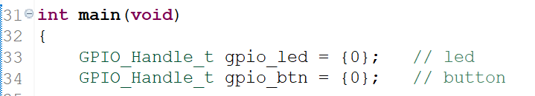

So, let's end the debug. So, you can click over here, Terminate or you can click over here. So, that will terminate the debug session. So, once the debug session is terminated, you can relaunch by right-clicking over here and clicking Relaunch, so you can always do that. Now, let's go to the C and C++ perspective and here before initializing these two structure variable, let's initialize each and every member element of these structures to 0.

So, this will actually set each and every member element of this structure to 0. So, this is actually an important tip in order to avoid bugs in the program. Now, let's build the project, download and let's check and here you can see that due to the debouncing of the button, the LED is not behaving properly. Right?? Now, how to solve this issue?? So, we have **debouncing problem**, right?? So, the interrupt can be triggered multiple times in this application because of the **button debouncing**, right??? So, when the interrupt is triggered, wait for some time. So, what I would do is, let's introduce **delay** for some time, let's say 200ms.

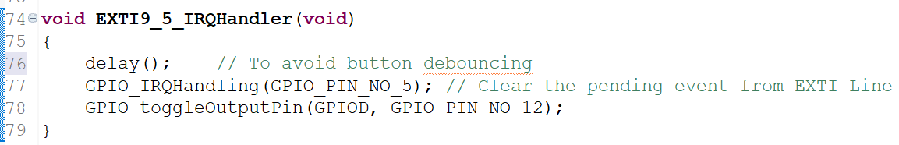

So, the delay function what we implemented, this one, it will actually cause approximately 200ms of delay. So, when the system clock is 16MHz and that is true in our case, because we are using internal RC oscillator, right?? All right. So, this value cause 200 milliseconds of delay. So, wait for 200ms until the debouncing gets over. Then **clear** the **pending event** from the **EXTI line** which is set in the **PR register**, right?? And after that, you handle the handle toggling of output pin. Alright...Now, let's test this application. Let's see how this works. All right. And now let's press the button. Here you can see that our application is working properly.

# Sezione 30: MCU I/O Pin Specifications

## 118. STM32 Pin specifications

Hey, welcome back.

So, in this lecture, let's understand **STM32 microcontrollers GPIO Pin specifications**. In this lecture, we are going to look at:

* **Absolute Maximum Ratings** (***AMR***) and **general operating conditions** of the pins of the STM32 microcontroller.
* **Maximum input voltage**, which can be applied to any **pin** of the STM32 microcontroller. When I say STM32 microcontroller, basically I am talking about the microcontroller, which I’m using in this course at least, that is **STM32F407** microcontroller. And the concepts which I'm going to explain in this video can also be applied to other microcontrollers as well. So, you have to cross verify by going into the ***Datasheet*** of your microcontroller.
* we'll also explain about **3.3V** and **5V tolerant pins**
* STM32 **logic levels maximum** and **minimum voltages**, which are required in order to respect a different logic level, like logic 0 and logic 1. So, this is very important when you want to connect your microcontroller to the external device.
* **source** and **sink current** of this microcontroller

And most of the discussions in this video are taken from the ***Datasheet*** of the device, and let's first start with **AMR**, that is **absolute maximum ratings** table of the ***Datasheet***. So, if you just open the ***Datasheet*** of this device, at table 11 you will find an **AMR table**, which explains the voltage as well as current characteristics of this device.

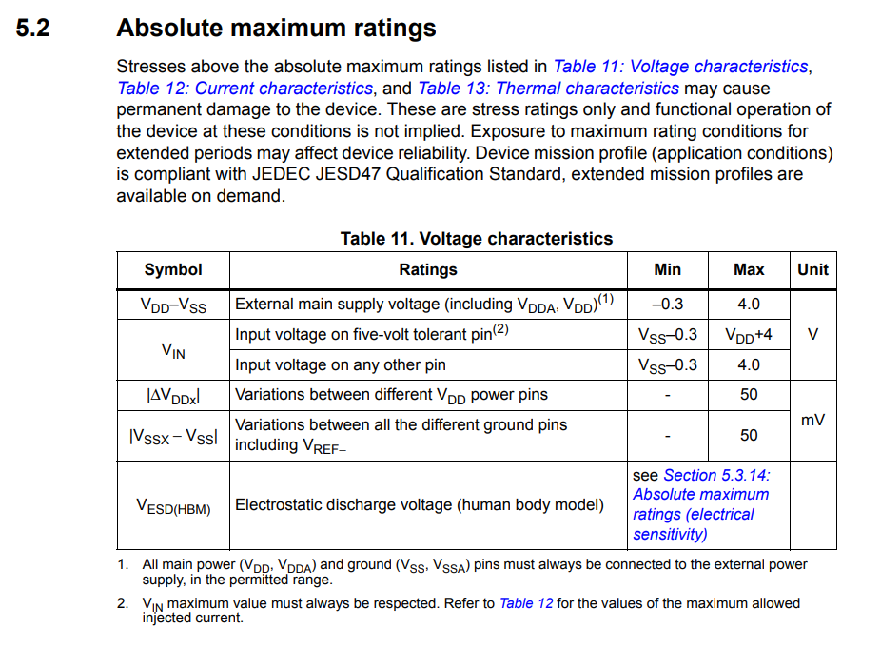

First let's explore what exactly is ***VDD*** and ***VSS***. Here you can see that there is a ***VDD***. So, ***VDD*** is an **external main power supply** to the microcontroller. This is a power supply which is provided externally through ***VDD*** pins of the microcontroller.

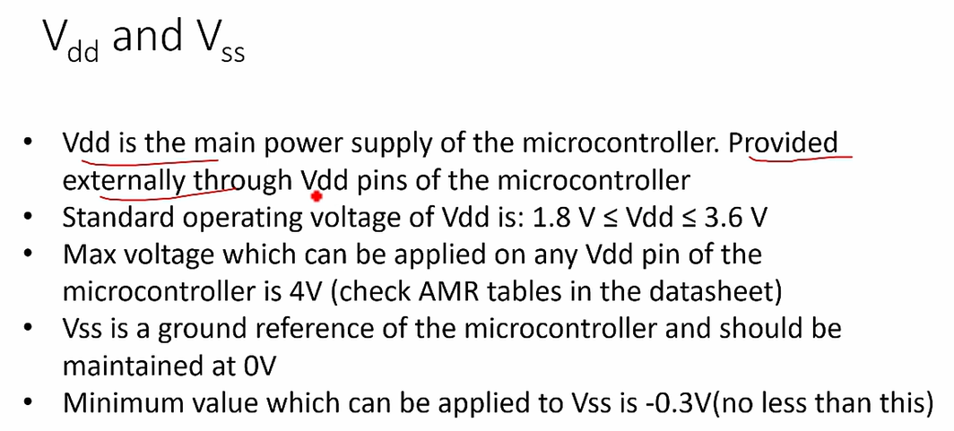

**Standard operating voltage** for ***VDD*** is, that ***VDD*** must be greater than **1.8V**, otherwise your microcontroller may not work properly. If any voltage, which is less than **1.8V** is **underpowered** and your microcontroller may not work properly. That's why, the ***VDD*** which is external power supply, its voltage has to be greater than 1.8V or at least equal to 1.8V and ***VDD*** must be less than or equal to **3.6V**. So, you should keep this in mind. The maximum voltage which can be applied on any ***VDD*** pin of the microcontroller is **4V**, that’s what mentioned in the ***Datasheet*** **AMR table**. Here you can see that 4V is maximum. So, you should not apply more than this voltage to the ***VDD*** pin of the microcontroller, otherwise you may **damage** the microcontroller.

That's why, whenever you are using any microcontroller, it need not be STM32 microcontroller, any microcontroller you have to check it's **AMR table** to determine what is a maximum and minimum voltages, which you can apply to a pin or as a power supply.

**VSS** is a **ground** reference of the microcontroller, and it should be maintained at **0V**.

***VDD*** is **4V** with respect to the **ground voltage**. The maximum ***VDD*** which you can applies is 4V respect to the ground voltage, which should be maintained at 0V. Minimum value which can be applied to the **VSS** is **-0.3V**, it should not apply any voltage less than this. Please keep this in mind. That's why the maximum voltage is 4V, but the general operating voltage is in this limit for the ***VDD***.

So, in the ***Datasheet***, we'll also find another table explaining the **general operating conditions** of the microcontroller.

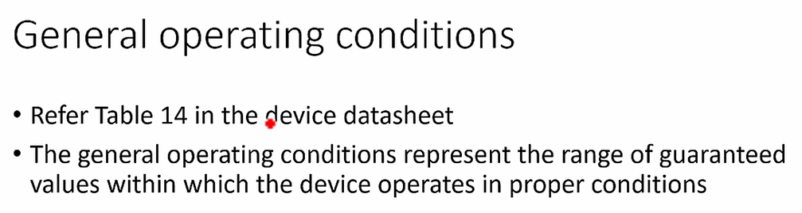

The **general operating conditions** represent the range of guaranteed values within which the device or the microcontroller operates in proper conditions. That's why, when you are applying any voltages to a ***VDD*** or to any pins of the microcontroller you should look at this table, which says general operating conditions.

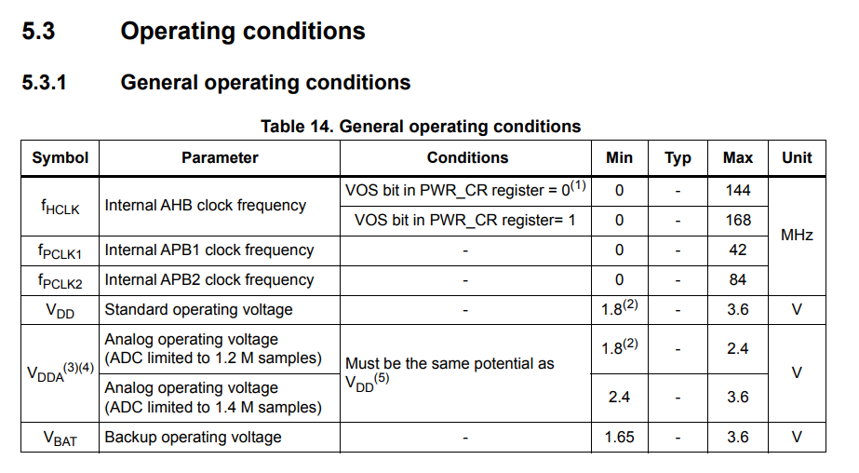

So, it not only talks about voltages, it also talks about handling of various other peripherals or various parameters as well, like frequency of operations, etc.

Now, let's get into the ***Datasheet***. Here at table 14, you find **general operating conditions**. So, if you see here ***VDD*** and standard operating voltage is between **1.8V** to **3.6V**. You will also see another power supply here: ***VDDA***, which is nothing but a voltage which is applied to the **analog** part of the microcontroller, where **'A'** stands for **Analog**. This is an **analog operating voltage**. The voltage which goes into analog peripherals such as **ADC** and other peripherals. And about that let's not discuss now. So, not only about voltages, but you can also derive other information as well from this table.

Let's move forward. Now, let's explore what is the **maximum input voltage**, which can be applied to any **pin** of the STM32 microcontroller.

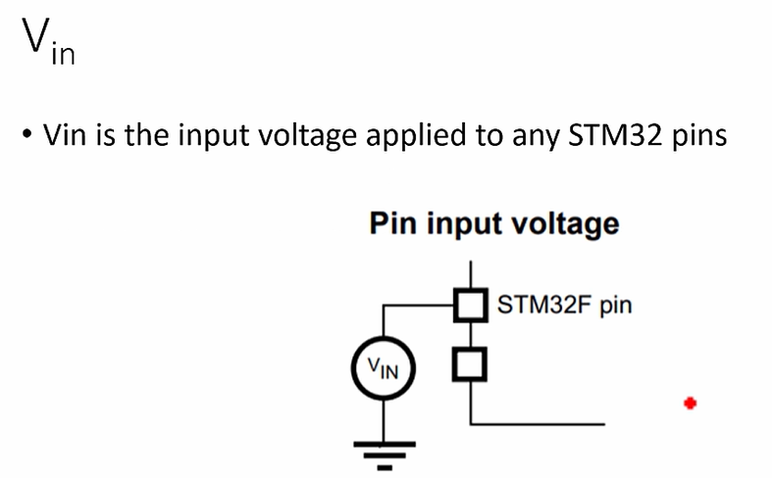

The voltage what we call ***VIN***. That's an **input voltage** applied to any STM32 microcontroller pin.

In STM32 microcontroller, if you just go through the ***Datasheet*** we will find 2 major types of pins:

* **TT pin**: means a **Three-volt tolerant pin**, a pin which cannot tolerate 5V of VIN, so which can only tolerate up to **3.3V.** Sometimes it is also mentioned as **TTa**. TTa and TT are the same.
* **FT pin**, FT means **Five-volt tolerant pin**. That means a pin which can tolerate **5V VIN** is called FT pin.

And in some ***Datasheet***, you will also see something like ***TTa***, which is nothing but **three-volt tolerant pin** which is directly connected to the **ADC** **peripheral** of the microcontroller.

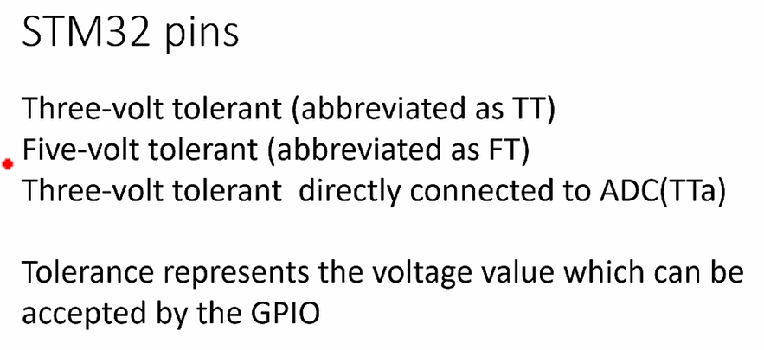

What is **tolerance**? **Tolerance** represents the **voltage value** which can be accepted by the **GPIO** without getting **damaged**.

If you take an example of a STM32F40x microcontroller, you see there are only 2 pins: PA4 and PA5, which are TT pins (Three-volt tolerant pin). That means, you should not apply 5V to these pins.

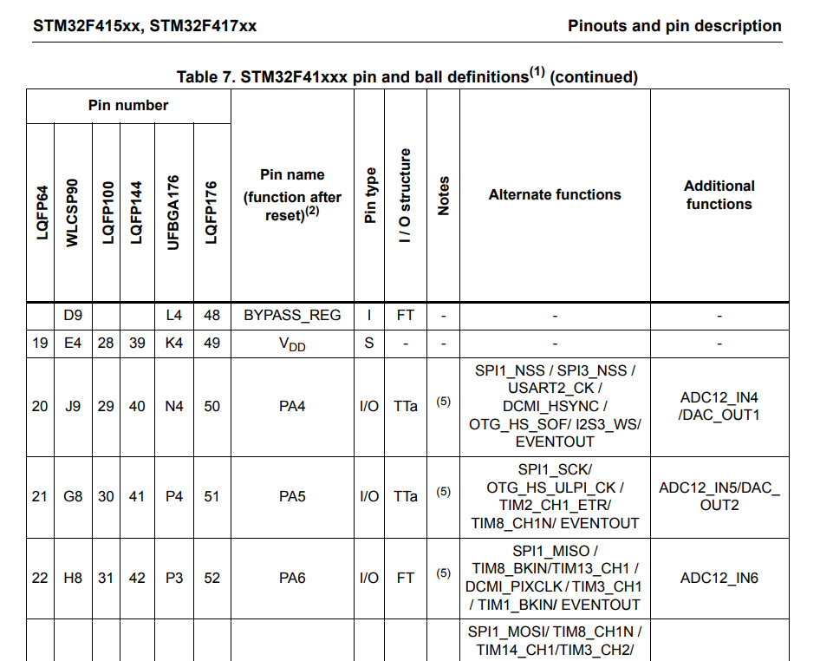

So, VIN should never be greater than 3.3V for these two pins, PA4 and PA5. You can see that, the I/O structure, this is a **I/O structure** of the **TT pin**.

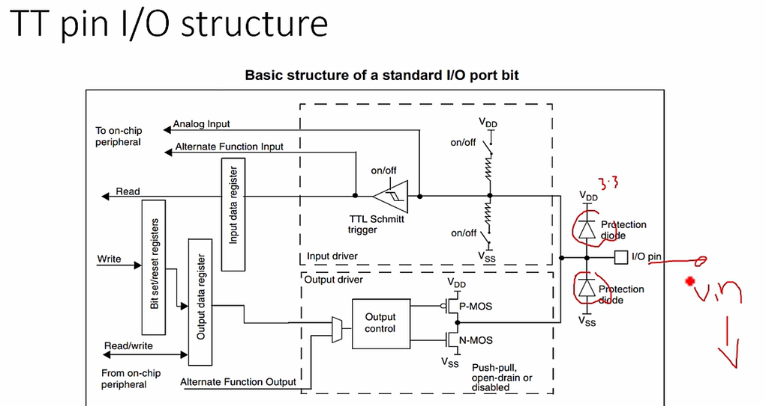

So, where there are some **protection diodes** here, and this is a ***VDD*** **3.3V**, let's take the value 3.3V, 3.6V as general operating voltage. So, the VIN should never cross 3.3V here, if it is a TT pin, otherwise its diodes will get damaged and the pin can be damaged. That's why these are TT pin, because, there I/O structure will not accept a voltage VIN which is greater than 3.3V.

And all other pins are FT pins. In this microcontroller, you'll find only these two pins as TT pins. The other ones are FT pins. That's why, when you are applying any input voltage to a microcontroller, it doesn’t matter which microcontroller it is, you have to ensure the VIN. So, you have to check VIN, that is a maximum voltage which can be applied on to that pin. After ensuring your voltage is within that limit, then only you should go ahead and start interfacing. Otherwise, you may damage the pin or sometimes you may damage the whole chip. I hope you get that idea.

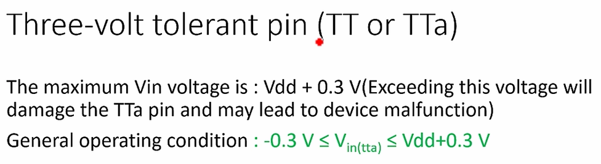

For this microcontroller, the maximum VIN for **TT pin** is ***VDD*** **+ 0.3**. That's the maximum limit. If you check the **AMR table**.



Here is a **AMR**, and Vin, you see here, the document says on TT pin the maximum is **4V**, but if you just check the **general operating condition** VIN for TTa pins should be less than **Vdd + 0.3V**.

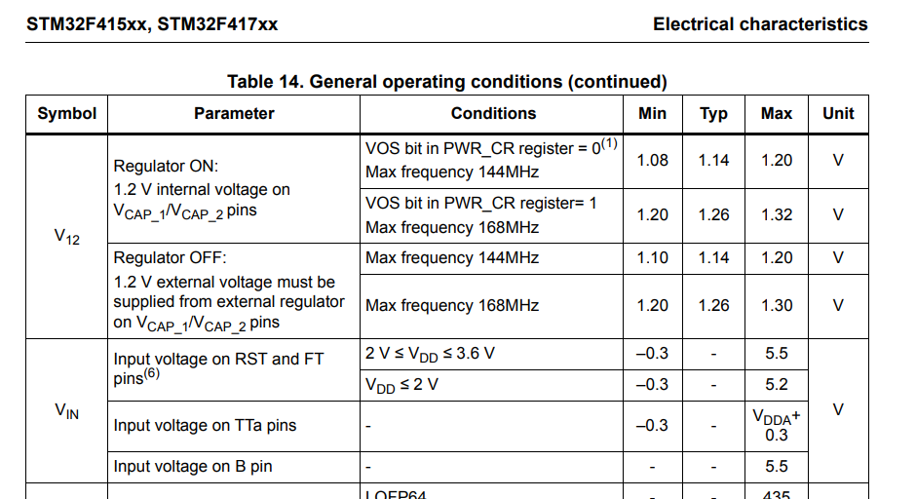

So, that's why you consider this as a **general operating condition** for the **TT pin**.

VIN must be greater than or equal to -0.3V and should be less than or equal to Vdd + 0.3V.

So, if you look at this equation, if ***VDD*** **= 0**, then the input voltage that is Vin, which can be applied to the TT pin should not cross **0.3V**. When do you have ***VDD*** **= 0**? When the **device** is **not powered**, that is when your STM32 microcontroller is unpowered, that means **VDD=0**, right? In that situation you should not apply any input voltage to the **TT pin**, or if you apply any input voltage it should not cross 0.3V. So otherwise, the pin may get **damaged**, or your device may malfunction, so please note this point.

Now let's explore a **Five-volt tolerant pin** (**FT pin**).

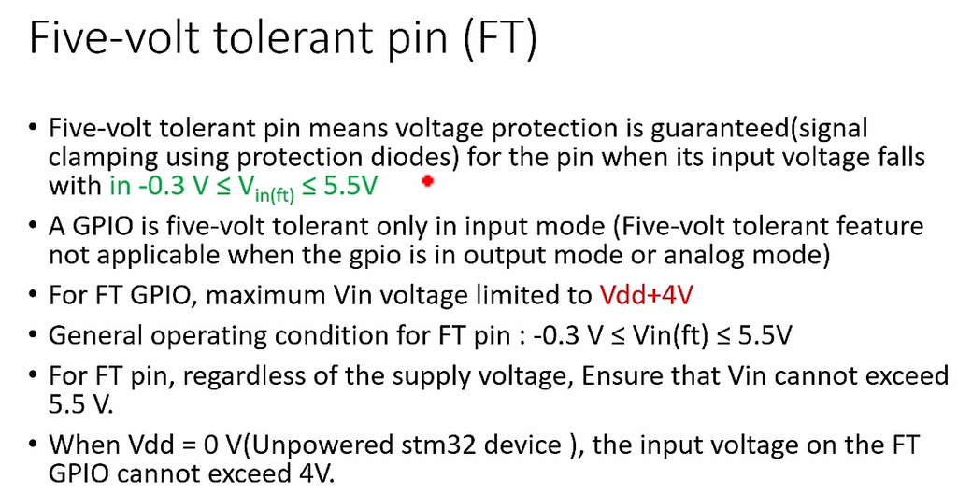

Five-volt tolerant pin means voltage protection is guaranteed. Basically, voltage protection using **signal clamping protection diodes**. In the I/O structure of the FT pin you see, the **protection diodes** here can tolerate an input voltage up to **5V**.

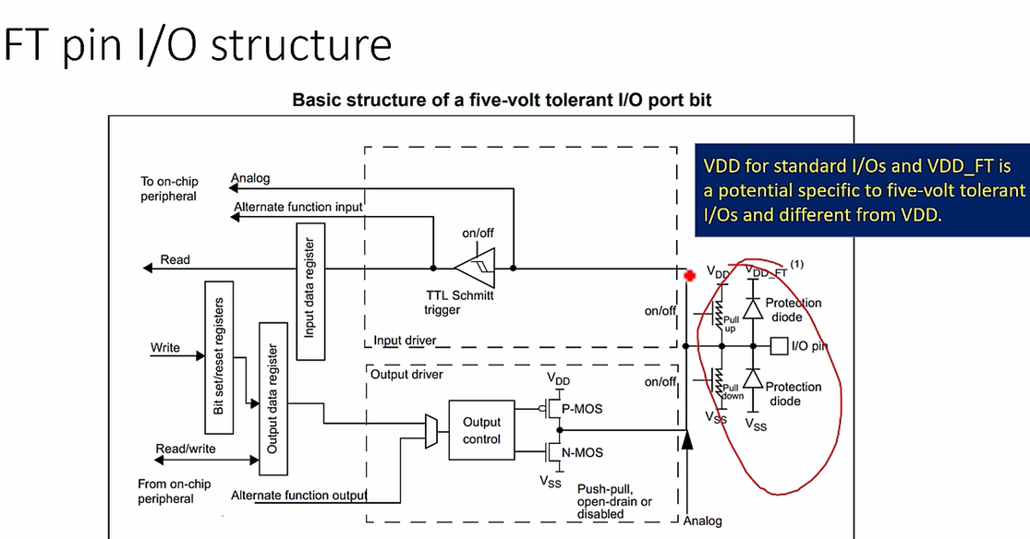

For the FT pin general operating condition is up to 5.5V. Please note that a GPIO is **five-volt tolerant** only in **input mode**. That means, five-volt tolerant features are not applicable when the GPIO is in output mode or in analog mode. So, you say five-volt tolerant only when the pin is in input mode.

For FT GPIO, maximum VIN is limited to **VDD+4V**.

Let's look at the ***Datasheet*** here, and the maximum voltage which can be applied to the FT pin is VDD+4V.

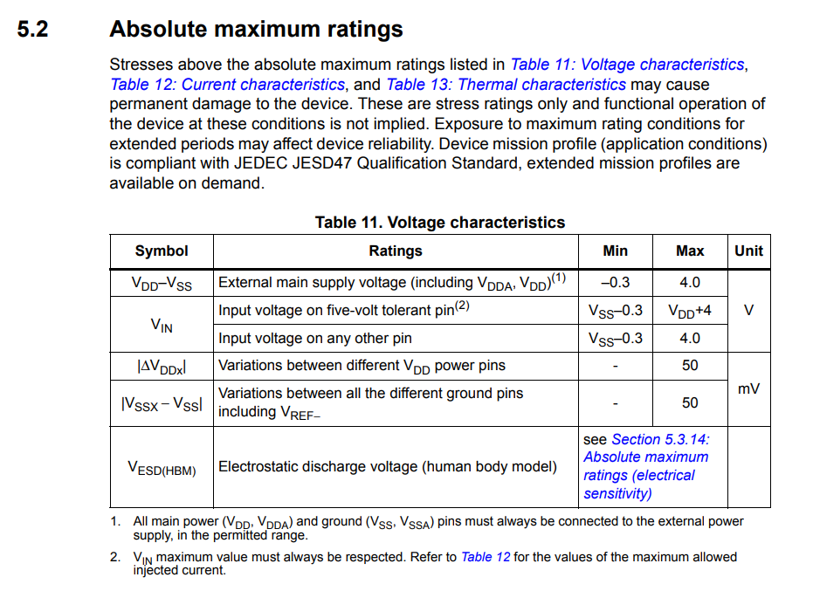

That means, when the ***VDD* = 0**, the input voltage **VIN** on an FT pin could be up to **4V**. And when ***VDD*** is 4V let's say. Because 4V is actually allowed, it's possible, because that's what ***Datasheet*** says. When ***VDD*** is 4V, then the maximum input voltage on an FT pin may reach 8V. But, as I said, it always refers to the **general operating conditions**. In the general operating conditions if you check ***VIN***, Input voltage for FT is from **-0.3V** to **5.5V**. So, that's why, treat this as a general operating condition.

That's why, the maximum input voltage on an **FT pin** when the device is **powered** is **5.5V**.

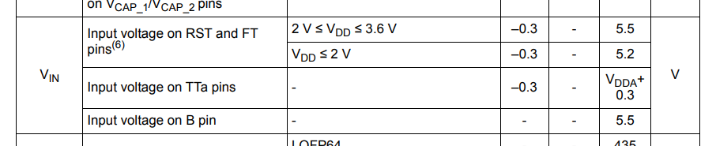

So, when the device is not powered, then the voltage should not cross more than **4V** on an **FT pin**, please note that. So, when ***VDD*** **= 0** (that is unpowered STM32 device), the input voltage on the FT GPIO cannot exceed **4V**. This is an I/O structure of an FT pin.

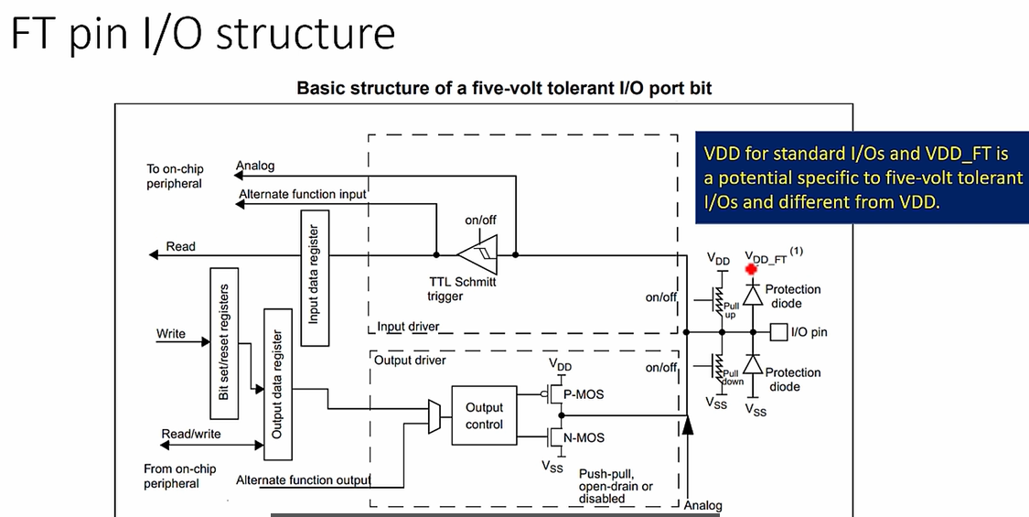

Here you see the **protection diode** is actually driven by **VDD_FT** which is slightly higher than **VDD**.

In the I/O structure of **TT pin** you see **VDD** here, that's not present in I/O structure of **FT pin**, because it has to handle little higher voltage, that’s why the signal here is **VDD_FT** which must be greater than **VDD**. And in the next lecture, let me explain the current characteristics.

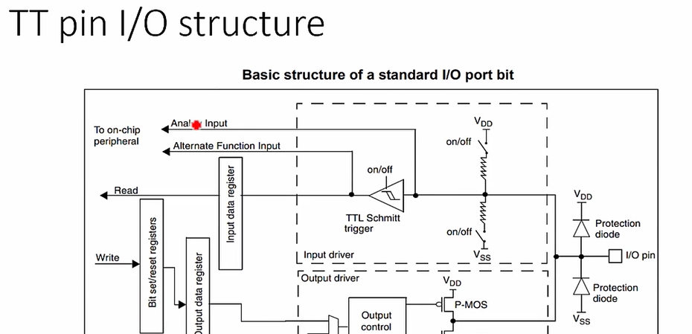

Vediamo il caso per l’FT pin, lo stesso ragionamento lo si può applicare al TT pin:

***FT pin***:

* ***ARM table***: ***VDD max = 4V,*** mentre ***VIN max*** = ***VDD + 4V***
* ***General operating conditions: VIN max = 5.5V***

Quindi, dovendo prendere sempre la condizione più stringente avremo che:

* Se ***VDD = 0***, allora ***VIN max*** ***= 4V*** in accordo con la **ARM table,** in quanto è un valore più basso di 5.5V.
* Se ***VDD*** != 0, allora ***VIN max = 5.5V*** in accordo con la **General operating conditions,** in quanto se avessi ***VDD = 4V***, dalla **ARM table** otterrei una *VIN max = 8V*, ma dovendo prendere la condizione più stringente prendo i **5.5V.**

## 119. Pin current characteristics

Now, let's explore the **current characteristics** of this microcontroller.

So, now you can find this table in the ***Datasheet***.

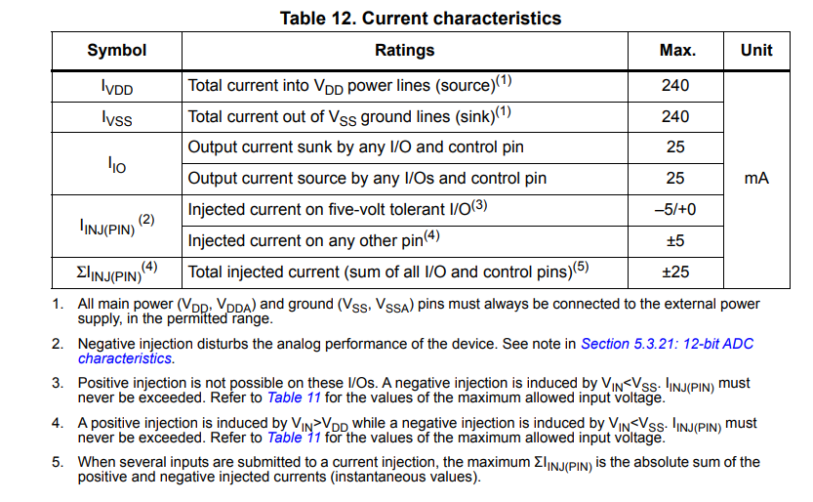

First let's discuss about the IVDD, which is nothing but the **total current** **into** **VDD** power lines. It's a total source current, that means, the maximum current which the microcontroller draws from the VDD power line to the external world. That means, at maximum this microcontroller can source a 240 mA of current.

Now let's see what is IVSS. IVSS is a **total current out** of **VSS** ground line. That means, the total current which can sink into the VSS line is limited to 240 mA. So, that means, IVSS is nothing but the maximum current which can sink into the VSS line of the microcontroller.

After that IIO: there are 2 types of IIO:

* source current
* sink current

So, IIO is nothing but a current which flows via a microcontroller pin to the external world or from external world into the microcontroller. If a current flows through a pin from microcontroller to the external world, then that is called a source current. For example, here is a picture which explains I/O source current:

The maximum current which flows out of the device through GPIO output pin when it is HIGH, that what we call as a source current. Here, what you see IOH is a source current. When you make this digital pin HIGH, let's say you write 1 to the output control here and which turns on this transistor and it deactivates the other transistor, a current flows. So, this is acts as a short now. Current flows from here to the external world / external load through this pin. So, its value is limited to **25 mA**. That's what they have given here. IIO, that is the current which flows through an I/O. So, if you consider sourcing, that means a current which is flowing to the external load, that is limited to 25 mA.

So, this picture you can find in the application note from ST microelectronics. Remember that, for STM32 microcontrollers, **maximum source current** possible is **25 mA**. A load cannot draw more than this amount of current from an I/O pin.

So, then what's a **sink current**: a maximum current which can be sunk into VSS by an GPIO output pin when it is LOW. Let's say this is a load. So, let's say load consist of an external power supply and let's say you make your GPIO output state as LOW by writing '0' into the output control. When you write 0, what happens here? This will be turned off, this transistors conducts, this is VSS. Let's say, here there is a power supply and the current flows from the external power supply to VSS. So, this current is nothing but **IOL**, which is a **sink current** and sink current must be limited to **25 mA**, otherwise the **pin** may get **damaged**.

That's why, the external power supply at maximum it can supply 25 mA of current into the microcontroller. This is current flowing from external world to the microcontrollers VSS pin. So, this is a current sinking and it should be limited to 25 mA. If sink current exceeds 25 mA, then device could be damaged. So, that's what they have mentioned in this table.

And after that, there is an **injection current**, so which will see later.

Let's say you have a microcontroller project where you have configured 5 GPIOs to the output mode and you make the state of each GPIO output as 1. When you make all these GPIOs as HIGH or 1, what happens? The pins will start **sourcing current** to the external world. That means, each pin will start sourcing 25mA. So, that's why, the total current which will be drawn from the VDD will be 125 mA. Remember that it's limit is 240mA. That's what they have mentioned here IVDD, so IVDD = 125mA and that is the total current which is drawn from the VDD.

Suppose you have a project where you have to configure 20 GPIOs to the output mode, and if you make all the GPIO state as 1, let's say HIGH. So then, remember that IVDD limit is 240mA. That's why you see lesser current coming out of an I/O pin. In this case, 240 divided by 20 will be around 12 mA. That's why, 25mA is a maximum limit which can be a source to the external world.

Here is an example of current sourcing and current sinking. So, let's say you have an LED here. And if you want to make this LED HIGH, what would you do? You make this pin as HIGH. When you make this pin HIGH, so current flows to the LED from VDD through this pin. Right? The current flows like this. This is a source current and your LED glows. You can control the current which flows into the LED by adjusting this resistor. This is an example of current sourcing.

What is Sinking? Sinking means from the external supply current flowing into the microcontroller and it is going into the VSS line. So, this is also another way of glowing an LED. If you make this pins output state as 0, what happens? The current starts flowing, isn't it? From external power supply through this pin and into the VSS, this is a current sinking and the LED glows, and this current should be limited 240mA by adjusting this resistor, otherwise you may damage this pin. And also note that, if current is sinking from various other pins, then the summation of all the sink current should be less than 240mA. So, that is what they have mentioned here IVSS. Total current which is getting sunk into the VSS line. So, the algebraic sum of all the sinking current must be less than 240mA.

Now let's explore the **injection current IINJ**.

* The injection current is the current that is being forced into a pin by an input voltage (Vin) which is higher than the positive supply (Vdd) or lower than the ground potential Vss.
* The injection current above the given specifications causes a current flow inside the device and it may affect the device reliability. Even a tiny current exceeding the specified limit is not allowed.
* There are 2 types of current injection into the pin or into the device. One is a positive injection and another one is negative injection. So, the positive injection happens when the Vin is higher than the Vdd (VIN > VDD). Negative injection current is the current induced when Vin is less than Vss (VIN < VSS). The **maximum negative injected current** is **-5mA**, and the minimum Vin voltage level acceptable on the GPIO is -0.3 V for TT and FT GPIO. So, negative injection current happens when Vin is less than Vss. The maximum negative injected current should be limited to -5mA. This you can obtain from the ***Datasheet***. Let's get into the ***Datasheet*** into the table and look at Table 12, **Current characteristics**.

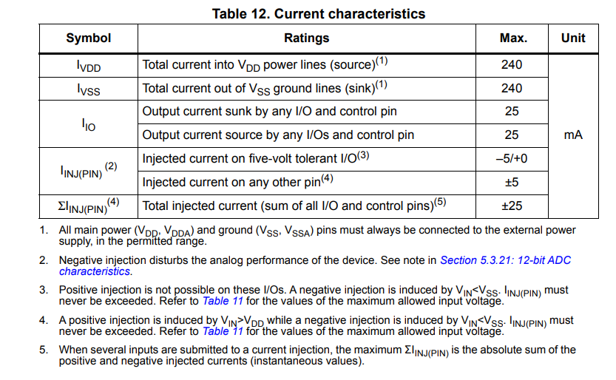

Here there is an injected current, and you see injected current on five-volt tolerant pin. So, the negative injection is allowed, it can go up to -5mA, no problem. But positive injection is not allowed, it is 0mA. That's why positive injections should not happen on five-volt tolerant pins.

On any other pins the injected current could be a plus or minus 5.

* What is **positive-injection current**? It is a current which is induced when Vin is greater than Vdd (VIN > VDD). For STM32 devices, the maximum positive-injection current on **FT** GPIO is usually defined as not applicable (N/A) or 0mA. For this microcontroller, the positive injection current for **FT pin** is defined as **0mA**. That means positive injection is not allowed. 0mA means that the current injection can damage the GPIO and induce STM32 malfunction.

**Positive current injection** is **prohibited** for **TT** or **FT** GPIO if it is defined as **0mA** in the ***Datasheet***. But in our case, if you see the positive injection is allowed, that is up to 5mA for TT, while for FT it is not allowed. As long as Vin on FT is less than AMR (Vdd + 4V), the positive current injection won't happen. The upper limit 0mA indicates that the positive injection current should never flow into the GPIO pin, otherwise, the device may be damaged. If Vin goes beyond Vdd + 4V, then positive injection happens, and the device may be damaged if the injection current is above the threshold and that threshold is actually not mentioned in the Datasheet. That means, on FT pin the positive injection won't happen until the voltage reaches or goes beyond Vdd + 4V. Once Vin crosses Vdd + 4V, then positive injection happens and the device may get damaged. So, note that positive current injection is prohibited for FT pin which is defined as 0mA. That's about injected current. And in the next lecture, let's understand the microcontrollers logic levels. I will see you in the next lecture.

## 120. Logic levels

In this lecture, let's understand STM32 Microcontrollers I/O pins a **Voltage levels** for different **Logic levels**. That is the threshold voltages for the Logic 0 and the threshold voltages for the Logic 1.

So, this discussion is not just applicable to STM32 microcontroller, you can apply to any microcontroller, all these are some generic discussions. Please note that, all I/Os of this microcontroller are CMOS and TTL compliant. So, whenever you are interfacing two devices you should take care of **Logic level compatibility**, otherwise, those two devices may not talk to each other or there could be data corruption.

So, let's discuss this Logic level compatibility in the case of STM32 microcontroller. As I said, Logic level compatibility really important whenever you are doing any interfacing project. That means, whenever you are interfacing different peripherals to your STM32 microcontroller, at that time you should really be concerned about this Logic level compatibility. In the case of **communication exchange**, STM32 output signals must be compatible with VIL and VIH of the receptor device and STM32 inputs must be compliant with VOL and VOH of the transmitter device as shown in the figure.

Here you see 4 voltages:

* VIL / VOL are called as **input threshold voltages**
* VOL / VOH are called as **output threshold voltages**.

Now, let me explain that. Let's take an example of a transmitter device. Let's say the transmitter device is STM32, and let's say there is one receptor device, let's say this is Arduino board. Now, let's say there are 2 signals which are going from STM32 microcontroller board to Arduino board. This is signal number 1, this is signal number 2, and let's say these two signals are **output signals**. So, that means, let's say these two pins are configured as output.

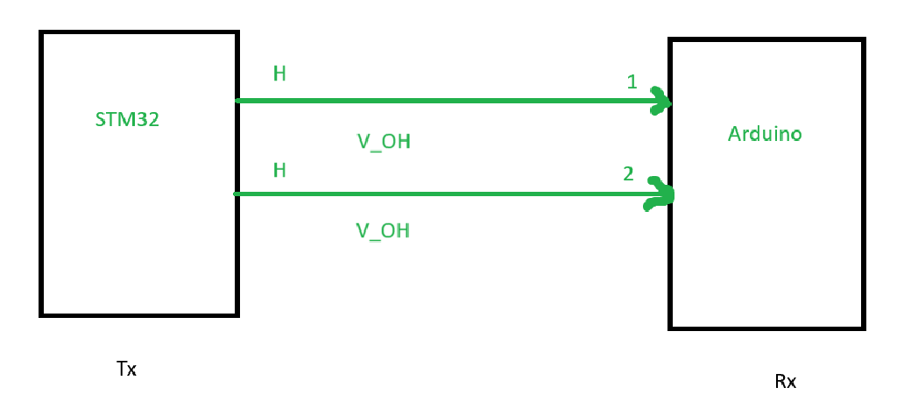

Those output signals will be received by this Arduino board, these two pins are configured as input here. And now let's say your program makes a these two lines as HIGH. So, the STM32 microcontroller drives these pins to HIGH voltage or HIGH Logical level. That means there is a voltage drop. And this voltage drop we call it as VOH. **VOH** means **output high voltage**. The voltage which is produced by STM32 microcontroller when it drives the pin to high in the output mode, that is VOH.

So, this VOH should be greater than or at least equal VIH of the Arduino board (VOH >= VIH) , otherwise Arduino board will NOT interpret this signal as HIGH.

Now there is another term VIH. In this case, VIH is nothing but it’s an **input high voltage**. This is a minimum voltage of the signal, which must be applied to the Arduino pin to recognize or to perceive it as a Logical high signal. If the VOH, which is produced by STM32 microcontroller, if it is less than VIH of the Arduino board, then the Arduino board may not recognize that signal or it may recognize the signal fastly. Like the signal high maybe recognized as signal low at the receiver side. There could be **data corruption**.

So, that's why, this **Logic level compatibility** is really important. Please note that:

* VIL and VIH are called as **input thresholds**, which are related to a **receptor device**
* VOL and VOH are called **output thresholds**, which are related to the **transmitter device**.

Now, let's study these parameters in the case of STM32 microcontroller, so every microcontrollers ***Datasheet*** must mention these **threshold voltages**. If you check the ***Datasheet*** of the STM32 microcontroller, you can see they have mentioned VIL.

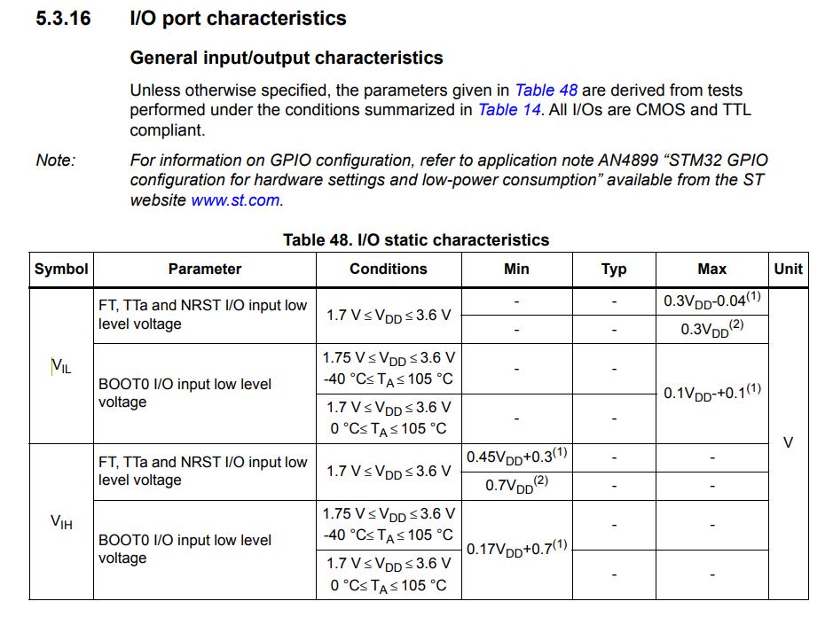

**VIL** is the **maximum voltage level** that is interpreted as **logical** **0** by a **digital input**. You should focus on this word 'maximum'. It's a maximum voltage level that is interpreted as logical 0 by a digital input circuitry of the microcontroller. So, that's why, you have to look at the maximum column here. And you see for FT and TT pins, it is around 30 percent of the VDD. That's the maximum value of the VIL parameter. Suppose if VDD is 3V, then 0.99V is the maximum voltage level that is interpreted as logical 0 by a digital input. So, if the applied signals voltage if it is above than this value, then it could be recognized as logical high. I hope you get that point.

**VIH** is the **minimum voltage level** that is interpreted as a **logical 1** by a **digital input**, here you should concentrate on this word 'minimum'. So, in the case of STM32 microcontroller, VIH is around 2.31V when VDD is 3.3V, it's actually relative to the VDD, because, it's a CMOS technology.

For the **CMOS technology**, the input threshold voltages are relative to the VDD. You can see that, 2.31V is derived by applying this formula: **VIH(min) ~ 2/3 VDD.**

While 0.99V is derived by applying the formula **VIL(max) ~ 1/3 VDD**.

So, it's like that. But for the **TTL technology**, these levels are **fixed**. The parameters VIH and VIL are fixed for TTL technology:

* **VIH(min) = 2V**
* **VIL(max) =** **0.8V**

But if it is CMOS technology, then it is relative to the VDD.

Here you can see that, for STM32 microcontroller, if the VDD is 3.3V, then VIL is 0.99V. Here, VIL maximum is equal to 0.99V, that means, if a signal needs to be interpreted as logical low, then its voltage must be less than this value (**VIL(max)**). If the signals voltage level is higher than this value, then that signal can't be recognized as logical 0. Similarly, if any signal needs to be recognized as logical high, then its voltage must be at least equal to this much or higher than this voltage (**VIH(min)**).

So, that's why, VIH and VIL comes into picture when you are handling STM32's Digital pin in input mode. And when you are driving your STM32 microcontrollers pin in output mode, then VOH and VOL will come into picture, and I will explain that in a moment.

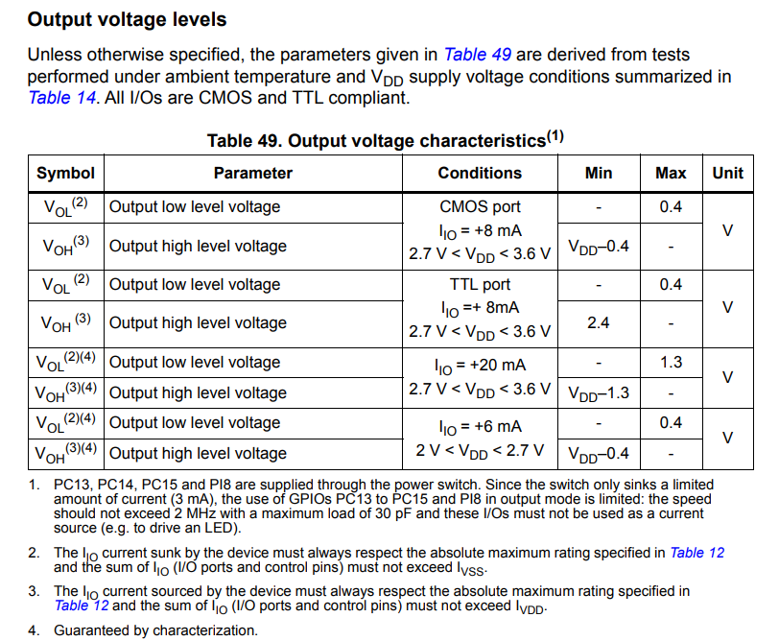

**VOL**, the **maximum output low level voltage** which can be interpreted as **logic 0**.

**VOH** is the **minimum output high level voltage** which can be interpreted as **logic 1**.

So, again you can get the information about these parameters by looking at this table.

Let's take the VOH row, output high level voltage, you should look at the minimum column. This is **VDD - 0.4**. So, if VDD is a 3.3, then it would be around 2.9 Volt. Right? That means, this is a minimum output high level voltage which will be produced by the microcontroller for **logic 1**. You can consider it as a worst-case scenario. At worst case, microcontroller will ensure that it will produce the voltage of 2.9V when you drive a digital pin to logical HIGH state.

Similarly, if you consider VOL here and VOL is a **0.4V**, that's a maximum output low level voltage which can be interpreted as **logic 0**.

Now let's discuss one case study, let's say you want to interface STM32 microcontroller board with Arduino board. Let's consider VDD for STM32 microcontroller as a 3.3V and let's consider Arduino board is running at 5V, and let's say our STM32 microcontroller board is transmitter and let's say Arduino is receptor. So, such interfacing we actually do in a later part of the course, when we are transmitting message from STM32 microcontroller to the Arduino board over a SPI or over I2C. So, we'll discuss more on such an interfacing things later. Here, you see VOL(Max) of STM32 microcontroller is 0.4V. And VIL(Max) of Atmel microcontroller, so whatever the microcontroller used in Arduino Uno board let's say. It's VIL(Max) is 1.5V. That's why, this 0.4V is well within this range. So, that's why, there is no problem from the Arduino side to interpret logic 0, because the noise margin is a pretty much higher. So, even if some noise gets added to this voltage, let's say, a noise of 1V gets added to the logic 0 voltage of the STM32 microcontroller pin and if this logic level shifts little higher, then also there is no problem actually, because, there's a big immunity here, because the noise margin is little high. So, still the logic 0 of STM32 microcontroller pin will be recognized as logic 0 by the Arduino board.

But, if you consider **logic 1**, then there is a **problem**. And look at the VOH(min) of STM32 microcontroller, it is 2.9V. But VIH(min) of Arduino board is 3V. That means, the signals voltage must be at least 3V or higher than 3V a to be interpreted as logic 1 by the Arduino. But at the worst case, STM32 microcontrollers VOH(min) is 2.9V. So, that's why the logic 1 voltage of the STM32 microcontroller may fall under this intermediate region here.

There is a very less noise immunity, because the noise margin is very a pretty much narrow. So, that's why, the logic 1 voltage of the STM32 microcontroller can be recognized as logic 0 sometimes by Arduino board, because it doesn't satisfy the minimum a VIH requirement of the Arduino board. That's why there could be a **data corrup**tion while receiving a logical 1 signal from transmitter to receptor device. So, that's why you may need one **logic level shifter** here, which shifts this voltage to a higher voltage.

So, we'll see that interfacing a little later. I hope you get this idea. So, you cannot directly connect a STM32's digital pin output to the Arduino pins a digital pin input, because there is a **logic level incompatibility**.

Now, let's consider this case where Arduino is transmitter and STM32 is a receiver. So, now here you see the VIL(max) for STM32 microcontroller is 0.99V, that is the maximum input voltage which can be interpreted as a logic 0. The VOL(Max) of Arduino board is 0.8V, which is very close to the VIL of STM32 microcontroller. So, the noise margin is very narrow. If any noise gets added up to this voltage, this logic level may shift to higher voltages, at that case, you know the signal may not be interpreted properly by the STM32 microcontroller. That's why here there's a **problem**. And the VOH(min) of Arduino board is 4.1V and VIH(min) of STM32 microcontroller is 2.31V. Since VOH is higher than VIH, there is no problem in interpreting logic 1 signal by the receiver device. But you should be careful here, because, when the STM32 microcontroller is **unpowered**, that means when **VDD = 0**, the maximum voltage that you can apply is limited to **4V**. If the Arduino board is supplying let's say 4V or higher than 4V to any pin of the STM32 microcontroller when it is unpowered, so then it could damage STM32 microcontroller or at least it could damage that pin. That's why it's better if you use some kind of **diodes** or **logic level shifters** in between to step up or step down the voltage levels. (Questo lo avevamo studiato nelle lezioni precedent quando avevamo visto la max tensione che può essere applicata ad un pin, in base a che questo sia TT o FT).

So, I hope you get the idea about logic level compatibility with these case studies, and so we'll do exercises on interfacing Arduino and STM32 microcontroller in future videos when we discuss SPI and I2C communications. So, I'll see you in the next lecture.

# Sezione 31: SPI introduction and bus details

## 121. Introduction to SPI Bus

Hey, welcome back to the course and in the previous lecture we actually explored about one of the most important peripheral of the microcontroller that is **GPIO**,and from this section onwards we are going to explore about the **SPI peripheral**.

First, let's start with introduction, so, what exactly is SPI? **SPI** stands for **Serial Peripheral Interface**. So, this is one of the protocol which is used to **communicate** with the **one master** and a couple of slave devices in embedded world.

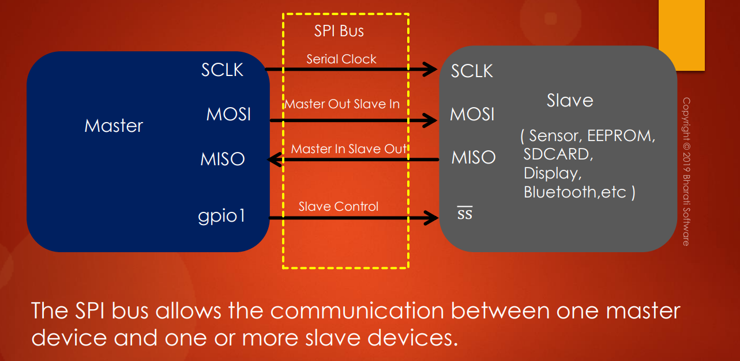

For example, let's say there is **one master device** and there is **one slave device**. Slave maybe anything, it can be your sensor, it can be EEPROM chip, it can be SD card, it can be display or wireless connectivity chips such as Wi-Fi or Bluetooth and if the master device wants to communicate with a slave, so, the communication means if it wants to send some data to the slave or if it wants to retrieve some data from the slave, a specific protocol is defined and **SPI protocol** is one among them.

So, there are various other protocols like CAN Protocol, I2C protocol, Ethernet, USB, RS232, RS485, so, there are various protocols and SPI is one among them. And the SPI bus which is actually the collection of couple of pins, about these pins, we are going to learn in a moment, don't worry. Basically, what you are seeing here is **SPI bus**, which allows the communication between one master device and one or more slave devices. So, you can connect more slaves to the master, no problem.

How this protocol works and what are the significance of these pins, we can study as we make progress in this course. But you have to remember that the **SPI** is a **protocol** which is used for **serial data communication** between one master and a couple of slave devices in Embedded World.

Let's move forward. So, let's learn about these **pins** which are part of the **SPI bus**.

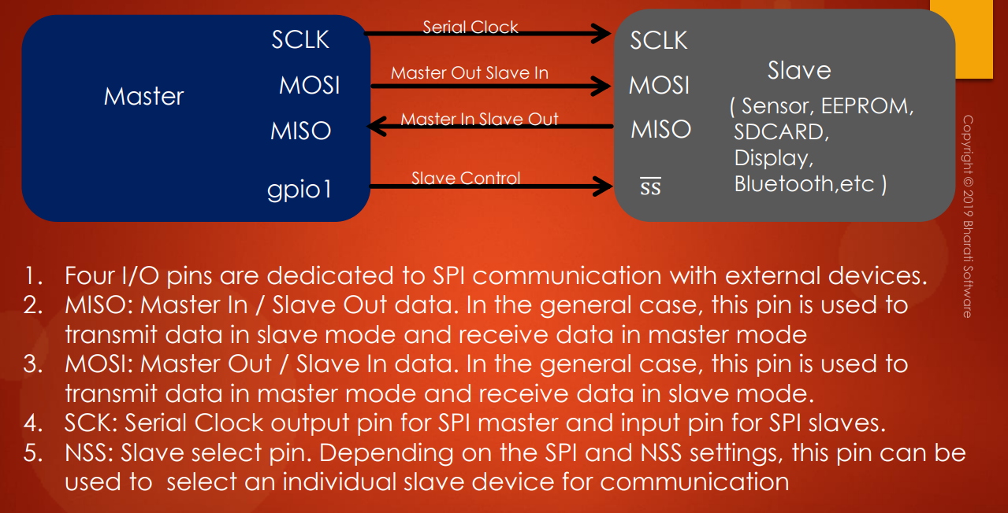

1. **4 I/O** pins are dedicated to SPI communication with external devices. So, typically SPI uses 4 or more pins.
2. **MISO** pins where it is written as MISO. So, the MISO pin which stands for **Master In Slave Out** data. So, basically, MISO is **data pin**. So, in the general case, this pin is used to transmit data in slave mode and receive data in master mode. So, as the name suggests, whenever slave sends data so that data will be received over the MISO pin by the master. So, the MISO pin is actually used to send data from the slave side, and it will be received by the master.
3. **MOSI** pin, where MOSI stands for **Master Out Slave In** data. So, in general cases, this pin is used to transmit data in master mode and receive data in slave mode. So, whenever master wants to send some data to the slave, it actually sends it over the MOSI pin and slave receives its data over its own MOSI pin. So, it's like you have to connect MOSI pin of master to the MOSI pin of slave and you have to connect MISO pin of master to the MISO pin of slave. So, these two are actually they are data pins because they carry data.
4. **SCK** or **SCLK** pin, so that stands for **serial clock**. Whenever the master wants to communicate with slave, all the data which are there on the MISO or MOSI pin will be synchronized with the clock produced by the master on this line. So, this pin actually carries the **clock**, the **data communication clock**. So, all the data communication between master and slave is synchronized with the **serial clock** which is produced by the **master**. So, hence **SPI** is also called **synchronous serial communication protocol**. And remember that in SPI protocol, master is the one which produces the clock while the slave will only receive the clock, so the slave has no control over the serial clock which is produced by the master. So, without this clock, SPI communication is not at all possible. So, that's why when the communication is not working, the very first debug tip is to see whether the master is indeed producing the clock or not. So, when we make progress in these lecture series, you'll understand more about these things practically. And if it is confusing to you, then don't worry. So, you are going to understand more.
5. **NSS** or **SS** which stands for **Slave Select**. So, let's understand about the **slave select pin**. So, depending on the SPI and the slave select settings, this pin can be used to select an **individual slave device** for communication. So, strictly speaking when you have one master and one slave, then this slave select is actually not required. So, this slave select makes sense only when master is communicating with the **different slaves**. So, master can select the slave to which the master wants to communicate. To make that selection, this pin is dedicated. So, that's why it is called **slave control** or **slave select**.

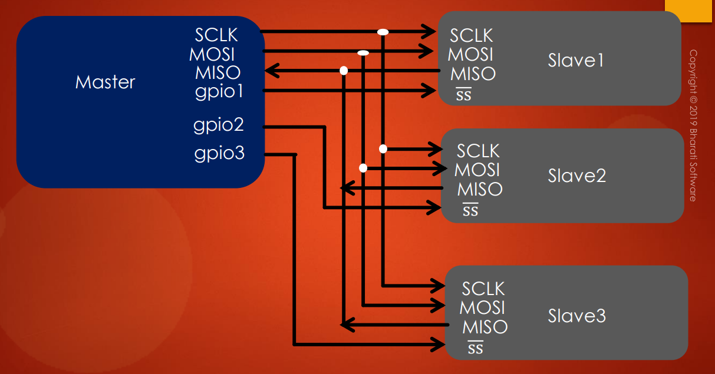

Basically, the SPI bus is a collection of these four important pins and remember that MOSI / MISO are actually data communication pins, NSS is a slave control pin, so this doesn't carry any data, remember and SCLK is the serial clock which is produced by the master to synchronize the data communication between master and slave. So, that's the brief introduction to the SPI pins and we'll understand more about the protocol as we make progress.

## 122. SPI comparison with other protocols

So, apart from SPI, there are various other serial data communication protocols are available like USB is also a serial communication protocol, Ethernet, I2C, RS-485, CAN, RS-232, etc..

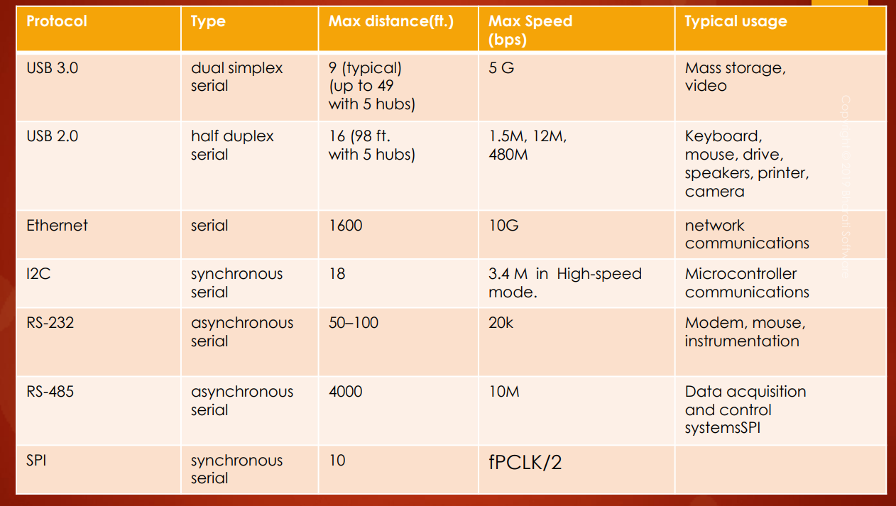

Depending on the application and application requirements, you have to carefully select which serial communication protocol or interface is suitable for your application. For example, in this table, I have documented some of the serial communication protocols and their maximum speed and typical use case and also maximum distance over those interfaces can work properly.

Here you can see that if you consider **SPI**, then the **maximum distance** you can achieve between master and slave device is actually **10 feet** or less than that. It also depends upon the **speed** at which the SPI bus is communicating. **Speed** means the speed of the **serial clock**. So, for example, if the SPI peripheral of your microcontroller is getting 50MHz of peripheral clock, then you can achieve max speed of peripheral clock divided by 2 (fPCLK / 2), that is 25mbps. So, that is the beauty of SPI. This actually works over shorter distances but you can achieve higher data rate or higher speed.

So, take a look into **I2C**. I2C is also one of the famous embedded interface protocol, but take a look into its speed. It is very very low compared to SPI, but I2C is more complex protocol than SPI and it has lots of other features, but its speed is very very less compare to SPI like 3.4 megabits per second in high-speed mode or a little more than that. But I2C can communicate with the larger distances between master and slave compare to SPI.

So, typical use of **SPI** is actually to gather data from the sensor at higher frequencies and in order to communicate with a **display**, in order to communicate with **serial flash**. Let's say you have lots of data in the serial flash and you have to fetch that into your RAM or whatever. So, in those cases, you can use SPI.

But **I2C** generally used with sensors to gather data and there are much more features to I2C, all those things will address when we take I2C section.

So, basically, **SPI** is a **short distance serial communication protocol**. So, you have to keep this in mind.

But take a look at **RS-485**. So, let's say you want to communicate with **larger distances** like 100 ft, 200ft, 1000ft, then obviously you cannot use SPI, because these data communication is actually based on TTL signals or single ended signals in SPI communication. So, whereas **RS-485** or **CAN peripheral**, they actually use differential signaling and their output voltage signaling is actually high and so they can cover more distances, and you can also achieve a maximum speed of 10mbps in RS-485.

So, basically, what I wanted to say is you have to use SPI or I2C communication in one embedded board or in one PCB scenarios.

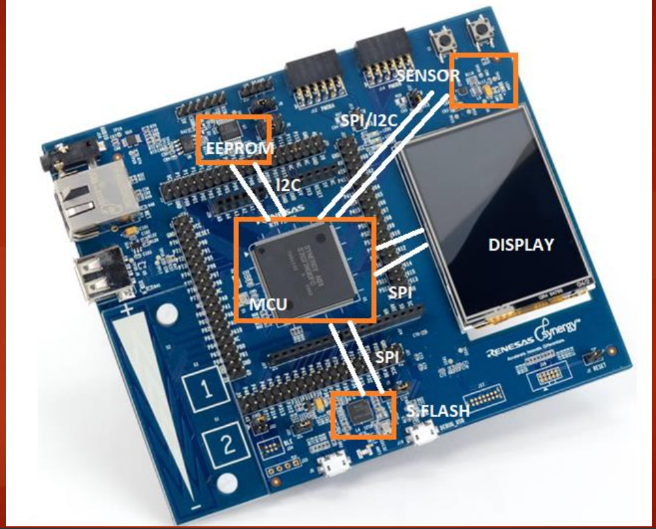

So, let's imagine you have a microcontroller and you have a couple of devices such as EEPROM, sensors, serial flash, display on a single PCB, then you can easily use a SPI or I2C interfaces in order to gather data from those slave devices. But if you have larger areas to cover like your car or your factory garage or if you want to establish a building automation or home automation, then you can never use I2C or SPI communication, if you want to cover larger distances. In those cases, you have to use CAN, Ethernet, RS-485 or combination of them in order to achieve data communication between various devices.

## 123. Importance of SPI slave select pin

So, now let's say you have one master device. Let's say this is your microcontroller and let's say this is the slave.

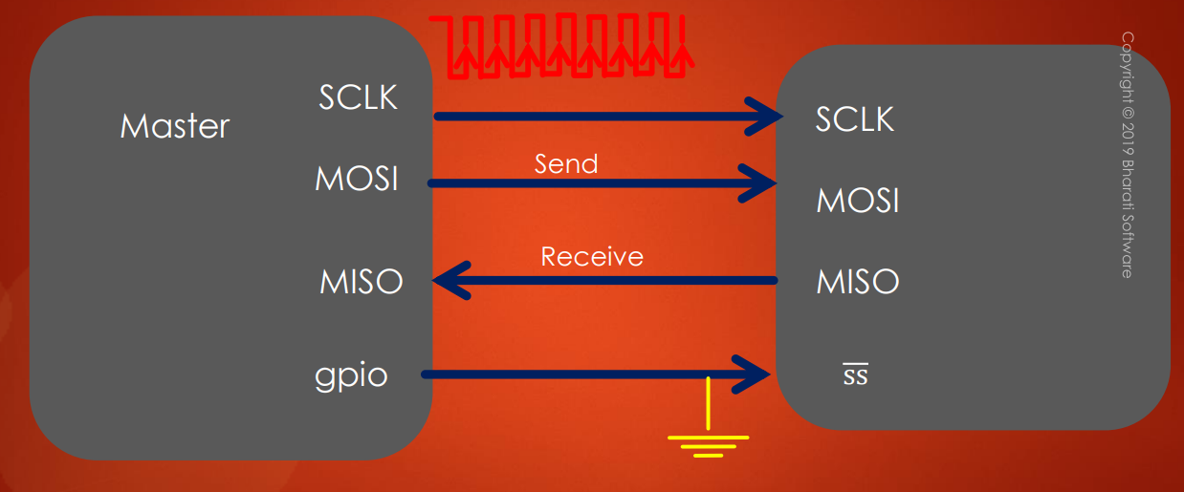

If you want to use the **SPI communication** between these devices, then both master and slave must support the SPI peripheral or the SPI interface. If slave doesn't support SPI interface, then you cannot successfully use the SPI communication between master and slave. So, the slave has to support that.

So, whenever master wants to communicate with slave, the first thing what master does is, it actually selects the slave. So, that means the master uses one of its GPIO in order to pull the slaves select pin of the slave to the ground. So, this is very very important step. Because when the slave select pin of the slave is pulled to ground, then only slave will activate these pins. Remember that. So, unless its slave select is pulled to 0 or ground, the slave will not activate the data communication on these two lines (MOSI/MISO). So, these two lines (MOSI/MISO) will be in HI-Z state. So, you have to remember that or high impedance state. So, only when master pulls that to ground, so, these pins will come out of HI-Z state or High Impedance state.

So, this is one of the most important step you have to do in your program. So, you have to connect GPIO of the master to the slave and then your program has to select that slave by pulling the slave select to ground. Then master will send data and it can receive data. So, in order to send the data, the clock must be sent along with the data. So, all this data communication lines will be synchronized with the clock signal.

So, the important takeaway from this discussion is making slave select of slave to ground is very very important in SPI communication and if you don't do that then these pins (MOSI/MISO) of the slave will be in high impedance state and slave will not respond to any data which is sent by the master.

So, I'll see you in the next lecture. In the next lecture, let's understand minimal SPI bus configurations. And I will see you in the next lecture.

## 124. SPI Minimum bus configuration

Hey, welcome back to the lecture. So, now let's understand the **minimal SPI bus configuration**.

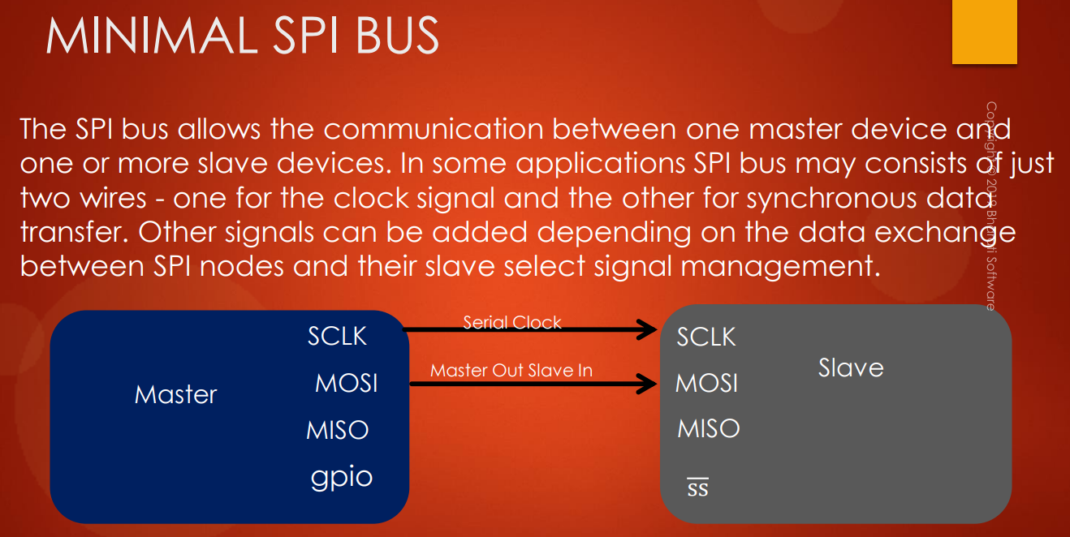

The SPI allows the communication between one master device and one or more slave devices. So, in some applications, SPI bus may consist of just 2 wires:

* one wire for the clock
* one wire for synchronous data transfer

The other signals can be added depending on the data exchange between SPI nodes and slave select signal management. So, this is one of the important things you have to remember.

So, let's consider this scenario, that is one master and one slave. And let's say the scenario is slave always it receives the data and slave will never send any data to the master. So, in that case, you can use only two lines. So, let's say the slave always keeps the slave select as grounded internally, maybe. So, slave can internally talk to the slave select pin and it can internally drive that slave select to ground. So, that is possible actually. Or you can take 1 wire and you can connect the slave select to ground always. So, you can do that. Why? Because there is only one slave, right? And remember this application is always master sends data and slave receives data. So, only one pin (MOSI) is enough, right? So, just connect MOSI of master to the MOSI of slave and the other wire is for the serial clock.

So, you can see that SPI communication can be achieved by using only two lines. All four lines are not actually required. So, hence it depends upon what kind of application you are using. So, based on that you can customize the SPI pins. So, that's about the **minimal SPI bus**. So, the takeaway from this discussion is so depending on your application, you can customize the SPI signals. It's not like you always should have four pins are more than four pins. It all depends on your application and how many slaves are really present and how you are communicating with the slave. So, by taking into consideration all these things, you have to decide how many pins are really required for your application. So, in the next lecture, let's understand the behind-the-scenes operation of SPI hardware.

## 125. SPI behind the scene data communication principle

Hey, welcome back to the lecture. So, in this lecture let's understand **SPI hardware** and behind the scenes operation. So, in this lecture basically we are going to explore how exactly data communication takes place between master and slave. How they exchange the data? So, let's see.

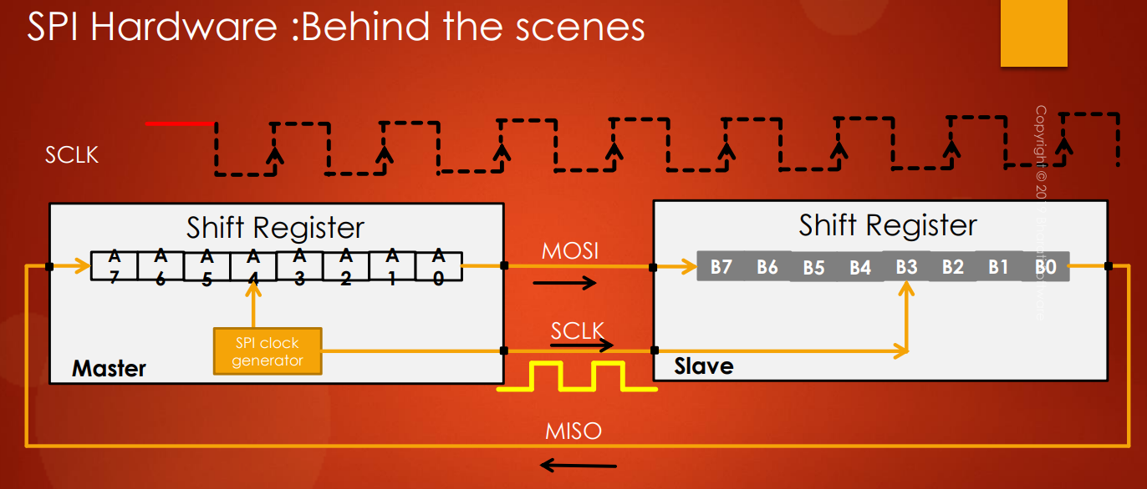

MSB

MSB

LSB

LSB

So, whenever you explore the SPI peripheral of your microcontroller you always see **shift registers**. You will actually see 1 shift register in your SPI peripheral. So, there is a shift register. So, SPI communication is based on shift registers. So, it's a very simple technique of data exchange and I will explain you this with an animation.

So, let's say there are 2 devices. One is master and another one is slave. And the master SPI peripheral has 1 shift register of 8 bits and this is the LSB and this is a MSB. And slave also has one shift register and you can see that the MOSI of master is connected to MOSI of slave, the clock pins are connected, and the MISO of slave is connected to the MISO of master. So, this is the connection.

You know that **SPI** is **synchronous serial communication protocol**. So, **clock** is required to send the data or push the data. So, this is a serial clock, on which the data communication is synchronized and this clock is going to be produced on the serial clock pin.

So, let's say our goal is to send the data which is there in the shift register to the slave. So, now let's say we have this data A0 to A7.

So, first what happens after **one clock cycle**:

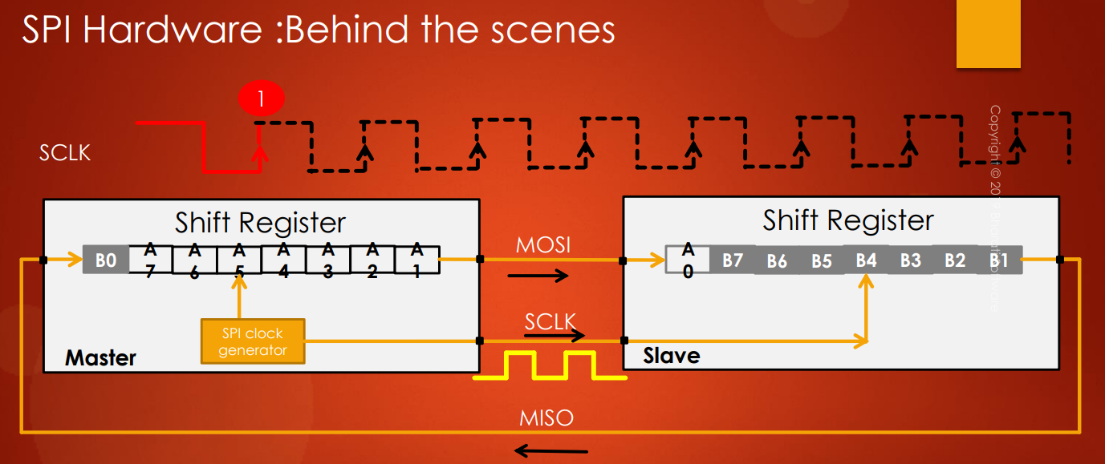

So, A0 which is there in the LSB is actually moved out of this MOSI and it reached the MSB position of the slave shift register. And the data is moved by one step. So, that's why the last data which is B0 actually moved out of MISO line and it actually came and settled to the MSB position of the master shift register. So, that means for every clock cycle there will be a shift in the shift register. So, that is a principle of shift register. So, if you can recollect from your basic electronics, shift registers position shift for each clock cycle.

So, if we want to see one more time I'll show you that. So, after one clock cycle so A0 is move to slave and the B0 is actually moved to master.

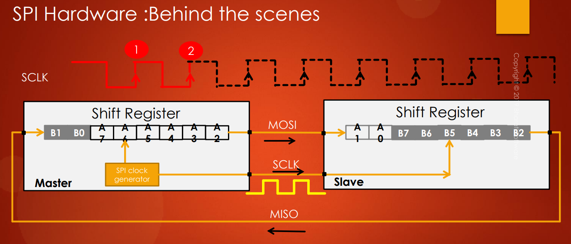

After **second clock cycle** you can see that A0 is moved by one position here and A1 came to the MSB position.

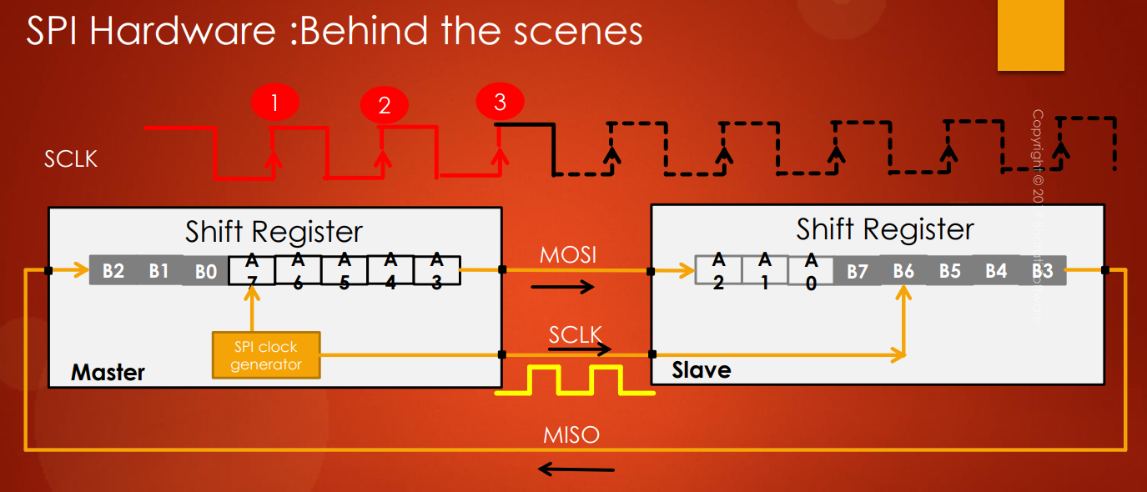

After **third clock cycle** A2 is moved, A3, A4, A5, A6, A7.

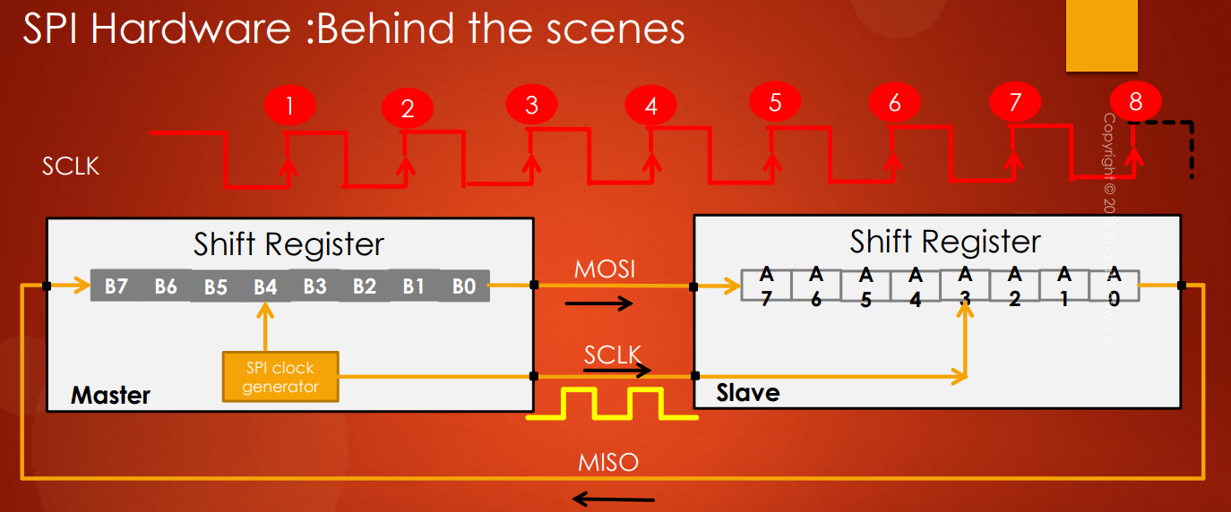

So, after the **8th clock cycle** the data which is there in the master shift register is exchanged with the data which is there in the slaves shift register.

So, this is how the SPI communication actually takes place behind the scene. Also remember that by doing this animation it is very clear that, whenever master sends data it also receives data. So, this is a data which is received by the slave. So, this is actually inevitable. So, you will always receive the data if MISO line is connected. Why? Because, there is a shift. Whenever master sends data to the slaves shift register so there is a data shift and that shifted data will come over the MISO line and it will settle in the shift register of Master. So, that's why inevitably you will always receive data, if the MISO line is connected.

So, that's about the behind the scenes operation of the SPI peripheral on your microcontroller and in the next lecture let's see customizing the SPI bus. So, let's see what different configurations we can have on a SPI bus. I'll see you in the next lecture.

# Sezione 32: SPI bus configuration and functional block diagram

## 126. SPI bus configuration discussion: full duplex, half duplex and simplex

Hey, welcome back to the lecture. So, now in this lecture let's see customizing SPI bus that various bus configurations. The SPI allows the microcontroller to communicate using different configurations, depending on the device targeted and application requirements.

First one is **full duplex communication**. Remember that, **SPI** is **full duplex communication**, because it has 2 dedicated data lines: so, when the data is actually transmitting you can also receive the data. So, that's why we call it at **full duplex communication**.

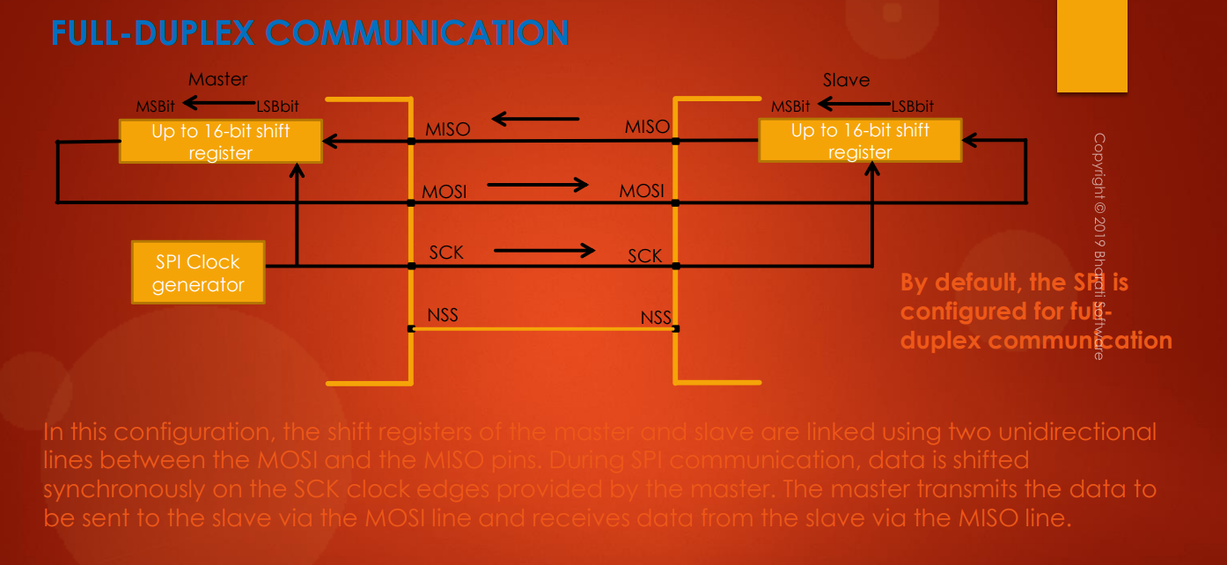

In the full duplex communication the shift registers of the master and slave are linked using two unidirectional lines between the MOSI and the MISO pins. During SPI communication, data is shifted synchronously on the clock edges provided by the master. The master transmits the data to be sent to the slave. via the MOSI line and receives the data from the slave via the MISO line.

Now, remember that by **default** the **SPI** is configured for **full duplex communication** in your microcontroller.

Remember that in SPI communication, slave will not initiate data transfer unless master produces the clock.

What are the other configurations we can have?

So, you can use **SPI** in **half duplex communication** that is possible.

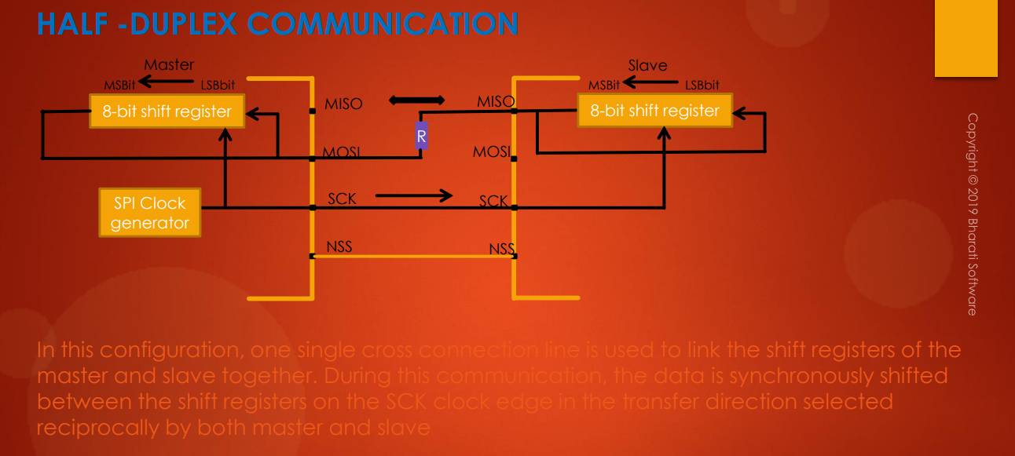



So, by using this communication method you can save some pins. So, in this configuration one single cross connection line is used to link the shift registers of the master and slave together. So, during this communication the data is synchronously shifted between the shift registers on the serial clock edge in the transfer direction selected reciprocally by both master and slave.

So, you have to understand that in **half duplex communication** there is only **one data line**. And this is how you should connect: the MOSI of the master has to be connected to the MISO of the slave and there must be 1 resistor in between a typical value maybe 1 kiloOhm etc..

And here you can see that this pin (master MISO pin) is actually free. So, a microcontroller can use that pin for some other purpose, no problem and clock has to be there and NSS need not be there, it is actually optional. Because, if there is only one slave.

So, whenever master wants to send data so master has to be in transmitter mode and slave has to be in receiver mode. So, this you have to configure in your program. So, the transfer actually happens in the direction selected reciprocally by both master and slave. So, that means if master is T, then slave has to be R, that means receiver. So, if master is in receiver mode then slave has to be in transmitter mode.

And let's say master wants to send some data. So, the data will come all the way from MOSI to MISO and so let's say slave is in a receiver mode so that's why, so this part will be in high impedance state (X blu). So, that's why the data will go in this path (percorso verde) and it will reach the shift register, so that's the principal actually.

And remember that most of the microcontrollers actually they allow you to configure the SPI in half duplex mode, but, there may be some microcontroller which will not allow you to handle the SPI in half duplex communication. So, you actually have to check the ***Reference Manual*** of your microcontroller to see whether the **half duplex communication** is really supported or not.

There is one more type of communication called **Simplex communication**.

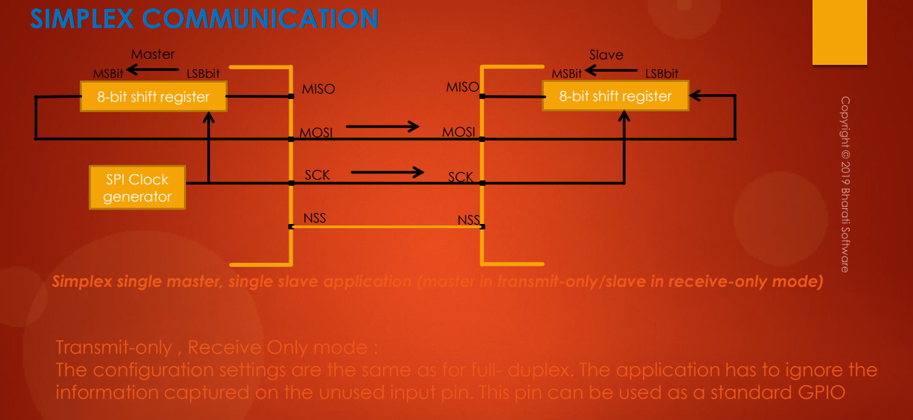



Simplex as it name indicates the communication is in simple mode. So, in simplex communication you will have 2 types of communication: **transmit-only** and **receive-only**.

So, for example, what you are seeing here is an example of **simplex single master**, **single slave communication** where master is in transmit-only mode and slave is in receive-only mode.

So, here you can see that the MOSI of both the devices are connected and so MISO line is disconnected, because in this application the master is never going to receive anything from the slave. So, this is called as simplex communication. So, if you want in simplex communication then you can disconnect those lines which are not required.

For example, here MISO lines are not required (X blu), so, that's why the MISO lines are disconnected.

The configuration settings are the same as a full duplex, remember. The application has to ignore the information captured on the unused input pin. This pin can be used as standard GPIOs.

For example, you can use these MISO pins as standard GPIOs for some other purposes.

So, in simplex communication you can configure a device in either transmit-only mode or receive-only mode.

Great!! So, now let's move forward and in the next lecture let's explore about the STM32 microcontrollers a functional block diagram and we are going to refer the ***Reference Manual*** for this and I would suggest you to open the ***Reference Manual*** and go to the SPI section. And I'll see you in the next lecture.

## 127. SPI functional block diagram explanation

Hey, welcome back to the lecture. So, in this lecture let's explore the **functional block diagram** of **STM32F407x** microcontroller.

So, for this I'm going to take you to the ***Reference Manual*** of the device and just browse through this document to reach **SPI section**, which is right here section number 28. And let's browse through this document and here you will see this **SPI block diagram**.

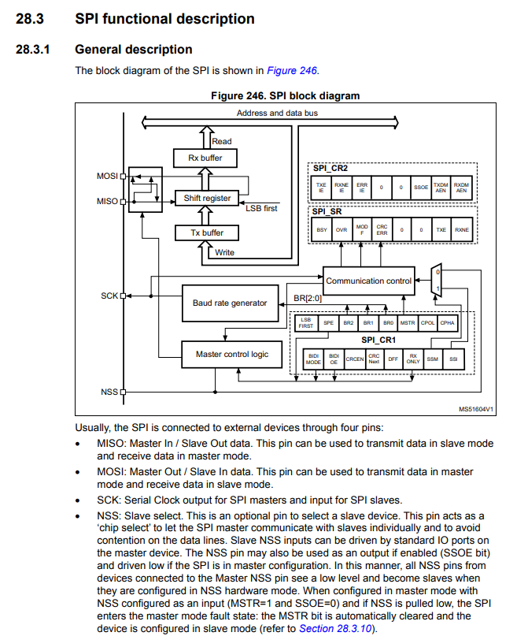

So, remember that most of the STs microcontrollers will have similar block diagrams. So, if you understand for 1 so you can apply the same points to all other microcontroller which are produced by ST, also to other microcontroller which are produced by other manufacturers like prescale, texas instruments, etc…

So, because the principle is same, everything is based on **shift register communication** maybe these register details are different or registers name may be different. At the end of the day the communication principle is same.

If you look at the SPI block diagram you can see that there are 4 pins for each SPI peripheral:

* MOSI pin
* MISO pin
* SCK pin
* NSS pin

So, the NSS pin, the serial clock pin, the MISO pin, and the MOSI pin.

And just take a look into this block here, there is a **shift register**:

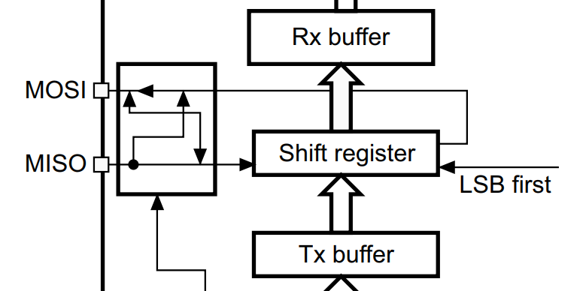

So, in ST's case this **shift registers width** is actually up to **16 bits**, because this peripheral also supports **data communication** of **16 bits**. So, at a time you can load a 16 bits of data into the shift register.

So, the width of the shift register will be up to 16 bits. And here you can see that the data lines that is MOSI and MISO are connected to shift register. So, if this peripheral is let's say if it is working as master, then data will be shifted out from the shift register and it will go to the external world over the MOSI line and if the peripheral is receiving the data, then the data will be received from the external world over the MISO line and it will get into the shift register.

And the **clock pin** is controlled by the **baud rate generator** if the peripheral is master. And here we can see that the baud rate generator you can configure by using the **baud rate settings**, which are there in the **baud rate setting bits** (**BR[2:0]**) which are there in the **control register SPI_CR1**.

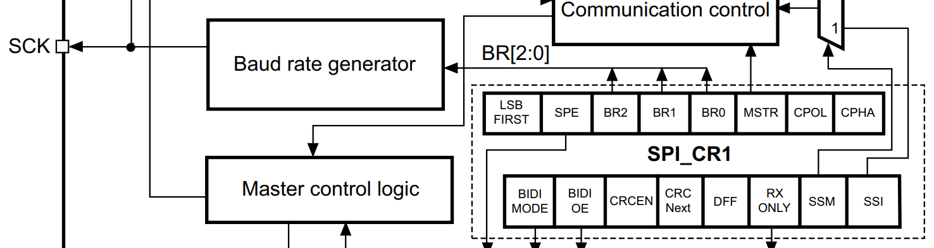

And after that, **NSS** is actually the **slave select** of the SPI peripheral. So, we will discuss more about slave select and its various other configuration details, maybe in the next video.

After that, you can also see there are **2 buffers**:

* RX buffer
* TX buffer

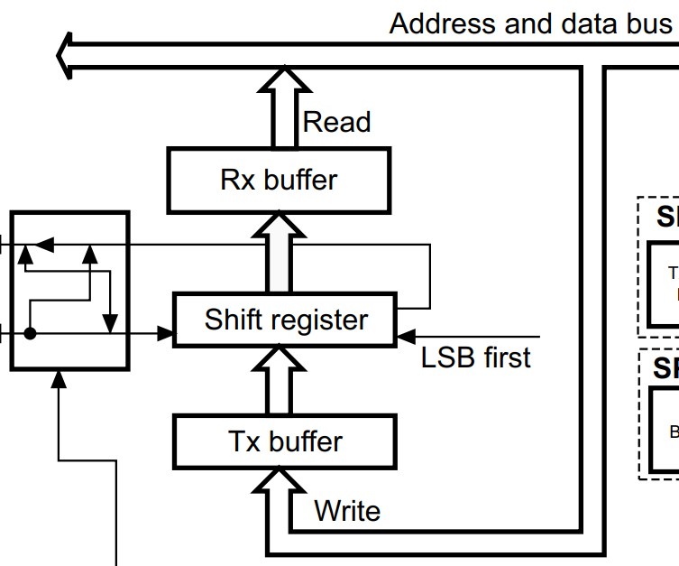

MOSI

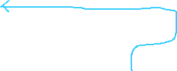

And you can access these buffers from the **APB bus**. So, this is the **Address and data bus**, which is **APB bus**. If the data frame format is 8 bits, whenever the shift register receives data of 8 bits, then if the shift register receives one complete byte, then the data will be moved to the **RX buffer**, and from the RX buffer you can read that data.

And whenever you want to transmit some data, then you actually write that data into the **TX buffer**. The firmware or your code actually writes the data into the TX buffer. And if the **shift register** is **free** so that means, if the SPI is not busy in communication, then that data you loaded into the TX buffer will immediately it will get loaded into the shift register and the transmission begins.

So, whenever you want to transmit data, then you will be writing the data into the TX buffer and from TX buffer the data will get loaded into the shift register, if the shift register is free and from the shift register the data will go out of the MOSI pin. So, this is actually the transmission path.

So, when to load data into the TX buffer? So, you will get an **interrupt** whenever **shift register** is **free**. So, or strictly speaking, whenever this **TX buffer** is **empty**, you will get an **interrupt**, so, that the application can load data.

And what is an RX path? So, whenever the data is received it will be stored in the shift register and when one complete data frame is received, let's say 8 bits, the shift register will move that data into the RX buffer and your application will get an **interrupt**, and then you can **read** the **data** from the **RX buffer**.

So, there will be **interrupt** for **TX buffer empty**, in that case you have to load the data if you want to transmit, and there will be one **interrupt** when **RX buffer** is **full**. Right? So, if you get RX buffer full interrupt, that means one data byte is received from the external world so you have to remember this point.

So, more on this will be discussed later when we discuss the programming aspects of the SPI peripheral. So, that's about the functional block diagram of a SPI peripheral and remember that there are 2 important blocks in this diagram:

* **data communication blocks:** where it has one **shift register** and associated **RX & TX** **buffers**
* If this **peripheral** is configured as **master**, then there is a **clock control circulatory** called as **baud rate generator**. And **SPI_CR1** and **SPI_CR2** are the register sets of the SPI. So, for GPIO you saw a couple of registers like mode register etc.. while here also there are a couple of registers called a control register 1, control register to 2, baud rate control register etc.. and by configuring those registers you can control these blocks. For example, you can use baud rate generation bits (**BR[2:0]**) of SPI control register 1 (**SPI_CR1**) in order to control the frequency of the serial clock, which actually affects the data rate of the communication. And you can also select the **data frame format** by using the **DFF** of **SPI_CR1**, the data frame format can be 8 bits or 16 bits. And by using the **master control bit** **MSTR**,you can configure the peripheral as master or slave. So, we will learn all these things as we make progress.

And in the next lecture, let's discuss about the slave select pin management. So, what are the configurations which are possible in slave select pin of STM32 microcontrollers and I'll see you in the next lecture.

# Sezione 33: STM32 NSS pin settings and management

## 128. NSS settings in STM32 master and slave modes

Hey, welcome back to the lecture. So, in this lecture let's understand the **slave select pin management**, that is **NSS pin management**.

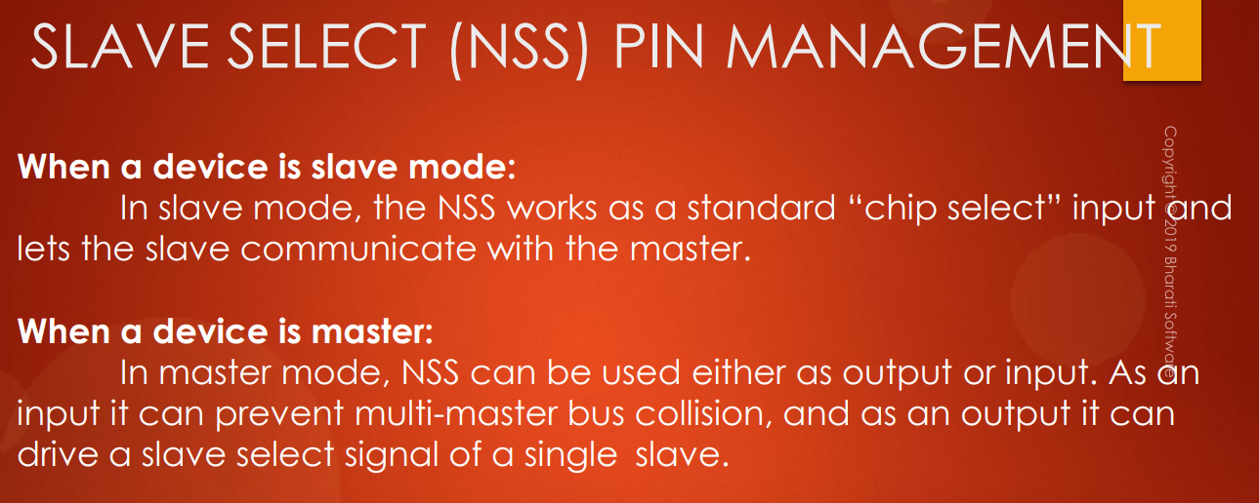

We have to understand this in 2 scenarios:

* When the **device** is in **slave mode**. So, when the device is in slave mode, the **NSS** works as standard "chip select" **input** and lets the slave communicate with the master. So, we have discussed this. So, when in slave mode, the NSS pin will just work like a standard chip select input pin.
* When the **device** is in **master mode**, **NSS pin** can be used either as **output** or **input** remember. So, as an **input** pin it can prevent multi-master bus collision: that means when the device is in master mode, then you can use the NSS pin in input mode in order to achieve the multi-master capability. That means, your **SPI** circuit can have **multiple masters**. Let’s not discuss this scenario, because this will drag our discussion to something else. So, the multi-master mode it is actually not discussed in this course or I may cover it later in this course, but as of now I have not planned to produce contents on multi-master modes of the SPI peripheral. But, remember that in standard communication when the device is in master mode, you keep the **NSS pin** always as **output**. So, when the NSS pin is in output mode it can drive a **slave select signal** of a **single slave**. So, now let's consider this scenario once again.

This is the scenario of **single master** and **single slave**.

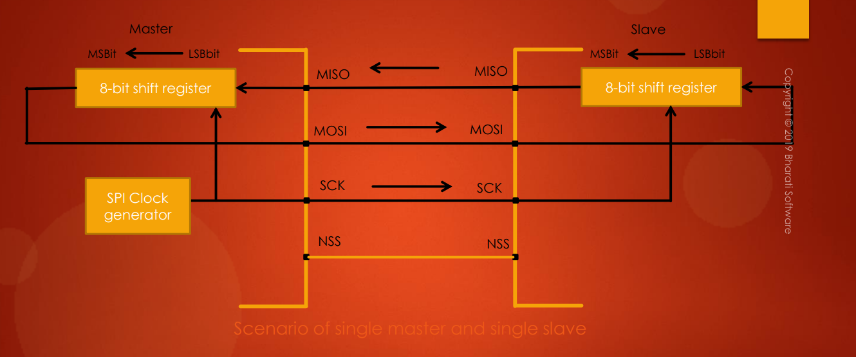

And in this case, let's assume that the slave is STM32 microcontroller which is in slave mode, and the master is another STM32 microcontroller which is in master mode. So, strictly speaking you need **not** to use the **NSS line**, because there is only one master and one slave.

But, if you want to use that pin then, remember that in the **slave** so you have to make this pin as **input**. So, from the slave side it just acts like a normal or standard chip select pin.

From the **master** side what have to do is, you have to make the **NSS** as **output**. So, this is very important because, if you make this as **input** then it is actually to detect the **multi-master collision** in when you use the microcontrollers in multi-master circuits. So, let's not discuss about that scenario, but make sure that you make the NSS always output. Let's move forward. So, now let's discuss about the different types of **slave management** in the next lecture. So, there are **2 types** of **slave management** and I'll see you in the next lecture.

## 129. STM32 SPI hardware and software slave managements

Hey, welcome back to the lecture.

So, in this lecture let's discuss about **2 types** of **slave managements** in STM32 microcontrollers:

* **hardware slave management**
* **software slave management**

First, let's discuss about the **software slave management**.

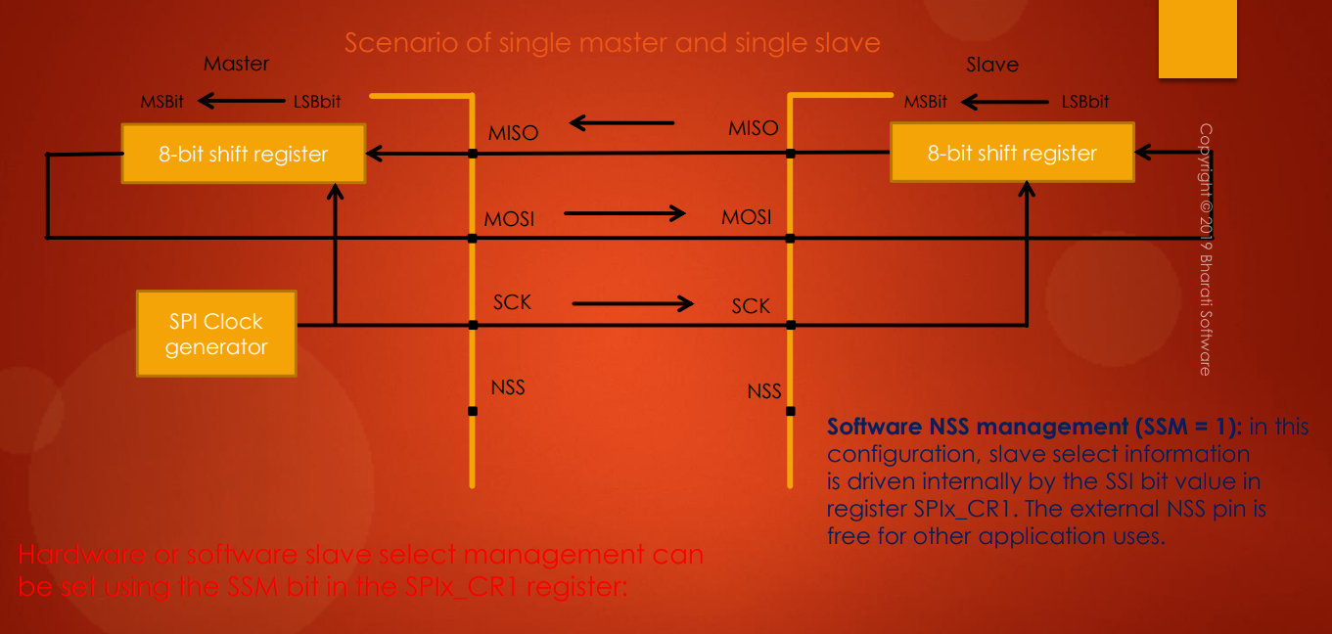

So, there is actually 1 bit called **SSM** **bit** in the **control register**, and you have to make that **SSM** bit as **1** in order to select the **software slave management** or **software NSS management**.

So, **hardware** or **software slave management** can be set using the **SSM bit** in the **SPIx_CR1**: so, we will see that when we do programming. Let's again consider the scenario with one master and one slave because this scenario is very easy to understand. And remember that, again there is an STM32 master and an STM32 slave. And since there is only one master and one slave, you can see that the **slave select** **pin** is **not used**. But if you want to make this slave to communicate with the master the **slave** **NSS** has to be **grounded**. So, here what you can do is, you can select the **software slave management** for this **slave**. When you do that what happens is, slave select information is driven internally by the **SSI bit** in the **SPIx_CR1**. So, the external NSS pin is free for other application.

So, what happens is, if you make **SSM = 1** and **SSI = 0**, then **slave NSS pin** will be **grounded** internally. That means this slave is always selected. So, that the slave can communicate with the master, so you need not to use NSS pin. All right. So, that is what we call as **software slave management**. So, there are 2 bits in the control register, one is SSM bit. So, you have to make **SSM = 1** in order to select the **software slave management** and the value of **SSI** will drive the **slave NSS pin**:

* if you make **SSI = 0**, then **NSS** will be **grounded internally**
* if you make **SSI = 1**, then the NSS will be pull to high to the **VDD**.

So, that's the concept. So, will understand more on this when we actually do some programming example. So, until then it may bother you but don't worry, if it is confusing you then it is completely normal. So, but your doubts will get clarified when you do programming. So, will do that when we cover couple of other concepts. All right. Now, let me move to the **hardware management**.

So, what happens when you select the **hardware management**?

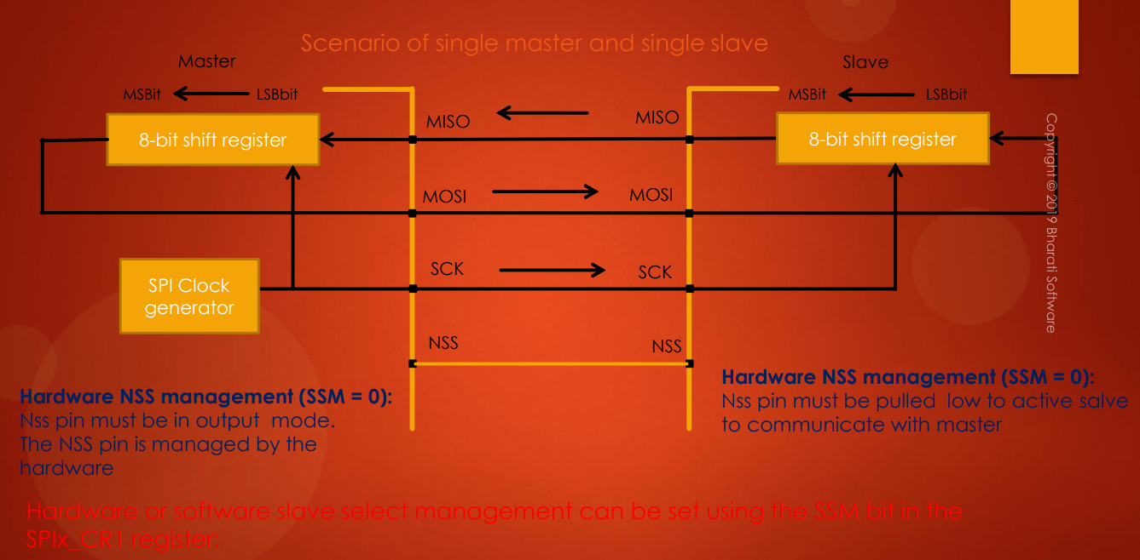



Suppose, in your application requirements let's say you have to use the **master NSS pin**, that is the **slave select pin**. So, if you want to use this pin then you are actually using **hardware** to control the **slave select**. So, that's why you need not to use software slave select. So, you can keep SSM = 0 here. So, if you make **SSM = 0**, then **SSI has no meaning**. So, by doing this you are actually expecting someone else to pull **NSS line** to **ground**. That's a meaning of **hardware slave select**. Remember that.

So, NSS pin must be pulled low to activate slave to communicate with the master. So, that's the meaning of hardware slave select. So, now in this case you can see here the master is actually using NSS pin. Right? So, as I said so **NSS pin** must be **output mode**. NSS pin is managed by the hardware. So, that's about the hardware slave management. So, the difference is in the software slave management you need not to use NSS pin. So, the hardware salve select means you are actually using NSS pin for the slave select.

Now, let's move forward. So, take a look at this picture.

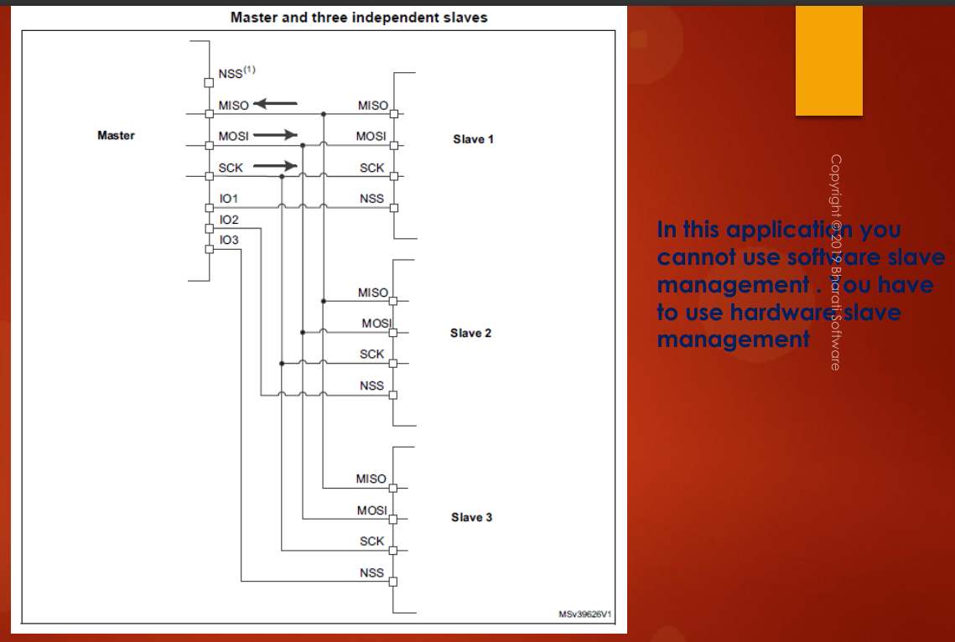

VDD



So, here there is **one master** and there are **3 slaves**. Right? And here you can see that, so here you **cannot** use **software slave management**. Right? Because, **master has to select the slave** first to which it wants to communicate, then it has to do the data transaction. So, obviously you cannot use software slave management here. So, you have to drive the slave select pins of the slaves by using the different **IOs** of the master.

So, for example here you can see that the IO line 1 of master is connected to the slave 1, IO2 to slave2 like that. Let's say, if master wants to communicate with slave2, then what it does is it will make IO1 line as high, it will keep IO3 line also as high but it will make IO2 line as low. So, when you make IO2 line as low this pin is grounded and this slave will be activated. Right? So, slave1 will be in high impedance state and slave3 also will be in high impedance state, so that's why data will be received only by slave2. Right?

So, that's why you have to use different pins over here from the master sides in order to control the slave selection. So, obviously you cannot use software slave management here. And here you can see that the **NSS pin** is actually **not used** in this configuration. So, when it is one master and multiple slaves you cannot use NSS pin of the master. So, what you have to do is, you have to connect **NSS pin** to **VDD** in order to avoid some errors. So, make sure that the NSS is connected to VDD. Otherwise, you can leave that NSS pin as unconfigured. That is also fine. If you configure that pin as NSS by using GPIO alternate functionality, then you have to connect that pin to +VDD.

So, that's about the slave management details and as I said if it is confusing to you then do not worry at all. So, that is completely normal and when we do exercises, we can understand more, but do the exercises we have to first develop the driver. Isn't it? So, will do those things as we make a progress and let me know if you have any questions. I will see you in the next lecture.

Points to remember:

* **Scenario 1 master – 1 slave**
  + You don’t need to use master & slave NSS pin if you use **software slave management**
  + if you don’t want to use **software slave management** then you can connect master NSS to slave NSS
* **Scenario 1 master – multiple slaves:**
  + You cannot use **software slave management**
  + You cannot use master NSS pin to connect to any of the slaves NSS pin
  + Master has to use some of its GPIO pins to control the different slaves NSS pins

# Sezione 34: SPI CPOL and CPHA discussion

## 130. SPI CPOL and CPHA discussion

Hey, welcome back to the lecture. So, in this lecture let's discuss about the **SPI communication formats**. So, SPI communication format depends on 3 important factors:

* **serial clock phase**, so that we call as **CPHA**.
* **serial clocks polarity**, that is denoted by **CPOL**
* **data frame format (DFF)**

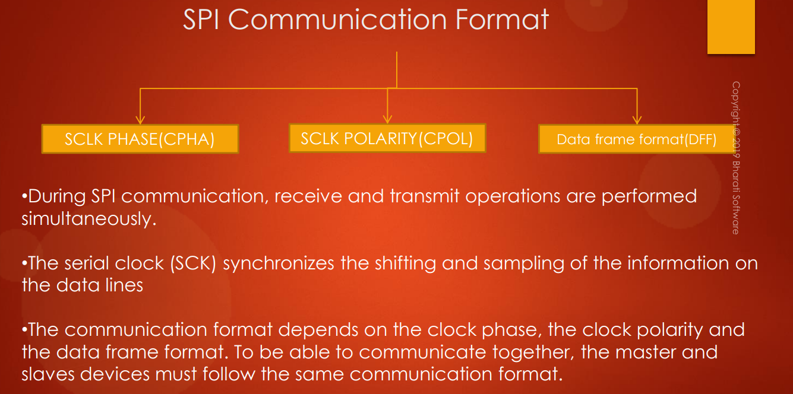

So, during SPI communication, receive and transmit operations are performed **simultaneously**. So, this you already know.

The serial clock (SCK or SCLK) synchronizes the shifting and sampling of the information on the data lines.

The communication format depends on the clock phase, clock polarity and the data frame format. To be able to communicate together, the master and slave devices must follow the same communication format. So, this is very very important.

So, when a master is communicating with slave, the communication formats of both the devices have to be same, otherwise the data communication will not be successful, like the master may read the invalid data from the slave or slave may receive some corrupted data etc…

So, the communication formats have to be same and the **communication format** is decided by the **CPHA value**, the **CPOL value**, and the **data frame format**.

**Data frame format** is very simple to understand: data format can be 16 bit data format or 8 bit data format. So, by **default** the master and slave communicates over the **8 bit data format**.

Now, let's explore what exactly is CPHA and what exactly is CPOL. First, let's explore about the **clock polarity** that is **CPOL**.

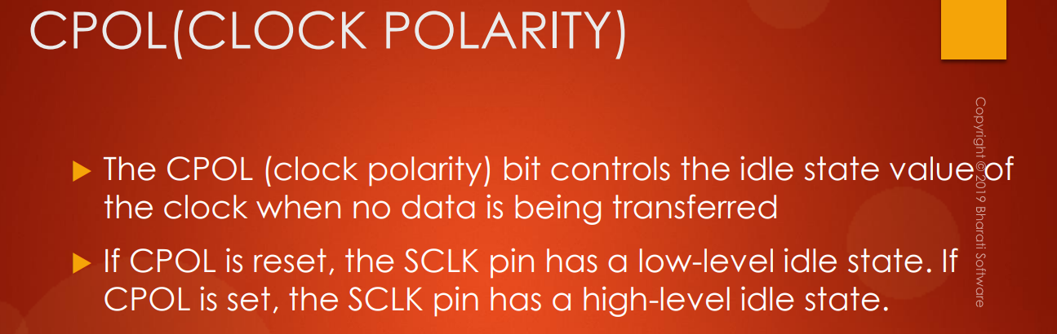

The **CPOL bit** controls the **idle state value** of the **clock** when **no data** is being transferred.

If **CPOL** is **reset**, the SCLK pin has a low-level idle state. If **CPOL** is **set**, the SCLK pin has high-level idle state. So, in the **SPI control register** there will be a bit called **CPOL** and you can make that bit as high or low and if you make the CPOL bit as 0, then this is the clock format, the serial clock format.

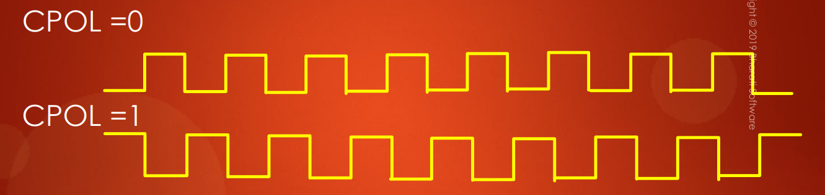

So, what happens here is, the clock actually starts from 0 and then it toggles. And you can see that the idle state this is an idle state. Right? The idle state will be 0. So, **idle state** means when there is no communication between master and slave the **clock line** or the **serial clock pin** will be at **0**. It will be at 0 or low level.

So, if you choose **CPOL** as **1**, then the clock starts from high level. So, there is a transition from high to low and when there is **no communication** between master and slave the **pin status** will be **1**. So, this is an idle state.

So, that's a difference between different clock polarities. So, you can select one among these clock polarities in your application according to your application requirements. And remember that by **default** the clock polarity will be 0 (**CPOL = 0**). So, configure this bit only if you need it according to your application design.

So, there is one more control bit in your control register of SPI peripheral that is called **CPHA**.

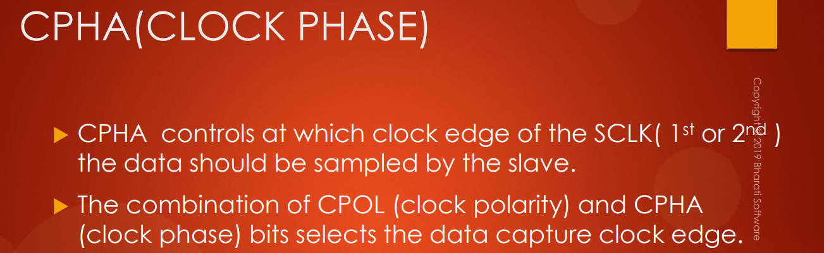

The **CPHA** decides the **clock phase**. So, CPHA controls at which clock edge of the SCLK (1st or 2nd) the data should be sampled by the slave.

So, the combination of **CPOL** and **CPHA** bits selects the **data capture clock edge**.

Let's understand more on this. Take a look into this timing diagram here.

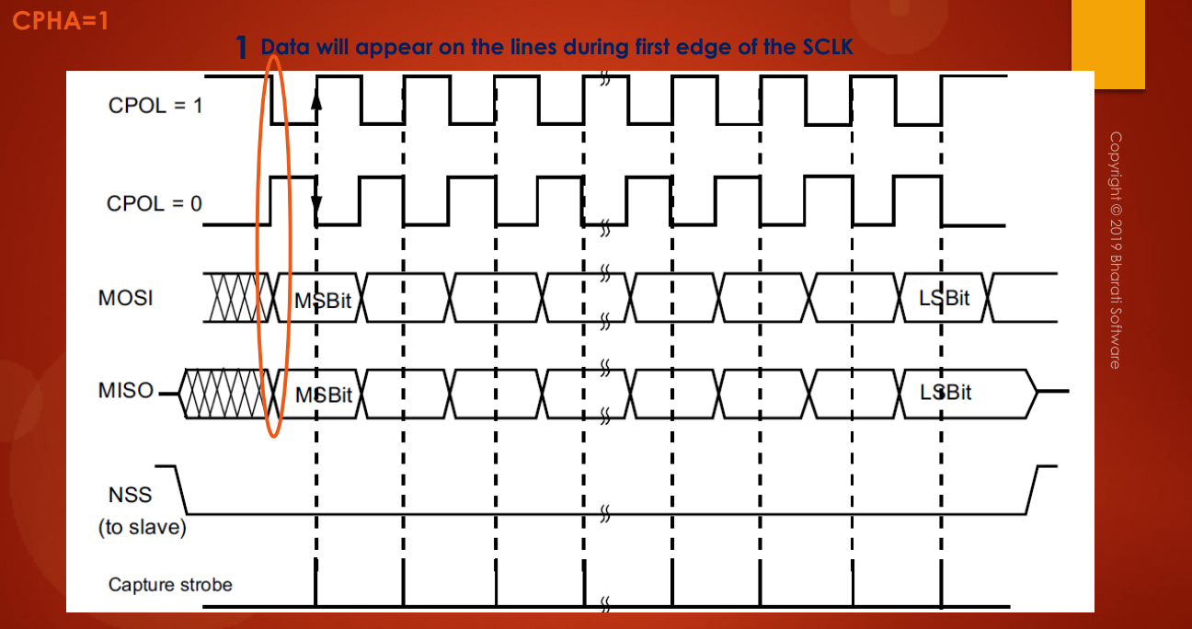

So, here this is actually SCLK clock, when CPOL = 1 and this is SCLK, when the CPOL = 0. Let's take the scenario of **master mode**. Let's consider the master. And let's say **CPHA = 1** and **CPOL = 1**.

For the master, MOSI pin is the TX pin. Right? It actually sends the data over MOSI line and it actually receives the data over the MISO line. So, when master wants to send data, it will always send the data during 1st clock edge of the serial clock. For example, in this case the data will be sent at this clock edge and after this, after this, after this, so like this. So, you can see here the data transition happens during the very 1st clock edge of the serial clock in a cycle. For example, if you consider this as one clock cycle, so one clock cycle has 2 edges. Right? So, in the 1st edge that data transition will happen. So, that's the meaning of this statement data will appear on the line during 1st edge of the serial clock.

And after that, the slave will sample this line during the 2nd edge of the clock, that is this clock. So, this is actually the capture stage from the slave. So, slave will capture that data after this much amount of time. So, what exactly is that time we will see later.

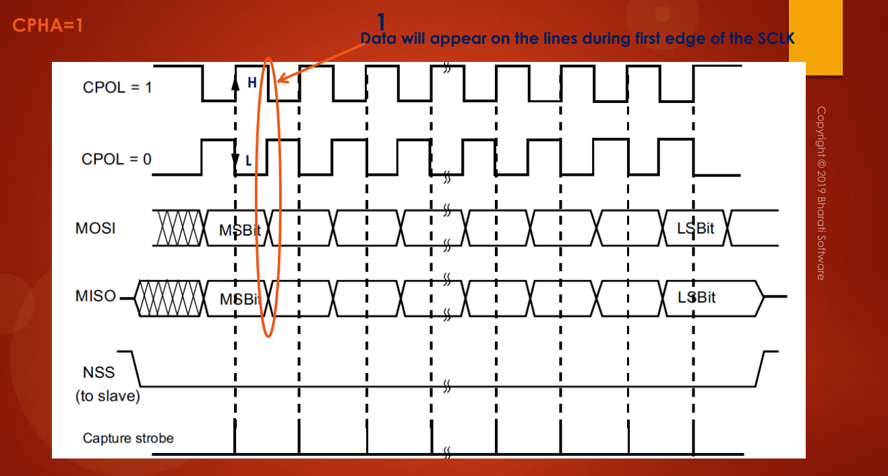

But, slave will definitely it will get some time. Right? And before that time the data has to be stabilized on the lines. Otherwise, slave may receive some random data or some invalid data. So, this is a data transition from the master and here is the place where the slave will sample the data. Slave will sample this data, right? TX line. Why? Because, this is slave in (MOSI). Right? And master also it will sample the data, so the master will actually sample the RX line (MISO – master in). Right? So, master sends the data here and master both they will sample the respective lines at this position. All right. So, here it is so slave captures the data.

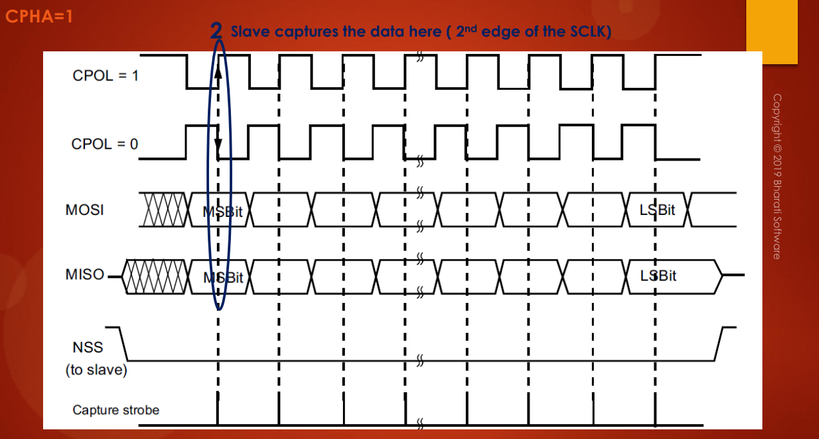Actually master and slave both actually capture the data during 2nd edge of the serial clock. So, like that.

And remember that if **CPHA=1** and if **CPOL=1**, then the capture will be **rising edge**. Right? The capture will happen during a rising edge of the clock. Right? If you want to make the data capture **falling edge**, then you have to change the polarity to **CPOL=0.**

So, if you take a look into this scenario so here what happens, the data will be captured. The data will be captured during the second edge, but the transition is **falling edge**.

So, now let's take a look into the scenario when **CPHA=0**. So, which is the **default** scenario.

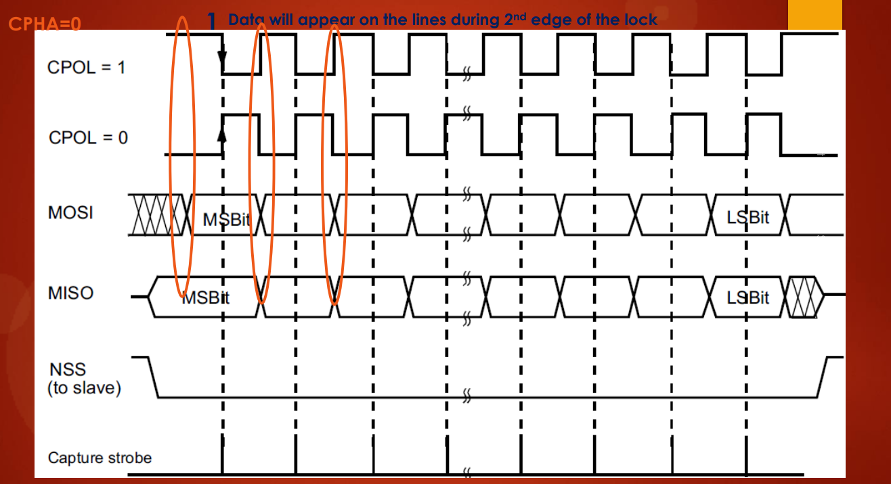

If you look into the **default** scenario that is **CPHA=0** and **CPOL=0**. Here what happens is, first the data will appear on the lines during 2nd edge of the clock. So, this is actually clock. So for example, if you consider this as a clock 1 cycle of the clock so the data will appear during the 2nd edge and the capture happens during 1st edge of the clock. So, that's a difference.

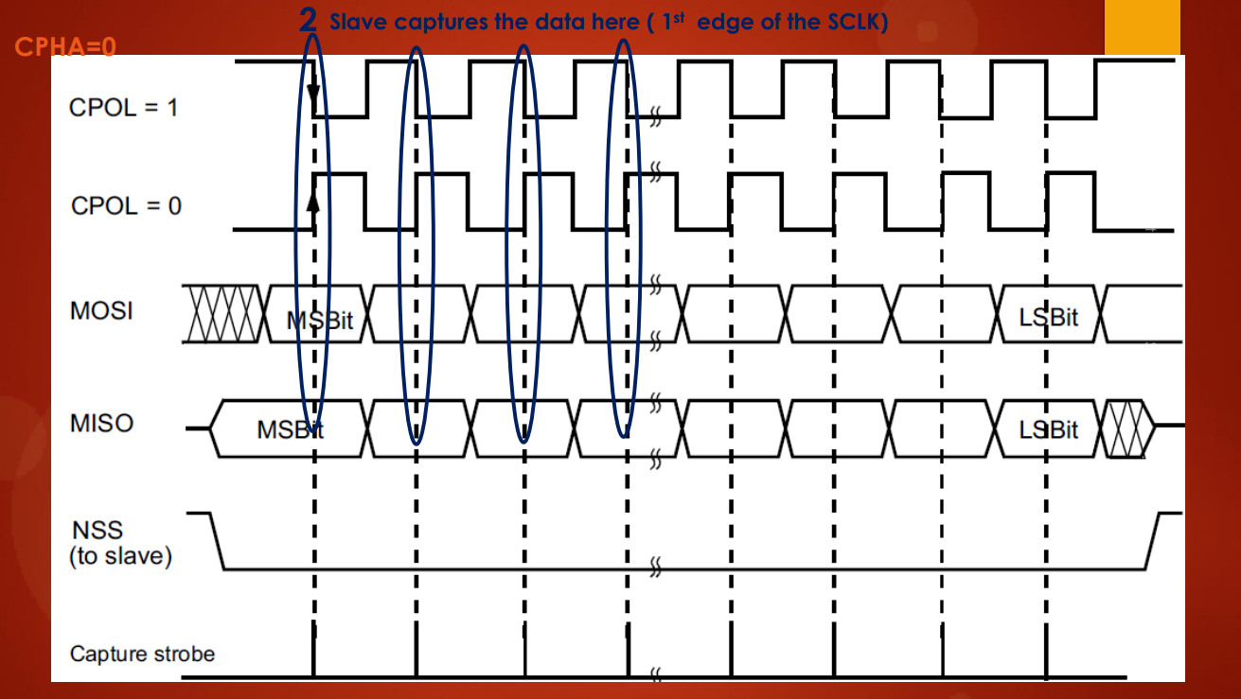

And the 1st edge of the clock will be **rising edge** (**CPOL=0**). Right? We can see that the 1st edge of the clock is rising edge. If you want to change this setting to **falling edge**, then you have to shift to these combinations: **CPHA=0** and **CPOL=1**.

So, in this combination the **capture edge** will be **falling edge**.

So, why do we want to change these settings? That actually depends on your application. So, why do we need different values of CPHA and CPOL? That should be driven from your application requirements and design. Let's say, there maybe some applications which demands the clock pin has to be high during idle state, then you should select CPOL=1. So, that purely depends on your application need. So, according to your application design or circuit design you may have to select suitable CPHA and suitable CPOL. But, for all normal operations you can keep defaults that is CPHA = 0 and CPOL = 0. The data communication will just work fine, no problem.

And let's move forward. So, based on these CPHA and CPOL combination we have 4 different modes of SPI. You might have heard about **SPI modes**.

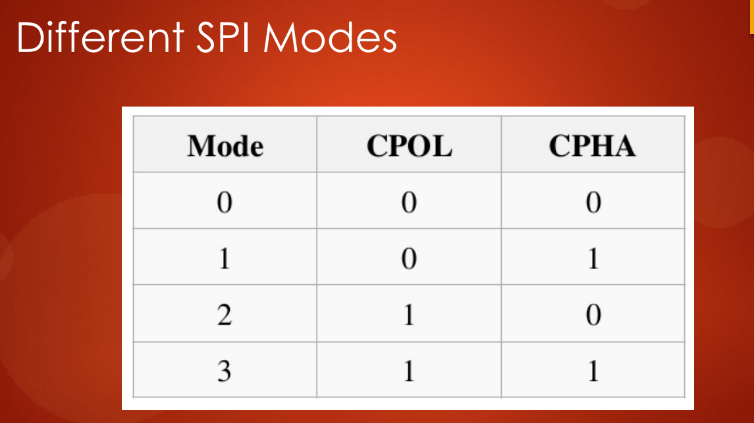

So, **SPI modes 0** means **CPOL=0** and **CPHA=0** so that's the **default mode**. So, you can vary these modes according to your application requirement. Let's move forward.

So, if you want to remember everything in just 2 sentence, then you can understand something like this:

* if **CPHA=1**, data will be sampled on the **trailing edge** of the clock, that is 2nd edge
* if **CPHA=0**, data will be sampled on the **leading edge** of the clock, that is 1st edge

So, what *data will be sampled* means? So, slave samples MOSI and master samples MISO. That's the meaning of **data sampling**.

So, these concepts are actually asked in the interviews. You can answer those questions by just remembering these 2 lines. And in the next lecture, let's take a look into some real waveforms of the SPI communication and I will see you in the next lecture.

# Sezione 35: SPI serial clock discussion

## 132. SPI peripherals of your MCU

Hey, welcome back to the lecture. So, in the previous couple of lectures we have been discussing about various concepts of the SPI peripheral. And those are actually pretty much generic, because you can apply those points to any microcontroller you have. So, the principle of working is same.

So, what I discussed is not something specific to ST. You can apply wherever you go. And also remember that, all these points are required all the knowledge is required in order to write the driver successfully.

Let's understand, how the **SPI peripherals** are connected in your microcontroller. So, you have to open up your microcontroller ***Datasheet*** or **memory map** in order to see the peripherals. And in **STM32F407xx** microcontroller we have got 3 SPI peripheral:

* SPI1 which is hanging on APB2 bus
* SPI2 which is hanging on APB1 bus
* SPI3 which is hanging on APB1 bus

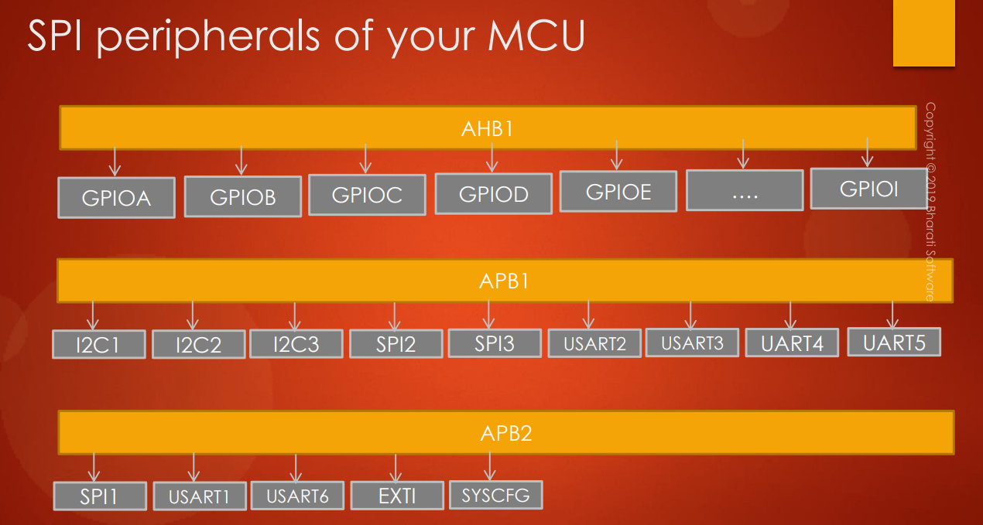

So, we have got 3 SPI peripherals here and check your microcontroller you may be having less or more. So, you can check this in your ***Reference Manual*** and I will see you in the next lecture. So, in the next lecture let's see how to control the serial clock of the SPI peripheral and I will see you in the next lecture.

## 133. SPI serial clock frequency

Let's explore about the **SPI serial clock**.

So, whenever you are working with **serial communication protocol**, this is the question you always should ask yourself that:

*What is the* ***maximum serial clock speed*** *of* ***SPI peripheral*** *which can be achieved on a given microcontroller?*

The answer to this is first you have to know the **speed** of the **APBx bus** on which the **SPI peripheral** is connected. So, whether it is APB1 or APB2 or APB3. So, you have to find out the speed of the bus on which the SPI peripheral is connected.

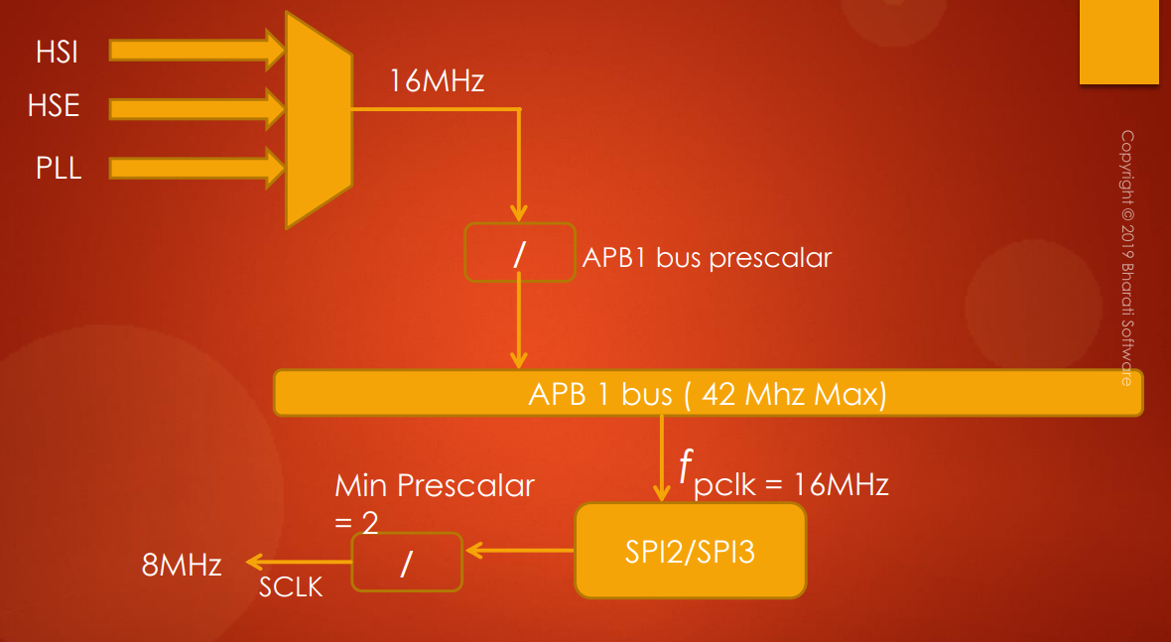

In all our projects what we have been doing is we are actually using the internal **16MHz HSI Oscillator**. So, that's why the APB1 bus for example is actually having SPI2, SPI3 peripheral. So, the speed of the **APB1 bus** in this case will be **16MHz**, because this **pre-scaler,** which is APB1 pre-scaler, is actually **1** by default. So, 16 / 1 is 16. So, APB1 bus will be running at 16 MHz of speed in our case. So, maximum it can go up to 42 MHz, so SPI2 and SPI3 are hanging on APB1 bus. So, the peripheral clock which is supplied to the SPI2 and SPI3 is 16 MHz.

So, now in the **SPI peripheral** you actually have another **pre-scaler** and by default its value is actually **2**. So 16 / 2 will be **8 Mhz**. So, that's why the **maximum serial clock** which this peripheral can produce is **8 MHz,** in this case.

So, that means it depends on how much is the peripheral clock and how much is the value of this internal pre-scaler, so, that actually decides the **serial clock speed**.

So, according to your application you can vary this pre-scaler. You can either increase or decrease in order to produce different serial clock speed. So, the default value is 2 and you cannot go below that. So, you have to remember that that means SPI2 and SPI3 peripherals can produce serial clock speed up to 21 MHz in this microcontroller, because the maximum value of the APB1 bus frequency will be 42 MHz.

So, if you use PLL and drive APB1 bus at 42 MHz, in that case you can configure the SPI2 and SPI3 to produce serial clock up to 21MHz. So, that is very very speed compared to let's say I2C peripheral or CAN peripheral.

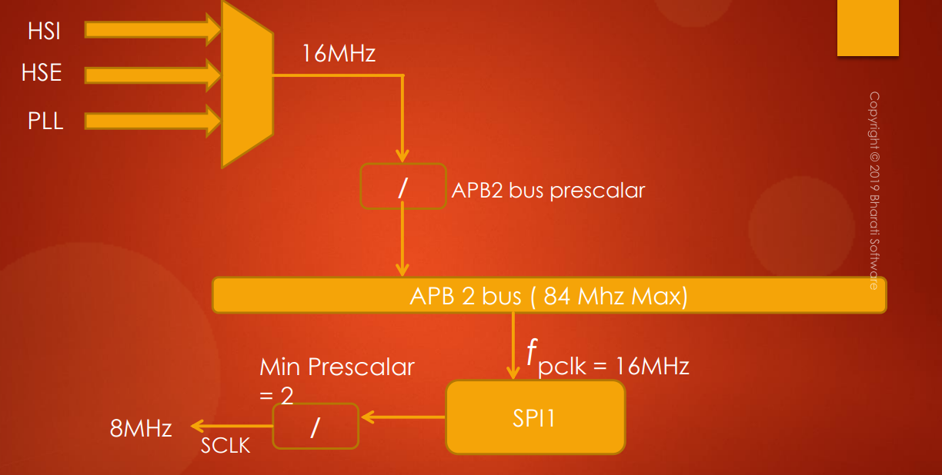

So, now if we go to the SPI1 peripheral which is hanging on **APB2 bus**, remember that the maximum operating frequency of the APB2 bus will be **84 MHz**. So, that means you can produce **serial clock** up to **42 MHz** in this case. So you have to remember this.

So, that means you can produce SPI serial clock up to 42 MHz in the case of SPI1 peripheral.

But in our application we are actually using **HIS:** so, **APB2** also will be running at **16MHz**, so hence the peripheral clock which is supplied to the SPI1 will be 16 MHz hence in our case **SPI1** also can produce the serial clock up to **8 MHz**.

So, that's about the **serial clock**. And while doing programming we'll see where exactly we have to configure this pre-scaler value. So, in the previous video I actually shown you some baud rate control registers. In the bit fields related to the baud rate control and there you have to configure these pre-scaler value in order to control the serial clock.

So, we'll see that when we do programming.

So, now the summary of this video is: if we use the **internal RC oscillator** of **16 MHz** as the **system clock** then **SPI1, SPI2, SPI3** **peripherals** can able to produce the **serial clock** of maximum **8 MHz**. So, you have to keep this in mind and in the next lecture onwards let's get started with our SPI driver development and I will see you in the next lecture.

Remember that in SPI communication, slave will not initiate data transfer unless master produces the clock.

# Sezione 36: SPI Driver: API requirements and configuration structure

## 134. SPI API requirements and configuration items

Hey welcome back to the course. And from this lecture onwards let's get started with **SPI driver development**. So, first let's see what are the driver API requirements and we'll discuss some user configurable items.

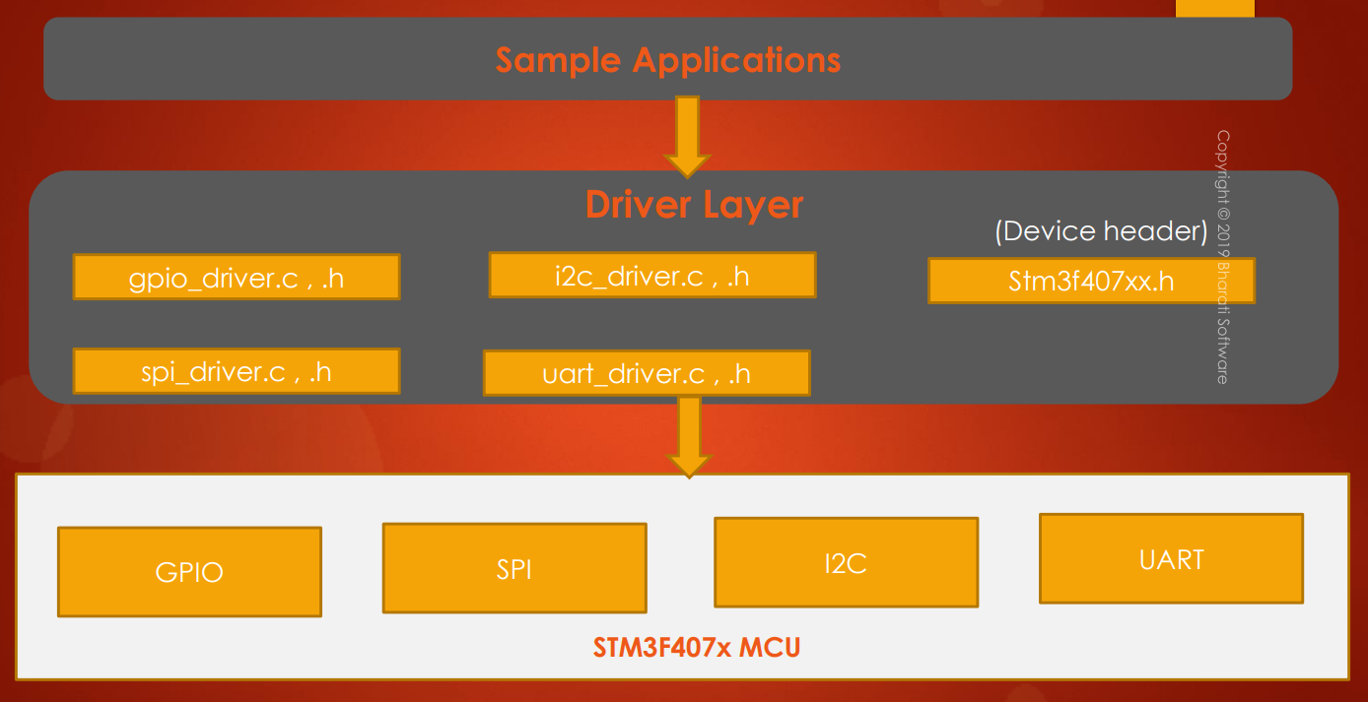

This is the overview. So, we currently developed **GPIO_driver.c** and **GPIO_driver.h**.

Now we are doing **SPI_driver.c** and **SPI_driver.h.**

We also have ***device header,*** right? The **MCU specific header file** and we have to update this file with SPI details. So, like its IRQ Number, its register definition structure, its peripheral definition and clock enable and clock disable macros, so all these things you have to update when you meet new peripheral.

So, after that we will write some sample applications to test our **SPI driver** exactly the way we did for GPIO. Now let's move forward. So, now let's look at some of the **API requirements**.

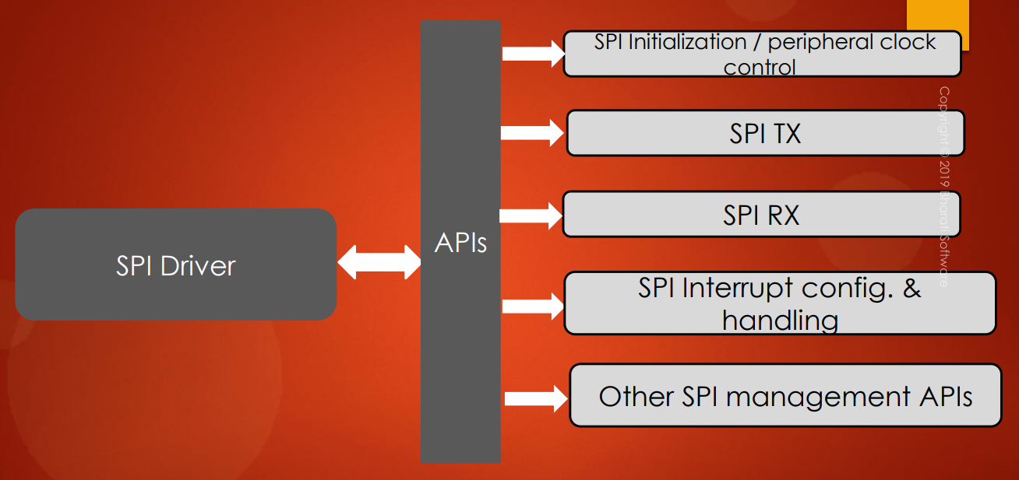

So, these are not final. So, we can modify later or we can add or remove new APIs. But **mandatorily** it should have at least these APIs:

* **SPI initialization API** which you have to give it to user, so that user can send the configurable items. So, you have to take the configurable items from the user and then you have to configure the appropriate SPI registers
* **Peripheral clock control** **API**
* **SPI TX** and **SPI RX** **APIs** in order to receive data from the external world and in order to transmit data to the external world. So, we will use SPI TX and SPI RX APIs.
* **SPI interrupt config**: this is similar to GPIO config. So, SPI also will have its own **IRQ number** and you have to take that and you have to initialize the **priority register** and **NVIC register** etc.
* **SPI interrupt handling**.
* Other management APIs like SPI peripheral will enable, disable and there are various other APIs which you can think of when we do programming so need not to discuss now.

Let's move forward.

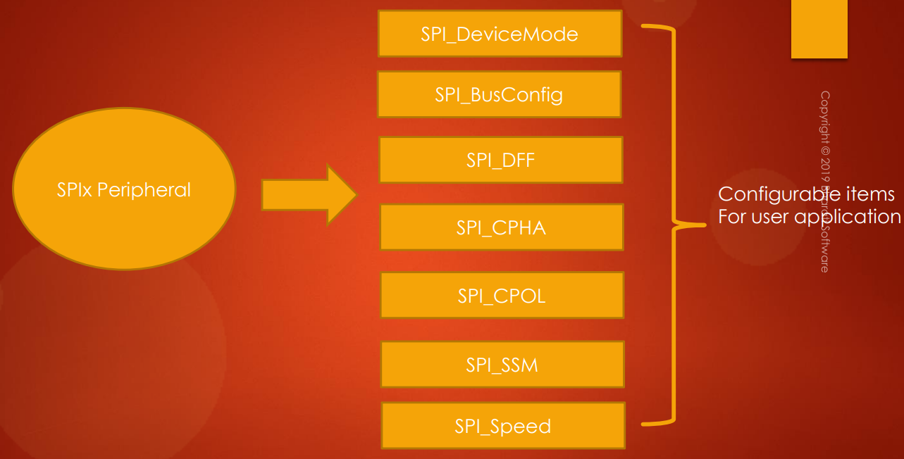

So, what are the **configurable items** for **user application**?

Now you have studied the SPI peripheral. So, you came to know that SPI will have different modes like SPI master and SPI slave.

So, we have to give one configurable item to decide the **mode** whether you are device wants to work like a master or you want to configure you are device as slave. So user has to decide that. So, that's why we have to give one configurable item and we'll call it as **SPI device mode**. So this will be our variable in order to hold the mode details.

After that you have to decide what kind of **communication** you want whether you want **full duplex,** **half duplex** or **simplex**? So we actually saw in the earlier videos that SPI can be configured in half duplex and simplex mode. So, this variable will decide that.

And after that **data frame format**: **DFF** means **data frame format** that at a time you want to send 8 bits or 16 bits data? So that you can decide from the **DFF**. So usually, it is **default** to **8 bits**. So, when you decide to 8 bits then shift register will be of 8 bits. So, when you want to send 16 bits at a time then shift register will extend and it will become 16 bits register. So that we can decide from DFF variable in order to hold that data.

Of course you have to initialize **CPHA** and **CPOL**. Remember that initializing CPHA and CPOL is actually **optional** because by **default** their values will be **0**. But user can decide different values for CPHA and CPOL.

After that **slave select management**. So, as I said in the previous lecture there are 2 types of slave management:

* software slave management
* hardware slave management

User can tell that to the driver using **SPI_SSM** variable.

And the last one is **SPI speed** and where user can mention the required **serial clock speed**.

So, these are the **configurable items** for **user application**.

We have to create one **SPI handle structure** and **configuration structure** exactly the way you did for **GPIO driver**. So, this will be our configuration structure which will be used by the user:

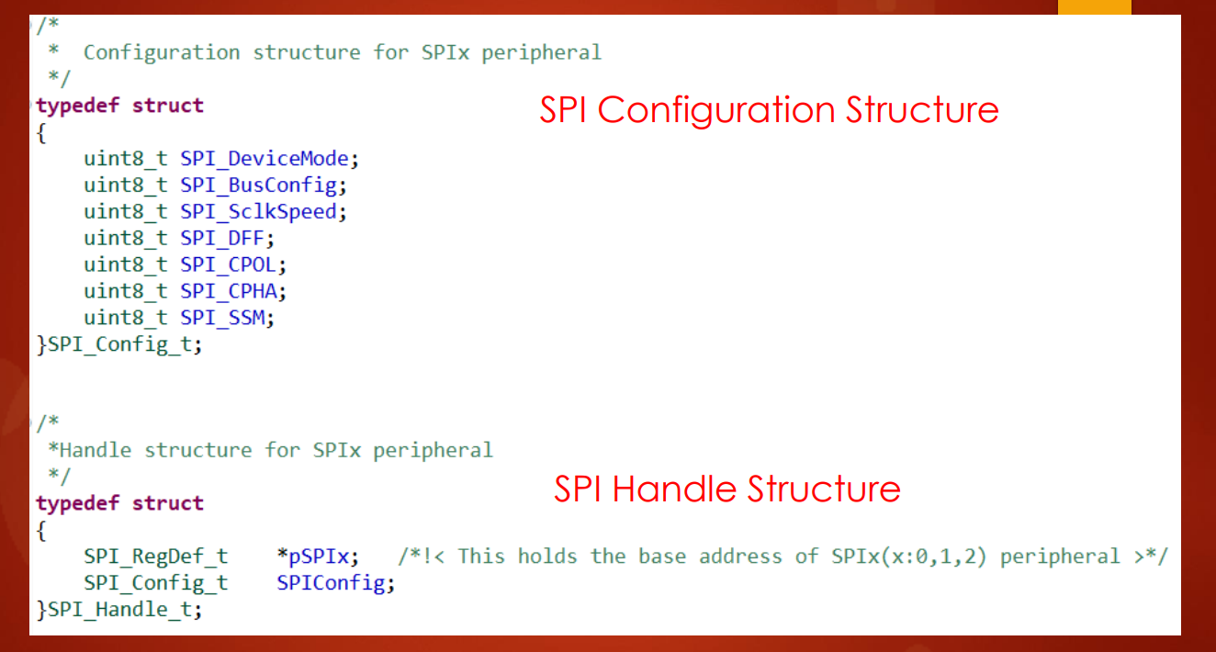

Here you can see that I have given all the discussed **configurable items** as different variables.

So, this will call as ***SPI_Config_t***.

And there will be one **handle structure:** handle structures first member element will be **base address** of the **SPIx peripheral** and which is of type ***SPI_RegDef_t***. And this is the configuration structure variable. So, now I would like to end this lecture here and before ending this lecture I would like to give you some exercises.

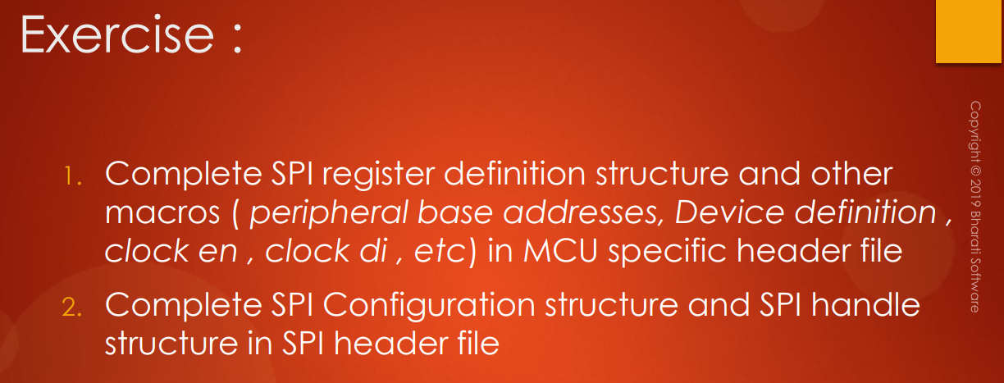

The first task for you is complete **SPI register definition structure** and other macros. So, what are the other macros like **peripheral base addresses** for different **SPI peripherals**, device definition and clock enable and clock disable macros etc.

So all these things you have to complete in **MCU specific header file**. And after that complete SPI configuration structure and SPI handle structure in **SPI header file**. So, in the SPI header file you actually have to create these structures.

So, before that let's create the **SPI driver source** and **header files**. And we already have a couple of files here right.

## 135. Updating MCU specific header file with SPI related details

Hey welcome back to the lecture. So, let's explore the changes you have to make to the **MCU specific header file**. So, let me quickly show you the changes I made.

First of all you have to add the **SPI peripheral base addresses**.





I actually mentioned about 3 SPI peripherals but it actually has 4 peripherals.

So, first you have to mention all the base addresses and after that you have to create one ***SPI_RegDef_t*** structure. So, by going into the details of the SPI registers. So, you can get all the SPI registers from SPI section. So, you to go to the SPI section and you have to explore the registers and you can go to the register map and you can get all the details right here.

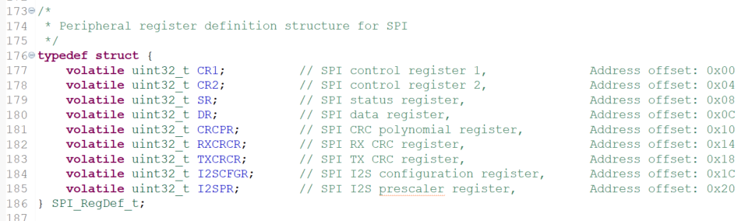

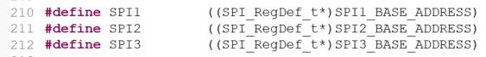

You can also include SPI4 and after that clock enable and disable macros. So, these are the clock enable macros for my microcontroller.

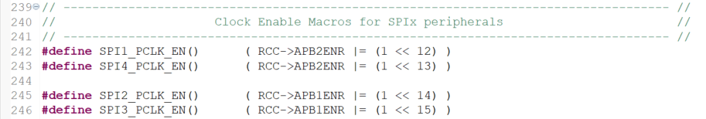

So that's it. So, these are the changes you have to make in this file and after that what you are to do is you have to create the IRQ definitions. So, that will do later to when we take up **SPI interrupts**.

So, for the time being only that much. And now let's go to the ***SPI_driver.h*** and here I hope you have created this structure definition that is configuration structure and this will be our handler structure.

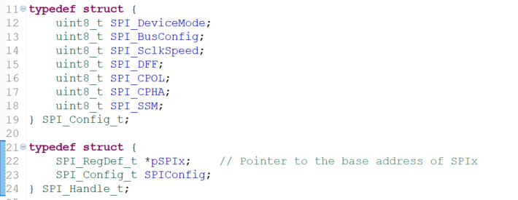

## 135. SPI adding API prototypes to driver header file

So, now let's continue our driver development for SPI. And now let's move forward after configuration structure and handle structure, The next thing what we're going to do is we are going to write prototypes for all our supported APIs. All right. So, now here I have documented a couple of sections. First one is peripheral clock set up. So we can just copy from what we did in the ***GPIO_driver.h***.

Now let me just copy these two sections: **Peripheral clock control** and **init** and **de-init**.

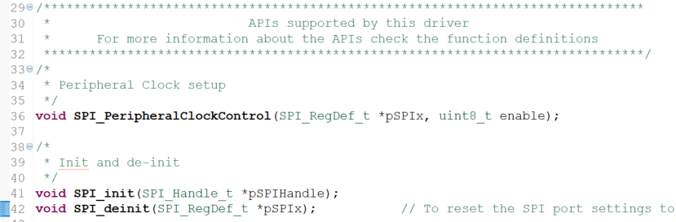

Now let's go to **Data send** and **receive**. Remember that in communication related to peripherals such as SPI, I2C, CAN or USB whatever, you may have 3 different types of data are transmitting or receiving methodologies:

* one is polling based that we also call as blocking call.
* second one is interrupt base that we also call as non-blocking type
* you can also implement an API which is DMA based.

So, in this course we are not discussing DMA, But we'll discuss and implement blocking and non-blocking types of APIs. So, as I said blocking is non-interrupt based and non-blocking will be interrupt based.

So, will first implement **blocking based APIs**, that is non-interrupt based. And I would tell you why that API is called as blocking type. So, when we implement the API we will explore about that. So, to **send** the data to the external world I would use the API ***void SPI_SendData()*** very simple or you can also write data send or whatever. So, but I would like to give. Only send. And let us decide the parameters later, and to **receive** the data from the external world. I would use the API ***SPI_ReceiveData()***.

Let's define the parameters. The very first parameter for these two calls will be the ***SPI_RegDef_t*** structure will be pointer to the **base address** of the **SPI peripheral** which is of type ***SPI_RegDef_t***.

So, let's copy this and this will be our very first parameter. And after that in the case of ***SPI_SendData*** the user will give the pointer to the data: so, now let's create another parameter in order to store the user provided pointer. So, for that let's create a pointer type of ***uint8_t*** and I would call this variable as ***pTxBuffer***: that means pointer to the TX buffer.

And also the third argument will be the **size** of **data transfer**. That means how many bytes this API should send. So, that will be **length** information actually. So, remember that always **length** must be in **uint32_t**.

So, this is the standard practice actually to define **length** as **uint32_t**, or more than that.

So, this will be our ***SPI_SendData()*** and for the received data you have to again give these 3 parameters. but this will be Rx buffer.

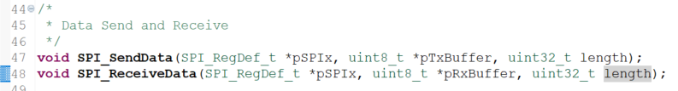

Now let's move on to the **IRQ configuration** and **ISR handling**.

Let's go to ***GPIO_driver.h*** and we can actually copy these 3 APIs. So, here for ***SPI_IRQHandling()*** this is not actually pin number but rather we can give pointer to the SPI handle structure.

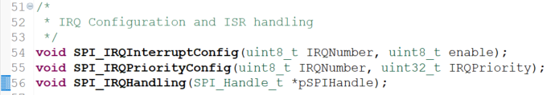

After that there are some more peripheral control APIs which we may have to create. So all those things we'll see later. So, but for the time being let's implement these APIs. So, I'll do that in the next lecture. So, meanwhile you complete up to here and also you can copy all these APIs prototypes into the driver .c and you can give the function definition. So, I will see in the next lecture.

## 137. Implementation of SPI peripheral clock control API

***SPI_driver.h()*** should contain ***#include*** of MCU Specific header file:

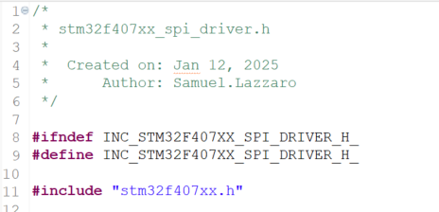

Let’s start to implement the APIs:

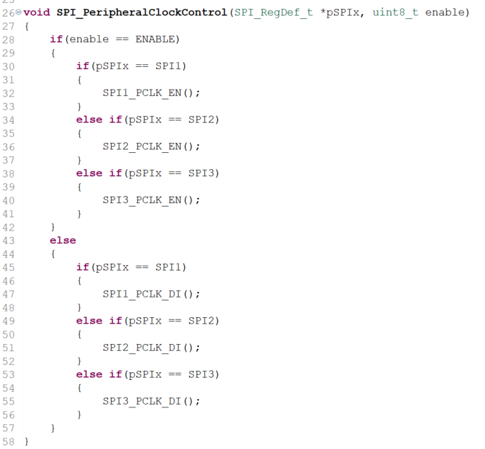

# Sezione 38: SPI Driver API implementation : SPI init / deinit

## 138. SPI user configuration options writing and register bit definition macros

***SPI_deinit()*** is very similar to ***GPIO_deinit()***, but before we have to implement the macros to reset register for SPIx:

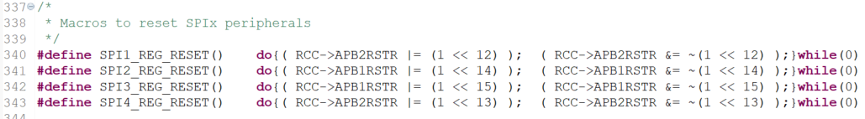

Then we can implement ***SPI_deinit()***:

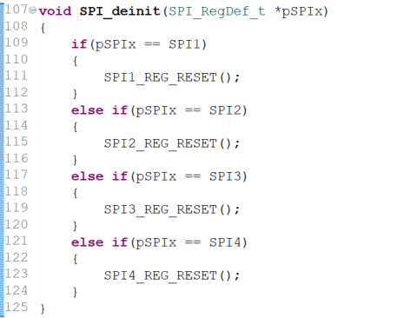

So, in this lecture we have to code the ***SPI_Init()*** API. And as you know in ***SPI_Init()*** actually we have to configure various bit fields of the **SPI registers**. But we have not yet explored the **SPI registers**. So, that we will do in a moment, don't worry, and because you should understand the register sets before configuring them otherwise you will not be having any idea how to and what fields you have to configure.

So, let's go to the **register set** of the **SPI peripheral**. Here I am in the ***Reference Manual,*** and this is SPI peripheral and go to the section SPI registers. And you will find various registers here and let's not discuss one by one. So, according to our need we will go to the respective register and we will explore the bit fields.

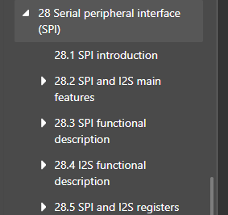

Remember that in **serial communication** related peripherals such as SPI, I2C, CAN, USB, SDIO etc. you will have a couple of control registers.

For example in this peripheral there are **2 control registers**: **CR1** and **CR2**. So, this may not be true for another peripheral which may have 1 control register. So, 1 or more control registers you will find where you have to store the configurable parameters.

So, the control register actually control the peripheral. And after that depending upon the data communication you will have 1 or 2 **data registers** in order to place the user data. And also 1 or more **status registers**. Remember that.

Now the **status register** is actually the house for various **status flags**.

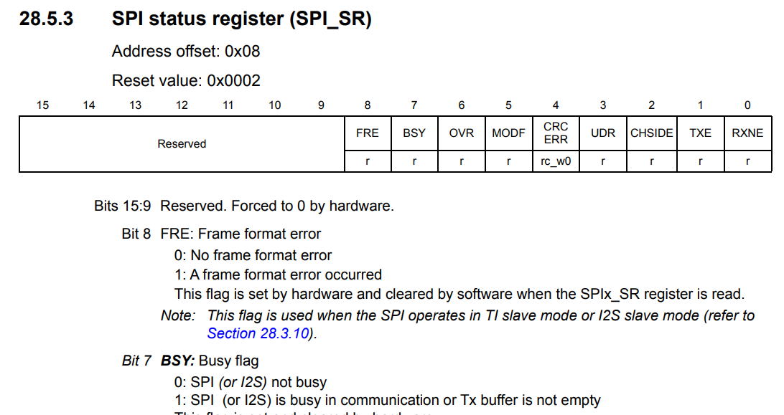

So, what are **status flags**? So as the name indicates they actually flag an event.

For example error event the RX buffer, a full event, the transmit buffer, empty event, bus idle event, CRC ERROR event, those various events will be recorded by the status register during the operation of the peripheral.

Now Status registers are there for almost all peripherals, like even if you go to the ADC, DAC and Ethernet.. so wherever you go. Almost all the peripherals actually they have 1 or 2 status registers.

So, if we just explore the **SPI block diagram**, here you can see that in the **SPI_CR1** these bit fields is **BR0**, **BR1** and **BR2**, they actually control the baud rate generator and that engine actually controls the serial clock speed.

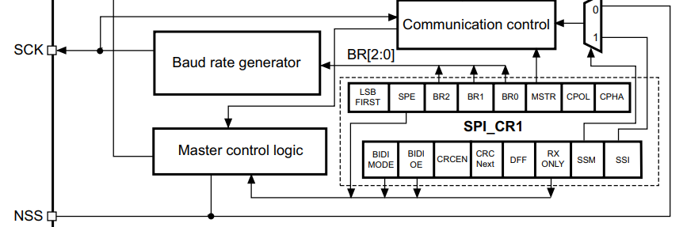

And various **communication control bits** are actually available in the **SPI_CR2** Control register and also the **communication control block** actually updates the **status register** to record an event.

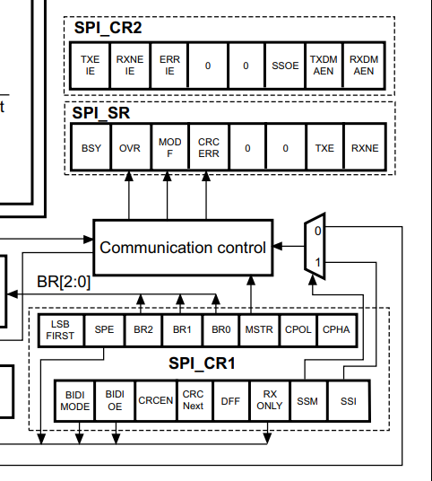

So as we make a progress so we will explore the various important bit fields. And now let's go to our program and we have to code ***SPI_init()***, and we actually get the user configurable items from a ***SPI_Config_t*** structure.

The first one is **device mode**.

Now what are the possible **device modes?** **Master** or **slave**. So, let's create some macros for the **device mode**.

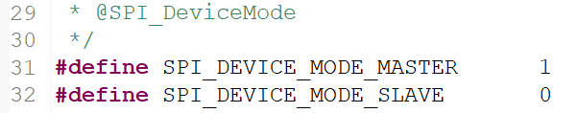

So, now what are the options which are available for **SPI_BusConfig**: actually the bus config is to decide whether the bus should be **full duplex,** **half duplex** or **simplex TX only** and **simplex RX only**. So, there are 4 possible options for bus config:

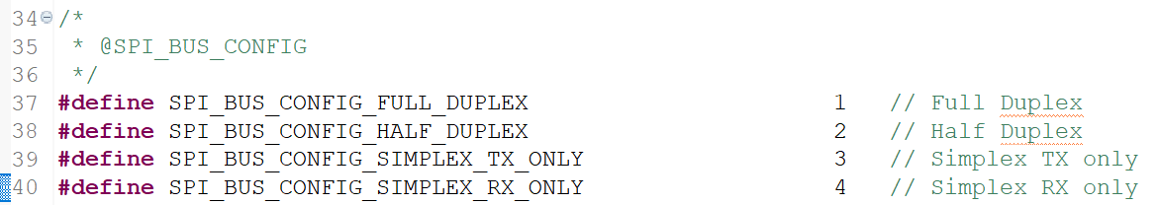

So, mostly we'll be working on **full duplex** and I have not plan to introduce **half duplex** but to see in the future.

The third one **is clock speed**. The references for clock speed will be so this we have to consult the reference manual in order to decide this. Now in order to create some configurable options for clock speed. So, we have to understand what are the different clock speeds are actually possible for the SPI peripheral. isn't it ? For that it's better to consult the reference manual.So in the reference manual, You can go to the control register one and in the control register 1, So, here are the fields in order to configure the serial clock speed.BR, BR means Baud rate 3,4,5.

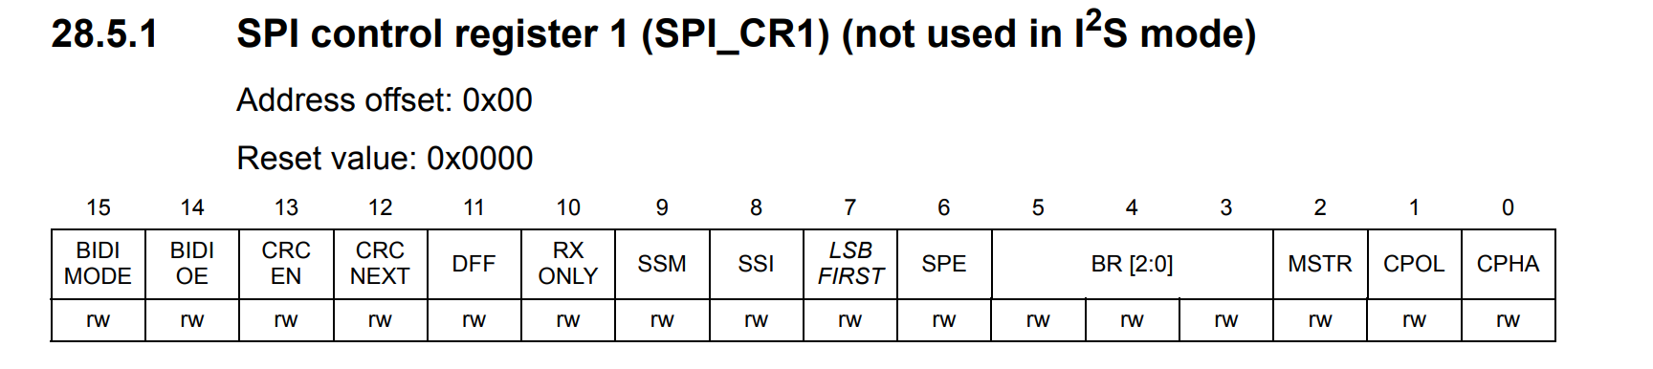

Let go and check. 3 4 5 which is right here.

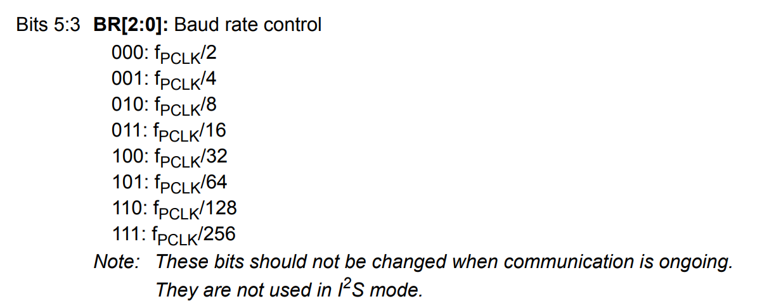

Here you can see that the **default baud rate** is **0**. So, that means the baud rate will be peripheral clock frequency (**fPCLK**) divided by 2. So, I hope you have seen this diagram.

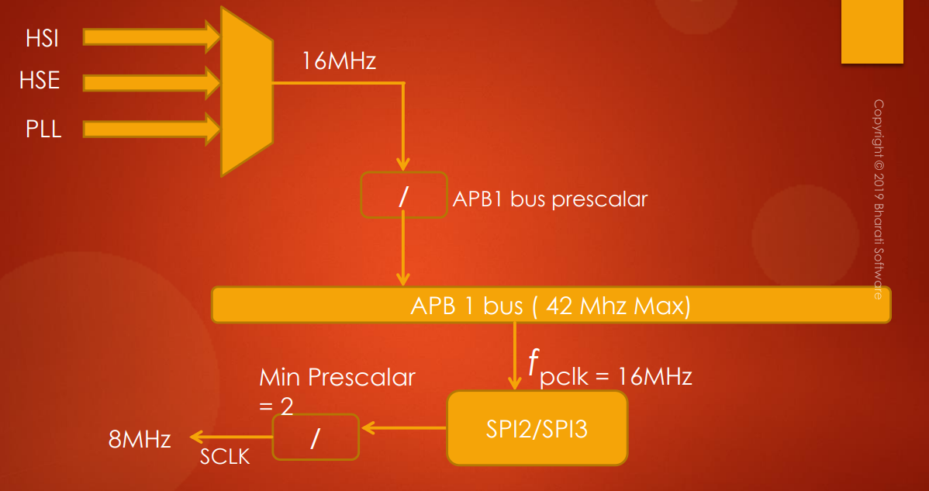

**BR ->**

And in this diagram here you can see that the **serial clock** is actually produced by dividing the **peripheral clock frequency** by this pre-scaler. This **pre-scaler** is the **BR** which is there in the **control register 1** and you have to configure this.

So, as I said the default value is 0. So, that's why if the **peripheral clock** is **16 MHz** then the **serial clock** will be **8 MHz**.

So now what we can do is now let's go back to the code and let's create some macros for the baud rate generation.

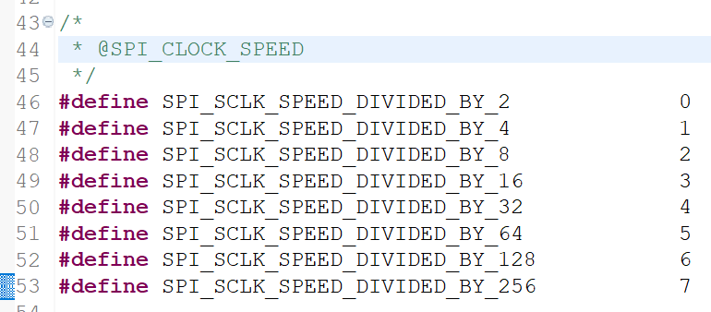

So those are the options for serial clock speed and after that.

Now let's go to **DFF**. **DFF** is very simple. There are only two options for DFF that is either 8 bit or 16 bits. so let's call it as one. And after that SPI_DFF_16BITS by default actually the DFF will be 8 bits. So, better to make this as 0 and let's make this as one. All right. And after that CPOL and CPHA. So, let's do that. First Let's do for CPOL so #defines SPI_ CPOL Right ? CPOL_HIGH so let's make it as one and LOW right ? So, similarly for CPHA. So, just make it as CPHA. HIGH and CPHA_LOW. That's it. And after that SSM. let's code for SSM. So For SSM There will be two options: 0 for software slave management disabled or1 for software slave management enabled. And the SSM is actually disabled by default.

So, user has to use one among these options in order to configure SPI peripheral.

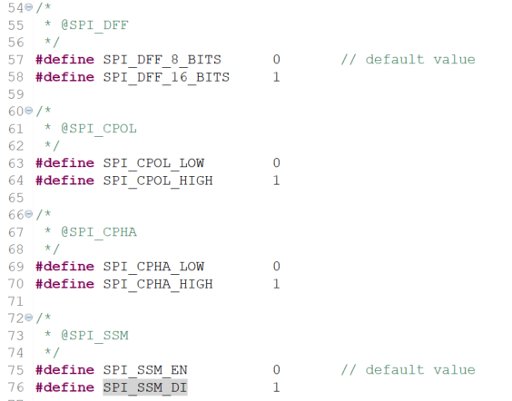

Let's go to the ***Reference Manual*** to see where the bit fields are. First one is for **SPI device mode** (**MSTR**). So that you can find obviously in the control register, because that is configurable parameter. So, here it is.

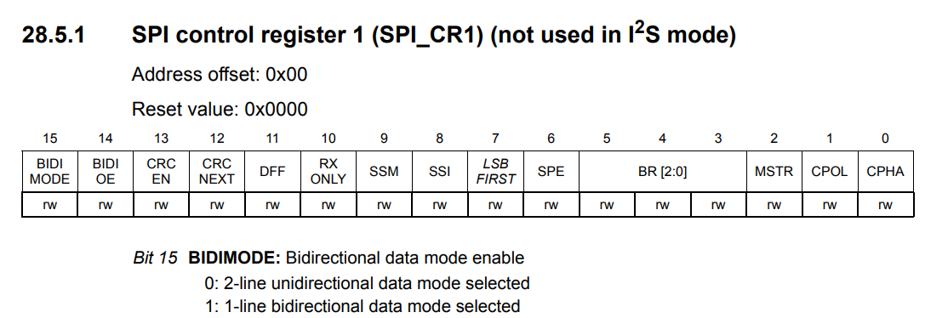

The 2nd bit field in the CR1 register **MSTR**. Let's see what exactly its value is. So, let's go to the second bit field.

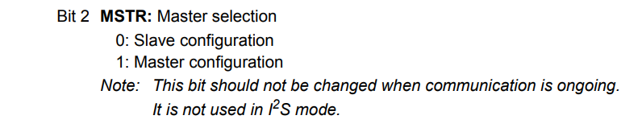

So, this bit will be 0 by default. Remember.. that means peripheral will be configured in slave mode automatically, when you reset the peripheral. So, you have to make this bit as 1 in order to make your peripheral as **master**. So, only when you make the peripheral as master it will produce the **serial clock**, otherwise it won't produce the serial clock. So first debugging tip here is if you see the peripheral is not producing clock then it should be in **slave mode**. So, come and check this bit field. If this field is 0 and if your peripheral is master then this bit should not be 0. So, that's why that will be a good debugging tip for you. So, you have to check this bit fields.

And after that BusConfig. So where to decide whether the bus is full duplex or half duplex or whatever. So, that also you can find either in control register 1 or 2 and let's see. I think it's actually available here.

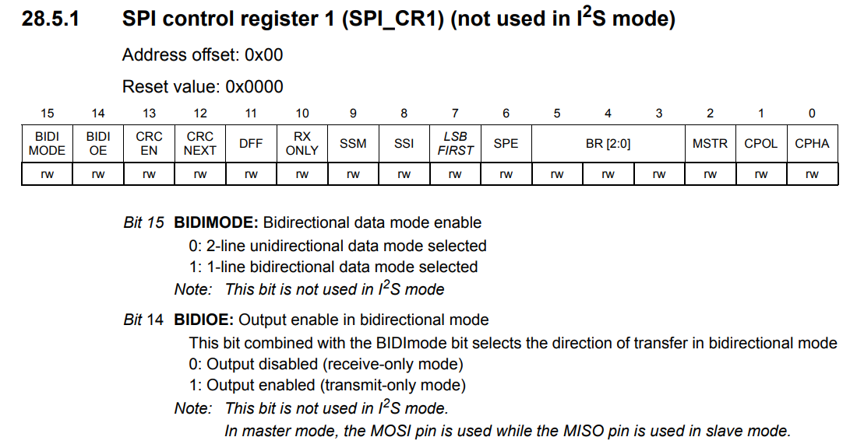

Go and check the 14th bit field and it says that BIDIOE (output enable in bidirectional mode), and 15th bit field which is BIDI MODE, that is bidirectional data mode enable which is nothing but half duplex.

So, let's go and check the 15th bit field which is BIDIMODE. So, if this is 0 which is true by default 2-line unidirectional data mode selected, so 2-line unidirectional. So, what does that mean. That means **full duplex** and if you are planning to use **half duplex** then this bit has to be 1. So, that means 1-line bi directional. So, you should make sure that if you are using **half duplex** then this bit must be **1**.

And after that there is one more field that is BIDIOE. So, remember when you are using 2 devices in half duplex, the modes must be reciprocal to each other. That means if one device TX then another device must be RX. So that's why this bit actually controls the output enable in bidirectional mode.

So, **BIDIOE** bit is 0 then output is disabled, so that means that device will be acting like receiver and if this bit is set to 1 then the device will be acting as transmitter. So, that's about the bus configuration. If you are planning to use full duplex then **BIDIMODE** will be 0 and **BIDIOE** is actually don't care, because it is actually combined with BIDIMODE. So, if **BIDIMODE** is 0 then **BIDIOE** is not important.

So, after that if you want **simplex communication** then you may have to check 10th bit.

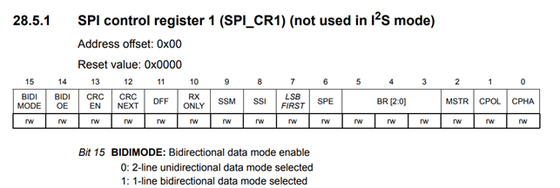

So, now let's go to the 10th bit and it says **RXONLY** (receive only).

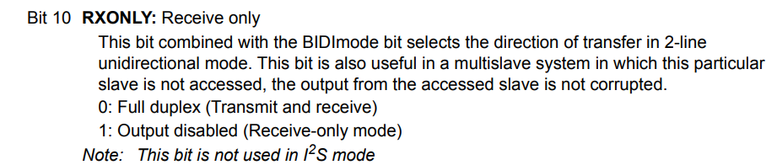

This bit combined with BIDIMODE bit selects the direction of transfer in 2-lineunidirectional mode.

This bit is valid only if **BIDIMODE** is set to 0. Remember. Because when BIDIMODE is 0 lines are 2-line unidirectional. So, now if you want to use simplex communication with **RX only** mode then you have to make this bit as 1. So, you have to remember that.

Now if you take a look into this diagram.

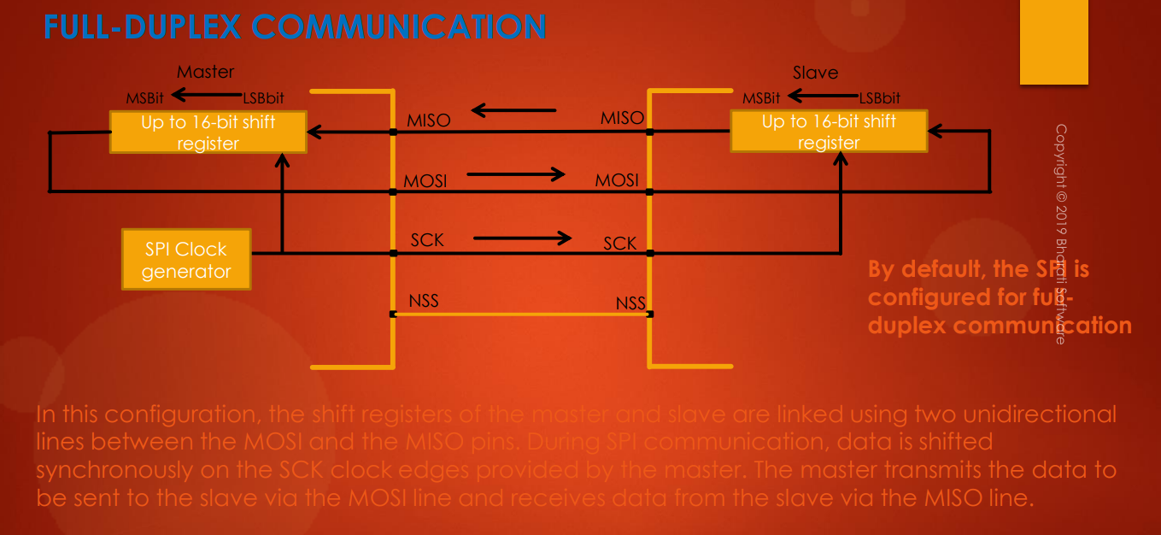



So, this is **full duplex communication**: there are 2-unidirectional lines.

*How to make this simplex communication transmission-only?*

So, to make that what have to do is very simple. So, you just have to **disconnect MISO line**. So, that means don't configure MISO pin at all. So, what happens. So, this will become simplex transmission only. So from the master end, this will become **simplex transmission only**.

Let's say you want to convert this circuit into simplex receive only from the master end.





So, what would you do: you may be thinking that you just had to remove MOSI line. So, just don't configure MOSI line at all. But if you do that this will not become receive only, because remember that *in SPI communication slave will not initiate data transfer unless master produces the clock* and Master produces the clock when you put some data into the data register of the SPI peripheral.

So, in this configuration only MISO line and SCK line are active: serial clock and MISO.

This MISO is receiving from the slave, so this is receive only configuration.

Remember that since this MOSI is deactivated, master will not produce clock on the serial clock line. That's because in SPI communication clock is produced only when data is produced on the MOSI line. Since you have disconnected or you have not configured the MOSI, the serial clock will not be produced on SCK. So, that means they will not respond, hence the reception fails.

So, now we have to force the master to produce serial clock even if the MOSI line is not configured.

To do that you have to force **RXONLY** bit to 1. So, when you force this bit to 1, the configuration will be output disabled, and it will go into receive only mode. So, that means the SPI peripheral will be forced to produce clock on the serial clock pin.

So, those are the different bus configuration options available for us. So, if you go back to our *driver.h*, actually we don’t need to use this *SPI_BUS_CONFIG_SIMPLEX_TX_ONLY*, so simplex TX is nothing but **full duplex** only. So, you just have to remove *SPI_BUS_CONFIG_SIMPLEX_TX_ONLY*. So, let me remove this *#define*.

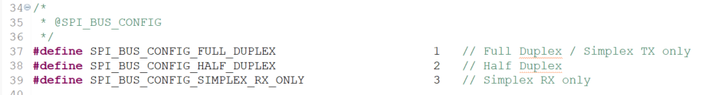

So, full duplex, half duplex, simplex receive only.

And now let's go to the **DFF**: this is in controller register 1, 11th bit.



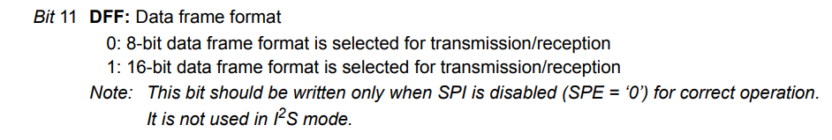

The data frame format (**DFF**), by default, it’s 0. That means 8-bit data frame format is selected for transmission as well as reception. If you make this bit as 1 then 16-bit data frame, that means a data frame consists of 16 bits. So, that means the shift register will stretch and it will become 16 bit shift register and 16 bits of data will be transferred in one frame.

Let’s see **CPOL** and **CPHA**. So, these are actually configured in **SPI_CR1**.

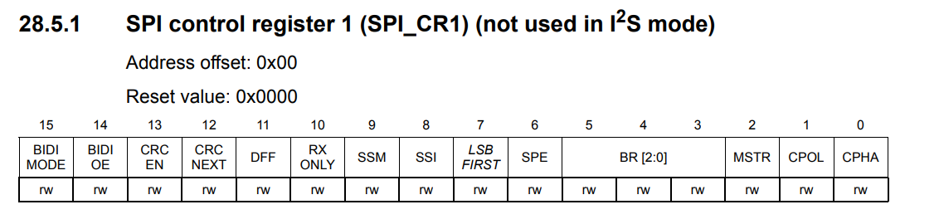

And here are the bits 0 and 1.

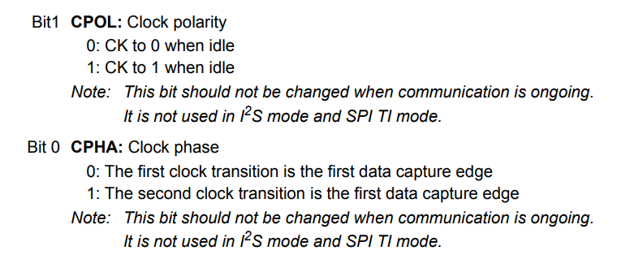

So, basically CPOL is by default 0: that means clock is 0 when idle.

CPHA is also 0 by default, so that means the first clock transition is the first data capture edge or data sampling edge. So, you have to remember that.

After that let’s see **SSM**: you can configure it from again SPI_CR1.

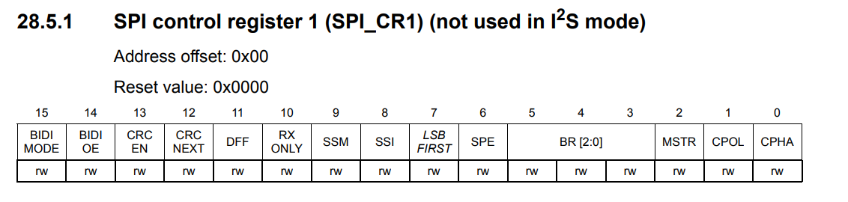

So, let's see where exactly the position: 9th one. So, let's go to the 9th one and here you can see that by default the **software slave management** is actually **disabled**.

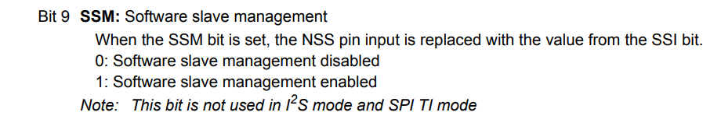

So, please note this point that the **software management** is **disabled** by **default**. So, that means SSM is equal to 0 by default.

So, that's it guys. So, these are our configuration options for the user to use and the user will use one among these macros in order to initialize this handle variable and in the next lecture let's code ***SPI_init()*** and I'll see in the next lecture.

## 139. Implementation of SPI init API : Part 1

And in this lecture let's code SPI_Init. All right. First let's configure the SPI_CR1 register. First let me take variable. Let's say uint32_t temp. All rights..or temp register. And let me initialize this to 0 and let's store all the configuration bit fields here and then we can copy this variable into the CR1 register. Right ? First thing, So let's configure the device mode. All right. So, what I can do is tempreg |= pSPIHandle->SPI_Devicemode Right ? So, device Mode left shifted by 2 right ? So, let's write 2 here. So, if SPI mode is master then what would happen. One will be shifted to second bit position. right ? So, if it is 0 then zero will be shifted to the second position. Right ? So, anyway we are actually initializing tempreg is equal to zero. Right ? All right. So, that would be good. And after that let's configure the bus config. All right. So, if the Bus_Config == SPI_Bus_CONFIG_FD (full duplex) then remember that BIDIMODE should be cleared. So else if If this is actually is equal to is equal to Half duplex then So, you have to enable the BIDIMODE. BIDIMODE should be set. Right ? So, else if if this is is equal to SPI_BUS_CONFIG_SIMPLEX_RXONLY only then remember that BIDIMODE should be cleared so then only we can achieve two lines unidirectional lines and RX only, bit must be set. So, this you have to do. All right let's do all these steps. All right. So, the BIDIMODE is actually 15th bit. So, that must be cleared. So, what we can do is tempreg &= ~ (1 << 15) and here it must be set Right ? For the half duplex. So let me make this as OR. All right. And after that here it must be cleared for the Simplex RX only. So, it must be cleared and RX only must be set.. right ? So, let's do that. RX only. All right. So, this is actually the tenth position. Alright..So, later we can replace this, these numbers by macros. I will show you that how ? So, but currently let's use hardcoded values like these numbers. So, that's not actually good practice because if someone is let's say checking your code and he won't understand what exactly is 15. Right ? So, you should replace this with the macro actually. So, we'll do that later. All right. So, that's about configuring the device mode and configuring the bus config. So, just give a thought about these settings and also try to do for the rest like these bit fields and like for these configurable items and I will see in the next lecture.

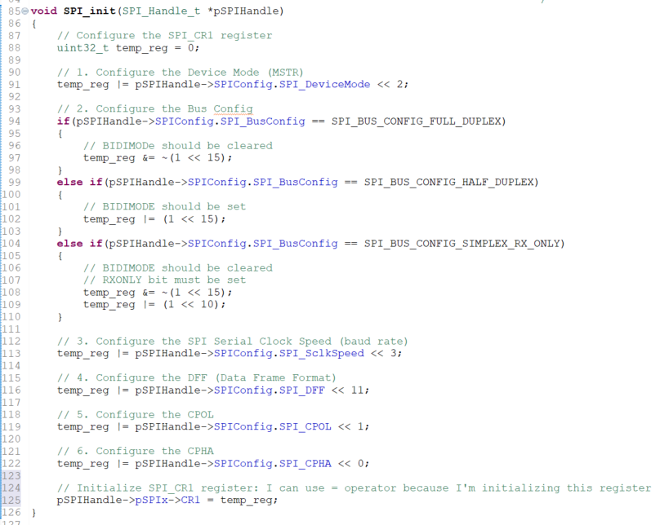

## 140. Implementation of SPI init API : Part 2

We can create in the **MCU specific header file** some macros for bit position of **SPI_CR1 register**, in order to use these macros instead of number in ***SPI_init()***:

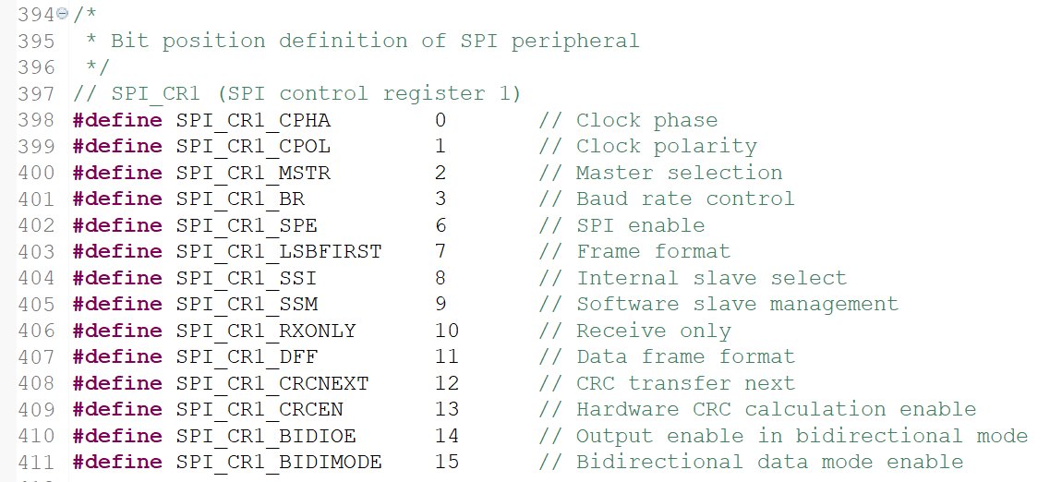

Now we can use them in ***SPI_init()***:

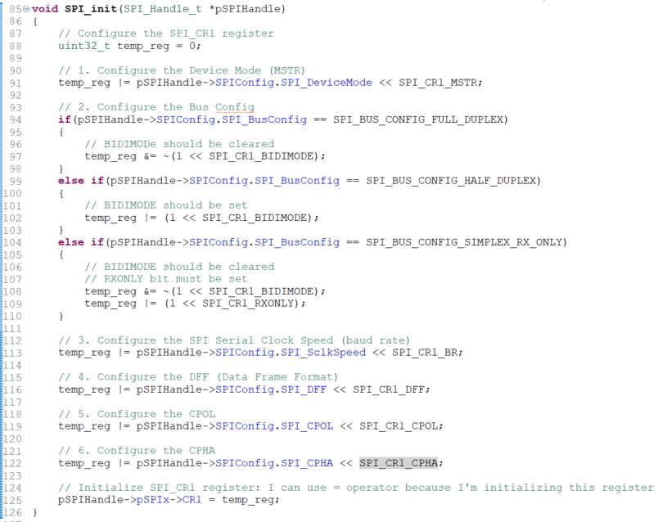

We can create other macros for **SPI_CR2** and **SPI_SR**: for now let’s skip the other registers:

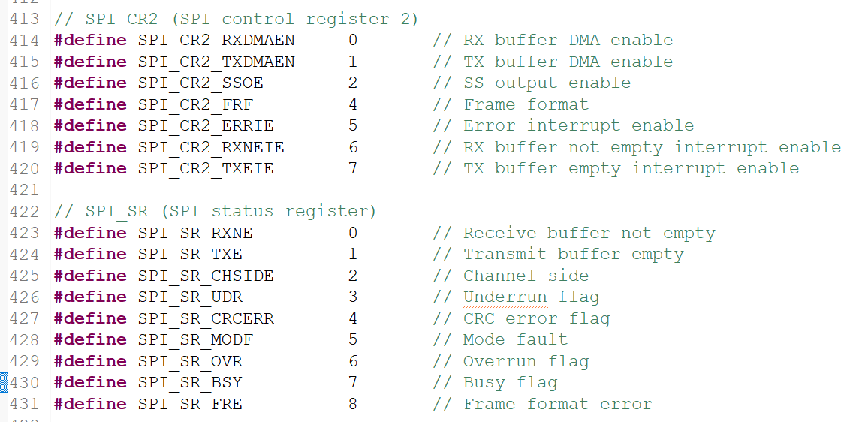

# Sezione 39: SPI Driver API implementation : Send Data

## 141. Implementation of SPI send data API : Part 1

Hey, welcome back to the lecture and in the previous lecture, we actually implemented the SPI_Init, right?? And after that, the next API to implement is SPI_DeInit, so that I will give you as an exercise.

In this lecture, let's implement SPI_SendData API. This is actually the **blocking API**. So, we call this as blocking API, because the function call will wait until all the bytes are transmitted. So, the number of bytes to transmit actually indicated by ***len*** input variable and ***\*pTxBuffer*** is a pointer to the data and after that ***\*pSPIx*** is the base address of the SPI peripheral.

Now let's take a look into the flowchart of this API.

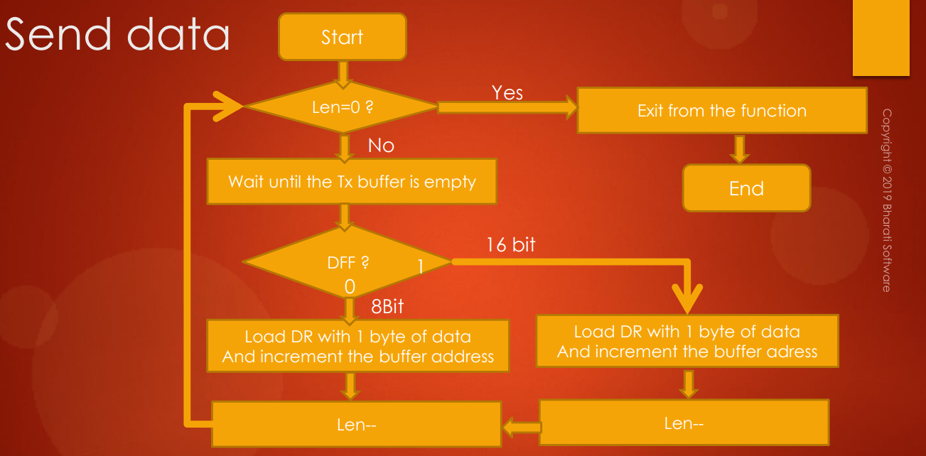

So, first when we enter into this function, first we have to check whether the **length** is 0 or not. So, length means it is user given length, so number of bytes to transmit.

So, if that is equal to 0, then that means all the bytes have been transferred or sent. So, we can exit from the function. So, that is actually the end of this function.

If length is not equal to 0, then you have to wait until the Tx buffer is empty.

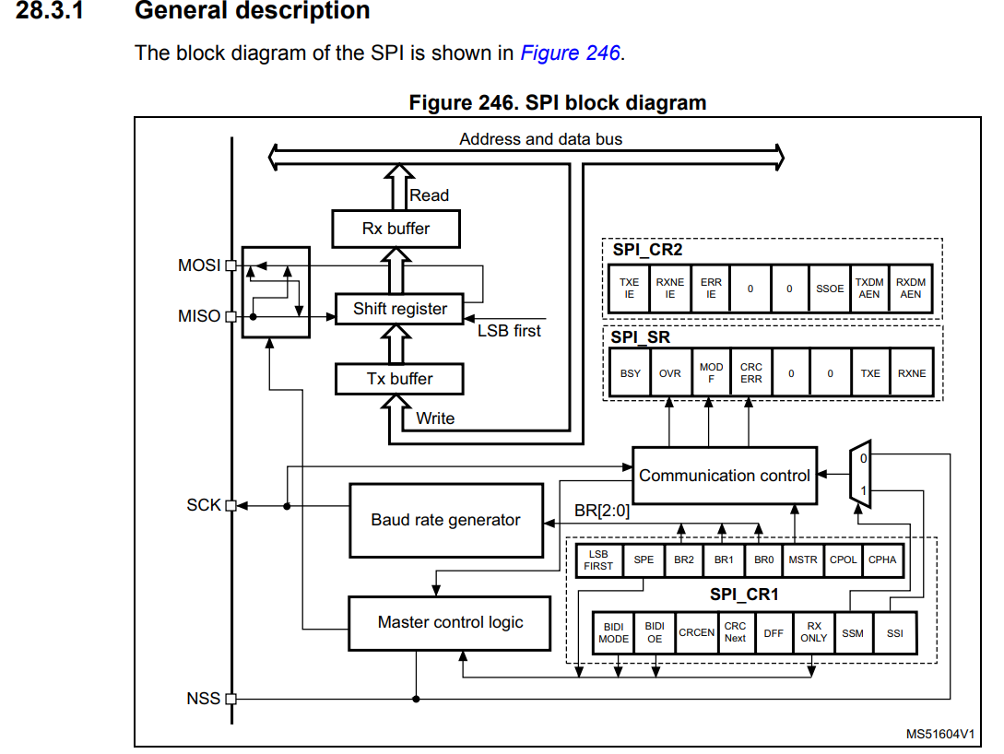

So, if you check the SPI block diagram once again, so, here you see **Tx buffer**. So, you have to put your data into this Tx buffer in order to trigger the transmission. But remember that when this Tx buffer is empty, then only user or your code must put the data. Otherwise, you will corrupt the data which is already there in the Tx buffer. So, that's the reason, you have to first confirm whether the Tx buffer is empty or not. You can get that confirmation from the **status register** (**SPI_SR**).

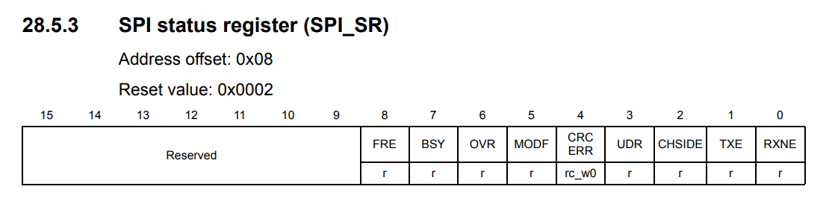

So, in the **SPI status register**, there is a bit called **TXE** that is a flag. So, remember, status register is a collection of flags which will capture various events of the peripheral. So, whenever that Tx buffer becomes empty, **TXE** flag will be set. So, let's go and check the **TXE** flag. So, here it is.

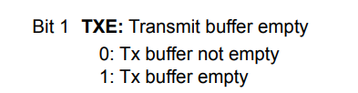

Its meaning is transmit buffer empty. So, whenever the TXE is 1, that means Tx buffer is empty and that is the indication to your firmware or your driver to program the transmit buffer. So, if TXE is 0, you should wait until TXE becomes 1 in order to put the next data byte. So, you should keep this in mind.

So, that means we have to wait until TXE becomes 1. So, we have to implement that.

Now, let's say transmitter is empty, which is true. So, then you have to check what exactly is the value of **DFF** bit, that is **Data Frame Format**.

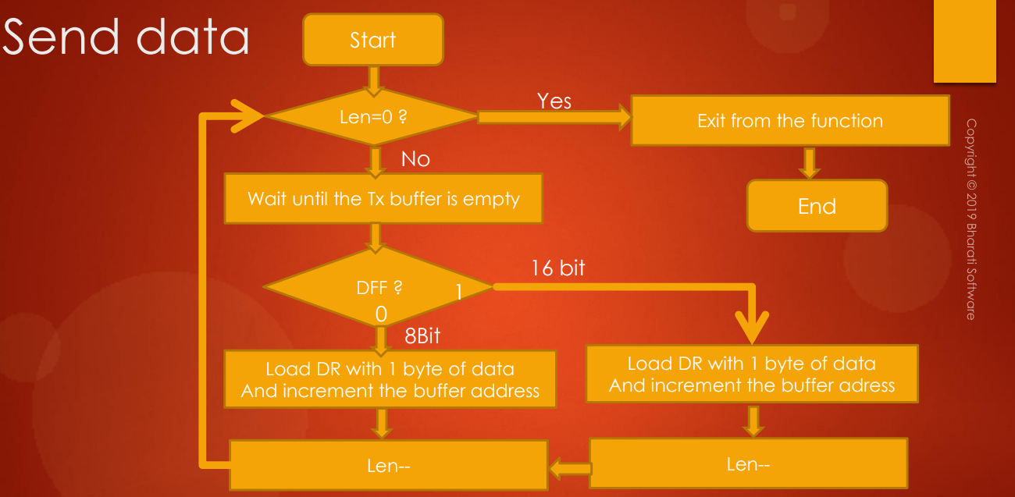

If DFF is 0, then this is 8 bit data transmission. So, that's why you have to load 1byte of data into the Tx buffer and you have to increment the buffer address in order to point to the next data byte. And then you have to decrement the length by 1. Why? Because, you have successfully transmitted 1 byte. So, and after that again you have to check whether length is equal to 0 or not.

So, if the DFF is 1, that means it is 16 bits of data transmission that means 1 SPI frame is nothing but it is a collection of 2 bytes: 2 bytes will be sent at a time. So, that's why you have to load DR with actually 2 bytes. So, you have to load DR, so DR means data registers, so about that I will talk in a moment. Don't worry. So, we have to load DR with 2 bytes of data and increment the buffer address. And then you have to decrement the length twice, *length--* and *length--* and again you have to repeat all these steps until length becomes 0.

So, remember that in the block diagram, we have Tx buffer and Rx buffer. So, please note that your firmware has no access to these buffers. These are internal buffers and your firmware cannot access them. The way to access these buffers will be through the **data register**. So, that's why you will find a register called **DR** (**Data Register**) and here you can see that this is of 16 bits and this is called data register and data received or to be transmitted.

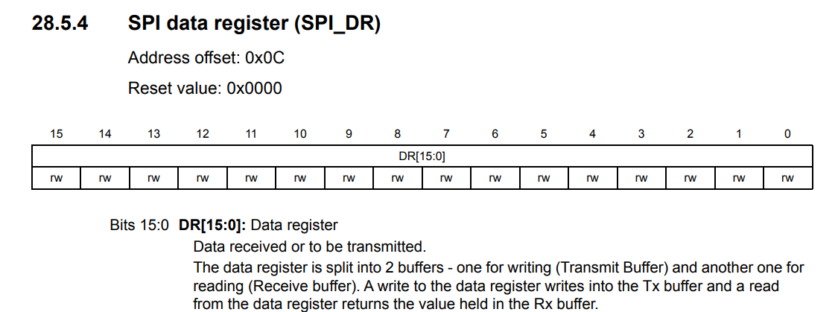

So, if you are in **transmitter mode**, then you have to keep your data into this register and then this data will get copied into the **Tx buffer**.

And whenever **reception** happens, the data which is there in the **RX buffer** will be moved to this register and firmware has to read from this register.

So, the firmware has access to this register. Firmware has no access to Tx buffer and Rx buffer directly.

So, the data register is split into 2 buffers: one for writing (Transmit Buffer) and one for reading. So, a write to the data register will write to the Tx buffer. So, this is basically like a window into the Tx buffer.

So, whenever you write into this register, that write will be actually to the Tx buffer. And read from the data register will return the value held in the Rx buffer. So, this is a very important sentence, and you have to remember this.

So, whenever read operation is performed on this register, the contents of the Rx buffer will be returned. And whenever you write into this register, the write actually will go to the Tx buffer. And remember that before writing to this register, make sure that Tx buffer is empty, that means you have to check the **TXE** flag, while before reading this register, you have to check the **RXNE** flag.

Now let's explore the RXNE flag in the status register. Here it is, RXNE.

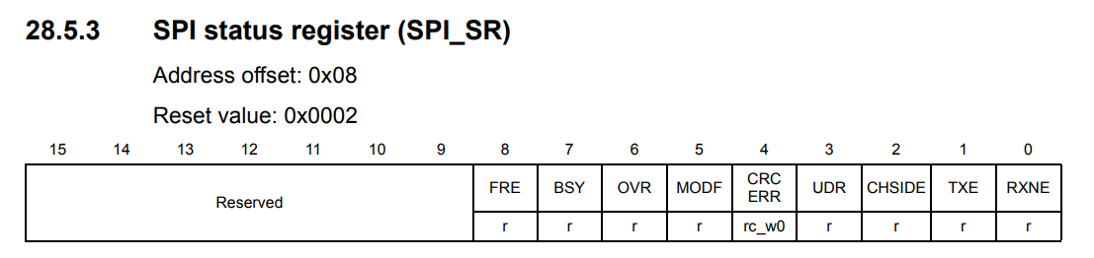

And let's explore that.

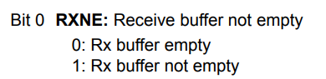

**RXNE** stands for **Receive buffer not** empty: whenever receive buffer is full, this flag will be set and that is an indication for your firmware or driver to read the Rx buffer. So, you have to keep this in mind. So, I have one small animation. For example, let's say this is the data register and let's say you want to send 1 byte of data to the external world. So, what you do? So, you just write into the data register, and when you write to the data register, that actually goes to the Tx buffer and to the shift register and from shift register, it actually goes out of the peripheral to the external world.

And whenever this peripheral receives data from the external world, and that will be in Rx buffer. And whenever you perform read operation on the data register, the content of the Rx buffer will be returned. So, you have to keep this in mind.

So, this is the flowchart to implement the send data, try to implement this and I will see you in the next lecture.

## 142. Implementation of SPI send data API : Part 2

Hey, welcome back to the lecture. So, now let's code this function SendData. So, first of all, let's loop until the length becomes 0 until length is greater than 0. So, first, actually, you have to wait until TXE is set. For that, what you have to do is, we have to look into this pointer. So, here we have to select SR. All right? So, we are checking the status flag, right?? The status flag is TXE and let's see the position of TXE which is 1. So, 1 shifted by 1. Right?? So, if this whole expression is 0, then we have to wait. So, we can use not operator here and let's wait. So, if this whole expression is 0, then the TXE is not yet set. Right?? So, 0 not of 0 is 1 and we will hang here. So, if TXE is set, then this whole expression will be 1 and not of 1 will be 0 and we will come out of the while loop. Right?? That's great. So, now, instead of implementing like this, we can implement a function which returns whether the requested flag is set or reset. So, we can implement a small function. I would call that function as SPI_GetFlagStatus(). So, now this is to quietly the requested flag status. Let's implement this function somewhere here. So, let me implement in the driver file. All right?? So, now this function actually takes the peripheral base address and the requested flag. So, let's say FlagName. All right. So, now this function should return either true or false or set or reset. So, we'll use uint8_t. So, now currently let's return let's say FLAG_RESET. So, just return FLAG_RESET. So, later we can implement this function. All right. So, let's define this flag reset macro, so this we can define in MCU specific header file. So, let's define here, Flag reset is actually reset and flag set is actually set.

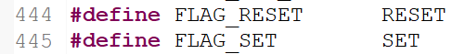

Let's go back and it actually takes the flag name, remember. So, we can use this function call in our send data. Right?? So, here let's send this base address here and the flag name. So, in this case, the flag name is SPI TXE flag. Right? So, we can later define this macro no problem. So, if the return value of this function is FLAAG_RESET, then the function should wait here. So, let's use while loop here.

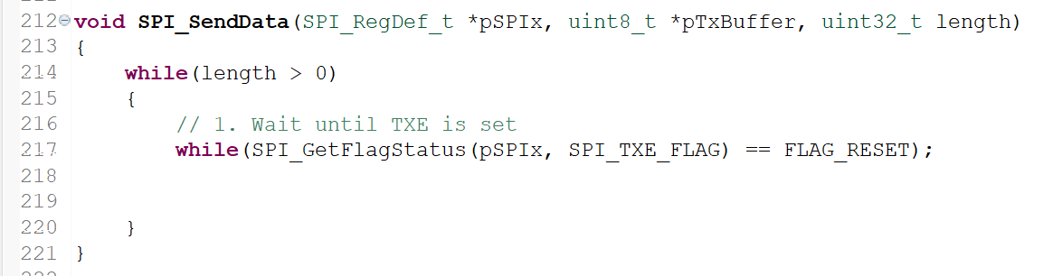

So, now let's define this TXE_FLAG. Remember that in this function, that is SPI_GetFlagStatus, we are actually going to test this flag whether it is set or reset, right?? So, that means in this parameter, we have to send the masking details of the TXE flag. That's why let's define this flag with its masking related info- that we can do in the "spi_driver.h". Why spi_driver.h ?? Because this flag is something specific to the SPI, isn't it?? So, that's why let's go to the spi_driver.h and maybe here after this line, we can define that macro. So, here you can see that this is actually defined to 1 shifted by the TXE position. The TXE position is 1, right?? So, that means this flag actually gives the masking info of the TXE field in the SR register. So, now what happens here?? So, now in this function, what you have to do is, so, now we have to test the received flag in the SR register. Right?? So, let's do that. Let's take the base register of the peripheral, go to SR and bitwise AND with this flag name. If that is set, then this will be true, isn't it?? So, if this is true, then return FLAG_SET. That's it. Very simple, isn't it??? So, this is a base address and we are actually testing the SR register and we are testing the bit position of the flag which we receive here.

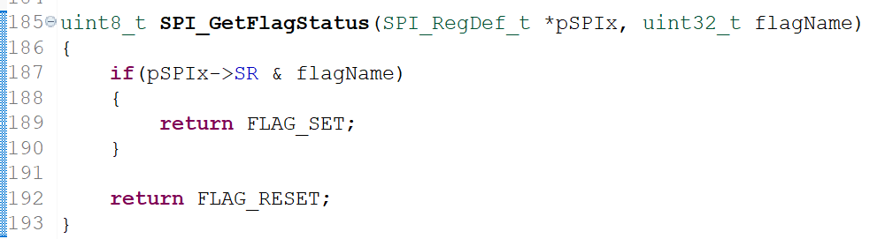

## 143. Implementation of SPI send data API : Part 3

So, basically, we have many flags in the SPI peripheral. So, that you can check in the **SR register**.

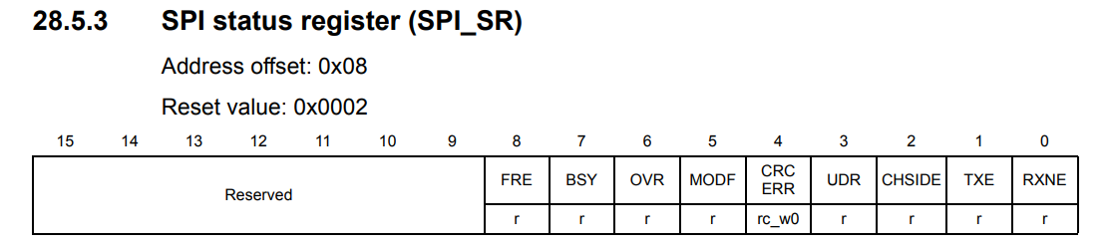

So, we have RXNE flag, TXE flag and CHSIDE flag, UDR, CRC, MODF, Overrun flag, busy flag and frame error flag. So, we have various flags here and for everything, you have to create one entry in this section.

So, currently, I have created for TXE, RXNE and Busy, because those flags will be using in this driver development task. So, these are nothing but their masking details in the SR register.

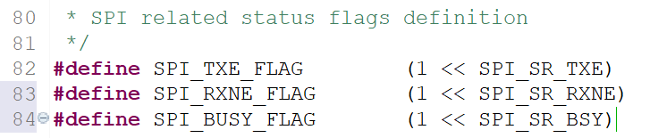

So, now let's go back to the SPI driver. So, wait until TXE is set. If this returns SET, then we will come over here. And the second step is check the DFF bit in CR1. So, let's test that. If CR1 & 1 shifted by the DFF. So, we have to test now the DFF bit field. So, that is SPI_CR1_DFF. So, if this whole expression is true, then 16 bit data frame format, 16 bit DFF, else, it will be 8 bit DFF.

So, here what you have to do? First, load the data into the data register. So, how do you load? Very simple. So, you have to take the base address, you have to select DR is equal to you have to load 16 bit data, remember. So, what you have to do is, we have to take this pointer that is ***pTxBuffer*** and you have to type cast that to uint16_t* and after that, you have to dereference that in order to load the data. So, this is actually the dereferencing.

So, if you just do without this, what happens? This is just dereferencing uint8_t pointer type, so that would actually load 1 byte of data into the DR. So, that's why we first have to type cast this to uint16_t pointer type. So, now this pointer will now become 16-bit pointer type. And when we dereference the value, the value which comes out of this expression will be 16 bit data. So, we have to make this as 16.

And after that you have to **decrease** this **length** 2 times you have to do, because you have just sent out 2 bytes of data. And if it is 8 bit, then again you have to repeat all these things. So, but you have to remove this typecasting. So, it is just dereferencing of this pointer which is of uint8_t pointer type. So, only one time you have to decrease the length. That's it. So, here the length is decreased by 2 and here the length is decreased by 1.

So, after that, so, you have to **increment** this ***pTxBuffer*** in order to make it point to the next data item.

Let's increment the pointer. So, here you have transferred 2 bytes, so that's why the buffer has to be incremented by 2. So, that's why I'm typecasting this pointer to uint16_t type and then incrementing which should be incremented by 2. And here we have to do the same thing for DFF 8 bit, and here also we have to do TxBuffer++, that's it!

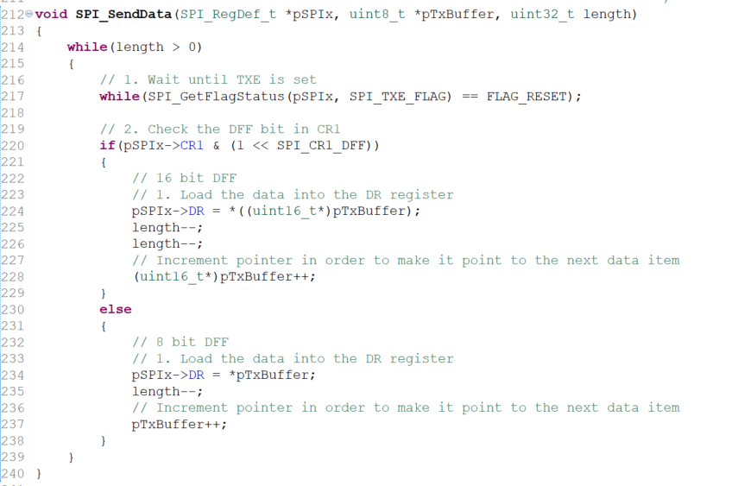

So, that's all you have to do. So, which completes the implementation of send data. And here you can see that this is actually the **blocking call**. That's because and you can see here until all the bytes have been transferred, this function will block. So, there are 2 while loops actually: for example, let's say length is 1000 bytes. So, until all the 1000 bytes are transferred, this function will not return. So, that is the meaning of **blocking**.

So, that's why you can give a small note here, this is blocking call. Later in this course, we can also implement another flavor of this function which is **interrupt** **based** that is called as **non-blocking** **call** where you will see that these while loops will not be there. So, interrupt based codes will not block actually. This you can also call it as **polling based** code, polling type API function because here you can see that this while loop has the potential to block permanently sometime, maybe due to the problem in the SPI peripheral or maybe due to problem in the SPI communication.



Surely, there are some possibilities that this while loop may hang permanently. So, in that case, you need a **watchdog** set up and all, in order to restart your whole program.

So, in the later part of the course, we will also implement **interrupt** flavors of this API, that we can only implement after covering interrupts. So, that completes send data and in the next lecture, let's test this function. Let's see how it works. Let's see whether it transmits some data or not.

So, I will see you in the next lecture.

# Sezione 40: Exercise: SPI Send Data

## 145. Exercise to test SPI Send Data API